|  |  |
| --- | --- |
| ARC ###/### FALL 2019 | Dr. Timothy Norris  University of Miami Libraries  Center for Computational Science  Chris Mader  Center for Computational Science |

GEOSPATIAL VISUALIZATION

GIS and CARTOGRAPHY in ARCHITECTURE

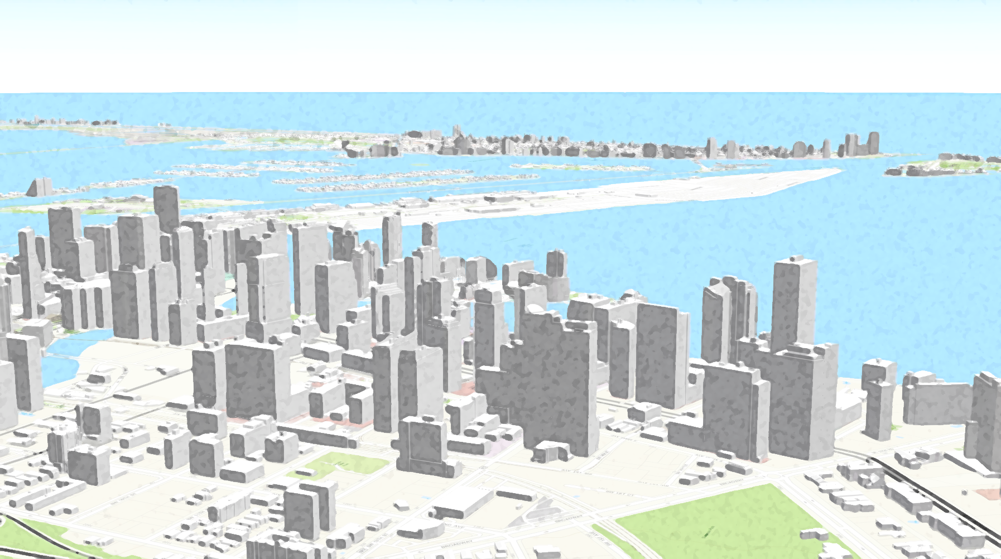

This course introduces the student to Geographic Information Systems (GIS) and how to apply GIS technologies in architectural design and urban planning contexts. Three principal activities will be emphasized: how to find, access, and use pre-existing GIS datasets; how to use industry standard tools such as ArcGIS and QGIS to perform basic analysis of geospatial data; and how to use ArcGIS and QGIS to transform and export geospatial data for use with applications such as Illustrator, AutoCAD and Rino. A series of hands on lab based exercises will build student GIS skill sets and encourage students to produce materials applicable to real-world projects in their respective design studios.