What you need to know form the Lectures:
[However, read the entire Lectures 7, 8, 9 & 10 for terminology, etc.]
- Linear Planar (= 2D) Systems: X’ = AX
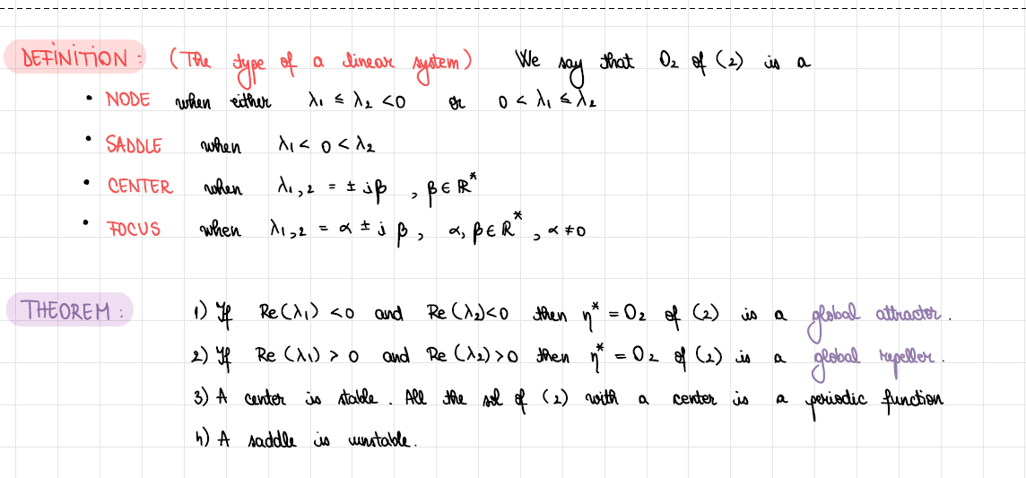

- NONlinear Dynamical System in 1D: x’ = f(x)

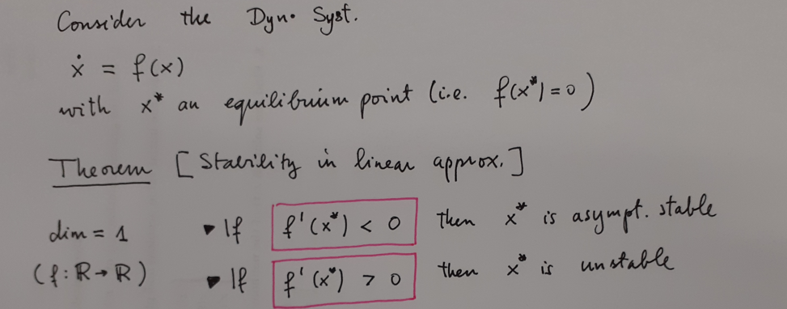

- NONlinear Planar (= 2D) Systems

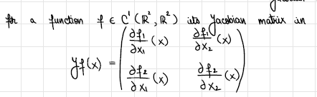
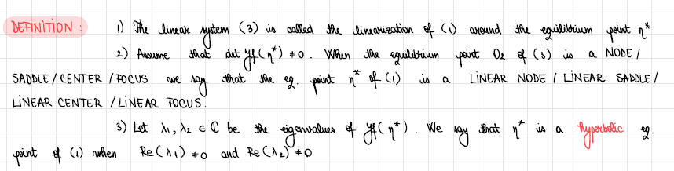
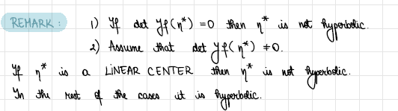

Stability is discussed separately in the two (hyperbolic & non-hyperbolic) cases:

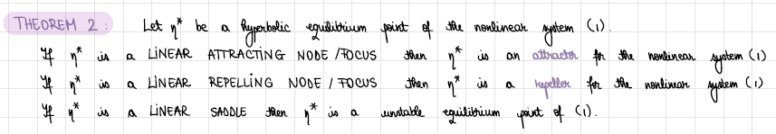

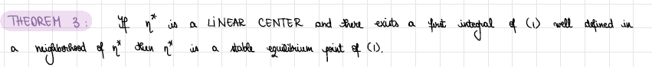

- How to find a First Integral for a Planar (Nonlinear) System

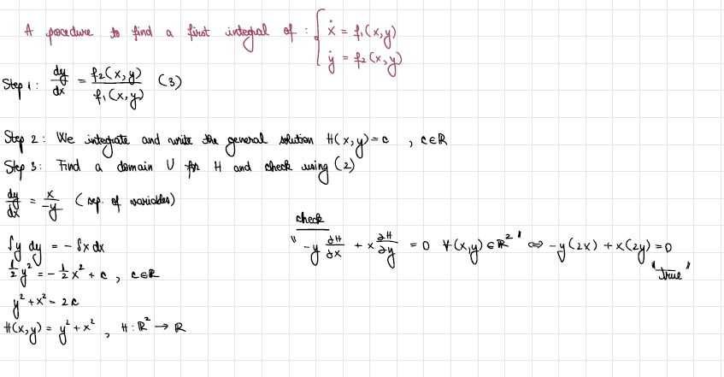

- How to find the general solution of a LINEAR system (with one off-diagonal zero)
