Use Case Specification: Personalized food menu generation

Authors: Akos Tiberiu Boros(tiberiu.a.boros@gmail.com )
Document Number: 1
Version: 1.0.2
Publish Date: 2015-05-05

Record of Processing
No. | Version | Date | Status | Who | Description
1 | 1.0.1 | 2015-05-05 |  | ATB | First draft
2 | 1.0.2 | 2015-05-06 |  | ATB | Final document
3
4
5
6
7

Record of Approval
No. | Version | Date | Who | Description
1 | … | … | …
2
3
4
5
6
7

Recipients of Document
No. | Version | Date of Distribution | Recipients
1 | … | …
2
3
4
5
6
7
Table of Contents
1 Personalized food menu generation 4
1.1 Brief Description 4
1.2 Primary Actor 4
1.3 Stakeholders and Interests 4
1.4 References 4
2 Flow of Events 4
2.1 Basic Flow 4
2.2 Alternative Flows 6
2.2.1 The application does not open 6
2.2.2 Incorrect food menu 6
3 Special Requirements 6
3.1 Doctor's prescription 6
3.2 Knowledge of the physical factor 6
4 Preconditions 7
4.1 Correctly estimated nutritional values 7
4.2 Correct information in the user profile 7
5 Postconditions 7
5.1 Food menu's compliance with the constrains 7
6 Extension Points 7
6.1 Application start failure 7
7 Technology and Data Variation List 7
8 Open Questions 7

Use Case Specification: Personalized food menu generation

Personalized food menu generation

Brief Description
The purpose of this document is to describe the steps that the user has to follow in order to obtain the best results from the application. He or she has to create his or her user profile, i.e. the predilections regarding various nutritional composition, food items, delivery cost and delivery time.

Primary Actor
The primary actor of this use case is the elder that wants a personalized food menu.

Stakeholders and Interests
The elder is the most important stakeholder because the food menu is recommended for him or her personal.
The Diet4Elders consortium is interested in the progress of the research activity performed by creating this application

References

Flow of Events

Basic Flow
The user starts the application and creates his or her profile. Then the system loads the data and waits for the user to push the button that triggers the algorithm that computes the best food menu for him or her.
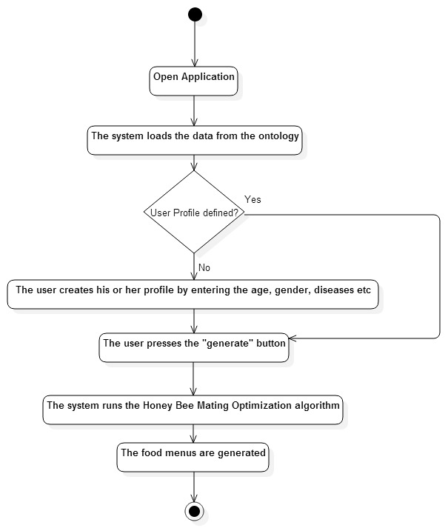
Use-Case Start
The user opens the application.
step 1
The user opens the application.
step 2
The system loads the data.
step 3
The user creates a profile.
step 4
The system waits until the user presses the generate button.
step 5
The system runs the Honey Bee Mating Optimization algorithm.
Use-Case End
The food menus are generated and displayed.

Alternative Flows

The application does not open
Alternative Flow Starts
The application does not open
step 1
The user tries to reopen the application for a finite number of times
step 2
Go to step 2
Alternative Flow Ends
The application opens, or the user calls custom support.

Incorrect food menu
Alternative Flow Starts
The generated food menu is incorrect, contains improper elements.
step 1
The user notes that the food menu is incorrect
step 2
Go to step 4
Alternative Flow Ends
If newly generated menu is still incorrect, then the user calls custom support.

Special Requirements

Doctor's prescription
The user may be a patient of a doctor which had prescribed him or her a prescription. That prescription has to be introduced to the user profile.

Knowledge of the physical factor
One requirement for the computation of the necessary amount of calories intake is based on the physical factor which has to be introduced to the user profile.

Preconditions

Correctly estimated nutritional values
The nutritional values that are estimated by a doctor must be correct in order to generate an adequate food menu.

Correct information in the user profile
The food generation algorithm takes into consideration the information the user introduces in the user profile. That being said, if the user introduces erroneous information, the results are altered.

Postconditions

Food menu's compliance with the constrains
The user must be sent the recommended food packages which should be eatable right out of the box.

Extension Points

Application start failure
The user will try to reopen the application and in case of another failure, other application are closed in order to free certain amounts of memory.

Technology and Data Variation List
N/A

Open Questions
N/A

