Hybrid Honey Bees Mating Optimization Method for Generating Healthy Menus for Older Adults

Authors…
Computer Science Department
Technical University of Cluj-Napoca
Cluj-Napoca, Romania
{}@cs.utcluj.ro

Abstract — This paper models the problem of generating healthy menu recommendations for older adults as an optimization problem and proposes a hybrid Honey Bees Mating Optimization method for solving this problem. The method hybridizes the state of the art Honey Bees Mating Optimization meta-heuristic by injecting strategies inspired from Genetic Algorithms, Path Relinking, Hill Climbing, Simulated Annealing, and Tabu Search into the steps that generate new solutions of the optimization problem. Experiments have been conducted on several hybridization configurations to identify the most appropriate hybridization that leads to the healthy menu recommendation that best satisfies the older adult’s diet recommended by the nutritionist, its culinary preferences and time and price constraints.
Keywords — Honey Bees Mating Optimization, optimization problem, fitness function, healthy menu recommendation.

Introduction
Nowadays there is the tendency to help older adults become more independent during their daily life activities. As aging may come with several health problems the older adult may become clumsy and unable to perform some of these daily life activities. One such activity involves preparing food and procuring the goods required for eating. The incapacity of performing such an activity may have a great impact upon the older adult’s health, as poor eating may quickly result in malnutrition which triggers other serious issues such as contributing to or aggravating chronic and acute diseases, speeding up the development of degenerative diseases, and even death.
Through this paper we aim to address this issue by proposing a software system that enables older adults to order food daily such that the nutritionist’s recommended diet, the older adult’s culinary preferences and time and cost constraints are satisfied. There are three actors interacting with the system, namely the older adult which orders food, the nutritionist that recommends a personalized a healthy diet for the older adult according to its profile and the food providers that advertise their food offers.
As the number of food providers is continuously increasing, the number of food offers is extremely high making the choice of the most appropriate offer that satisfies both the nutritionist’s diet and older adult’s constraints difficult for the older adult. To overcome this issue, we propose a bio-inspired optimization method that based on the set of food offers available on the market provides the food offers required to cover the breakfast, lunch, dinner and snack meals for one day that best satisfy the nutritionist’s diet and older adult’s cost and time constraints. The proposed optimization method hybridizes the state of the art Honey Bees Mating Optimization meta-heuristic [] with strategies borrowed from Genetic Algorithms, Path Relinking, Hill Climbing, Simulated Annealing, and Tabu Search to identify the most appropriate hybridization configuration that provides the best result in a short time. The optimization method is further integrated in the ordering system that we propose. In what follows, the paper will mainly focus on presenting the optimization method.
The paper is structured as follows. Section II presents related work. Section III formally defines the optimization problem we intend to solve using a Honey Bees Mating Optimization-based method. Section IV presents the proposed Honey Bees Mating Optimization-based model, while Section V details the associated algorithm. Section VI illustrates the experimental results obtained for a given case study. The paper ends with conclusions.

Related Work
Related work related work related work related work work Related work related work related work related work work
Related work related work related work related work work
Related work related work related work related work work
Related work related work related work related work work
Related work related work related work related work work
Related work related work related work related work work
Related work related work related work related work work
Related work related work related work related work work
Related work related work related work related work work
Related work related work related work related work work
Related work related work related work related work work
Related work related work related work related work work
Related work related work related work related work work
Related work related work related work related work work
Related work related work related work related work work
Related work related work related work related work work
Related work related work related work related work work
Related work related work related work related work work
Related work related work related work related work work
Related work related work related work related work work
Related work related work related work related work work
Related work related work related work related work work
Related work related work related work related work work
Related work related work related work related work work
Related work related work related work related work work
Related work related work related work related work work
Related work related work related work related work work
Related work related work related work related work work
Related work related work related work related work work
Related work related work related work related work work
Related work related work related work related work work
Related work related work related work related work work
Related work related work related work related work work
Related work related work related work related work work
Related work related work related work related work work
Related work related work related work related work work
Related work related work related work related work work
Related work related work related work related work work

Problem Definition
The Hybrid Honey Bees Mating Optimization (HBMO) method proposed in this paper aims to solve the following optimization problem:
“Given a repository of food packages provided by several food providers, find the optimal combination of food packages for each of the meals of a day such that they meet an older adult’s profile (containing information about his or her preferred food and allergies), price and delivery time constraints, and recommended diet”.
The following sub-sections will detail how a solution of this optimization problem is defined as evaluated.

Solution Representation
In this case, a solution of the optimization problem is formally represented as follows:
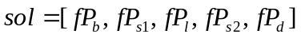 (1)
where fP_{b}, fP_{s1}, fP_{l}, fP_{s2} and fP_{d} are the food packages selected for breakfast, the first snack, lunch, the second snack, and dinner respectively. Each food package can have a starter, main course and/or desert dish. Figure 1 illustrates the relationships between meals and dishes.

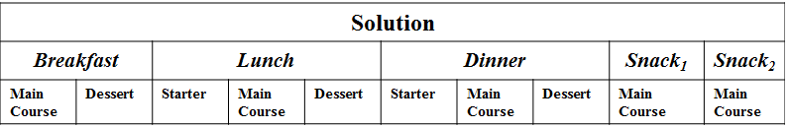
Figure 1. Solution representation

A food package is formally represented as:
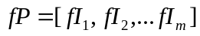 (2)
where fI_{i} is a food item (e.g. noodle soup) and m is the number of food items part of the food package, each food item being classified as either a starter, main course, or a dessert. Additionally, each food item has a recipe associated as well as a set of values corresponding to the nutrients that are being considered.

Solution Evaluation
A solution of our optimization problem is evaluated according to the following criteria:
- Nutritionist’s diet referring to the recommended number of
  - Kilocalories
  - Macro-nutrients (i.e. carbohydrates; proteins; fats)
  - Micro-nutrients (i.e. Vitamins A, B, C, D; calcium; iron; sodium)
- Older adult’s culinary preferences
- Older adult’s cost and delivery time constraints
Thus, the evaluation of a solution, is done on three different levels and then combined to provide the final fitness value:
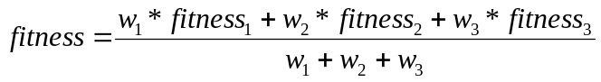
(3)
where fitness₁ evaluates the quality of a solution from the nutritionist’s recommended diet perspective, fitness₂ evaluates the quality of a solution from the older adult’s culinary preferences, and fitness₃ evaluates the quality of a solution from the older adult’s cost and delivery time constraints. The definitions of all three fitness function components, i.e. fitness₁, fitness₂ and fitness₃ rely on the following aspects:

Ideal value – the evaluation of a component of a solution (e.g. a nutrient or a food item) will be done by comparing it with an ideal value. Thus, the following two pieces of information will be required:

The quantity of the component in the current solution being evaluated. For example, if the meal contains 1700 kilocalories, it is said that the “quantity” of the component “kilocalories” is 1700.

The desired quantity, or ideal value, of the component as specified in the nutritionist’s diet recommendation or older adult’s culinary preferences. For example, for a female adult, the desired quantity of kilocalories is 2000, thus, it is said that the “ideal value” of “kilocalories” is 2000.
The solutions that contain components in quantities closer to the “ideal” values are marked higher than the ones that contain components in quantities further from the “ideal” values. The function error margin evaluates each component from this point of view (deviation of the real value from the ideal value) and marks it by a number between 0 (smallest) and 1 (greatest).

Weight - each component in one solution can be declared as more “important” than the others by assigning it a weight greater than the weights of the other components. The motivation for this is giving priority to the user’s preferences for some component and also to the doctor’s prescription.

Error function - used to analyze and penalize the deviation of the real value from the ideal value. Because of the different criteria that the solution is evaluated on, the error functions differ in their implementation, but the output is standardized. Irrespective of the criterion that the error function is applied to, the co-domain is the interval [0, 1], where 1 indicates that the evaluated quantity is the ideal one whereas 0 indicates an unacceptable quantity.
In what follows, we present the definitions of the three components of the fitness function defined in Formula 3:

The fitness component fitness₁
The formula for the fitness component that evaluates a solution from the nutritionist’s recommended diet perspective, fitness₁, is defined as:
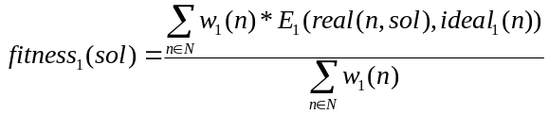 (4)
where: w₁(n) represents the value of the weight associated to the nutrient n, N is the set of nutrients associated to the food packages part of the solution sol, ideal₁(n) represents the ideal value of the nutrient n, real(n) represents the actual value of the nutrient n in the current solution sol being evaluated, and E₁ is the error function defined for the fitness component fitness₁ (see Formulas 5 and 6).
The error function scores the deviation of the actual value of the nutrient n in the current solution sol from the ideal one. As we consider two possibilities for storing the ideal value of a nutrient, either as a single fixed value or as an interval, we define the following two variants for the error function:
Error function definition for fixed values:
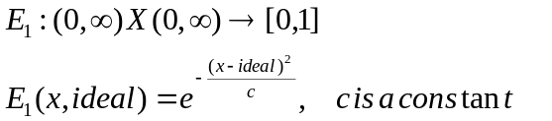 (5)

Error function definition for intervals:
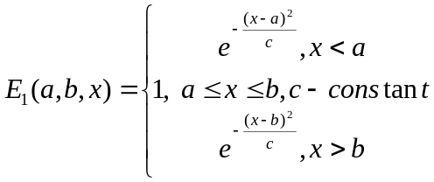 (6)
For example, if for some nutrient the ideal value is 5 mg per day, the error function is the following: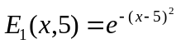, supposing that the constant c = 1.

The fitness component fitness₂
The fitness component fitness₂ evaluates a solution from the older adult’s culinary preferences, by checking whether each ingredient present in the food packages associated to the solution in the like list and not in the dislike list:
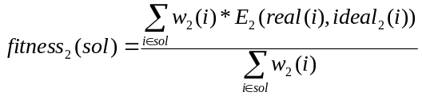 (7)
where: w₂(i) represents the value of the weight associated to the ingredient i, real(i) represents the ingredient i, ideal₂(i) indicates whether the ingredient i is among the ones preferred by the older adults or not, and E₂ is the error function defined for the fitness component fitness₂.
The older adult has the possibility to specify a list of ingredients that he or she wishes to be present in his or her recommended menu. Therefore, the older adult’s profile will contain a like list containing the ingredients the older adult likes (the ideal value for these ingredients is 1), and a dislike list containing the ingredients the older adult does not like (the ideal value for these ingredients is 0).
In the context of weights, an ingredient specified in the like list has a weight value equal to 1, an ingredient specified in the dislike list has a weight value equal to 1, while an ingredient which is not specified neither in the like list nor in the dislike list has a weight value equal to 0.
The error function E₂ evaluates an ingredient for which the preference of being present or absent in the meal has been specified by the older adult. Basically, it is the same as the error function defined for the fitness component fitness₁, but instead of analyzing nutrients, it analyzes real food items and assesses a fitness value based on the presence (or absence) of ingredients that are on the culinary preferences list of the older adult. When computing the value of the error function we consider the following four possible cases:
- The user does specifically not want a food item (ideal = 0) and the item is not present in the meal (real = 0). This is marked with 1, because it is as desired.
- The user wants a food item (ideal = 1) and the item is not present (real = 0). This is marked with a value k ∈ (0, 1), because it is not desired to be marked with 1, but also it is not very critical to be marked with 0. This particular case is of a lower importance. For example, k = 0.7 is a good approximation of “how important” it is.
- The user does specifically not want a food item (ideal = 0) and the item is present in the meal (real = 1). This is marked with 0, because the meal should avoid that item.
- The user wants a food item (ideal = 1) and the item is present in the meal (real = 1). This is marked with 1 because it is as desired.
Table 1 illustrates these four cases considered for the error function.

Table 1. Error function values for the fitness component fitness₂
real(i) | ideal₂(i) | E(real(i), ideal₂(i))
0 | 0 | 1
0 | 1 | k (0, 1)
1 | 0 | 0
1 | 1 | 1

The fitness component fitness₂
The fitness component fitness₃ evaluates the quality of a solution based on the older adult’s cost and delivery time constraints:
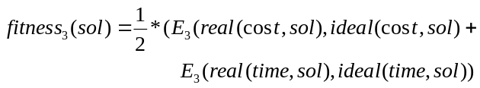
(8)
where real(cost, sol) represents the cost of the food menu recommendation sol, ideal(cost, sol) represents the maximum cost desired by the older adult, real(time, sol) represents the delivery time of the food menu recommendation sol, ideal(time, sol) represents the maximum delivery time accepted by the older adult, and E₃ is the error function defined for the fitness component fitness₃ as follows:
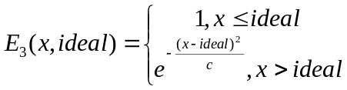 (9)
Thus, a value less than the ideal one is a positive aspect (e.g. a food package that costs 10 euros less than expected), and the error function takes the value 1. If the value is greater than the ideal one, the Gauss function is applied.
The weights for cost and delivery time do not have any significant impact on the fitness function, so they are set to value 1.

The Hybrid Honey Bees Mating Optimization Model
The Hybrid Honey Bees Mating Optimization Algorithm proposed in this paper relies on a hybridization model consisting of a core component and of a hybridization component which will be detailed in the following sub-sections:

The Core Component
The core component of our model is the Honey Bees Mating Optimization-based component which is defined by mapping the concepts from the state of the art Honey Bees Mating Optimization algorithm to the concepts associated to the problem of generating the optimal combination of food packages for the meals of the day as illustrated in Table 2.

Table 2. Mapping the Honey Bees Mating Optimization algorithm to the our optimization problem
Biological Concepts [1] | HBMO Concepts [1] | Concepts from our Optimization Problem
Queen | The current optimal solution | The current optimal combination of food packages
Drone | Solution | Combination of food packages
Worker | Solution | Combination of food packages
Mating flight | Simulated Annealing-based strategy for selecting the drone solutions that will be modified according to the current optimal solution | Selection of the combination of food packages that will be modified based on the current optimal combination of food packages
Breeding process | Crossover/heuristic functions applied between the selected solutions and the current optimal solution | Crossover/Path relinking-based strategies applied between a combination of food packages and the current optimal combination of food packages
Feeding selected broods and queen | Modifying the new solutions according to the worker solutions using mutation and heuristic functions | Hill Climbing /Simulated Annealing/Tabu Search-based strategies for improving a combination of food packages

The Hybridization Components
The hybridization components that will be injected in the model’s core component are classified in two categories according to the point in which they can be injected. Thus, we define a Crossover-based Hybridization component and a Path relinking-based Hybridization component which are alternatives for implementing the breeding process (i.e. brood creation). We also define a Tabu Search-based Hybridization component and a Hill Climbing Hybridization component which are alternatives for implementing the process of feeding the selected broods by the workers. The following sub-sections describe each of these hybridization components.

Hybridization components for implementing the breeding process
A brood creation process takes place between a queen and a drone and will generate a set of broods. In our approach we have considered two strategies for implementing this process: the Crossover-based strategy and the Path Relinking-based strategy.
Uniform Crossover-based strategy. The uniform crossover-based strategy applies a uniform crossover operator in one single point for generating the brood solutions as a result of the mating between the queen solution and the drone solution. The crossover point corresponds to a package of a solution associated to breakfast, lunch, dinner, snack 1 or snack 2. The uniform crossover-based strategy is applied as follows between a queen solution and a drone solution:
- For each new brood solution that needs to be generated do:
  - Select each package of the current brood solution by randomly choosing either the corresponding package from the queen solution or from the drone solution.
Figure 2 illustrates the result of applying the crossover-based strategy upon a queen solution and a drone solution supposing that it has been randomly established that the breakfast, snack 1 and snack 2 packages are taken from the queen solution while the lunch and the dinner packages are taken from the drone solution.

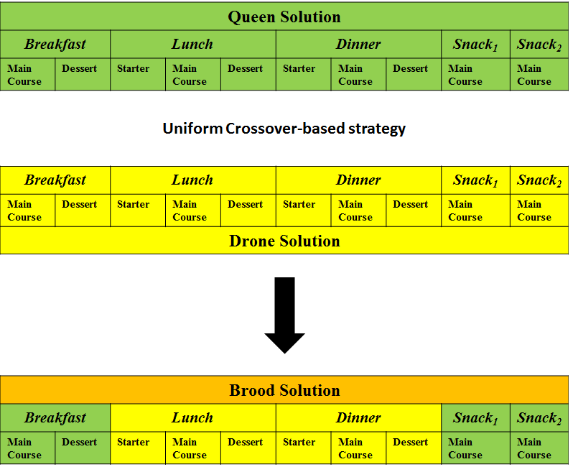
Figure 2. Example of applying the crossover-based strategy in an iteration

Path Relinking-based strategy. The Path Relinking-based strategy generates solutions by iteratively combing a single component of a bad solution with the one of a good solution until a better one is found, or until all components of the bad solution have been replaced. In our case, a drone solution sol_{i} firstly takes one random component (e.g. breakfast or lunch package) from the queen solution and gives birth to a brood solution. If the brood solution is not better than the queen solution, sol_{g}, the new brood solution takes further a random component from the queen solution. This process is repeated until a solution at least as good as the queen solution is found. All the intermediary brood solutions are stored in a set and returned. In what follows, we exemplify how the Path Relinking-based strategy is applied between a drone solution sol_{i} and a queen solution sol_{g}:
- Initial step:
  - Drone solution: sol_{i} = (fP_{bi}, fP_{li}, fP_{di}, fP_{s1i}, fP_{s2i}), fitness = 0.6
  - Queen solution: sol_{g} = (fP_{bj}, fP_{lj}, fP_{dj}, fP_{s1j}, fP_{s2j}), fitness = 0.3
- First Step: sol_{i}’ = (fP_{bi}, fP_{lj}, fP_{di}, fP_{s1i}, fP_{s2i}), fitness = 0.4
- Second Step: sol_{i}’ = (fP_{bi}, fP_{lj}, fP_{di}, fP_{s1j}, fP_{s2i}), fitness = 0.2

Hybridization components for implementing the feeding process
The feeding process takes place after the broods have been created as a result of the mating between the queen and the selected drones. In our approach, the feeding process maps on applying modification strategies upon the brood solutions, strategies which involve applying the Hill Climbing, Simulated Annealing and Tabu Search heuristics. Because there are no data dependencies between the brood solutions, the brood improvement process is done in parallel by a certain number of threads. The set of brood solutions is partitioned into the number of threads and each thread executes in parallel the brood improvement processes on its own set of brood solutions. For each brood, a random heuristic is chosen to improve it among Hill Climbing, Simulated Annealing and Tabu Search.
Hill Climbing-based strategy. The Hill Climbing-based strategy searches for better solutions in the neighborhood of the current best solution. If one is found, it replaces the current best solution. The solutions that are worse than the current one are ignored. This step is repeated for a certain number of times or until a local maximum is found. To generate the neighborhood of a solution sol multiple random mutations are applied on the solution sol. Each mutation involves replacing a package of the solution sol with a randomly selected package from a repository of packages.
Simulated Annealing-based strategy. The Simulated Annealing-based strategy is similar to the Hill Climbing-based strategy, but instead of accepting only better solutions, it accepts also worse solutions with probabilities based on the current timestamp, from which the temperature is deduced, and the fitness values of the solutions. The Simulated Annealing-based strategy is applied on a brood solution and tries to improve its fitness by searching for a better solution in its neighborhood (generated in the same manner as in the case of the Hill Climbing-based strategy).

Tabu Search-based strategy. The Tabu Search-based strategy implements a simple version of Tabu Search, i.e. the heuristic uses only the short-term memory instead of using also the other types of memories. The Tabu Search-based strategy is also similar to the Hill Climbing-based strategy, but additionally it uses a short-term memory (the tabu list) to avoid visiting some solutions that have already been visited. The Hill Climbing-based strategy may visit the same solutions multiple times, thus being less efficient. The best solution from the neighborhood (generated in the same manner as in the case of the Hill Climbing-based strategy) is added to the tabu list.

The Hybrid Honey Bees Mating Optimization Algorithm
The Hybrid Honey Bees Mating Optimization Algorithm (see Algorithm 1) identifies the optimal combination of food packages for the meals of a day by processing a set of semantic descriptions of food packages provided by different providers. The algorithm takes as input the following parameters: (i) Rep – repository of semantic descriptions of food packages, (ii) popSize – the size of the initial population, (iii) maxNoIt – maximum number of iterations, (iv) sp – the queen’s initial speed, and (v) maxNoMatings – the maximum number of mates that a queen can have.
The algorithm consists of an initialization and an iterative stage. In the initialization stage the initial population of individuals is randomly generated, from which the queen solution will be extracted as the best solution in the population, while the rest of the solutions are labeled as drone
solutions that will further attempt to mate with the queen solution.
In the iterative stage, the following steps are performed until the maximum number of iterations is achieved:
Step 1: Mating and Breeding Process. For each drone solution, the probability of mating with the queen solution is computed and if it is above a computed threshold, then a number of brood solutions will be generated by applying one of the modification strategies based on Uniform Crossover or Path Relinking.
Step 2: Worker Process. Each brood solution generated in Step 1 will be submitted to an improvement process consisting of applying the Hill Climbing, Simulated Annealing, or Tabu Search-based strategies.
Step 3: Population Adjustment. The updated brood solutions resulted from Step 2 will be appended to the population of solutions. The queen solution will be updated if it is necessary, and the population of solutions will be adjusted such that it contains a number of popSize solutions (the extra worse solutions will be eliminated).

---------------------------------------------------------------------------
Algorithm 1: Hybrid Honey Bees Mating Optimization
---------------------------------------------------------------------------
Inputs: Rep, popSize, maxNoIt, sp, maxNoMatings
Output: sol_{opt}
Begin
Population = Random_Generate(Rep, popSize)
sol_{queen} = Extract_Best_Solution(Population)
i = 0
while (i<maxNoIt) do
noMatings = 0
Broods = {}
for each drone in Population do
if (noMatings ≤ maxNoMatings ) then
P = Compute_Mating_Probability(drone, sol_{queen}, sp)
Δ = Generate_Random_Number(0, 1)
if (P > Δ) then
noMatings++
Broods’ = Modification_Strategy(drone, queen)
Broods = Broods U Broods’
end if
end if
end for
for each brood in Broods do
brood = Worker_Modification_Strategy(brood, Worker)
Broods = Broods U brood
end for
Population = Population U Broods
sol_{queen} = Get_New_Queen(Population)
Population =Adjust_Population(Population, popSize)
i++
end while
return sol_{queen}
End
---------------------------------------------------------------------------
As a result of combining the hybridization components with the core component presented in Section IV we have obtained a number of 8 hybridization variants (see Table 3). Out of these variants there are two, namely HBMOUCR and HBMOPRR which randomly choose one strategy among Hill Climbing, Simulated Annealing and Tabu Search when improving a brood solution.

Table 2. Hybridization variants of the Honey Bees Mating Optimization algorithm
Mating and Breeding Process | Worker process strategy | Acronym
Uniform Crossover | Hill Climbing | HBMOUCHC
Uniform Crossover | Simulated Annealing | HBMOUCSA
Uniform Crossover | Tabu Search | HBMOUCTS
Uniform Crossover | Hill Climbing or Simulated Annealing or Tabu Search | HBMOUCR
Path Relinking | Hill Climbing | HBMOPRHC
Path Relinking | Simulated Annealing | HBMOPRSA
Path Relinking | Tabu Search | HBMOPRTS
Path Relinking | Hill Climbing or Simulated Annealing or Tabu Search | HBMOPRR

Experimental results
This section presents the architecture of the software system we proposed for ordering food daily as well as the experimental results obtained by the Hybrid Honey Bees Mating Optimization method when applied for an older adult profile.

System Architecture
Architecture

Case Study
This sub-section will present the experimental results obtained when applying the eight hybridization variants presented in Table 2 on an older adult’s profile illustrated in Table 3.

Table 3. Profile of an older adult
Attribute name | Value
Age | 75
Height | 1.80 m
Weight | 78 kg
Gender | Male
PAF?!?!? | Ce este
Culinary preferences | Ham, nut, lettuce
Culinary dislikes | Pepper, apricot
Maximum accepted cost per day | 70 – cam mare – ar trebui sa consideram in euro si eventual undeva la 20 euro
Maximum accepted delivery time | 50 minutes

Experimental Results

Conclusions

References

- O. B. Haddad, A. Afshar, M. A. Marino, Honey-Bees Mating Optimization (HBMO) Algorithm: A New Heuristic Approach for Water Resources Optimization, Water Resources Management, Volume 20, Issue 5, pp. 661-680, 2006.
- Squirrel's RecipeML Archive, http://dsquirrel.tripod.com/recipeml/indexrecipes2.html

