DIET4Elders: a Service Oriented Architecture for the Prevention and Self-Management of Malnutrition

LICENSE THESIS

 | Graduate: | Akos Tiberiu BOROS
 | Supervisor: | Dr. Eng. Viorica Rozina CHIFU  Dr. Eng. Cristina POP

2015

DEAN, |  |  | HEAD OF DEPARTMENT,
Prof. dr. eng. Liviu MICLEA |  | Prof. dr. eng. Rodica POTOLEA

Graduate: Akos Tiberiu BOROS

DIET4Elders: a Service Oriented Architecture for the Prevention and Self-Management of Malnutrition

- Project proposal: With the rapid growth of the population, studies have shown that in Europe, by 2050, the senior population will double to a procentage of 54.2%. This will result in a need of medical care services that the current health care systems simply cannot withstand. A user-oriented nutrition health care system is proposed in this thesis. By using hybrid bio-inspired optimization algorithm and real nutritional data of food ingredients, together with food packages provided by local food vendors, Diet4Elders succeeds in generating the most fit daily food menus according to the user's health needs.

- Project contents: (enumerate the main component parts) Presentation page, advisor's evaluation, title of chapter 1, title of chapter 2, …, title of chapter n, bibliography, appendices.

- Place of documentation: Technical University of Cluj-Napoca, Computer Science Department

- Consultants:

- Date of issue of the proposal: November 3, 2014

- Date of delivery: June 18th, 2015

Graduate: | Akos Tiberiu BOROS
Supervisor: | Dr. Eng. Viorica Rozina CHIFU  Dr. Eng. Cristina POP

Declaraţie pe proprie răspundere privind
autenticitatea lucrării de licenţă

Subsemnatul(a) BOROS AKOS TIBERIU, legitimat(ă) cu C.I. seria XH nr. 779535
CNP 1921128055076, autorul lucrării DIET4Elders: a Service Oriented Architecture for the Prevention and Self-Management of Malnutrition elaborată în vederea susţinerii examenului de finalizare a studiilor de licență la Facultatea de Automatică și Calculatoare, Specializarea Calculatoare din cadrul Universităţii Tehnice din Cluj-Napoca, sesiunea IUNIE a anului universitar 2015 declar pe proprie răspundere, că această lucrare este rezultatul propriei activităţi intelectuale, pe baza cercetărilor mele şi pe baza informaţiilor obţinute din surse care au fost citate, în textul lucrării, şi în bibliografie.
Declar, că această lucrare nu conţine porţiuni plagiate, iar sursele bibliografice au fost folosite cu respectarea legislaţiei române şi a convenţiilor internaţionale privind drepturile de autor.
Declar, de asemenea, că această lucrare nu a mai fost prezentată în faţa unei alte comisii de examen de licenţă.
In cazul constatării ulterioare a unor declaraţii false, voi suporta sancţiunile administrative, respectiv, anularea examenului de licenţă.

Data  18.06.2015 |  | Nume, Prenume  Boros Akos Tiberiu
 |  | Semnătura

De citit înainte (această pagină se va elimina din versiunea finală):

- Cele trei pagini anterioare (foaie de capăt, foaie sumar, declaraţie) se vor lista pe foi separate (nu faţă-verso), fiind incluse în lucrarea listată. Foaia de sumar (a doua) necesită semnătura absolventului, respectiv a coordonatorului. Pe declaraţie se trece data când se predă lucrarea la secretarii de comisie.
- Pe foaia de capăt, se va trece corect titulatura cadrului didactic îndrumător, în engleză (consultaţi pagina de unde aţi descărcat acest document pentru lista cadrelor didactice cu titulaturile lor).
- Documentul curent a fost creat în MS Office 2007. Dacă folosiţi alte versiuni e posibil sa fie mici diferenţe de formatare, care se corectează (textul conţine descrieri privind fonturi, dimensiuni etc.).
- Cuprinsul începe pe pagina nouă, impară (dacă se face listare faţă-verso), prima pagina din capitolul Introducere tot aşa, fiind numerotată cu 1. Pentru actualizarea cuprinsului, click dreapta pe cuprins (zona cuprinsului va apare cu gri), Update field->Update entire table.
- Vizualizaţi (recomandabil şi în timpul editării) acest document după ce activaţi vizualizarea simbolurilor ascunse de formatare (apăsaţi simbolul  din Home/Paragraph).
- Fiecare capitol începe pe pagină nouă, datorită simbolului ascuns Section Break (Next Page) care este deja introdus la capitolul precedent. Dacă ştergeţi din greşeală simbolul, se reintroduce (Page Layout -> Breaks).
- Folosiţi stilurile predefinite (Headings, Figure, Table, Normal, etc.)
- Marginile la pagini nu se modifică (Office 2003 default).
- Respectaţi restul instrucţiunilor din fiecare capitol.

Table of Contents

Chapter 1. Introduction 2
1.1. Project context 2
1.2. Thesis Structure 4
Chapter 2. Project Objectives 5
2.1. Problem Statement and Motivation 5
2.2. Objectives 6
2.3. Requirements 6
2.3.1. Functional Requirements 6
2.3.2. Non-functional Requirements 8
Chapter 3. Bibliographic Research 10
Chapter 4. Analysis and Theoretical Foundation 17
4.1. Ontologies 17
4.1.1. OWL and SWRL 18
4.1.2. SPARQL 18
4.1.3. Ontology Modelling from Medical Perspective 19
4.2. Food Modelling 23
4.2.1. USDA Database 23
4.2.2. USDA Database Structure 24
4.3. Cuckoo Search Optimization Algorithm 27
Chapter 5. Detailed Design and Implementation 28
Chapter 6. Testing and Validation 29
Chapter 7. User’s manual 30
Chapter 8. Conclusions 31
Bibliography 32
Acronyms 33
Appendix 1 (only if needed) 34

Introduction
One of the most important and most difficult things in life is obtaining balance. This of course, goes to nutrition as well. One can observe, that a proper equilibrium in the diet of a person can prevent most diseases from occurring. Because of bad eating habits and a hazardous diet, diseases are increasing in an alarming percentage amongst the population of most countries, with certain predilections to some classes of people.
Despite the strong evolution of the science of nutrition, it has become more and more neglected, and people do not assure their daily recommended nutrients intake, which eventually, in a point in life will backfire. If an equilibrium is not offered, the human body is thrown in an off-balanced state, and the response will be undesired medical conditions.
Nutrition is arguably amongst the few ways that one can influence their health, because it is a responsibility that nature has assigned to every person, and this can be done by understanding and complying with the laws of nature that reside within the human body.
It is advisable that one should have a healthy daily menu, in order to lead a healthy life. For a healthy daily menu, the meals should be rich in all the nutrients that are needed. The daily diet of a person should have the nutrients values as close as possible to the Recommended Daily Allowance (RDA) . It is true of course, that the RDA values for nutrients differs from a person to another. These values rely on the individual’s weight, height, gender and age as well as taking into consideration the physical activity level.

Project context
Nowadays there is the tendency to help older adults become more independent during their daily life activities. As aging may come with several health problems the older adult may become clumsy and unable to perform some of these daily life activities. One such activity involves preparing food and procuring the goods required for eating. The incapacity of performing such an activity may have a great impact upon the older adult’s health, as poor eating may quickly result in malnutrition which triggers other serious issues such as contributing to or aggravating chronic and acute diseases, speeding up the development of degenerative diseases, and even death.
Malnutrition amongst seniors has become more and more frequent in the last years. It is estimated that in Europe around 15% of the elderly population is affected by poor nutrition and malnutrition caused by the problems of ageing such as decrease in sensitivity, poor dental health, lack of transportation, physical difficulty, forgetfulness and other issues.
The costs determined by malnutrition are not negligeable. According to studies, United Kingom spends up to £7.4 billion per year. The prevalence of malnutrition is high and an issue is that it is hard to recognize malnutrition, because the effect appear with a delay and tracking the nutrition process of an individual can be too costy.
A nutrition system that would generate daily food menus that are best for a user’s profile would tackle this problem. By using food packages that are offered by the local food vendors, the nutrition system would provide the user with both the possibility to procure daily meals from the catering parties and order the menus are most appropriate according to the user’s medical condition and profile.
The food menu generation for a person must offer a daily menu that best fits the user. Because the metabolism is different from one person to another, the correct recommended nutrient values should be computed, in order for the menu to have ideal values to which it can compare its nutrients to. Food menus must also receive a ‘score’, that will reflect how well the combination of menus is a fit to the user’s profile. That ‘score’ in genetic algorithm terms is called the fitness value, and it is computed by applying a designed fitness function to, in our case, the combination of food menus that represent a day’s meals.
Because of the fact that the search space could grow exponentially with the number of food packages that are provided by local vendors, the time necessary for the search of the optimal solution by using brute-force search methods is very high. As this is more of an artificial intelligence problem, the solution proposed in this thesis for this is to use a heuristic search algorithm inspired by nature processes, more accurately, a swarm-intelligence-based algorithm hybridized with genetic algorithm heuristics.
Due to the drawbacks given by the computation of conventional numerical methods in solving complex optimization problems, researchers may have to rely on meta-heuristic algorithms. Since the explosion of artificial intelligence and growth of interests in this field, many meta-heuristic algorithms have been successfully applied to various engineering optimization problems. For most complicated real-world optimization problems, they have provided better solutions in comparison with conventional numerical methods.
To imitate natural phenomena, most meta-heuristic algorithms combine rules and randomness. These phenomena include the biological evolutionary processes, such as genetic algorithm, evolutionary algorithm and differential evolution, animal behavior, such as particle swarm optimization, tabu search and ant colony algorithm, as well as physical annealing processes, such as simulated annealing.
Deterministic optimization algorithm tend to fail as the problem size increases, as opposed to the bio-inspired stochastic approach that is a computationally efficient alternative to the former. Meta-heuristics are based on the iterative improvement of either a population of solutions or a single solution, and both types of heuristics can be applied in order to obtain a more efficient hybrid algorithm.
On the subject of bio-inspired computation, a vast literature exists for solving an impressive array of problems, and, more recently, studies have reported on the favorable results and success of such methods for solving difficult problems in all key areas of computer-science.
Many projects have been started, ideas have been launched and visions have been made regarding health care systems in the past years because of the rapid technological progress and the market need. And currently this is a field that has yet to be fully explored because the applications of health care systems can be infinite. Limitations that have been stopping development will soon be removed or reduced, thus ideas of applications that were considered to be impossible before can now be put to practice.

Thesis Structure
The structure of everything hereafter is as follows:

- Chapter 2 conveys a general overview of the purpose of this thesis together with some sub-goals, reasoning and motivation for choosing the subject and some specification of the underlying project.

- Chapter 3 covers related work which was done in the same field, a bibliographic study that was done before this thesis was even began. Here the reader will find some medical approaches to this problem and some facts that help the reader obtain a better understanding of the whole domain of the problem.

- Chapter 4 illustrates the theoretical foundation on which this project was built on. This includes some techniques and algorithms which form the backbone of the system and which ended up being used in its implementation.

- Chapter 5 presents the implementation details covering design decisions and code-level analysis of the project. Here, the reader can see how the theoretical foundation found in chapter 4 was abstracted and represented into code.

- Chapter 6 revolves solely around how the system was evaluated and tested, which parameters were involved and how it behaved in different situations. Measurements and before and after tests are also present in this chapter.

- Chapter 7 consists of a step-by-step guide to installing and using the built system accordingly.

- Chapter 8 presents a summary of the proposed solution with emphasis on scientific contributions, results and innovation.

- The Bibliography is also provided at the end of the paper

- An Acronyms sections is available for abbreviations

- The final section is comprised of an Appendix

Project Objectives

Problem Statement and Motivation
As the number of food providers is continuously increasing, the number of food offers is extremely high making the choice of the most appropriate offer that satisfies both the nutritionist’s diet and older adult’s constraints difficult for the older adult. To overcome this issue, in this thesis a bio-inspired optimization method is proposed that, based on the set of food offers available on the market, provides the food offers required to cover the breakfast, lunch, dinner and snack meals for one day that best satisfy the nutritionist’s diet and older adult’s cost and time constraints.
Studies have shown that the ratio of retirees to workers in Europe will double to 0.54 by 2050. Because of the high rate of mortality and low rate of natality, the ratio between the age groups will greatly incline towards the higher numerosity of the elderly. The growth of the senior population will result a need of medical care services that the current medical care systems simply cannot withstand.
Following the up-to-date evolution of the population, it is easy to conclude from observations that there will be a continuous growth in the need for elderly carers. By using this system for generating food menus for the elderly, such situations can be avoided or treated. The number of human carers can be reduced by the user of automated carers, that are, without doubt, more superior in many ways for certain tasks, if designed properly.
By offering an automated carer for each person, the problem of nutrition amongst the population can be aided and also a great load of the medical health care services will be exempted. The automated carer should generate food menus that are most appropriate according to the user personal profile. This will be done by searching the optimal combination of food packages that follow certain filters of the user.
Because of the fact that setting a personalized diet for each individual is difficult considering that it does take a lot of time resources, which apparently are becoming more and more scarce with the day to day activities, it is clear that the need for an automated care that would generate food menus is high.
By making use of the advanced technological progress and bringing it to the whole health care process, the overall medical system care experience will be greatly improved. This project is will do just that, as small step in the ladder of health care system improvement. By having a system that assures proper nutrition to elder people, the health care becomes more efficient, more available (the „cyber” carer will be present anytime) and it will reduce costs grealty.
This will also stimulate the food vendor market to provide food packages that are healthy and nutritious, as well as offer a centralized system that after gathering all data, will generate food packages also by the user’s budget and patience (if the user wants the delivery time to be as short as possible).
This application can be extended greatly. Special features for patients with certain medical conditions could be added. Special regimes for patients suffering from diabetes, anaemia, certain vitamin or mineral defficiencies, etc could be available by certain recommended daily allowance preset values.
This application can also aid conditions such as overweight or underweight by adjusting the nutrients value according to formulas for losing weight provided by nutriotionists’ research.

Objectives
The main objective of this project is that given a repository of food packages (i.e. set of food items corresponding to breakfast, lunch, dinner or snack) provided by several food providers, find the optimal combination of food packages for each of the meals of a day such that they meet an older adult’s profile (containing information about the preffered food and allergies), prices and delivery time constraints and recommended diet.
In order to obtain this goal of food menu generation, the following objectives must be achieved:
- Analysis on the personalized food menu generation by enforcing the need of the development of a bio-inspired technique
- Thorough study of existing meta-heuristics that can be applied to the context of this problem, comparison and final decision regarding the chosen method
- Design of an ontology model fit to the medical and nutritional domain
- Design of a database fit to the nutrition domain
- Population with real data of the nutritional database, meaning ingredients with authentic nutritional values and a starting set of real recipes, together with some mockup data for the food packages offered by food vendors
- Design of a hybrid search optimization algorithm inspired from nature, more particularly, by the behaviour of the mating process of cuckoo birds. The algorithm should be subject to analysis, observation of its advantages and disadvantages, in order to improve the overall results
- Design of a prototype of the application with the integrated model and algorithm that will successfully prove the method works
- Evaluation of the classic algorithm and the hybrid version and perform analysis of the obtained results with the variation of the adjustable parameters

Requirements
The starting point of each application is a set of requirements. These requirements can be either functional or non-functional, one dealing with what the application should be able to do and the others cover constraints and requirements on how these functional specifications should be implemented. The following section presents the two types of requirements

Functional Requirements
The behavioral and functional aspects of the application are covered by the functional requirements. These requirements are basically the tasks which have to be done in order to get to the final goal. In our case, the main functional requirements would be to develop a bio-inspired technique for generation of recommended food menus for the elderly. The food menus generated should take into account the personal profile of the user, thus the menus being dependent of the following:
- Doctor’s medical prescription, if any
- User’s allergies or unallowed ingredients
- User’s likes and dislikes, i.e. ingredients that the user would prefer the menu to have, and ingredients that the user does not want to appear in the food menus’ recipes
- Food menu cost from local food vendor
- Food menu delivery time duration from local food vendor
- Recommended Daily Allowance for the ideal nutrition values, that is a function of the user’s
  - Age
  - Gender
  - Height
  - Weight
  - Physical Activity Factor (PAF)
The nutrients are divided into micronutrients and macronutrients. For the Recommended Daily Allowance the following nutrients should be taken into account:
- Micronutrients:
  - Calcium
  - Iron
  - Sodium
  - Vitamin A
  - Vitamin B
  - Vitamin C
  - Vitamin D
- Macronutrients
  - Lipids
  - Carbohdrates
  - Proteins
The search algorithm that will be responsible should be able to find a solution that has a high fitness and also integrate diversity of food menu by combining them in an intelligent way.
Thus the product functionality can be divided into features as follows:
- Personalized general food menu recommendation. The system automatically computes the values of macro- and micro-nutrients that are recommended for a person's daily intake based on his or her profile: age, weight and amount of physical activity. The computations are based on the well-known nutritional formulas Harris-Benedict Equation and Dietary Reference Intake (DRI).
- Integration of doctor’s prescriptions. If the doctor prescribes a prescription to a patient, the previously described general recommended values for nutrients are overwritten.
- Integration of user allergies. If the user has allergies then the results will not include the recipes that have ingredients that the user is allergic to. The respective ingredients are removed at the beginning from the work data set.
- Implementation of the Cuckoo Search Optimization algorithm. This project is a research project that implements the bio-inspired algorithm entitled Cuckoo Search.
- Algorithm hybridization. The Cuckoo Search (CS) algorithm is improved by adding different heuristics from other artificial intelligence algorithms like swarm particle optimization or others as the CS can be considered as being part of one. Heuristics are benchmarked to see which improve algorithm performance the most.
- User profile management. The user is able to modify his profile data. This is available through a graphical user interface (GUI) that can be manipulated either by the user, or the user carer.

- Food vendor interface. This feature should enable food vendors to add food packages with cost and delivery time information

Non-functional Requirements
System qualities, as they are also called, are the requirements used to evaluate the behavior of a system. There is quite a long list of non-functional requirements but we will only analyze those which are relevant to our system.
- Efficiency: Because of the fact that this application will require a search optimization algorithm, it is very important that the application should not perform any tasks that would waste resources. The algorithm must be subject to analysis in order to adjust it’s variable parameters so that the best results are achieved with the minimum of effort.
- Scalability: Large amounts of data should not be an issue as the system should be able to operate and perform its tasks with small or large input all the same.
- Modularity: Adding more modules should not cause issues nor require great architectural changes. Adding more modules should be a seamless problem with as little implementation impediments as possible.
- Accuracy: The system should provide accurate results. Delicate as it may seem, a close to as if it were random result set is of no use because then the algorithm would not output the desired results.
- Reliability: Feeding the system with invalid or corrupt data should yield errors not crash it. Error handling should be present in all the layers of the applications.
Of course there could be other, less important non-functional requirements but which will not be mentioned here. Security might be a problem once a crawler is created on top of the application which should provide constant input to it, however, this is not yet the case.

Bibliographic Research

Several automated nutrition systems have already been developed similar to project’s idea, however, with some differences. Some nutrition systems have been presented in some articles where the main goal is to provide a personalized nutrition menu and there are some that are more oriented towards overweight people or regimes for diabetes people and so on. Nutrition systems that are particularly focused on the elderly are not that many.
In this section several approaches to this problem will be described. Some notions will be presented that are similar or related to the problem tackled in this diploma thesis. Because of the fact that there are 3 main perspectives (medical perspective, food generation algorithm perspective and model perspective – including ontologies) that are related to the problem context, the information from the articles bellow will stick mainly to these.
In article [1] a nutrition counseling system is proposed for offering variety in the daily menus. Due to the effects of industrial growth, drastic changes in consuming behavior, standard of living and lifestyle have appeared. People stopped preparing food by themselves and have adopted the well known habit of the more wealthy countries of procuring the daily food menus by eating out regularly. This often means that they cannot control the characteristics of the food they take, such as its taste calories per portion, and other nutritional details. The results of this is appearance of obesity and unbalanced nutrition.
Also, because of the industrial growth, the population percentage with low physical activity level has risen due to the sedentary lifestyle which affects the nutritional needs of the human body. Thus, due the fact that the daily intake of calories remains the same the result is that the population is more and more prone to obesity. Previously, researchers have designed a few expert or intelligent systems in order to deal with this issue. Lee et al. proposed “An intelligent Healthcare Agent for Food Recommendation at Tainan City”, but the quantity of calories daily that people should consumed is unknown. In addition to this, another well known issue that has arisen with this change is that a large amount of people eat the same menus on a daily basis, leading to an overall small variety of nutrients intake.
The solution proposed in this article [1] is clustering food, which is a procedure to identify attribute similarities between foods. If comparable foodstuffs are allotted to the same cluster then one can replace certain foods of similar characteristics in order to avoid generating the same monotonous dish or menu suggestions each time.
The essential nutritional constituents selected in this approach consists of the following:
- Energy - The energy used for the human body to work properly. The amount of energy in a food depends on the amount of calories from such food. The amount of energy required also depends on age, height, weight, gender and activity level
- Carbohydrates - The macronutrients needed the most. Based on “Dietary Reference Intakes” published by the United States Department of Agriculture (USDA), around 50% of calories come from carbohydrates. There are many reasons why carbohydrates are very important for human body and they are as follows:
  - The main source of energy in human’ body is carbohydrates.
  - The central nervous system, the heart, the brain, and the muscles use carbohydrates to function correctly.
- Proteins - With reference to the USDA’s, “Dietary Reference Intakes”, a small amount of calories come from protein, for which, most of people get this kind of nutritional need sufficiently. People require protein because:
  - Growth (In particular, chiefly influential for children, teenagers, and pregnant women)
  - Repairing other cells.
  - Body immune system.
  - Producing mainly enzymes and hormones
  - Being energy when carbohydrate is not available
- Fats - Fats have been portrayed as the main culprit for causing obesity and therefore have a poor reputation. However some fats are essential for survival. According to the USDA, “Dietary Reference Intakes” one-third of calories come from fats. Fats are required for:
  - Growth
  - The most concentrated source of energy by fats
  - Taking care of all cell membranes

The flow diagram for the nutrition system described in this article [1] is depicted in the figure 3-1.
The first phase consists of extracting the nutritional information from the menus as well as scaling the values in order for them to be evaluated as a whole. The second phase is the food cluster generation step. The food types are classified by certain criteria and second tier clustering by using a K-means clustering algorithm is the performed.
In the third phase, the macronutrients are computed with the help of the well known Harris-Benedict equation.

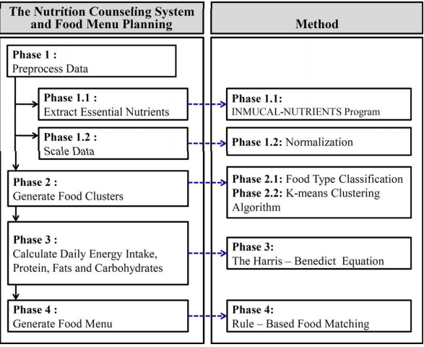
Figure 3-1. Nutrition counseling framework

Some experimental results of this approach that are presented show that all the user’s menus have higher percentage resemblance values in terms of energy content than nutrient composition. In Figure 3-2 an example of the outpul of a resulted daily menu solution is shown.

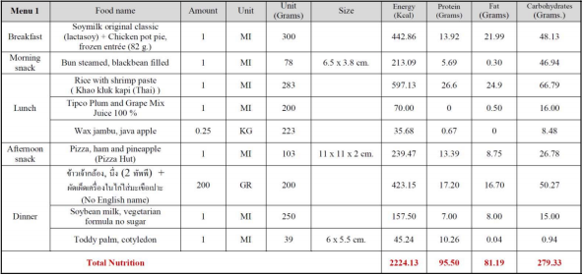
Figure 3-2. Output example of solution

The results from the eight user volunteers suggest that the NCS is capable of generating individual menus for three meals (breakfast/lunch/dinner) and also offering a variety of foodstuff choices. Overall the users were satisfied with the program and its interface with many willing to consider using it again. The NCS can be useful for people who are concerned with their health and more specifically, their dietary habits.

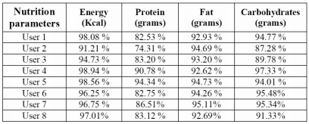
Figure 3-3. Nutrition Counseling Results

In article [2] the development and design of a personalized nutrition and food planning system for older people that uses a food-oriented ontology together with an expert system is described.
The world population is rapidly increasing, and due to growing health and medical care this is also the case for the elderly. Old people have limited regenerative abilities and are more prone to disease, syndromes, and sickness than other adults. In addition, their bodies also produce less sex hormone which results in the accumulation of body fat or not eating a full nutritional benefit, which also may cause nutritional based diseases. Among the diseases that older people often suffer from are hypertension, diabetes, osteoarthritis, osteoporosis, heart disease, and enlarged prostate.
In order to solve this problem, in this article [2] an approach to develop a personalized food and nutrition planning system for the elderly on the basis of a food-oriented ontology for the management of knowledge about food and nutrition has been presented. A use of an expert systems for food an nutrition planning for the elderly is made, which takes into account the physical condition and needs of the older people accurately and efficiently. The system is developed for the use as a hospital service to a provide food and nutrition plan for the older patients.
The system framework is shown in Figure 3-4. The framework comprises a (1) User Interface; a (2) Food Planning System; the (3) Personal Health Record; a (4) Knowledge Base; and a (5) Database.
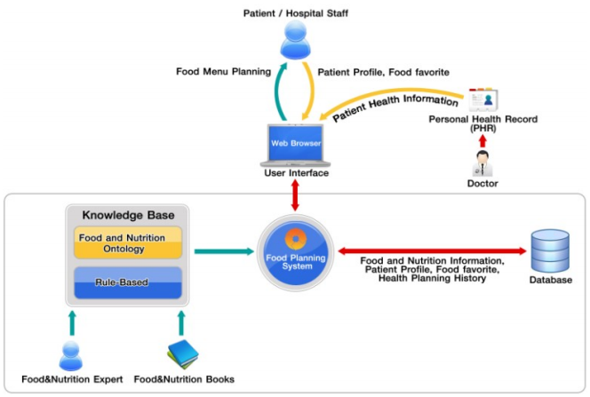
Figure 3-4. Ontology-Drived Personalized Nutrition System Framework

This paper uses the concept ontology from (Snae, & Brueckner, 2008) in Figure 3-4 adapted to suit the aims of this research. Ontologies have become recognized and widely used in state-of-the-art gathering of information and intelligence, information retrieval, knowledge representation, and database management systems (Thomas, 1993). RDF (RDF, 2004), RDF Schema (RDF Schema, 2004) and OWL (OWL, 2004) to describe food and nutrition knowledge have been employed. These languages are proposed by W3C.
Protégé ontology editor (Protégé, 1987) has been used in order to create, expand and edit the ontology. The ontology makes use of food specifics, such as animal-based or plant-based food, flavors, added by nutritional facts, such as vitamins, proteins, fats, carbohydrates, and so on. This information can be used to recommend food and nutrition an appropriate to the physical condition and personalized to the patient likes and dislikes.

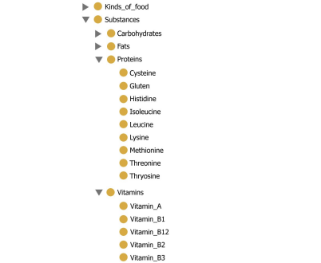

Figure 3-5. Ontology Nutritional System F

In article [3] an approach to solve the problem of obesity or being overweight is presented. Obesity or being overweight in general often leads to other more severe diseases. With more than half of the population in the western countries being overweight or even obese, systems are developed to help users make healthier food choices by recommending healthier recipes or food items according to the user’s needs or likes and dislikes.
Professional nutritionists utilize a broad selection of tools to establish an individual’s nutritional intake. These include food diaries, 24-hour recalls or questionnaires, with food diaries or 24-hour recalls being preferred giving superior measures. With food diaries the user records all amounts of consumed foods and beverages over a period of time preferably at the time they were consumed, usually no more than 3 or 4 days are recorded. For 24-hour recalls the user has to give a report during a meeting with the nutritionist of every food or beverage consumed over the last 24 hours or the last day.
More recently systems were developed which calculate the amount of food intake with the help of pictures of meals the user has taken. Applications for this are already available, which identify food pictures in the user’s web archives and calculates the dietary balance of meals.
In article [4] a review of the computer aided diabetes therapy is presented introducing GIGISim (Glucose-Insulin and Glycemic Index Web Simulator) e-learning tool based on the glucose and insulin plasma levels simulation models and genetic algorithms optimization
Together with the system, recently reported solutions assisting diabetes therapy were summarized and their functionality presented. Artificial intelligence is applied in GIGISim tools to improve patients’ management and health awareness. Interactive, diabetes-dedicated simulators, supported with genetic algorithms (GA) have a great deal of educational potential for patients and their families, and may also offer a means of training for health-care professionals.
In this paper the newly developed, diabetes dedicated, educational tools compared to existing approaches and solutions is presented. Glucose-Insulin and Glycemic Index Web Simulator (GIGISim) serves as a graphical simulator of postprandial glucose profiles of diabetic individuals, and can be accessed via Internet. Results are based on human carbohydrate metabolism model and influenced by user’s diet – meals and food products can be entered into the system and possible glucose and insulin fluxes simulated.
One of the main advantages of using GIGISim is the possibility to create personalized profiles and perform simulations based on adapted model. Information on age, body mass index (BMI) and possible diabetes is used to personalize simulation result by choosing model parameters from predefined sets. More advanced method includes patient’s results of Oral Glucose Tolerance Test as one of the algorithm inputs, adapting dynamically the set of model parameters.
The use of this system has been limited to educational purposes, because model takes into account only a confined number of the factors associated with glucose metabolism, and model parameters are not easily individualized to accurately simulate metabolic processes for all specific diabetes individuals.

Analysis and Theoretical Foundation

Ontologies
Our model containing that will be designed by using ontologies. Ontologies are a way to abstract data in a way similar to the real world model by using classes, individuals, data properties and object properties. Ontologies support the representation of different taxonomies and vocabularies. The concept of class used in defining ontologies is similar with the concept of class used in the object oriented programming languages. Classes are templates or blue prints that represent a group of entities that have the same properties. Data from the real world may be classified by using a hierarchy of classes and subclasses, similar to the concepts of object oriented programming where real objects are mapped in a semantic transformation process. Individuals are instances of classes, and can have data properties and object properties. The line between individuals and classes is hard to determine, and sometimes the same entity may be represented in both ways. Data properties are similar with the fields from object oriented languages, and can have different types such as Boolean, integer, string, etc. Object properties represent relations between individuals.
One of the characteristics that differentiate the ontologies from the other representations of the data is the fact that the ontologies are very flexible, and sometimes the same entity can be represented in different manners: as a class, as an individual, as a data property, or as an object property. Ontologies are a dynamic way to represent data, they provide a multitude of different ways for the representation of the same set of data
For building an ontology, in general it is necessary to use a special ontology language, for example OWL (Web Ontology Language). OWL provides ways to represent the elements that constitute an ontology: ontology classes, ontology subclasses, data properties, object properties, and individuals. OWL represents elements from the ontologies in a simple manner. The syntax of OWL is similar with the syntax of XML. The ontologies can be saved in .owl files which can be viewed from different applications, such as Protégé, or they can be opened from different developing environments, by using special tools
There are two main important concepts when defining object properties or data properties:
- Domain of the property - represents the set of classes or data types to which the property refers
- Range of the property - represents the values that the property can take
Also, object properties can have different characteristics such as functional (can have only one value), inverse (to some other property), sub-property (of another property), or equivalent (to some other property). One important aspect that must be taken into consideration is the way the ontologies are built. There are many ways to represent data in the form of ontologies. There are situations in which the same entity can be represented as an individual or as a class. Also there are cases in which a data property can replace the subclass relation.
Data for the project will be provided from different domains such as food domain, diet domain, health domain, diagnostic domain and prescription domain. It is very important to group together the elements that belong to the same domain, while providing a flexible way to deal with any changes that can appear. This fact can be obtained by constructing an ontology which contains other small ontologies. Each of these small ontologies will represent a different domain.

OWL and SWRL
In [7], data representation possibilities include axioms, including class declaration, individual declaration, class assertion, subclass assertion, property declaration, property assertion, negative property assertion and annotation assertion. SWRL rules are a consequence of the fact that OWL language is not able to express all possible relations. The expressivity of OWL can be extended by adding rules to the ontology. SWRL rules are similar with the rules from Prolog or Datalog languages. Rules have the format premise-conclusion. The premise is represented as a list of statements connected by ‘and’, and the conclusion is represented by a list of statements that become true when the premise is true.
Among the things that can be inferred by using SWRL are the following: an individual is an instance of some specific class, an individual has a certain data property, an individual is related to another individual by a certain object property etc. The rules increase the expressivity of the ontologies. It would take too much time to represent all the data of the ontologies. By writing a small number of rules regarding the classes, individuals, data properties, and object properties of the ontology, the knowledge may be doubled, tripled, or increased with any rate. Inferring information becomes a time consuming operation when the ontology data is too large and the rules are too complex.
Limitations are not exempted from OWL and SWRL. OWL cannot express relations between individuals referenced by properties. There are concepts that cannot be expressed in OWL but which can be expressed in SWRL. A limitation of SWRL is the fact that arbitrary SWRL rules lead to undecidibility. Only the so DL-safe rules are implemented in reasoners. DL, as a fragment of FOL, cannot express fuzzy expressions, non-monotonicity, propositional attitudes, and modal logic including possibility and necessity, epistemic modalities, temporal logic and deontic logic.
Using SWRL rules has some disadvantages. One of the is the fact that the ontology increases after each calling of the reasoner, and thus all the information that was inferred before remains in the ontology. A solution would be to remove the properties that are no longer true from the ontology, but this is a very complicated process. There are situations in which it is impossible to determine which properties have two values, when in fact they need to have only one value. Another disadvantage of using SWRL is the time. It takes too much time to infer new data due to the complexity of the rules. This period of time can be saved by storing more information in the database, but in this case the role of the reasoning rules becomes useless.

SPARQL
For querying information that is stored in ontologies, as in [5] is exemplified, SPARQL queries are used. A very important aspect of the semantic systems is the ability to query data. It provides some advantages such as including restrictions and other conditions. It is possible to change the order in which the results are retrieved, to limit the number of the results or Chapter 3 14 to change the starting element. SPARQL is similar with sql and has the advantage that it can be used to query an ontology. Complex queries may be written using SPARQL in a syntax easy to understand. This query language also permits some mathematical functions such as sum, count, min, max. For data which is not explicitly defined by the user, one can query data which is inferred from existing data, which is yet another advantage of using SPARQL.
As for query techniques, the methodologies vary, as stated in [6]. The first option is to use SWRL rules, while the second option is to use SPARQL queries. When using SWRL rules, without SPARQL, querying information becomes a complicated process. When the data that is retrieved refers to a single individual, data property or object property, there are no major problems. The situation changes in the case data from multiple individuals must be retrieved, and some operations are performed on this data (sum, count, etc.).

Ontology Modelling from Medical Perspective
Different ontologies will be presented in detail. The highest level ontology is the nutrition care process ontology. It will be composed from other four ontologies:
- Nutrition monitoring ontology
- Nutrition assessment ontology
- Nutrition diseases diagnostic ontology
- Nutrition intervention ontology

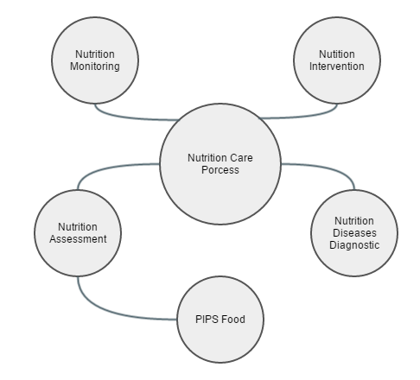
Figure 4-1. Nutrition Care Process Ontology Representation

Nutrition monitoring ontology is the first ontology from the four ontologies that compose the nutrition care process ontology. The purpose of this ontology is to represent the information that is relevant for assessing the feeding behavior of an elder. It will store data such as: the older adult daily food intake, the older adult personal data – anthropometric measurements (height, weight change, weight, BMI), biochemical data, health profile (diseases), and other personal data (gender).
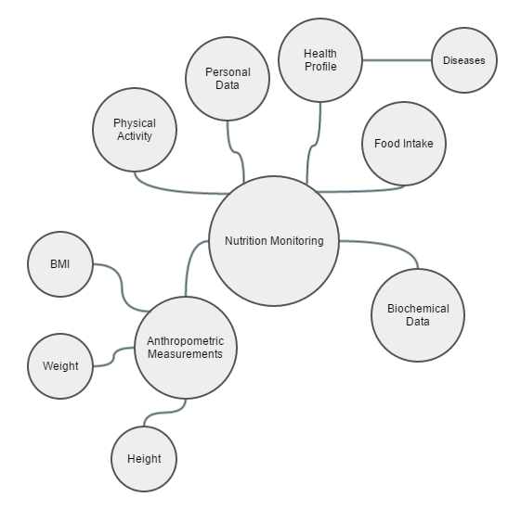
Figure 4-2. Nutrition Monitoring Ontology Representation
Nutrition assessment ontology is the second ontology that is contained in the nutrition care process ontology. It will store data about different types of foods and their associated nutritional values. There are two different types of foods. The first type is represented by the combined foods which are based on a recipe. The second type is represented by the basic foods, which are classified according to the PIPS food ontology.
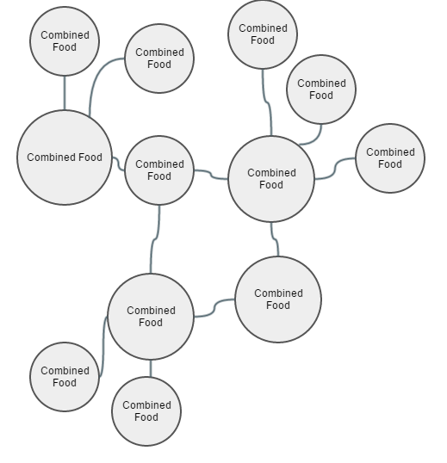
Figure 4-4. Nutrition Assessment Ontology Representation

PIPS Food ontology contains a classification of the foods. There will be different types of foods such as: beverages, egg products, fruits, grain products, meat, milk products, nuts and seeds, oils and fats, sea food, soups and sauces, special nutrition products, sugar products and vegetables. Each of these types will contain different subtypes. This classification is done in order to facilitate the daily work of the elder which consists in choosing which products he consumes during the day. Another important part of this ontology is represented by the food quantities. There will be different types of food quantities such as slice, cup, bowl, dish, pound, piece, can, box, bag, carton, jar and loaf. Each food will have different values for each of these quantity types. Considering the fact that the intention of the application is to be a proof of concept, the values for each of these quantities will be generated as a random number that belongs to an interval (for example a random number between 20 and 250). The reason for choosing random numbers is because many of the foods that will populate the database will consist of different ingredients, each of them having a different density, and the proportion of the ingredients that compose these foods is not known exactly.
Recipes are another part of this ontology. They represent a collection of basic foods in different proportions and each recipe will be associated with a combined food. There will be different types of combined foods: flavored food, regional cuisine food and dish, and each of them will have different subtypes. For example, flavored food will have the following subtypes: sour food, bitter food, spicy food, salted food and sweet food. Regional cuisine food will be of two types: Italian cuisine food and Spanish cuisine food. Finally, there will be three types of dish: desert, main course, and starter dish. Nutrition intake will be evaluated each day and it will contain the amounts of nutritional values the older consumes during the day such as: energy (kcal), fat (g), carbohydrates (g), fatty acids (g), protein (g), potassium (mg), calcium (mg), sodium (mg), vitamin D (ug), alcohol (g), and water (g). These values are very important because malnutrition is prevented by imposing some restrictions on them.
Nutrition diseases diagnostic ontology has the main goal to define, classify and represent the nutrition related diseases. There are different types of nutrition diseases such as weight diagnostic (obesity, underweight, overweight and normal weight), malnutrition, imbalance of nutrients, fluid intake diagnostic (excessive fluid intake and suboptimal fluid intake), and energy balance diagnostic (excessive energy intake and suboptimal energy intake).

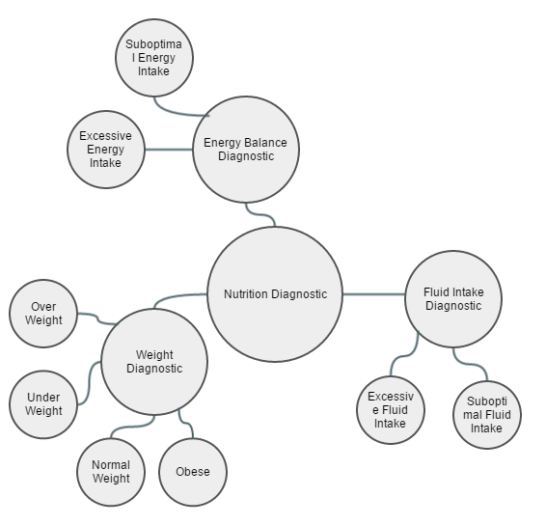
Figure 4-3. Nutrition Diseases Diagnosis Ontology Representation

Nutrition intervention ontology is the last ontology from the four ontologies that compose the nutrition care process ontology. Nutrition prescription will define different types of diets such as cardio vascular disease diet and diabetes type 2 diet. Each of these diets will have associated different restrictions that the elder is advised to follow.

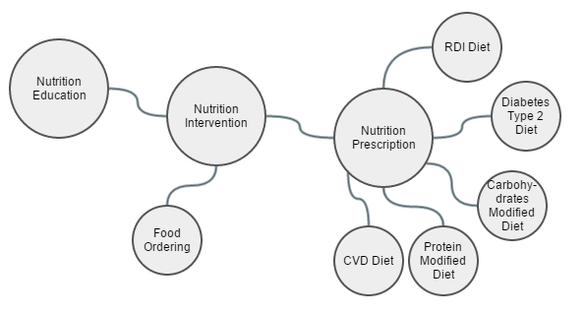
Figure 4-5. Nutrition Intervention Ontology Representation

New data can be inferred from data that already exists by using ontologies, with the help of the reasoner. Inference rules are written in SWRL (Semantic Web Rule Language). Rules are used in order to increase the expressivity of OWL. As described in [7], SWRL rules are similar with the rules written in Prolog or DATALOG languages.
Amongst many others, an objective of the inference rules is to determine nutritional recommendations associated to a specific elder. Each elder has different specific characteristics such as gender, height, weight, which will influence the amount of energy that he should consume during the day. By knowing the amount of energy that the elder should consume during the day, the rest of the nutritional values that he should consume can be determined as different fractions of this value.

Food Modelling
Collecting data about foods in a structured manner is also one of the objectives. Even though there are a lot of resources on the internet, many of them are not classified very well. The objective is to classify data about foods in a hierarchy so that the elder to be able to select very easily what foods he consumes during the day. The first step is to collect data from the internet. A database for basic food ingredients with the nutritional values of each according to specific measurements must be used. For that, the database provided by USDA has been chosen.

USDA Database
In [8] the USDA is presented. USDA is National Nutrient Database for Standard Reference (SR) is the major source of food composition data in the United States. It provides the foundation for most food composition databases in the public and private sectors. As information is updated, new versions of the database are released. This version, Release 27 (SR27), contains data on 8,618 food items and up to 150 food components. It replaces SR26 issued in August 2013.
National Nutrient Data Bank is a repository of information for up to 150 nutrients for about 8,500 foods. It is made available in the principle database- the USDA National Nutrient Database for Standard Reference (SR). The data can be accessed online or downloaded for use on A PC. Programs are available to look up the nutrient content of foods using a Windows PC.
For the health care sector, food composition data are used in dietary therapy of patients in hospitals and community settings, formal and self-directed nutrition education programs for adults and children, and preventive guidance for obstetric, pediatric, and geriatric populations. The data are essential to the calculation of school, hospital, nursing home, and other institutional menus.
USDA is a great source for gathering nutritional information a very large set of food ingredients. The database consists of several sets of data: food descriptions, nutrients, weights and measures, footnotes, and sources of data. The sections below provide details about the information in each.

USDA Database Structure
Database content is structured as with the following components:
Food Descriptions - This includes descriptive information about the food items. A full description (containing the name of the food with relevant characteristics, e.g., raw or cooked, enriched, color) and a short description (containing abbreviations) are provided. Scientific names, common names, manufacturers’ names, amounts of refuse, and refuse descriptions are provided where appropriate. The common name field includes alternative names for a product, e.g., soda or pop, for a carbonated beverage.
Food Group - To facilitate data retrieval the food items in SR are organized into food groups. Currently there are 25 food groups, which are listed in the Food Group Description file. Data on ethnic foods are contained in their respective food groups, for example data on plantains, a Latino ethnic food are in food group 9 (Fruit and Fruit Juices), while the Asian foods, miso and natto, are entered in food group 16 (Legumes and Legume Products). Food group 36 (Restaurant Foods) contains foods obtained from casual dining, full service restaurants, Latino restaurants, and Chinese restaurants (not Fast Foods, which are in food group 21). Home prepared items or prepared frozen entrees are included in Food Group 22, Meals, Entrees, and Side dishes. Some food items, such as beverages and rice, though obtained at restaurants are included in their respective food groups.
Nutrients - The Nutrient Data file contains mean nutrient values per 100 g of the edible portion of food, along with fields to further describe the mean value.
Weights and Measures - Information is provided on household measures for food items (for example, 1 cup, 1 tablespoon, 1 fruit, 1 leg). Weights are given for edible material without refuse, that is, the weight of an apple without the core or stem, or a chicken leg without the bone, and so forth. The Weight file contains the gram weights and measure descriptions for each food item. This file can be used to calculate nutrient values for food portions from the values provided per 100 g of food. The following formula is used to calculate the nutrient content per household measure:
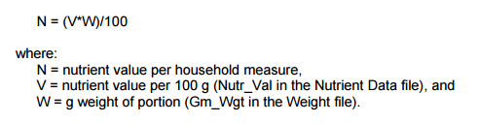
Figure 4-5. Nutrient content per household measure formula [8]

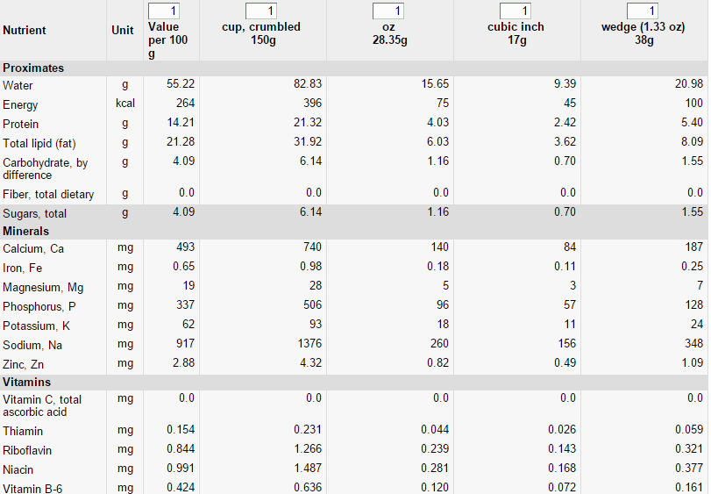
Figure 4-6. Food ingredient nutritional values by measurement for feta cheese[8]

In the Figure 4-6, an example of the nutritional information of a feta cheese food ingredient. It can be seen that USDA contains nutritional values for all nutrients available (not all are shown in the figure) fir several measurement types.
Nutritional information is shown for crumbled cup (~150g), oz (~28.35g), cubic inch (~17g) and wedge(~38g). Other measurements exist for different food ingredients. This feature is very helpful in the case of our problem context. The food packages will consist of dishes that are composed of one or more recipes. These recipes that food ingredients, and as most recipes available nowadays, the measurement unit is not always in grams. For example a recipe could have the following description: 4 skinless, boneless chicken breast halves, 1/4 teaspoon salt, 1 pinch ground black pepper to taste, 1 pinch ground black pepper to taste, 1/2 cup low-sodium chicken broth, 1/4 cup white wine, 2 tablespoons honey and 2 tablespoons whole-grain mustard. It can be seen that the necessary steps for integrating this recipe description into the database model can be quite difficult. If the measurement unit were to be only in grams, at each ingredient transformations should be made which can prove to be quite time consuming unless automatized. USDA however solve this problem by offering nutritional values for other measurement units such as cup, table spoon, small spoon etc.

The USDA nutrient database has the following schema.
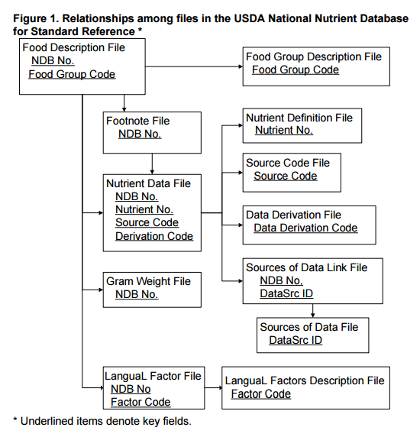

Metaheuristics

Optimization Algorithms

Detailed Design and Implementation
Together with the previous chapter takes about 60% of the paper.
The purpose of this chapter is to document the developed application such a way that it can be maintained and developed later. A reader should be able (from what you have written here) to identify the main functions of the application.
The chapter should contain (but not limited to):
- a general application sketch/scheme,
- a description of every component implemented, at module level,
- class diagrams, important classes and methods from key classes.

Testing and Validation
About 5% of the paper.

User’s manual
In the installation description section your should detail the hardware and software resources needed for installing and running the application, and a step by step description of how your application can be deployed/installed. An administrator should be able to perform the installation/deployment based on your instructions.
In the user manual section you describe how to use the application from the point of view of a user with no inside technical information; this should be adorned with screen shots and a stepwise explanation of the interaction. Based on user's manual, a person should be able to use your product.

Conclusions
About. 5% of the whole.
In this chapter you present:
- A summary of your contributions/achievements,
- A critical analysis of the results achieved,
- A description of the possibilities of improvements/further development.

Bibliography

[1] Y. Usthasopha, S. Phimoltares, N. Cooharojananone, Nutrition Counseling System and Food Menu Planning, International Conference on Information Science and Applications, 2010.
[2] S. Sivilai, C. Snae, M. Brückner, Ontology-Driven Personalized Food and Nutrition Planning System for the Elderly, The 2nd International Conference in Business Management and Information Sciences, 2012.
[3] S. Mika, Challenges for Nutrition Recommender Systems, Context Aware Intelligent Assistance, 2011.
[4] J. Bulka, A. Izworski, J. Koleszynska, J. Lis, I. Wochlik, Automatic meal planning using artificial intelligence algorithms in computer aided diabetes therapy, Proceedings of the 4th International Conference on Autonomous Robots and Agents, 2009.
[5] Nuno Alexandre de Jesus Lopez, A SPARQL Query Engine over Web Ontologies using Contextual Logic Programming, Master Degree in Computer Science, Universidade de Evora, October, 2007
[6] Algirdar Sukys, Lina Nemuraite, Bronius Paradauskas, Edvinas Sinkevicius, SBVR Based Representation of SPARQL Queries and SWRL Rules for Analyzing Semantic Relations, Bustech 2011: The First International Conference on Business Intelligence and Technology
[7] OWL 2 and SWRL tutorial, http://dior.ics.muni.cz/~makub/owl/
[8] US Department of Agriculture, Agricultural Research Service, Nutrient Data Laboratory. USDA National Nutrient Database for Standard Reference, Release 27 (revised). Version Current: May 2015. Internet: http://www.ars.usda.gov/ba/bhnrc/ndl

Acronyms
RDA – Recommended Daily Allowance

Appendix 1 (only if needed)
…
Relevant code sections
…
Other relevant info (proofs etc.)
…
Published papers (if any)
etc.

