# Measured values - UDS

You can open this module by selecting „measured values“ from the function list and clicking „Next“.

You can also double click the function list entry to open the module.  
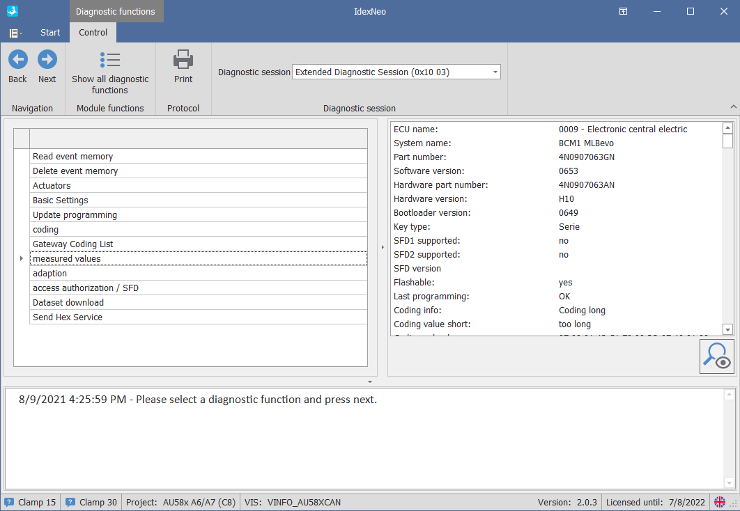

After you open the module, you will see all available measurements of the current ECU.

Simply select the measurements you want to read and click “Next”.

You will also have some buttons available, which is explained in the table below.

|  |  |
| --- | --- |
|  | Load a previously saved configuration. |
|  | Save the currently selected measurements as configuration. |
|  | Just resets the current configuration to none. Will not delete any saved configuration. |
|  | Quick filter to only show measurements which contain the entered text. |
|  | Returns to the ECU function list |
|  | Read the values of the selected measurements |

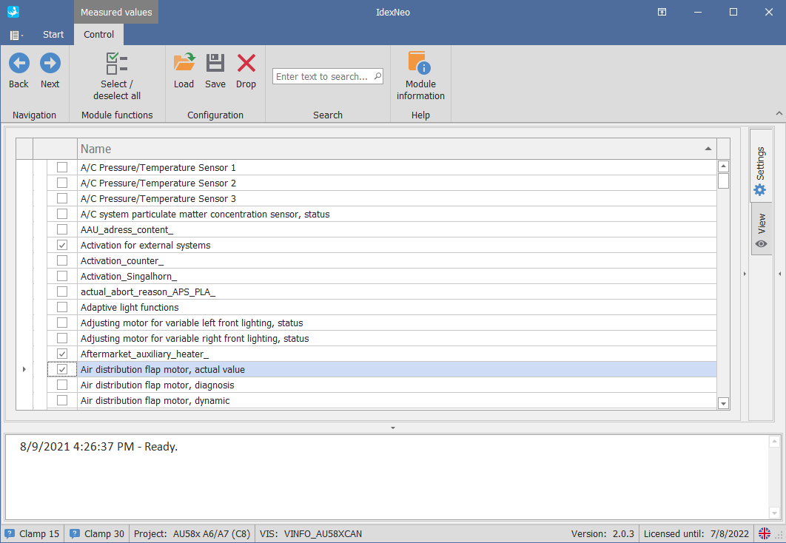

Select the required measurements and click “**Start**”.

The selected measured values are read out and displayed in a tree structure.

Depending on the amount of selected measurements and the speed of the ECU this may take some time.

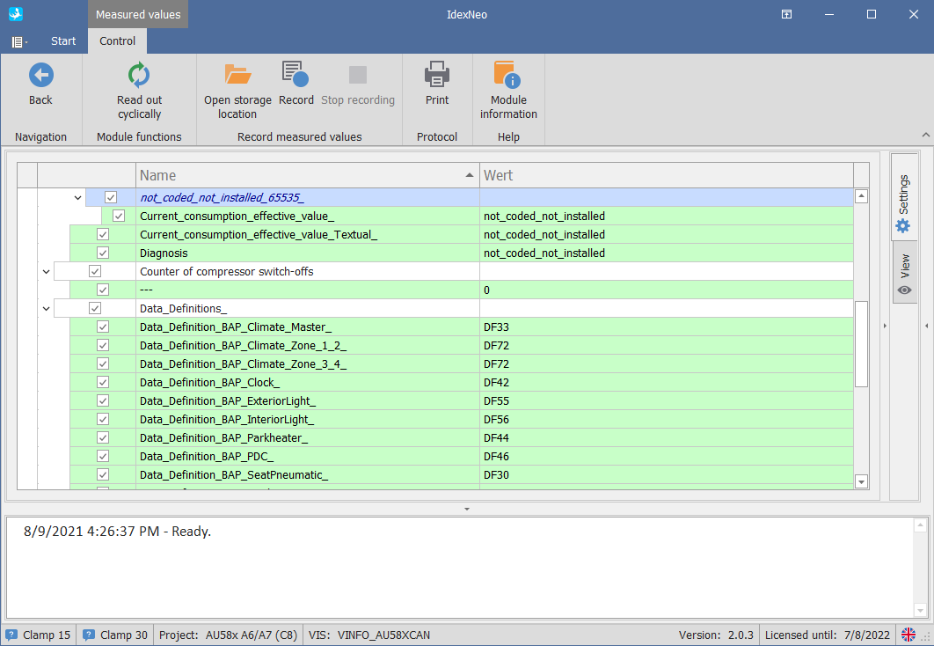

You will have the following options in the result view.   
Depending on the current state of the module you will see the “Start” or “Stop” button.

|  |  |
| --- | --- |
|  | Start to continuously read out the measurements. |
|  | Stops the continuous read out. |
|  | Prints an iDEX protocol with the selected measurements |

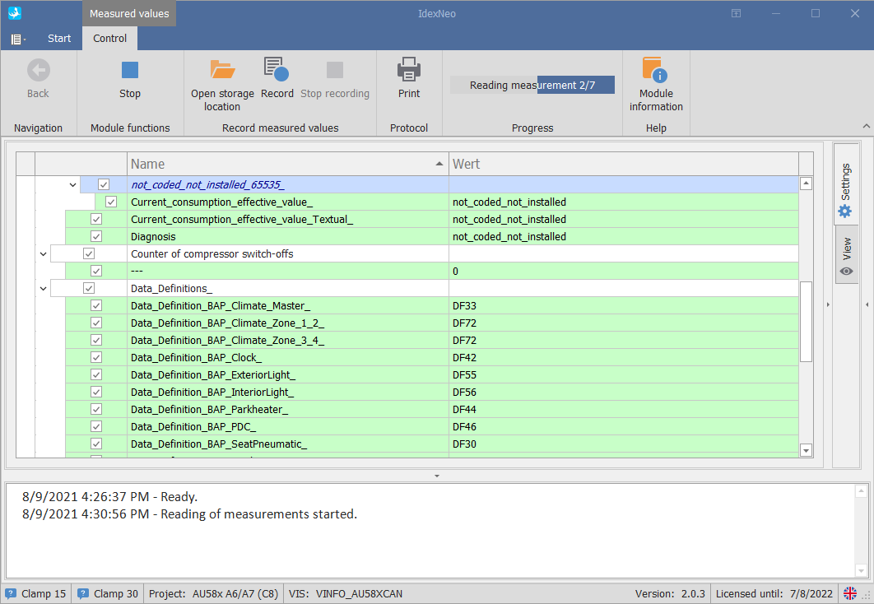

## Settings menu

### Settings

Click „settings“ on the right side of the iDEX window to open the module settings.

Here you can change the minimum time between the automatic read outs of the measurements between 200ms and 5seconds (default 1second).

You can also change the value while already reading the measurements.

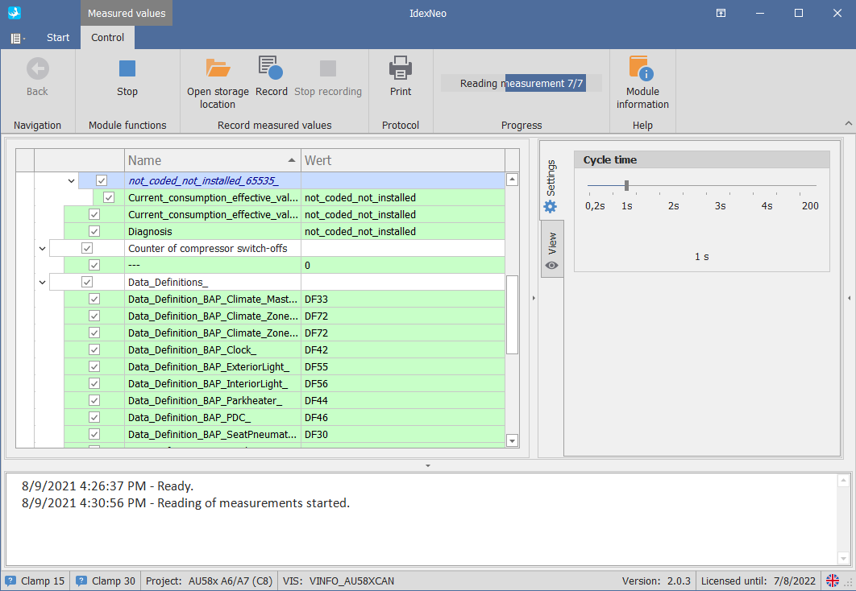

### View

Click „view“ on the right side of the iDEX window to open the view settings of the module.

Select any of the options to add an appropriate column in the main and result view.

* *show ODX names*adds a column which shows the ODX defined name of the measurement
* *show service ID*adds a column which shows the ODX defined ID of the measurement

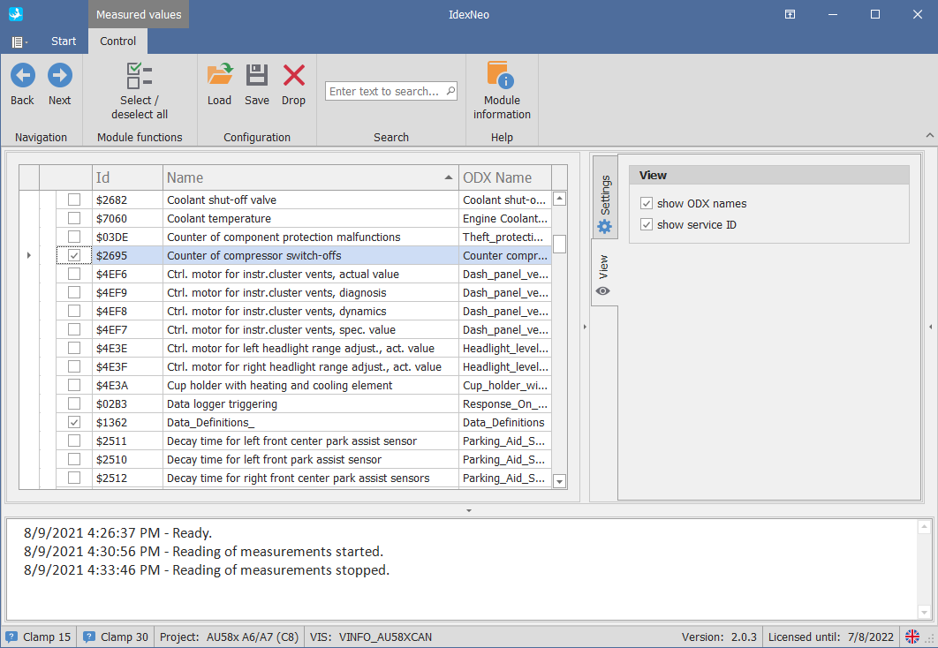

# Measured values - KWP

You can open this module by selecting „measured values“ from the function list and clicking „Next“.

You can also double click the function list entry to open the module.  
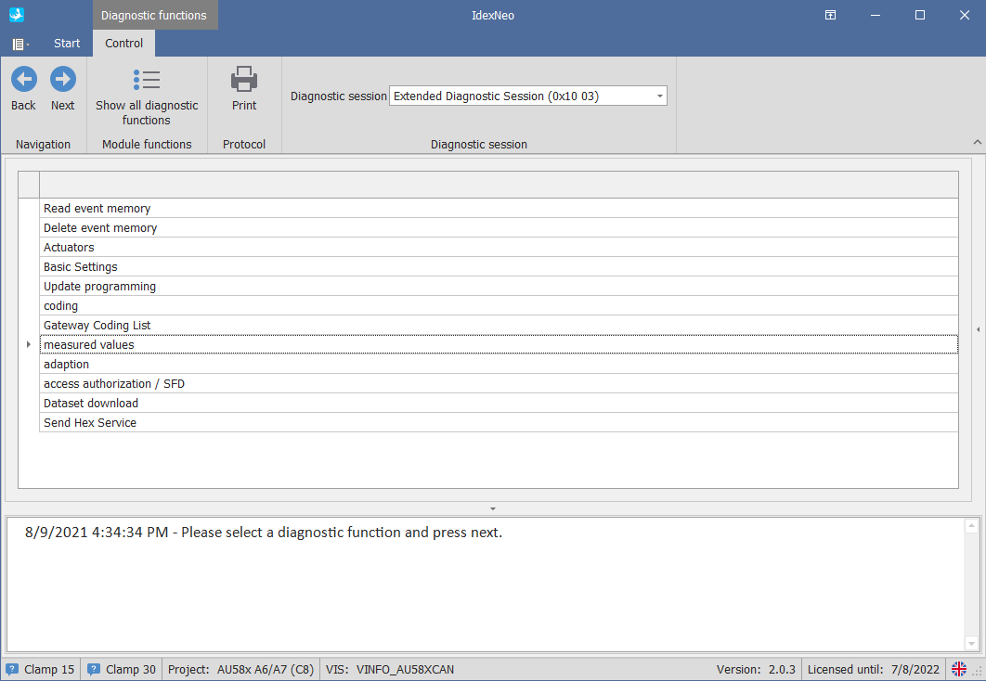

Enter the channel number and click the „+“ sign to add them to the configuration.   
(refer to the next page to see the allowed format options)

Click “Next“ to start the read out.

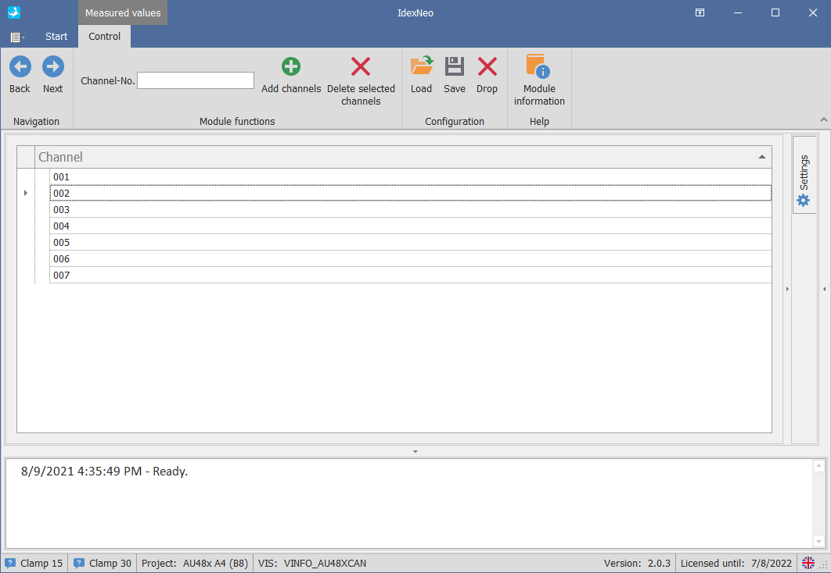

|  |  |
| --- | --- |
|  | Load a previously saved configuration. |
|  | Save the current config. |
|  | Just resets the current configuration to none. Will not delete any saved configuration. |
|  | Channel numbers to add. Allowed format options are:   * Single channel e.g. 1 * List e.g. 1,2,3,5,8 * Range e.g. 4-12   Allowed values are 1 - 255. |
|  | adds the entered channels to the config  removes the selected channels from the config |
|  | Returns to the ECU function list |
|  | Read the values of the selected measurements |

You will have the following options in the result view.   
Depending on the current state of the module you will see the “Start” or “Stop” button.

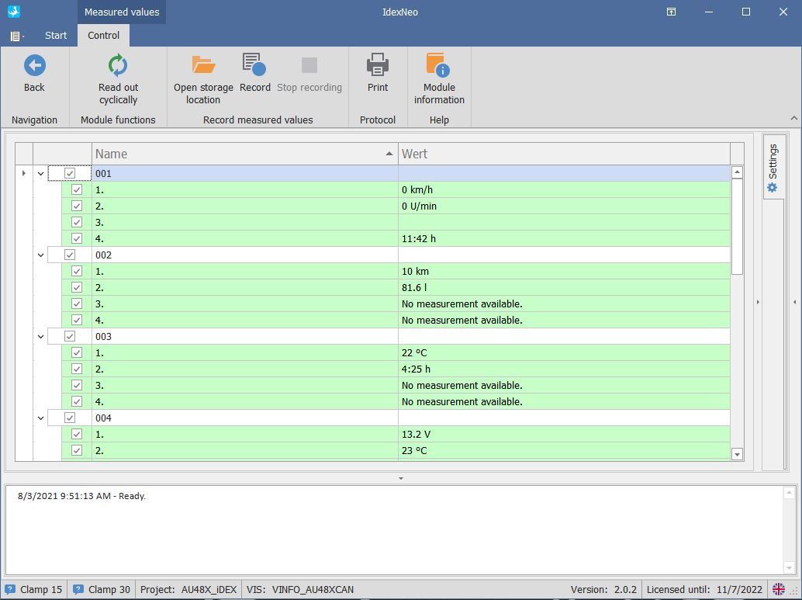

|  |  |
| --- | --- |
|  | Start to continuous read out the measurements. |
|  | Stops the automatic read out. |
|  | Prints an iDEX protocol with the selected measurements and their values. |

## Settings menu

Click “**settings**” at the right side of the iDEX window to open the module settings.

Here you can change the minimum time between the automatic read outs of the measurements between 200ms and 5seconds (default 1second).

You can also change the value while already reading the measurements.

