
COMPREHENSIVE USER MANUAL
Receipt accountability from office receipt through final archival
Municipality of Dipaculao
Province of Aurora
Municipal Treasury Office
Document | Version | Issued | Classification
AFMS User Manual | 1.0 | 16 July 2026 | Internal office use

IMPORTANT
This manual describes AFMS as implemented in version 1.0. Commands shown to a user depend on assigned permissions and transaction status. Never share passwords or use another person's account.

CHAPTER 1

About This Manual
Purpose, audience, system scope, and how to use this guide.

1.1 Purpose
AFMS - Accountable Forms Management System is an offline Windows desktop application used by the Municipal Treasury Office to track Official Receipts and other accountable forms. It preserves the chain of accountability from stock receipt through issuance, use, transfer, return, exception handling, reversal, reporting, fiscal-year close, and archival.

1.2 Intended users
- Accountable Forms Custodians who receive, safeguard, and issue accountable forms.
- Encoders who record authorized usage information.
- Supervisors who review and approve sensitive transactions.
- Administrators who maintain users, settings, backups, and exceptional access.
- Auditors or viewers who inspect inventory, ledgers, movements, reports, and audit records.

1.3 What AFMS does
- Maintains editable master data for form types, barangays, collectors, users, and office settings.
- Generates controlled booklet inventory from validated serial ranges.
- Tracks current holder, barangay, remaining quantity, movements, usage, returns, and exceptions.
- Uses permission-based workflows and records approvals, rejections, finalization, reversal, printing, export, backup, and restore activity.
- Produces printable PDF forms, professional reports, and Excel workbooks entirely offline.

1.4 What AFMS does not replace
AFMS supports accountability records; it does not replace statutory source documents, physical receipt custody, required signatures, cashbook procedures, or applicable Commission on Audit and treasury regulations. Retain original documents according to office policy.

1.5 Contents at a glance
Chapter | Subject
2 | Installation, first launch, login, and security
3 | Application interface and navigation
4 | Roles, permissions, and transaction statuses
5 | Master data
6 | Stock receiving
7 | Inventory and movement history
8 | Issuance and collector accountability
9 | Usage, transfers, returns, exceptions, attachments, and reversals
10 | Reports, PDF, Excel, and printing
11 | Users, settings, audit log, and session security
12 | Backup, restore, and fiscal years
13 | Recommended operating workflows and checklists
14 | Troubleshooting and frequently asked questions
Appendices | Reference numbers, statuses, initial data, and glossary

CHAPTER 2

Getting Started and Signing In
Installation, first administrator setup, login, password changes, and logout.

2.1 Computer requirements
- Windows 10 or Windows 11, 64-bit.
- A user account with permission to install the application when using the installer.
- Sufficient local storage for the database, attachments, reports, logs, and backups.
- A configured printer only when paper printing is required. AFMS itself works without internet access.

2.2 Install AFMS
- Close any running AFMS window.
- Run AFMS-Setup-1.0.0-win-x64.exe.
- Follow the installer prompts and optionally create a desktop shortcut.
- Open AFMS from the Start Menu or desktop shortcut.
- On upgrade, install over the existing application. Operational data is stored separately under the user's local application-data folder.
DATA LOCATION
The live database, attachments, and rolling logs are stored under %LOCALAPPDATA%\AFMS. Uninstalling the program does not silently delete those records. Back them up before computer replacement or operating-system reinstallation.

2.3 First launch administrator setup
- Enter the administrator's full display name.
- Enter a unique username.
- Create a password with at least 12 characters containing uppercase and lowercase letters, a number, and a symbol.
- Enter the same password in Confirm password.
- Choose Create administrator. AFMS hashes the password with BCrypt; the plain-text password is never stored.
- Store the administrator credentials using the municipality's approved credential-control procedure.
NO DEFAULT PASSWORD
AFMS does not contain a permanent administrator password. If the first administrator password is lost, follow the office's authorized recovery procedure; do not edit the database manually.

2.4 Sign in
- Open AFMS.
- Enter your username and password.
- Choose Sign in.
- If prompted, create a new password before proceeding. Temporary passwords should be changed immediately.
- Confirm that your name and role appear in the lower-left account area.
Failed login messages are intentionally generic. Repeated failed attempts increase the failed-login count and may temporarily lock the account. Inactive accounts cannot sign in.

2.5 Sign out and automatic timeout
- Use the sign-out icon beside your account name whenever leaving the workstation.
- AFMS automatically ends an inactive session after the configured timeout.
- Unsaved form entries may be lost when a session expires; save drafts before leaving the workstation.
- Never allow another employee to continue using your signed-in session.

CHAPTER 3

Understanding the AFMS Interface
Navigation, page structure, filters, tables, editor panels, and notifications.
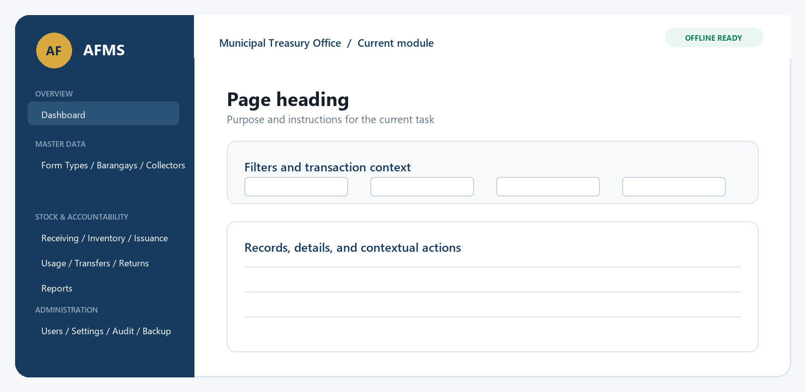
Figure 1. AFMS application shell and the main working areas.

3.1 Left navigation
The left navigation is grouped into Overview, Master Data, Stock & Accountability, and Administration. The selected page is highlighted. A page is hidden when the signed-in user lacks the required permission.

3.2 Top bar
- The breadcrumb identifies the current module.
- OFFLINE READY confirms that AFMS is designed to operate without an internet connection.
- The window title identifies AFMS and the Municipal Treasury Office.

3.3 Common page pattern
Area | How to use it
Page heading | Explains the purpose of the module.
Search and filters | Narrow records before loading or exporting. Clear filters when a record appears missing.
Data grid | Select one complete row before using View, Edit, Submit, Approve, Finalize, Print, or Reverse.
Editor panel | Enter or review transaction fields. Required fields are marked with an asterisk where applicable.
Action bar | Commands apply to the selected record and may be disabled because of status or permission.
Notification area | Shows success, validation, or error messages. Read the message before retrying.

3.4 Keyboard and resizing
- Use Tab and Shift+Tab to move between controls.
- Press Enter on a default Search or Save action where supported.
- Use arrow keys to move through list and table selections.
- Maximize AFMS for wide inventory and movement grids. Horizontal scrolling remains available when necessary.
- Focused controls display a clear border for keyboard accessibility.
SELECTION MATTERS
Most transaction commands operate on the selected row, not merely the visible page. Confirm the reference number and status before approving, finalizing, reversing, printing, or attaching a file.

CHAPTER 4

Roles, Permissions, and Workflow Statuses
Who can do what and how records move through controlled approval.

4.1 Default roles
Role | Typical access
Administrator | All permissions, including users, backups, restore, settings, reversals, and fiscal-year administration.
Accountable Forms Custodian | Master data, stock receipt and issuance, operational transactions, inventory, ledgers, reports, and fiscal-year maintenance.
Encoder | Dashboard, receipt usage recording, and reports.
Supervisor | Operational processing, approvals, reports, inventory, ledgers, fiscal-year close, and reopen approval.
Auditor or Viewer | Read-only dashboard, inventory, movements, issuances, ledgers, reports, exports, and audit log.

SEPARATION OF DUTIES
A user must not approve a sensitive transaction that the same user submitted when separation of duties is required. Fiscal-year reopening requires an administrator request and a supervisor approval by a different authorized user.

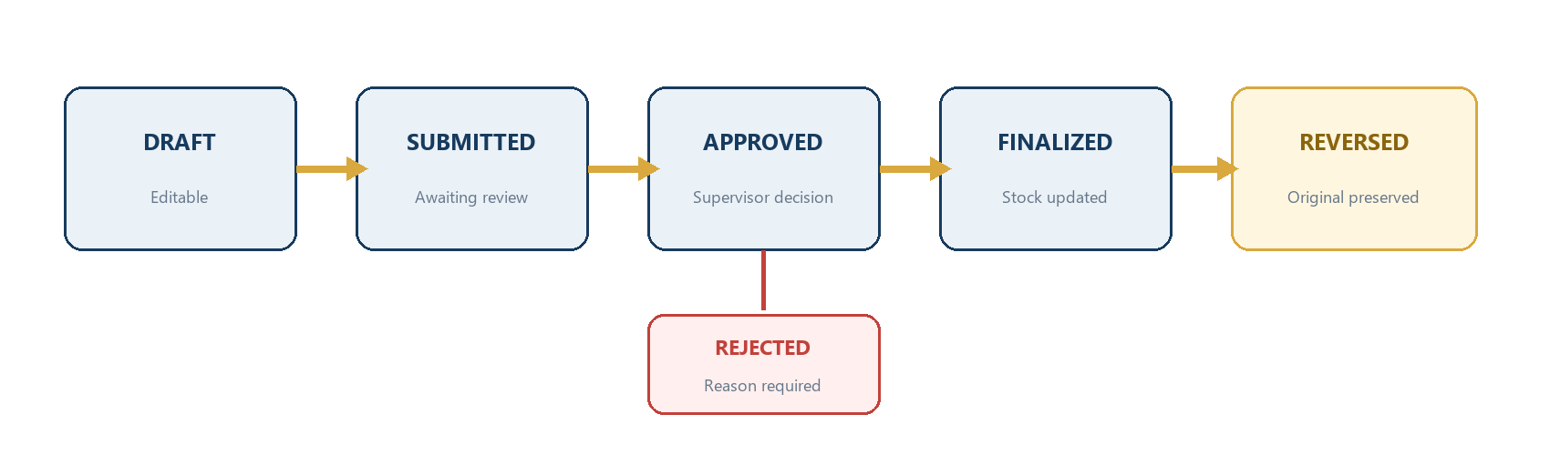
Figure 2. Standard approval and reversal workflow.

4.2 Transaction status meanings
Status | Meaning | User action
Draft | Editable working record. | Complete fields, save, and verify.
Submitted | Sent for review. | Supervisor reviews; preparer should not directly edit.
Approved | Supervisor approved the transaction. | Authorized user may finalize.
Rejected | Supervisor declined the request. | Review the reason; create or correct a valid draft as policy permits.
Finalized | Inventory and accountability effects are committed. | Do not edit or delete directly.
Reversed | A controlled opposite transaction was posted. | Original remains in history; review movements and ledgers.
Archived | Retained for history and no longer operational. | Read-only reference.

4.3 Booklet status meanings
Status | Meaning
Available | In office stock and eligible for issuance.
Issued | Assigned to a collector; no recorded usage.
Partially Used | Some serials were used; usable balance remains.
Fully Used | No usable receipts remain.
Returned | Returned from a collector under a recorded return.
Transferred | Accountability moved between collectors.
Spoiled / Cancelled | Not available for normal use.
Lost / Missing | Unavailable and subject to exception handling.
Archived | Removed from active operations but preserved historically.

CHAPTER 5

Master Data
Form types, barangays, collectors, users, and configuration records used by transactions.

5.1 Accountable Form Types
Use Form Types to define each accountable-form product before receiving stock.
Field | Purpose
Form Code | Unique short code used throughout AFMS.
Form Name | Required official or working name.
Description / Category | Classification and explanatory details.
Receipts Per Booklet | Default quantity; must be greater than zero.
Serial Prefix / Length | Optional serial-number formatting information.
Individual Tracking | Indicates whether every receipt is tracked.
Active / Remarks | Operational availability and notes.

- Open Form Types.
- Use Search and the active/inactive filter to find an existing definition.
- Choose Add form type, enter all required information, then Save.
- To change a record, select it and choose Edit.
- Use Deactivate / Reactivate instead of deleting historical definitions.
VALIDATION
Form Code must be unique, Form Name is required, and Receipts Per Booklet must be greater than zero. Historical form types remain visible after deactivation.

5.2 Barangays
- Open Barangays.
- Search by code or name and filter by active status.
- Choose Add barangay and enter Barangay Code, Barangay Name, Municipality, Province, status, and remarks.
- Select a record and choose Edit to update it.
- Deactivate a barangay that should no longer be selectable; reactivate it when authorized.
DUPLICATE PROTECTION
Barangay codes and names must be unique. Seeded Dipaculao records remain editable and are imported only once per configuration version.

5.3 Collectors
Field | Purpose
Collector Number | Required unique collector code.
Full Name | Collector's official name.
Employee Number / Position | Employment reference information.
Office or Department | Organizational assignment.
Assigned Barangay | Optional current area assignment.
Contact / Email | Optional contact details.
Appointment Reference | Designation or authority reference.
Active / Remarks | Eligibility for new transactions and notes.

- Open Collectors.
- Search by number, name, or employee number; optionally filter by barangay and status.
- Choose Add collector and enter the required collector number and full name.
- Use View details to inspect a record without editing.
- Use Edit to update authorized details.
- Deactivate collectors who should no longer receive forms. Historical transactions continue to show them.
DO NOT DELETE HISTORY
Collectors with transaction history must not be permanently deleted. Deactivation prevents new assignments while preserving prior accountability and reports.

CHAPTER 6

Stock Receiving
Create receiving drafts, validate serial ranges, generate booklets, and finalize stock.
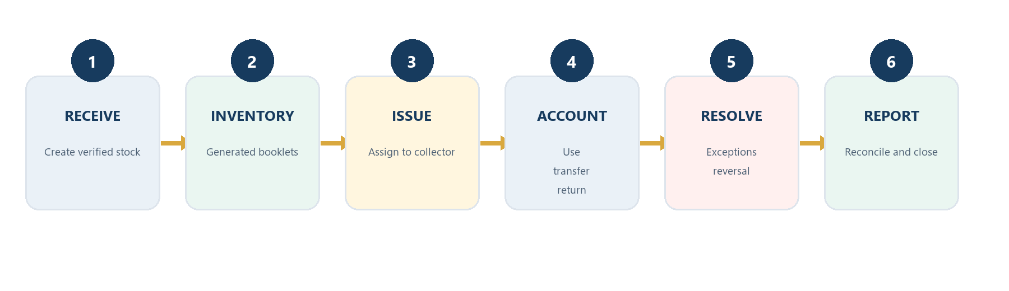
Figure 3. The accountable-form lifecycle managed by AFMS.

6.1 Before receiving
- Confirm the accountable form type exists and is active.
- Verify the source document, physical booklet count, receipts per booklet, and complete serial range.
- Confirm the correct series year and storage location.
- Do not receive a range already recorded in AFMS.

6.2 Create a receiving draft
- Open Receive Stock.
- Choose New receiving draft. AFMS assigns a reference such as RCV-2026-000001.
- Enter Date Received, Series Year, Form Type, Source or Issuing Office, Source Document Number, Storage Location, Received By, and Remarks.
- Choose Add range for each stock-receipt item.
- Enter Number of Booklets, Receipts Per Booklet, Beginning Serial, and Ending Serial. Confirm the calculated total.
- Add additional ranges when one receiving transaction contains more than one valid item.
- Choose Save draft.

6.3 Quantity and range calculation
Total receipt quantity equals Ending Serial minus Beginning Serial plus one. It must also equal Number of Booklets multiplied by Receipts Per Booklet.
EXAMPLE
10 booklets x 50 receipts = 500 receipts. Beginning 100001 and ending 100500 also equals 500. AFMS generates 100001-100050, 100051-100100, continuing through 100451-100500.

6.4 Submit and finalize
- Select the saved draft and use View to recheck every field and range.
- Choose Submit when the transaction is complete.
- An authorized reviewer confirms the source, quantities, and non-overlapping serials.
- Choose Finalize. AFMS validates all items again inside one database transaction.
- Confirm that generated booklets appear in Stock Inventory and Received movements appear in Movement History.

6.5 Receiving protections
- Beginning serial cannot exceed ending serial.
- Zero and negative quantities are rejected.
- Booklet count, per-booklet count, range quantity, and generated booklet count must agree.
- Duplicate or overlapping serial ranges are rejected.
- If any item fails, the entire finalization rolls back.
- Finalized receipts cannot be edited or deleted directly.
- Repeated finalization clicks do not create duplicate inventory.

6.6 Reversal
Use Reverse only when authorized and when a receiving correction must be recorded. Enter a complete reason. AFMS preserves the original transaction and writes reversal audit and stock history. A reversal may be blocked when later transactions depend on the stock.

CHAPTER 7

Stock Inventory and Movement History
Find booklets or individual receipts and trace every movement.

7.1 Search inventory
- Open Stock Inventory.
- Enter free text to search references, form type, collector, or storage location.
- Optionally choose Form Type, Series Year, Status, Collector, Barangay, and received-date range.
- Use Available only for issuable office stock or Outstanding only for collector-held accountability.
- To find an individual receipt, enter its serial number in the serial-number field and choose Search inventory.
CONTAINING-RANGE SEARCH
Searching serial 100025 returns the booklet whose beginning and ending serials contain 100025; an exact beginning-serial match is not required.

7.2 Read inventory columns
Column group | Information
Identity | Form Type, Series Year, Booklet Number, Beginning Serial, Ending Serial.
Quantity | Total, Used, and Remaining quantities.
Accountability | Current Holder and Barangay.
Dates | Date Received, Date Issued, and Last Movement Date.
Control | Current Status, Storage Location, and Remarks.

7.3 Inventory detail
- Select a booklet row.
- Choose Load selected details.
- Review the original receiving reference, source, booklet range, current accountability, and status.
- Review the chronological movement history.
- Review usage ranges, exceptions, and remarks before taking corrective action.

7.4 Stock Movement History
Movement History is the central immutable chronology for received, issued, used, transferred, returned, adjusted, cancelled, archived, and reversed movements.
- Open Movement History.
- Search by reference, form, source, or destination.
- Optionally filter by Form Type, Movement Type, individual receipt serial, and date range.
- Use the results to reconcile inventory, collector accountability, and reports.
NEVER OVERWRITE HISTORY
Current holder fields describe present accountability. Historical movements preserve prior holders and should be used when investigating how a range reached its current status.

CHAPTER 8

Issuance and Collector Accountability
Reserve available booklets, obtain approval, finalize issuance, and review collector ledgers.

8.1 Create an issuance
- Open Issue to Collectors and choose a new issuance draft.
- Enter Date Issued, Collector, Barangay or Collection Area, Purpose, Released By, Approved By, Received By, and Remarks.
- Open the inventory-selection area and filter by form type, series year, storage location, or serial range.
- Select one or more available booklets and add them to the issuance.
- Review form type, booklet range, quantity, and series year for each item.
- Save the draft. AFMS assigns an ISS reference number.

8.2 Submit, approve, and finalize
- The custodian selects the draft and chooses Submit.
- A supervisor using a separate authorized account reviews the collector, purpose, booklets, ranges, and physical release documents.
- The supervisor chooses Approve or Reject and records comments when required.
- After approval, an authorized user chooses Finalize.
- AFMS marks each booklet Issued, assigns collector and barangay, records Date Issued, writes Issued movements, and updates the collector ledger atomically.

8.3 Issuance restrictions
- Inactive collectors cannot receive new issuances.
- Only available stock may be issued.
- Already issued, fully used, cancelled, lost, missing, and archived booklets are excluded.
- A booklet reserved in another unfinalized issuance cannot be selected twice.
- Closed fiscal periods are protected.
- If one item fails, the entire issuance finalization rolls back.

8.4 Print the issuance receipt
- Select the issuance reference.
- Choose the print-preview or PDF action available on the Issuance screen or select Accountable Forms Issuance Receipt in Reports.
- Confirm municipality, province, office, collector, ranges, quantities, purpose, remarks, and signatory lines.
- Print or save the PDF and obtain required signatures.

8.5 Collector Accountability Ledger
The ledger is calculated from immutable stock movements and shows Quantity In, Quantity Out, and Running Balance for each collector.
- Open Collector Ledger.
- Choose a Collector and optionally filter by Form Type, Barangay, month, year, or date range.
- Use Outstanding only to focus on current accountability.
- Choose Load ledger.
- Review transaction date, reference, type, serial range, quantities, balance, barangay, status, and remarks.
BALANCE INTERPRETATION
Issuance and Transfer In increase accountability. Usage, Transfer Out, Return, cancellation/spoilage, valid adjustment, and reversal effects change the balance according to their recorded movement direction.

CHAPTER 9

Usage, Transfers, Returns, Exceptions, and Reversals
Receipt-level accountability changes after issuance.

9.1 Select the accountable range
- Open Usage, Transfers & Returns.
- Select the Current Collector.
- Choose Load owned ranges.
- Select the Owned unused range.
- Confirm Beginning, Ending, Transaction Date, and the required reason or source reference.
- Choose the correct Usage, Transfers, Returns, or Exceptions tab.

9.2 Record used or sold receipts
- On Usage, enter Amount Collected when applicable and Remarks.
- Enter a beginning and ending serial within the selected collector-held range.
- Choose Add serial range. Repeat for additional continuous ranges in the same report.
- Review the pending ranges and choose Save usage draft.
- Select the saved usage report and choose Finalize selected after verification.
- AFMS rejects ranges outside the collector's accountability, under the wrong collector, duplicated, overlapping, negative, or greater than the usable balance.
- A sequential gap requires an explanation when sequential use is required.
- Partial use sets the booklet to Partially Used; no remaining usable receipts sets it to Fully Used.

9.3 Transfer unused receipts
- Select the original collector and unused range.
- On Transfers, choose an active Receiving Collector.
- Enter Released or Approved By and Remarks.
- Save the transfer draft.
- Select the record and follow Submit, Approve, and Finalize.
- Use Add attachment for supporting documents when needed.
Only unused receipts currently held by the original collector can be transferred. Partial-range transfer is supported. Finalization writes Transfer Out and Transfer In movements and ledger entries while preserving the original issuance history.

9.4 Return unused forms
- Select the collector-held unused range.
- On Returns, choose the correct Disposition.
- Enter Received By and Remarks, then save the return draft.
- Submit, obtain supervisor approval, and finalize.
- Attach supporting documents when required.
Disposition | Inventory result
Returned to Available Stock | Usable returned range becomes available for future issuance.
Returned but Damaged | Not returned to issuable stock.
For Cancellation | Held for controlled cancellation.
Archived | Removed from active operations and retained historically.
Subject to Investigation | Not available until investigation and resolution.

9.5 Exception management
Use Exceptions for Spoiled, Cancelled, Lost, Missing, Damaged, Numbering Error, Invalidated, or Other incidents.
- Select the affected collector and booklet/range.
- Choose the Incident Type.
- Enter a detailed reason or explanation, action taken or approved by, and remarks.
- Save the exception draft and add allowed supporting attachments.
- Submit for supervisor review.
- A supervisor approves or rejects the incident.
- Finalize only after approval.
PERMANENT RECORD
Exception transactions are never permanently deleted. Lost, missing, damaged, cancelled, spoiled, and invalidated receipts do not become normally issuable stock.

9.6 Attachments
- Attachments are supported for transfers, returns, and exceptions.
- Select a saved transaction before choosing Add attachment.
- AFMS stores the file outside the database in an organized application-data folder and records file metadata.
- Dangerous executable file types are rejected.
- Use only authorized supporting documents and follow privacy requirements.

9.7 Rejecting and reversing
Reject applies to a submitted record and requires a meaningful reason. Reverse applies to an eligible finalized record and requires special permission plus a complete reason.
- Select the exact reference and confirm its status.
- Enter the reason in the reason/source field.
- Choose Reject or Reverse as authorized.
- Read the confirmation carefully and proceed once.
- Verify the opposite stock movement, collector balance, transaction status, and audit entry.
REVERSAL SAFETY
A reversal never deletes the original transaction. It may be blocked when later activity makes restoration unsafe. Repeated reversal is prohibited.

CHAPTER 10

Reports, PDF, Excel, and Printing
Generate official reports from shared finalized-transaction calculations.

10.1 Report Center workflow
- Open Reports.
- Choose a category and report type.
- Enter applicable filters: date range, fiscal year, form type, collector, barangay, status, reference number, outstanding only, or include drafts when specifically required.
- Choose Generate or Preview.
- Review totals and metadata before printing or exporting.
- Choose Save as PDF, Export to Excel, or Print.
- Open the generated file when prompted and file it according to office policy.
FINALIZED DATA BY DEFAULT
Official reports use finalized transactions unless the user explicitly selects drafts. Reversals, returned-to-stock forms, and exceptions are handled by shared report query services to avoid duplicate business calculations.

10.2 Available report families
Category | Reports
Inventory | Accountable Forms Stock Inventory; Available Forms; Inventory by Form Type; Beginning, Ending, and Year-End Inventory; Stock Movement; Inventory by Storage Location
Collector | Issuance per Collector; Accountability Ledger; Outstanding Forms; Used or Sold Receipts; Unused Forms; Transaction History; Accountability by Barangay; Year-End Accountability
Transaction | Stock Receiving, Issuance, Usage, Transfer, Return, and Reversal Registers
Exception | Spoiled; Cancelled; Lost or Missing; Damaged; Serial Number Gap; Inventory Variance; Unresolved Exceptions
Consolidated | Annual Consolidated; Monthly Issuance and Usage; Inventory by Barangay; Issued vs Used vs Remaining; Balance Roll-Forward; Summary by Form Type or Collector
Audit | Audit Activity Report

10.3 Printable transaction forms
- Stock Receiving Form
- Accountable Forms Issuance Receipt
- Usage Report Form
- Accountable Forms Transfer Form
- Accountable Forms Return Form
- Accountable Forms Exception Report
- Transaction Reversal Record

10.4 Official report layout
Official reports use System Settings for the Republic of the Philippines heading, Province, Municipality, Municipal Treasury Office, office address, report title, period, generated date/time, report reference, Prepared By, Checked By, Certified Correct By, and page numbering.

10.5 Excel output
- Clear headers and report metadata
- True numeric quantities and appropriate date formats
- Auto-sized columns
- Frozen header row
- Filters where appropriate
- Configured output folder and friendly file-access errors

10.6 Printing checklist
- Confirm the report title, filters, reporting period, and reference number.
- Compare a sample total with Inventory, Movement History, or Collector Ledger.
- Confirm signatory names from System Settings.
- Use Print Preview before paper printing.
- Select the correct printer and paper size.
- File the signed output and retain the electronic copy if required.

CHAPTER 11

Administration and Audit
Users, system settings, audit-log review, and security operations.

11.1 User Management
- Open Users. Only administrators with Manage Users permission can use this module.
- Choose Create user.
- Enter unique Username, Full Name, optional Linked Collector, Role, and Active status.
- Create a temporary password that meets the password policy and confirm it.
- Enable Force password change at next login.
- Choose Save and securely communicate the temporary credential.

11.2 Edit, reset, activate, or deactivate
- Edit updates full name, collector link, role, and active status; username is not casually changed.
- Reset password creates a temporary password and can force change at next login.
- Deactivate blocks future login while preserving activity and transaction history.
- View activity shows login, account, and security events for the selected user.
- Password hashes are never displayed.

11.3 System Settings
Group | Settings
Municipality and office | Municipality, Province, Office Name, Office Address, Municipal Treasurer, Default Fiscal Year.
Report signatories | Prepared By, Checked By, Certified Correct By.
Files and references | Reference prefixes, backup folder, report output folder.
Backup policy | Daily backup enabled/time, retention days, recent-backup warning hours.
Session security | Automatic logout after inactivity in minutes.

CONFIGURATION SOURCE
Do not hard-code signatories or office information into reports. Update System Settings and regenerate the report. Prepared By, Checked By, Certified Correct By, and Default Fiscal Year are intentionally flexible.

11.4 Audit Log
- Open Audit Log.
- Search by user, description, entity, reference, or computer name.
- Filter by date range and activity type.
- Use Previous and Next to move through paginated results.
- Select a row to review original values, new values, reason, and integrity hash.
Audit records include login, logout, failed login, create, edit, submit, approve, reject, finalize, reverse, print, export, backup, restore, permission changes, and fiscal-year actions. Ordinary users cannot edit or delete the audit log. Records are append-only and integrity-chained.

CHAPTER 12

Backup, Restore, and Fiscal Years
Protect the database and control year-end operations.
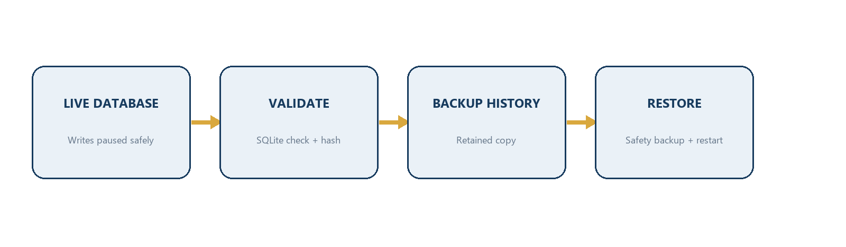
Figure 4. Validated backup and restart-safe restoration flow.

12.1 Backup responsibilities
- AFMS can create manual, scheduled, application-closing, and pre-restore backups.
- The backup service validates SQLite integrity, records file size and hash, and keeps backup history.
- Retention settings remove old backups according to policy.
- A visible warning appears when no recent valid backup exists.
- Use a separate drive or approved network location; do not keep every backup beside the live database.

12.2 Create and validate a manual backup
- Open Backup & Fiscal Years and select Backups.
- Confirm the configured backup folder and any location warning.
- Enter a reason when required.
- Choose Create backup.
- Select the new history row and choose Validate backup.
- Confirm Valid is checked and record the created date, file, size, and creator.

12.3 Restore a backup
SENSITIVE OPERATION
Restoration replaces the working database after restart. Ensure all AFMS users are out, no writes are active, and the selected file is the correct validated backup.

- Create and validate a current manual backup first.
- Choose the backup file to restore or select an eligible history record.
- Enter the required restore reason.
- Choose Restore and confirm the warning.
- AFMS validates the file and creates an automatic pre-restore safety backup.
- AFMS schedules the replacement and restarts safely.
- After restart, confirm users, settings, recent transactions, inventory totals, and audit entries.

12.4 Fiscal-year creation and close
- Open Backup & Fiscal Years and select Fiscal Years.
- Enter Year, Start Date, and End Date; choose Create fiscal year.
- Before closing, select the year and choose Pre-close check.
- Resolve draft transactions, unresolved exceptions, inventory discrepancies, invalid balances, and unapproved transactions.
- Enter the reason and choose Request close.
- A different supervisor account reviews the check and chooses Approve close.
- AFMS creates a year-end snapshot, carries forward outstanding forms, and protects the closed period from edits.

12.5 Documented exceptions
When authorized by office policy, Allow documented exceptions permits closure despite listed issues only when the reason fully documents the exception. This does not remove the underlying audit trail or reconciliation responsibility.

12.6 Reopen a fiscal year
- An administrator selects the closed year, enters a detailed reason, and chooses Request reopen.
- A separate supervisor reviews the reason and chooses Approve reopen.
- AFMS records the administrator request, supervisor decision, timestamps, and reason.
- After authorized corrections, rerun the pre-close check and close the year again.

CHAPTER 13

Recommended Operating Procedures
Practical daily, receiving, issuing, monthly, and year-end checklists.

13.1 Daily opening checklist
- Sign in using your own account.
- Review Dashboard counts and pending approvals.
- Check the backup warning and last validated backup.
- Confirm the correct fiscal year is open.
- Review unresolved exceptions or rejected transactions requiring attention.

13.2 Receiving-day checklist
- Count physical booklets and verify the source document.
- Check beginning and ending serials on the first and last booklet.
- Confirm per-booklet quantity and series year.
- Save as draft, independently review, then submit/finalize.
- Search the first and last serial in Inventory.
- File the receiving document and generated receiving form.

13.3 Issuance-day checklist
- Confirm collector is active and authorized.
- Select only Available inventory.
- Match physical booklet serials to the issuance items.
- Use separate preparer and supervisor accounts.
- Finalize only after physical release controls are complete.
- Print, sign, and file the issuance receipt.
- Verify the collector ledger increased correctly.

13.4 Usage reporting checklist
- Use the collector who actually holds the range.
- Record continuous ranges accurately and explain legitimate gaps.
- Compare amount collected with the source report where applicable.
- Finalize and verify Used and Remaining quantities.
- Resolve spoilage, cancellation, loss, or numbering errors through Exceptions rather than forcing usage.

13.5 Monthly reconciliation
- Generate Stock Inventory and Stock Movement reports.
- Review Outstanding Forms per Collector and collector ledgers.
- Compare Issued versus Used versus Remaining totals.
- Review unresolved exceptions and serial gaps.
- Confirm all submitted transactions were approved, rejected, or finalized.
- Create and validate an off-device backup.

13.6 Year-end checklist
- Complete all draft and pending transactions.
- Investigate inventory variances and invalid balances.
- Resolve or formally document exceptions.
- Generate beginning, ending, year-end, and consolidated reports.
- Run the fiscal-year pre-close check.
- Obtain authorized close approval and inspect the snapshot.
- Create, validate, and securely retain a year-end backup.

13.7 Complete lifecycle example
- Receive 10 booklets of 50 receipts, serials 100001-100500, and finalize.
- Verify 10 Available booklets and 10 Received movements.
- Issue booklet 100001-100050 to an active collector and finalize.
- Record usage 100001-100020; verify Partially Used and remaining 30.
- Transfer unused 100021-100030 to another active collector and finalize.
- Return 100031-100040 to available stock when physically usable.
- Record an approved cancellation exception for 100041 if required.
- Verify both collector ledgers, movement history, inventory detail, and consolidated reports.
CHAPTER 14

Troubleshooting and Frequently Asked Questions
Safe responses to common operating problems.
Problem | Safe response
I cannot see a menu item. | Your role likely lacks the required permission. Confirm your signed-in role and ask an administrator to review the assigned role. Do not use another user's account.
Save or Finalize is disabled. | Confirm a row is selected, required fields are complete, the transaction has the correct status, and your role has the permission. Wait for an active save to complete before clicking again.
AFMS says the range overlaps. | Search the beginning, ending, and a middle serial in Inventory. Review the original receiving reference. Correct the draft; never alter finalized database records manually.
An individual serial cannot be found. | Clear restrictive filters, search only the serial-number field, then review whether the relevant receiving transaction was finalized or reversed.
A collector is missing from issuance. | The collector may be inactive. Review the Collectors module and reactivate only with authorization.
Approval is rejected because I submitted it. | Use a different authorized supervisor account. This is the intended separation-of-duties control.
A reversal is blocked. | Later activity may depend on the transaction, or it may already be reversed. Review inventory detail and movements, then follow the authorized correction procedure.
A report is empty. | Check date range, fiscal year, status, reference, collector, and form filters. Official reports usually require finalized transactions.
PDF or Excel export fails. | Confirm the output folder exists and is writable, the destination file is not open, and sufficient disk space is available. Technical details are written to AFMS logs.
Backup validation fails. | Do not restore the file. Select another validated backup or create a new one. Preserve the failed file for technical investigation.
I forgot my password. | Ask an administrator to reset it. AFMS cannot display the old password because only a secure hash is stored.
The application closes after inactivity. | This is the configured session timeout. Sign in again and save drafts before leaving the workstation.

14.1 When to contact technical support
- AFMS cannot start after an upgrade or restore.
- The same error continues after correcting visible validation issues.
- Database validation or backup validation fails.
- Inventory, movement, and ledger totals disagree after filters are aligned.
- PDF, Excel, printer, attachment, or folder failures persist despite verified access.
- The log contains repeated Error or Fatal entries.
DO NOT EXPOSE SENSITIVE DATA
When reporting a technical problem, provide the time, signed-in username, module, reference number, and error message. Do not send passwords, password hashes, or unrestricted database copies through unapproved channels.

CHAPTER A

Appendix A - Reference Number and Status Guide
Prefix | Transaction | Example
RCV | Stock Receiving | RCV-2026-000001
ISS | Issuance | ISS-2026-000001
USE | Usage Report | USE-2026-000001
TRF | Transfer | TRF-2026-000001
RTN | Return | RTN-2026-000001
EXC | Exception | EXC-2026-000001

Reference sequences are generated atomically. AFMS does not obtain the next number by merely counting rows, which protects against duplicate references during repeated or concurrent operations.

Stock movement types
- Received
- Issued
- Used
- Transferred
- Returned
- Adjusted
- Cancelled
- Archived
- Reversed

Exception types
- Spoiled
- Cancelled
- Lost
- Missing
- Damaged
- Numbering Error
- Invalidated
- Other

CHAPTER B

Appendix B - Initial Dipaculao Configuration
EDITABLE SEED DATA
These records are starter configuration only. Authorized users may edit or deactivate them in AFMS. The initializer imports each configuration version once and does not overwrite later office edits.

Barangays
Code and name | Code and name
001 North Poblacion | 014 Gupa
002 South Poblacion | 015 Ipil
003 Bayabas | 016 Laboy
004 Borlongan | 017 Lipit
005 Buenavista | 018 Lobbot
006 Calaocan | 019 Maligaya
007 Diamanen | 020 Mijares
008 Dianed | 021 Mucdol
009 Diarabasin | 022 Puangi
010 Dibutunan | 023 Salay
011 Dimabuno | 024 Sapangkawayan
012 Dinadiawan | 025 Toytoyan
013 Ditale

Accountable form types
Code | Form name | Per booklet
BIR-0016 | CEDULA | 50
AF51 | LOCAL | 50
AF56 | RPT | 50
AF57 | SLAUGHTE | 50
AF53 | OWNERSH | 50
AF54 | MARRIAGE | 50
AF58 | BURIAL | 50
AF51-TRUST | TRUST | 50
AF52 | TRANSFER | 50
CASH-TICKET | CASH TICKET | 50
AF51-BLD | LOCAL (BLD) | 50
BIR-0017 | CORPORATE CEDULA | 50

Collectors
Collector no. | Full name
SMV | Shella May I. Velasco
AU | Marigold L. Dela Cruz
LCM | Leonardo C. Marzan Jr.
NPDR | Nobleza P. Delos Reyes
ADRA | Angelita Dr. Agua
KFJ | Kristofferson F. Javar
CJC | Cherrie Joy L. Cacanindin
RMGC | Rhonica May G. Cagurangan
CLQ | Cecille Lyn C. Quirino
MEPC | Maria Elena P. Chavez

CHAPTER C

Appendix C - Glossary
Term | Definition
Accountability | The forms or receipt ranges currently assigned to a holder and not yet discharged by valid usage, transfer, return, exception, adjustment, or reversal.
Booklet | A generated accountable-form inventory unit with a controlled beginning and ending serial.
Collector | A person authorized to receive accountable forms and report their disposition.
Exception | A controlled incident such as spoiled, cancelled, lost, missing, damaged, numbering error, or invalidation.
Finalization | The atomic step that commits inventory, movements, ledgers, and audit effects.
Fiscal year snapshot | The preserved year-end balance by form type produced during fiscal-year close.
Outstanding | Accountable forms currently held by collectors or otherwise not discharged.
Range | An inclusive beginning and ending serial; quantity equals ending minus beginning plus one.
Reversal | A controlled opposite entry that preserves the original transaction and audit trail.
Stock movement | An immutable chronological record of inventory or accountability change.
Transaction status | The workflow stage controlling what actions may occur.
Validated backup | A database copy that passed file, schema, SQLite integrity, and hash checks.

CHAPTER D

Appendix D - Document Control and Training Sign-Off

Revision history
Version | Date | Summary | Approved by
1.0 | 16 July 2026 | Initial comprehensive AFMS user manual.

User training acknowledgment
I acknowledge that I received orientation on AFMS, understand that I must use only my assigned account, and agree to follow Municipal Treasury Office procedures for accountable forms, approvals, reports, backups, and confidential information.
Name and position | Signature | Date

Office notes
________________________________________________________________________________
________________________________________________________________________________
________________________________________________________________________________
________________________________________________________________________________
________________________________________________________________________________
________________________________________________________________________________

