Introduction to R Markdown

Tiberius

9 July 2016

This is my first R Markdown document. Markdown is a simple formatting syntax for authoring HTML, PDF, and MS Word documents. For more details on using R Markdown see <http://rmarkdown.rstudio.com>.

Using the **rmarkdown** package (pandoc version 1.12.3 or higher is required), the rendering command is

rmarkdown::render("your rmd file")

The default is HTML output (because *output* was specified as such in the heading of the current document). If you would like a markdown (.md) document, add an argument:

rmarkdown::render("your rmd file", md_document())

The same way, PDF output (*pdflatex* is needed, that is *texlive-base*, *texlive-latex-base*, *texlive-latex-extra*, and *texlive-fonts-recommended*):

rmarkdown::render("your rmd file", pdf_document())

or Word document:

rmarkdown::render("your rmd file", word_document())

or *slidy* presentation:

rmarkdown::render("your rmd file", slidy_presentation())

When the document is generated that includes both content as well as the output of any embedded R code chunks within the document. You can embed an R code chunk like this:

summary(mtcars)

## mpg cyl disp hp   
## Min. :10.40 Min. :4.000 Min. : 71.1 Min. : 52.0   
## 1st Qu.:15.43 1st Qu.:4.000 1st Qu.:120.8 1st Qu.: 96.5   
## Median :19.20 Median :6.000 Median :196.3 Median :123.0   
## Mean :20.09 Mean :6.188 Mean :230.7 Mean :146.7   
## 3rd Qu.:22.80 3rd Qu.:8.000 3rd Qu.:326.0 3rd Qu.:180.0   
## Max. :33.90 Max. :8.000 Max. :472.0 Max. :335.0   
## drat wt qsec vs   
## Min. :2.760 Min. :1.513 Min. :14.50 Min. :0.0000   
## 1st Qu.:3.080 1st Qu.:2.581 1st Qu.:16.89 1st Qu.:0.0000   
## Median :3.695 Median :3.325 Median :17.71 Median :0.0000   
## Mean :3.597 Mean :3.217 Mean :17.85 Mean :0.4375   
## 3rd Qu.:3.920 3rd Qu.:3.610 3rd Qu.:18.90 3rd Qu.:1.0000   
## Max. :4.930 Max. :5.424 Max. :22.90 Max. :1.0000   
## am gear carb   
## Min. :0.0000 Min. :3.000 Min. :1.000   
## 1st Qu.:0.0000 1st Qu.:3.000 1st Qu.:2.000   
## Median :0.0000 Median :4.000 Median :2.000   
## Mean :0.4062 Mean :3.688 Mean :2.812   
## 3rd Qu.:1.0000 3rd Qu.:4.000 3rd Qu.:4.000   
## Max. :1.0000 Max. :5.000 Max. :8.000

You can also embed plots, for example:

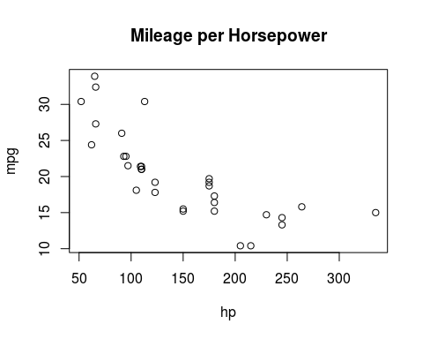

Note that the echo = FALSE parameter was added to the code chunk to prevent printing of the R code that generated the plot.