Description

Intended User

Features

User Interface Mocks

Screen 1

Screen 2

Key Considerations

How will your app handle data persistence?

Describe any corner cases in the UX.

Describe any libraries you’ll be using and share your reasoning for including them.

Describe how you will implement Google Play Services.

Next Steps: Required Tasks

Task 1: Project Setup

Task 2: Implement UI for Each Activity and Fragment

Task 3: Your Next Task

Task 4: Your Next Task

Task 5: Your Next Task

**GitHub Username**: tiborkosa

Grocery List

# Description

This app lets you create a grocery list that you can share among other app users or via email.

Why always rely on memory or a piece of paper when you have you phone with you?

# Intended User

This app is intended to target all people who tend to forget grocery items.

# Features

* Saves information
* Shares information among other app user
* Shares information via email
* Marks due date in you calendar

# User Interface Mocks

## Screen 1

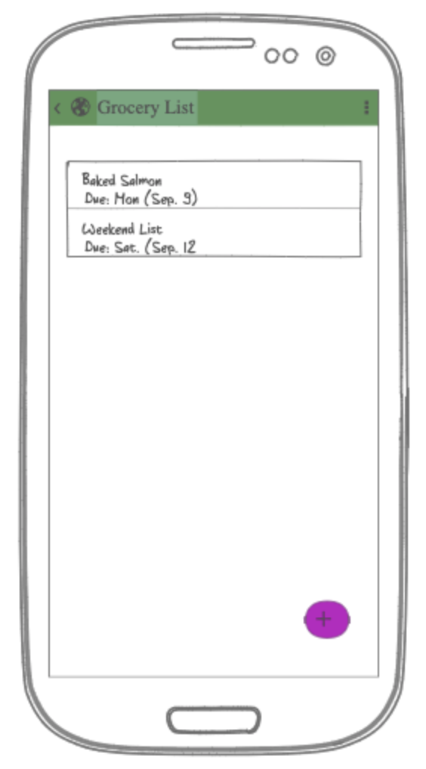

The main screen will have a list of items to purchase sorted by due date.

Here we will allow user to mark the item as purchased or update/delete.

The action bar will allow user to add additional items or create a new list.

Note: color profile might change

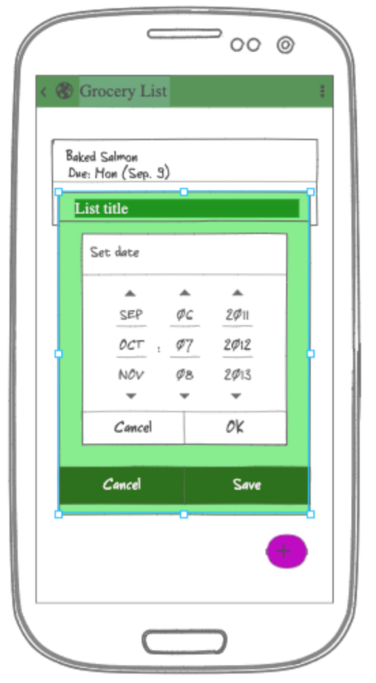

This screen demonstrates the add/change item or list

## Screen 2

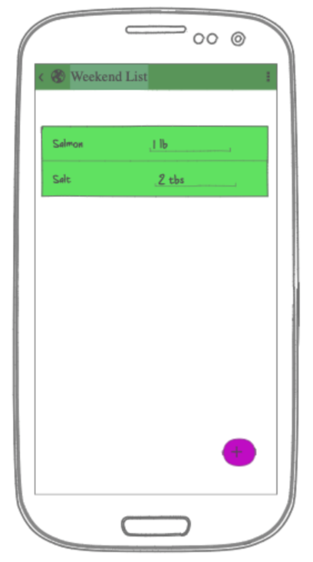

This screen will show the items in the list. Here the user can modify the list and share it among others.

# Key Considerations

### How will your app handle data persistence?

This app will save the data on the phone and will be connected to Firebase Database. It will detect changes and will synch the data with the database. Also, if other user adds/ changes/ shares information will reflect on the device

### Describe any edge or corner cases in the UX.

UI will contain simple transitions and animations.

### Describe any libraries you’ll be using and share your reasoning for including them.

I will be using lots of libraries that was used in the course: Picasso, Firebase, ButterKnife …

### Describe how you will implement Google Play Services or other external services.

This might change but I’d like to user google calendar and email.

# Next Steps: Required Tasks

## Task 1: Project Setup

I will be using the Android Studio build in firebase tools to connect to the database. After this I will create the local database with live data. Every time a list is created/ modified I will run a background task to synch up the data with the database. With this approach I will limit the network traffic. Every time a new change has happened on the database I will send either the data or a synch notification to synch the data.

## Task 2: Implement UI for Each Activity and Fragment

* Build UI for MainActivity
* Create recycle view
* Build UI for the ListActivity
* Create the pop up dialogs for modifying the list or item
* Create pop up to share information
* Add menu for settings and other navigations

## Task 3: Your Next Task

* Create layout for all activities and list
* Create all recycle view for lists (one for the list and one for the items)
* Create settings activity and menu

## Task 4: Your Next Task

* Implement the firebase database
* Implement live data and necessary models for local sql storage
* Implement synch service
* Implement firebase messaging

## Task 5: Your Next Task

* Polish the UI
* Add simple animations and transitions
* Create a free and paid version if there is enough time