**COMPUTER GRAPHICS ASSIGNMENT-1**

**PRIMITIVES**

**Name-**ABHISHEK TIBREWAL

**Id-**2016UCP1103

**Batch-**A(1,2)

* **LINE:**

**--CODE**

from graphics import *

def draw_slope_less(x0,y0,x1,y1): #for line having slope between -1 and 1

dy=y1-y0

dx=x1-x0

yi=1

if(dy<0): #if slope is between -1 and 0

yi=-1

dy=-dy

dne=2*(dy-dx)

de=2*dy

d=2*dy-dx

y=y0

r=1

if x1<x0:

r=-1

for x in range(x0,x1,r):

pt=Point(x,y)

time.sleep(0.03)

pt.draw(window)

if(d>0):

y=y+yi

d=d+dne

else:

d=d+de

#print("("+str(x)+","+str(y)+")")

def draw_slope_more(x0,y0,x1,y1): #for line having slope greater than 1 or less than -1

dy=y1-y0

dx=x1-x0

xi=1

if(dx<0): #if slope is less than -1

xi=-1

dx=-dx

dne=2*(dx-dy)

de=2*dx

d=2*dx-dy

x=x0

r=1

if y1<y0:

r=-1

for y in range(y0,y1,r):

pt=Point(x,y)

time.sleep(0.03)

pt.draw(window)

if(d>0):

x=x+xi

d=d+dne

else:

d=d+de

#print("("+str(x)+","+str(y)+")")

def draw_line(x0,y0,x1,y1):

if abs(y1-y0) < abs(x1-x0): #if |slope|<1

if x0>=x1:

draw_slope_less(x1,y1,x0,y0) #here we interchange starting and end point of line because we have to draw from bottom to top

else:

draw_slope_less(x0,y0,x1,y1)

else: #if |slope|>1

if y0>=y1:

draw_slope_more(x1,y1,x0,y0)

else:

draw_slope_more(x0,y0,x1,y1)

msg =Text(Point(x0,y0),"("+str(x0)+","+str(y0)+")")

msg.draw(window)

msg =Text(Point(x1,y1),"("+str(x1)+","+str(y1)+")")

msg.draw(window)

#taking input from user

print("Enter starting point of line:")

x0=int(input("Enter X0:"))

y0=int(input("Enter Y0:"))

print("Enter ending point of line:")

x1=int(input("Enter X1:"))

y1=int(input("Enter Y1:"))

window=GraphWin("2016UCP1103_LINE",600,600) #for viewport(device coordinates)

window.setCoords(-300,-300,300,300) #for window(user coordinates)

window.setBackground("yellow")

#drwing user coordinate system

X=Line(Point(-300,0),Point(300,0)) #for drawing X-axis

X.setArrow('both')

X.setOutline('blue')

X.draw(window)

msg=Text(Point(290,10), "+X")

msg.draw(window)

msg=Text(Point(-290,10), "-X")

msg.draw(window)

Y=Line(Point(0,-300),Point(0,300)) #for drawing Y-axis

Y.setArrow('both')

Y.setOutline('blue')

Y.draw(window)

msg=Text(Point(10,290), "+Y")

msg.draw(window)

msg=Text(Point(10,-290), "-Y")

msg.draw(window)

msg=Text(Point(0,0), "(0,0)") #for origin

msg.draw(window)

draw_line(x0,y0,x1,y1)

window.getMouse()

window.close()

**--OUTPUT**

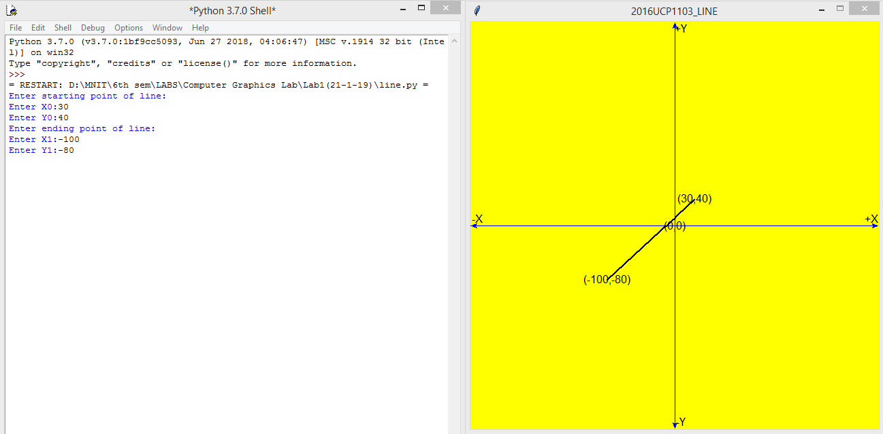

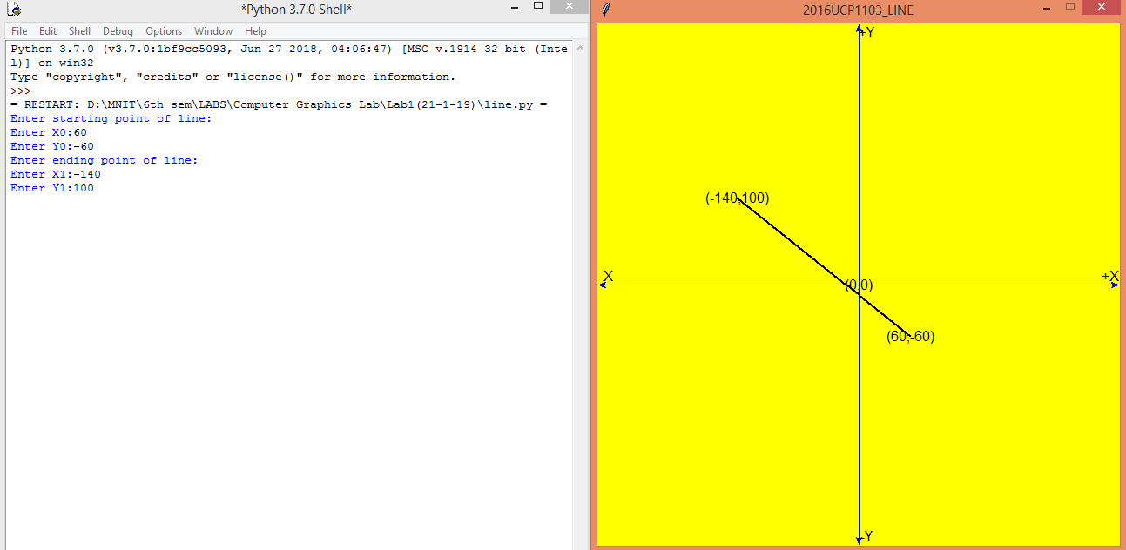

* **CIRCLE:**

**--CODE**

from graphics import *

def draw_circle(x,y):

pt=Point(x0+x,y0+y)

pt.draw(window)

pt=Point(x0+x,y0-y)

pt.draw(window)

pt=Point(x0-x,y0+y)

pt.draw(window)

pt=Point(x0-x,y0-y)

pt.draw(window)

pt=Point(x0+y,y0+x)

pt.draw(window)

pt=Point(x0-y,y0+x)

pt.draw(window)

pt=Point(x0+y,y0-x)

pt.draw(window)

pt=Point(x0-y,y0-x)

pt.draw(window)

time.sleep(0.03)

#print("("+str(x)+","+str(y)+")")

#taking input from user

print("Enter coordinates of the center:")

x0=int(input("Enter X0:"))

y0=int(input("Enter Y0:"))

R=int(input("Enter radius of Circle:"))

window=GraphWin("2016UCP1103_CIRCLE",600,600) #for viewport(device coordinates)

window.setCoords(-300,-300,300,300) #for window(user coordinates)

window.setBackground("yellow")

#drwing user coordinate system

x_axis=Line(Point(-300,0),Point(300,0)) #for drawing X-axis

x_axis.setArrow('both')

x_axis.setOutline('blue')

x_axis.draw(window)

msg=Text(Point(290,10), "+X")

msg.draw(window)

msg=Text(Point(-290,10), "-X")

msg.draw(window)

y_axis=Line(Point(0,-300),Point(0,300)) #for drawing Y-axis

y_axis.setArrow('both')

y_axis.setOutline('blue')

y_axis.draw(window)

msg=Text(Point(10,290), "+Y")

msg.draw(window)

msg=Text(Point(10,-290), "-Y")

msg.draw(window)

msg=Text(Point(10,-10), "O") #for origin

msg.draw(window)

center=Point(x0,y0)

center.draw(window)

msg=Text(Point(x0,y0), "C("+str(x0)+","+str(y0)+")") #for center of circle

msg.draw(window)

pt=Point(x0+R,y0)

pt.draw(window)

msg=Text(Point(x0+R+20,y0), "R="+str(R))

msg.draw(window)

pt=Point(0,0)

pt.draw(window)

d=1-R #initial d

x=0.0

y=R+0.0

while(y>x):

x=x+1

if(d<=0):

d=d+2*x+3 #de=2x+3

else:

y=y-1

d=d+2*(x-y)+5 #dse=2(x-y)+5

draw_circle(x,y)

window.getMouse()

window.close()

**--OUTPUT**

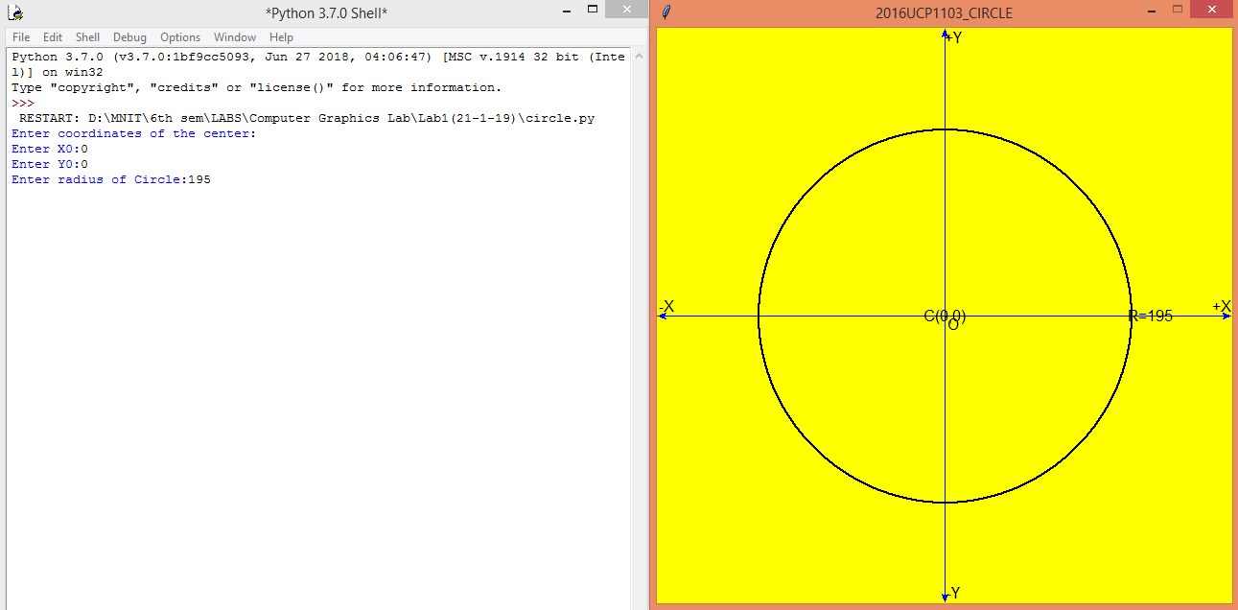

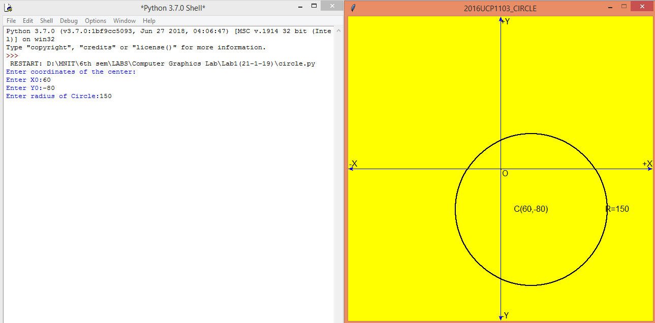

* **ELLIPSE:**

**--CODE**

from graphics import *

def draw_ellipse(x,y):

pt=Point(x0+x,y0+y)

pt.draw(window)

pt=Point(x0+x,y0-y)

pt.draw(window)

pt=Point(x0-x,y0+y)

pt.draw(window)

pt=Point(x0-x,y0-y)

pt.draw(window)

time.sleep(0.03)

#print("("+str(x)+","+str(y)+")")

#taking input from user

print("Enter coordinate of center of ellipse:")

x0=int(input("Enter x-coordinate:"))

y0=int(input("Enter y-coordinate:"))

print("Enter length of axes:")

a=int(input("Enter length of major axis:"))

b=int(input("Enter length of minor axis"))

window=GraphWin("2016UCP1103_ELLIPSE",600,600) #for viewport(device coordinates)

window.setCoords(-300,-300,300,300) #for window(user coordinates)

window.setBackground("yellow")

#drwing user coordinate system

x_axis=Line(Point(-300,0),Point(300,0)) #for drawing X-axis

x_axis.setArrow('both')

x_axis.setOutline('blue')

x_axis.draw(window)

msg=Text(Point(290,10), "+X")

msg.draw(window)

msg=Text(Point(-290,10), "-X")

msg.draw(window)

y_axis=Line(Point(0,-300),Point(0,300)) #for drawing Y-axis

y_axis.setArrow('both')

y_axis.setOutline('blue')

y_axis.draw(window)

msg=Text(Point(10,290), "+Y")

msg.draw(window)

msg=Text(Point(10,-290), "-Y")

msg.draw(window)

msg=Text(Point(10,-10), "O") #for origin

msg.draw(window)

center=Point(x0,y0)

center.draw(window)

msg=Text(Point(x0,y0-10), "C("+str(x0)+","+str(y0)+")") #for center of ellipse

msg.draw(window)

x=0

y=b

d1=(b*b)-(a*a*b)+(0.25*a*a)

while((a*a)*(y-0.5)>(b*b)*(x+1)):

if d1<0:

d1+=(b*b)*(2*x+3)

else:

d1+=(b*b)*(2*x+3)+(a*a)*(-2*y+2)

y=y-1

x=x+1

draw_ellipse(x,y)

d2=(b*b)*(x+0.5)*(x+0.5)+a*a*(y-1)*(y-1)-a*a*b*b

while y>0:

if d2<0:

d2+=b*b*(2*x+2)+a*a*(-2*y+3)

x+=1

else:

d2+=a*a*(-2*y+3)

y-=1

draw_ellipse(x,y)

window.getMouse()

window.close()

**--OUTPUT**

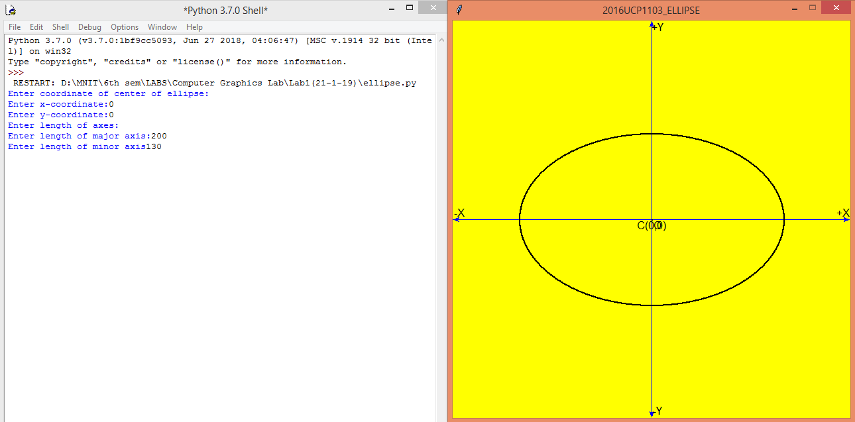

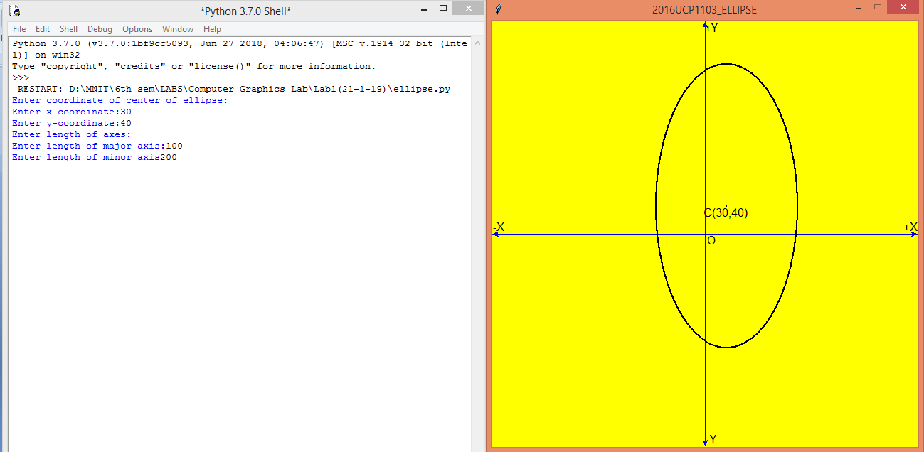

* **POLYGON:**

**--CODE**

from graphics import *

def draw_slope_less(x0,y0,x1,y1): #for line having slope between -1 and 1

dy=y1-y0

dx=x1-x0

yi=1

if(dy<0): #if slope is between -1 and 0

yi=-1

dy=-dy

dne=2*(dy-dx)

de=2*dy

d=2*dy-dx

y=y0

r=1

if x1<x0:

r=-1

for x in range(x0,x1,r):

pt=Point(x,y)

time.sleep(0.03)

pt.draw(window)

if(d>0):

y=y+yi

d=d+dne

else:

d=d+de

#print("("+str(x)+","+str(y)+")")

def draw_slope_more(x0,y0,x1,y1): #for line having slope greater than 1 or less than -1

dy=y1-y0

dx=x1-x0

xi=1

if(dx<0): #if slope is less than -1

xi=-1

dx=-dx

dne=2*(dx-dy)

de=2*dx

d=2*dx-dy

x=x0

r=1

if y1<y0:

r=-1

for y in range(y0,y1,r):

pt=Point(x,y)

time.sleep(0.03)

pt.draw(window)

if(d>0):

x=x+xi

d=d+dne

else:

d=d+de

#print("("+str(x)+","+str(y)+")")

def draw_line(x0,y0,x1,y1):

if abs(y1-y0) < abs(x1-x0): #if |slope|<1

if x0>=x1:

draw_slope_less(x1,y1,x0,y0) #here we interchange starting and end point of line because we have to draw from bottom to top

else:

draw_slope_less(x0,y0,x1,y1)

else: #if |slope|>1

if y0>=y1:

draw_slope_more(x1,y1,x0,y0)

else:

draw_slope_more(x0,y0,x1,y1)

msg =Text(Point(x0,y0),"("+str(x0)+","+str(y0)+")")

msg.draw(window)

msg =Text(Point(x1,y1),"("+str(x1)+","+str(y1)+")")

msg.draw(window)

#taking input from user

print("Enter no. of sides in polygon:")

s=int(input("Enter sides:"))

print("Enter the points:")

po=[]

for i in range(0,s):

print("enter x coordinate of point-",i+1,":")

x=int(input())

print("enter y coordinate of point-",i+1,":")

y=int(input())

a=[x,y]

po.append(a)

window=GraphWin("2016UCP1103_POLYGON",600,600) #for viewport(device coordinates)

window.setCoords(-300,-300,300,300) #for window(user coordinates)

window.setBackground("yellow")

#drwing user coordinate system

X=Line(Point(-300,0),Point(300,0)) #for drawing X-axis

X.setArrow('both')

X.setOutline('blue')

X.draw(window)

msg=Text(Point(290,10), "+X")

msg.draw(window)

msg=Text(Point(-290,10), "-X")

msg.draw(window)

Y=Line(Point(0,-300),Point(0,300)) #for drawing Y-axis

Y.setArrow('both')

Y.setOutline('blue')

Y.draw(window)

msg=Text(Point(10,290), "+Y")

msg.draw(window)

msg=Text(Point(10,-290), "-Y")

msg.draw(window)

msg=Text(Point(0,0), "(0,0)") #for origin

msg.draw(window)

for i in range(1,s):

x1=po[i-1][0]

y1=po[i-1][1]

x2=po[i][0]

y2=po[i][1]

draw_line(x1,y1,x2,y2)

x1=po[0][0]

y1=po[0][1]

x2=po[s-1][0]

y2=po[s-1][1]

draw_line(x1,y1,x2,y2)

window.getMouse()

window.close()

**--OUTPUT**

