**COMPUTER GRAPHICS ASSIGNMENT-2**

**FILLING**

**Name-**ABHISHEK TIBREWAL

**Id-**2016UCP1103

**Batch-**A(1,2)

* **BOUNDARY FILLING ALGORITHM:**

**--CODE**

**from graphics import \***

**points=[] #2-d list for storing border and filled points**

**for i in range(-300,301):**

**points.append([])**

**for j in range(-300,301):**

**points[i+300].append(" ")**

**def draw_slope_less(x0,y0,x1,y1): #for line having slope between -1 and 1**

**dy=y1-y0**

**dx=x1-x0**

**yi=1**

**if(dy<0): #if slope is between -1 and 0**

**yi=-1**

**dy=-dy**

**dne=2*(dy-dx)**

**de=2*dy**

**d=2*dy-dx**

**y=y0**

**r=1**

**if x1<x0:**

**r=-1**

**for x in range(x0,x1,r):**

**pt=Point(x+300,y+300)**

**time.sleep(0.03)**

**pt.draw(window)**

**points[x+300][y+300]="bc"#store border point while drawing polygon**

**if(d>0):**

**y=y+yi**

**d=d+dne**

**else:**

**d=d+de**

**#print("("+str(x)+","+str(y)+")")**

**def draw_slope_more(x0,y0,x1,y1): #for line having slope greater than 1 or less than -1**

**dy=y1-y0**

**dx=x1-x0**

**xi=1**

**if(dx<0): #if slope is less than -1**

**xi=-1**

**dx=-dx**

**dne=2*(dx-dy)**

**de=2*dx**

**d=2*dx-dy**

**x=x0**

**r=1**

**if y1<y0:**

**r=-1**

**for y in range(y0,y1,r):**

**pt=Point(x+300,y+300)**

**time.sleep(0.03)**

**pt.draw(window)**

**points[x+300][y+300]="bc"#store border point while drawing polygon**

**if(d>0):**

**x=x+xi**

**d=d+dne**

**else:**

**d=d+de**

**#print("("+str(x)+","+str(y)+")")**

**def draw_line(x0,y0,x1,y1):**

**if abs(y1-y0) < abs(x1-x0): #if |slope|<1**

**if x0>=x1:**

**draw_slope_less(x1,y1,x0,y0) #here we interchange starting and end point of line because we have to draw from bottom to top**

**else:**

**draw_slope_less(x0,y0,x1,y1)**

**else: #if |slope|>1**

**if y0>=y1:**

**draw_slope_more(x1,y1,x0,y0)**

**else:**

**draw_slope_more(x0,y0,x1,y1)**

**p1=Point(x0+300,y0+300)**

**points[x0+300][y0+300]="bc"**

**p1.draw(window)**

**p2=Point(x1+300,y1+300)**

**points[x1+300][y1+300]="bc"**

**p2.draw(window)**

**msg =Text(Point(x0+300,y0+300),"("+str(x0)+","+str(y0)+")")**

**msg.draw(window)**

**msg =Text(Point(x1+300,y1+300),"("+str(x1)+","+str(y1)+")")**

**msg.draw(window)**

**def flood_fill():**

**print("Click anywhere inside the polgon to fill it::\n")**

**seed_point=(window.getMouse())**

**lis=[]**

**lis.append(seed_point)**

**fc="fc" #fill color**

**bc="bc" #boundary color**

**while(len(lis)!=0):**

**pt=lis[len(lis)-1]**

**lis.pop()**

**x=int(pt.getX()) #accessing x coordinate of point**

**y=int(pt.getY()) #accessing y coordinate of point**

**if(points[x][y]!=fc and points[x][y]!=bc):**

**window.plot(x,y,"red")**

**points[x][y]=fc**

**pt=Point(x+1,y)**

**if(points[x+1][y]!=bc and points[x+1][y]!=fc):**

**lis.append(pt)**

**pt=Point(x,y+1)**

**if(points[x][y+1]!=bc and points[x][y+1]!=fc):**

**lis.append(pt)**

**pt=Point(x-1,y)**

**if(points[x-1][y]!=bc and points[x-1][y]!=fc):**

**lis.append(pt)**

**pt=Point(x,y-1)**

**if(points[x][y-1]!=bc and points[x][y-1]!=fc):**

**lis.append(pt)**

**#taking input from user**

**print("Enter no. of sides in polygon:")**

**s=int(input("Enter sides:"))**

**print("Enter the points:")**

**po=[]**

**for i in range(0,s):**

**print("enter x coordinate of point-",i+1,":")**

**x=int(input())**

**print("enter y coordinate of point-",i+1,":")**

**y=int(input())**

**a=[x,y]**

**po.append(a)**

**window=GraphWin("2016UCP1103_FILLING1",600,600) #for viewport(device coordinates)**

**window.setCoords(0,0,600,600) #for window(user coordinates)**

**window.setBackground("white")**

**#drwing user coordinate system**

**X=Line(Point(0,300),Point(600,300)) #for drawing X-axis**

**X.setArrow('both')**

**X.setOutline('blue')**

**X.draw(window)**

**msg=Text(Point(590,310), "+X")**

**msg.draw(window)**

**msg=Text(Point(10,310), "-X")**

**msg.draw(window)**

**Y=Line(Point(300,0),Point(300,600)) #for drawing Y-axis**

**Y.setArrow('both')**

**Y.setOutline('blue')**

**Y.draw(window)**

**msg=Text(Point(310,590), "+Y")**

**msg.draw(window)**

**msg=Text(Point(310,10), "-Y")**

**msg.draw(window)**

**msg=Text(Point(300,300), "(0,0)") #for origin**

**msg.draw(window)**

**for i in range(1,s):**

**x1=po[i-1][0]**

**y1=po[i-1][1]**

**x2=po[i][0]**

**y2=po[i][1]**

**draw_line(x1,y1,x2,y2)**

**x1=po[0][0]**

**y1=po[0][1]**

**x2=po[s-1][0]**

**y2=po[s-1][1]**

**draw_line(x1,y1,x2,y2)**

**flood_fill()**

**window.getMouse()**

**window.close()**

**--OUTPUT**

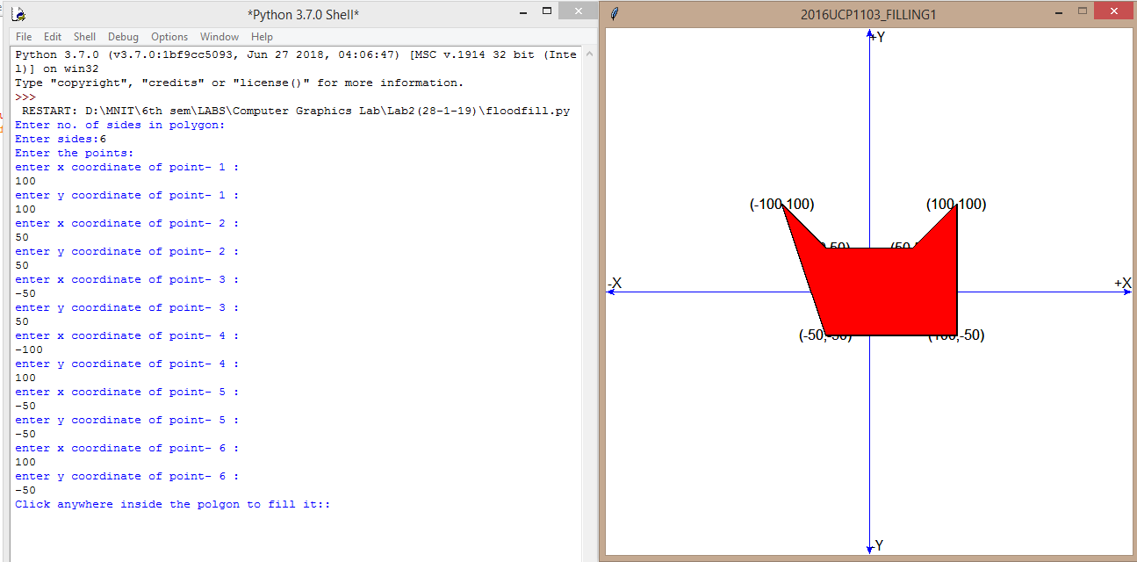

* **SCANLINE POLYGON FILLING ALGORITHM:**

**--CODE**

**from graphics import \***

**def draw_slope_less(x0,y0,x1,y1): #for line having slope between -1 and 1**

**dy=y1-y0**

**dx=x1-x0**

**yi=1**

**if(dy<0): #if slope is between -1 and 0**

**yi=-1**

**dy=-dy**

**dne=2*(dy-dx)**

**de=2*dy**

**d=2*dy-dx**

**y=y0**

**r=1**

**if x1<x0:**

**r=-1**

**for x in range(x0,x1,r):**

**pt=Point(x,y)**

**time.sleep(0.03)**

**pt.draw(window)**

**if(d>0):**

**y=y+yi**

**d=d+dne**

**else:**

**d=d+de**

**#print("("+str(x)+","+str(y)+")")**

**def draw_slope_more(x0,y0,x1,y1): #for line having slope greater than 1 or less than -1**

**dy=y1-y0**

**dx=x1-x0**

**xi=1**

**if(dx<0): #if slope is less than -1**

**xi=-1**

**dx=-dx**

**dne=2*(dx-dy)**

**de=2*dx**

**d=2*dx-dy**

**x=x0**

**r=1**

**if y1<y0:**

**r=-1**

**for y in range(y0,y1,r):**

**pt=Point(x,y)**

**time.sleep(0.03)**

**pt.draw(window)**

**if(d>0):**

**x=x+xi**

**d=d+dne**

**else:**

**d=d+de**

**#print("("+str(x)+","+str(y)+")")**

**def draw_line(x0,y0,x1,y1):**

**if abs(y1-y0) < abs(x1-x0): #if |slope|<1**

**if x0>=x1:**

**draw_slope_less(x1,y1,x0,y0) #here we interchange starting and end point of line because we have to draw from bottom to top**

**else:**

**draw_slope_less(x0,y0,x1,y1)**

**else: #if |slope|>1**

**if y0>=y1:**

**draw_slope_more(x1,y1,x0,y0)**

**else:**

**draw_slope_more(x0,y0,x1,y1)**

**msg =Text(Point(x0,y0),"("+str(x0)+","+str(y0)+")")**

**msg.draw(window)**

**msg =Text(Point(x1,y1),"("+str(x1)+","+str(y1)+")")**

**msg.draw(window)**

**#fuction for scanline polygon filling**

**def spf(et,n):**

**ycur=500**

**aet=[]**

**for i in range(len(et)):**

**if ycur>et[i][1]:**

**ycur=et[i][1]**

**while len(et)!=0 or len(aet)!=0:**

**p=-1**

**cnty=0**

**for i in range(len(et)):**

**if et[i][1]==ycur:**

**cnty+=1**

**for i in range(0,cnty):**

**for j in range(len(et)):**

**if et[j][1]==ycur:**

**break**

**aet.append(et[j])**

**del et[j:j+1]**

**#print(p)**

**aet.sort()**

**cnt=0**

**for i in range(len(aet)):**

**if aet[i][3]==ycur:**

**cnt+=1**

**for i in range(0,cnt):**

**for j in range(len(aet)):**

**if aet[j][3]==ycur:**

**break**

**del aet[j:j+1]**

**check=True**

**for i in range(len(aet)-1):**

**xfrom=aet[i][0]**

**xto=aet[i+1][0]**

**#print("(",xfrom,xto,")")**

**if check==True:**

**j=xfrom**

**while j<xto:**

**window.plot(j,ycur,"red")**

**j+=1**

**check=False**

**else:**

**check=True**

**ycur+=1**

**for i in range(len(aet)):**

**aet[i][0]+=aet[i][4]**

**#print(et,end='\n')**

**#print(aet,end='\n')**

**#taking input from user**

**print("Enter no. of sides in polygon:")**

**s=int(input("Enter sides:"))**

**print("Enter the points:")**

**po=[]**

**for i in range(0,s):**

**print("enter x coordinate of point-",i+1,":")**

**x=int(input())**

**print("enter y coordinate of point-",i+1,":")**

**y=int(input())**

**a=[x,y]**

**po.append(a)**

**window=GraphWin("2016UCP1103_POLYGON",600,600) #for viewport(device coordinates)**

**window.setCoords(-300,-300,300,300) #for window(user coordinates)**

**window.setBackground("yellow")**

**#drwing user coordinate system**

**X=Line(Point(-300,0),Point(300,0)) #for drawing X-axis**

**X.setArrow('both')**

**X.setOutline('blue')**

**X.draw(window)**

**msg=Text(Point(290,10), "+X")**

**msg.draw(window)**

**msg=Text(Point(-290,10), "-X")**

**msg.draw(window)**

**Y=Line(Point(0,-300),Point(0,300)) #for drawing Y-axis**

**Y.setArrow('both')**

**Y.setOutline('blue')**

**Y.draw(window)**

**msg=Text(Point(10,290), "+Y")**

**msg.draw(window)**

**msg=Text(Point(10,-290), "-Y")**

**msg.draw(window)**

**msg=Text(Point(0,0), "(0,0)") #for origin**

**msg.draw(window)**

**edge_t=[] #edge table**

**for i in range(1,s):**

**x1=po[i-1][0]**

**y1=po[i-1][1]**

**x2=po[i][0]**

**y2=po[i][1]**

**if y2-y1!=0:**

**if y1>y2:**

**y1,y2=y2,y1**

**x1,x2=x2,x1**

**m=(x2-x1)/(y2-y1)**

**edge_t.append([x1,y1,x2,y2,m])**

**draw_line(x1,y1,x2,y2)**

**x1=po[0][0]**

**y1=po[0][1]**

**x2=po[s-1][0]**

**y2=po[s-1][1]**

**if y2-y1!=0:**

**if y1>y2:**

**y1,y2=y2,y1**

**x1,x2=x2,x1**

**m=(x2-x1)/(y2-y1)**

**edge_t.append([x1,y1,x2,y2,m])**

**draw_line(x1,y1,x2,y2)**

**spf(edge_t,s)**

**window.getMouse()**

**window.close()**

**--OUTPUT**

