**COMPUTER GRAPHICS ASSIGNMENT-4**

**TRANSFORMATIONS**

**Name-**ABHISHEK TIBREWAL

**Id-**2016UCP1103

**Batch-**A(1,2)

**2-D**

* **TRANSLATION:**

**from graphics import \***

**#function for translation**

**def translation(tx,ty):**

**for i in range(0,s):**

**pbt[i][0]+=tx**

**pbt[i][1]+=ty**

**print(pbt)**

**#taking input from user**

**print("Enter no. of sides in polygon:")**

**s=int(input("Enter sides:"))**

**print("Enter the points:")**

**pbt=[]**

**for i in range(0,s):**

**print("enter x coordinate of point-",i+1,":")**

**x=int(input())**

**print("enter y coordinate of point-",i+1,":")**

**y=int(input())**

**a=[x,y]**

**pbt.append(a)**

**window=GraphWin("2016UCP1103_TRANSLATION",600,600) #for viewport(device coordinates)**

**window.setCoords(-300,-300,300,300) #for window(user coordinates)**

**window.setBackground("yellow")**

**#drwing user coordinate system**

**X=Line(Point(-300,0),Point(300,0)) #for drawing X-axis**

**X.setArrow('both')**

**X.setOutline('blue')**

**X.draw(window)**

**msg=Text(Point(290,10), "+X")**

**msg.draw(window)**

**msg=Text(Point(-290,10), "-X")**

**msg.draw(window)**

**Y=Line(Point(0,-300),Point(0,300)) #for drawing Y-axis**

**Y.setArrow('both')**

**Y.setOutline('blue')**

**Y.draw(window)**

**msg=Text(Point(10,290), "+Y")**

**msg.draw(window)**

**msg=Text(Point(10,-290), "-Y")**

**msg.draw(window)**

**msg=Text(Point(0,0), "(0,0)") #for origin**

**msg.draw(window)**

**#drawing original polygon**

**for i in range(1,s):**

**x1=pbt[i-1][0]**

**y1=pbt[i-1][1]**

**x2=pbt[i][0]**

**y2=pbt[i][1]**

**line=Line(Point(x1,y1),Point(x2,y2))**

**line.setFill("red")**

**line.draw(window)**

**Text(Point(x1,y1),"("+str(x1)+","+str(y1)+")").draw(window)**

**x1=pbt[0][0]**

**y1=pbt[0][1]**

**x2=pbt[s-1][0]**

**y2=pbt[s-1][1]**

**line=Line(Point(x1,y1),Point(x2,y2))**

**line.setFill("red")**

**line.draw(window)**

**Text(Point(x2,y2),"("+str(x2)+","+str(y2)+")").draw(window)**

**#calling translation**

**tx=int(input("Enter Translation in x:Tx="))**

**ty=int(input("Enter Translation in y:Ty="))**

**translation(tx,ty)**

**#drawing tranlated polygon**

**for i in range(1,s):**

**x1=pbt[i-1][0]**

**y1=pbt[i-1][1]**

**x2=pbt[i][0]**

**y2=pbt[i][1]**

**line=Line(Point(x1,y1),Point(x2,y2))**

**line.setFill("blue")**

**line.draw(window)**

**Text(Point(x1,y1),"("+str(x1)+","+str(y1)+")").draw(window)**

**x1=pbt[0][0]**

**y1=pbt[0][1]**

**x2=pbt[s-1][0]**

**y2=pbt[s-1][1]**

**line=Line(Point(x1,y1),Point(x2,y2))**

**line.setFill("blue")**

**line.draw(window)**

**Text(Point(x2,y2),"("+str(x2)+","+str(y2)+")").draw(window)**

**window.getMouse()**

**window.close()**

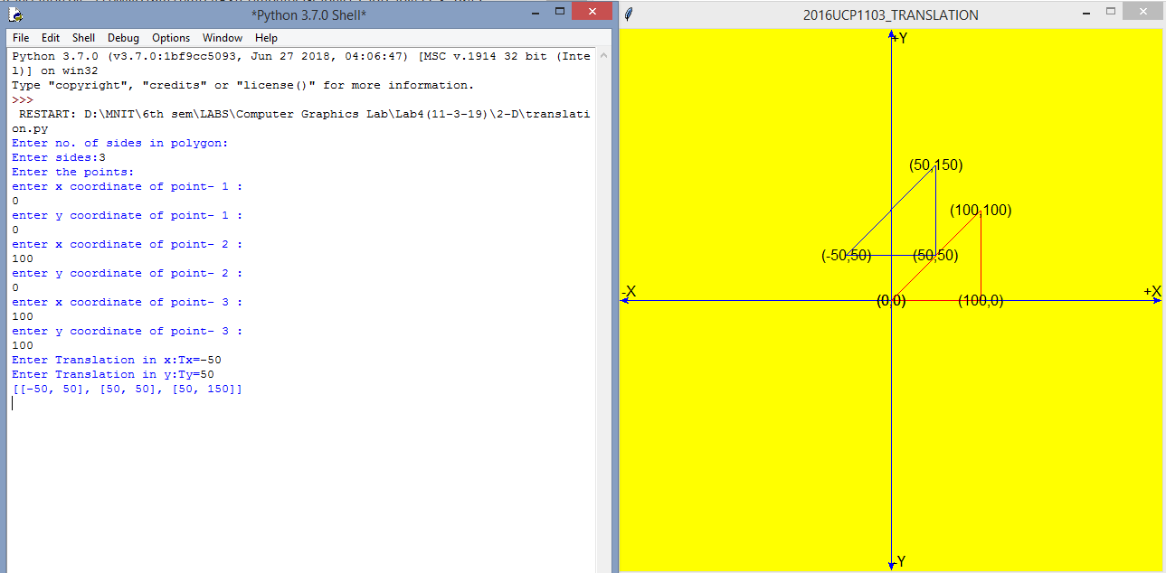

* **SCALING:**

**from graphics import \***

**#function for center of polygon**

**def getcenter():**

**global cx,cy**

**for i in range(0,s):**

**cx+=pbt[i][0]**

**cy+=pbt[i][1]**

**cx/=s**

**cy/=s**

**#function for translation**

**def translation(tx,ty):**

**for i in range(0,s):**

**pbt[i][0]=int(pbt[i][0]+tx)**

**pbt[i][1]=int(pbt[i][1]+ty)**

**print(pbt)**

**#function for scaling**

**def scaling(sx,sy):**

**for i in range(0,s):**

**pbt[i][0]=int(pbt[i][0]*sx)**

**pbt[i][1]=int(pbt[i][1]*sy)**

**print(pbt)**

**#taking input from user**

**print("Enter no. of sides in polygon:")**

**s=int(input("Enter sides:"))**

**print("Enter the points:")**

**pbt=[]**

**for i in range(0,s):**

**print("enter x coordinate of point-",i+1,":")**

**x=int(input())**

**print("enter y coordinate of point-",i+1,":")**

**y=int(input())**

**a=[x,y]**

**pbt.append(a)**

**window=GraphWin("2016UCP1103_SCALING",600,600) #for viewport(device coordinates)**

**window.setCoords(-300,-300,300,300) #for window(user coordinates)**

**window.setBackground("yellow")**

**#drwing user coordinate system**

**X=Line(Point(-300,0),Point(300,0)) #for drawing X-axis**

**X.setArrow('both')**

**X.setOutline('blue')**

**X.draw(window)**

**msg=Text(Point(290,10), "+X")**

**msg.draw(window)**

**msg=Text(Point(-290,10), "-X")**

**msg.draw(window)**

**Y=Line(Point(0,-300),Point(0,300)) #for drawing Y-axis**

**Y.setArrow('both')**

**Y.setOutline('blue')**

**Y.draw(window)**

**msg=Text(Point(10,290), "+Y")**

**msg.draw(window)**

**msg=Text(Point(10,-290), "-Y")**

**msg.draw(window)**

**msg=Text(Point(0,0), "(0,0)") #for origin**

**msg.draw(window)**

**#drawing original polygon**

**for i in range(1,s):**

**x1=pbt[i-1][0]**

**y1=pbt[i-1][1]**

**x2=pbt[i][0]**

**y2=pbt[i][1]**

**line=Line(Point(x1,y1),Point(x2,y2))**

**line.setFill("red")**

**line.draw(window)**

**Text(Point(x1,y1),"("+str(x1)+","+str(y1)+")").draw(window)**

**x1=pbt[0][0]**

**y1=pbt[0][1]**

**x2=pbt[s-1][0]**

**y2=pbt[s-1][1]**

**line=Line(Point(x1,y1),Point(x2,y2))**

**line.setFill("red")**

**line.draw(window)**

**Text(Point(x2,y2),"("+str(x2)+","+str(y2)+")").draw(window)**

**#calling translation**

**sx=float(input("Enter Scaling in x:Sx="))**

**sy=float(input("Enter Scaling in y:Sy="))**

**cx=0**

**cy=0**

**getcenter()**

**translation(-cx,-cy)**

**scaling(sx,sy)**

**translation(cx,cy)**

**#drawing scaled polygon**

**for i in range(1,s):**

**x1=pbt[i-1][0]**

**y1=pbt[i-1][1]**

**x2=pbt[i][0]**

**y2=pbt[i][1]**

**line=Line(Point(x1,y1),Point(x2,y2))**

**line.setFill("blue")**

**line.draw(window)**

**Text(Point(x1,y1),"("+str(x1)+","+str(y1)+")").draw(window)**

**x1=pbt[0][0]**

**y1=pbt[0][1]**

**x2=pbt[s-1][0]**

**y2=pbt[s-1][1]**

**line=Line(Point(x1,y1),Point(x2,y2))**

**line.setFill("blue")**

**line.draw(window)**

**Text(Point(x2,y2),"("+str(x2)+","+str(y2)+")").draw(window)**

**window.getMouse()**

**window.close()**

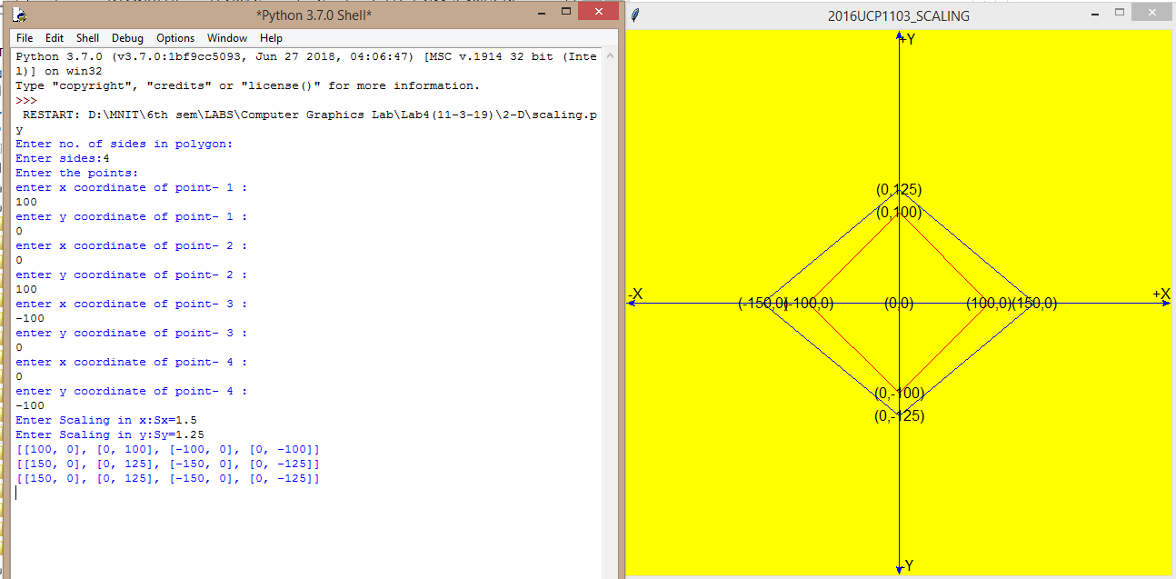

* **ROTATION:**

**from graphics import \***

**import math**

**#function for rotation**

**def rotation(phi):**

**for i in range(0,s):**

**angle=math.radians(phi)**

**x=pbt[i][0]**

**y=pbt[i][1]**

**pbt[i][0]=int((x*math.cos(math.radians(phi)))-(y*math.sin(math.radians(phi))))**

**pbt[i][1]=int((x*math.sin(math.radians(phi)))+(y*math.cos(math.radians(phi))))**

**print(pbt)**

**#function for translation**

**def translation(tx,ty):**

**for i in range(0,s):**

**pbt[i][0]=int(pbt[i][0]+tx)**

**pbt[i][1]=int(pbt[i][1]+ty)**

**print(pbt)**

**#taking input from user**

**print("Enter no. of sides in polygon:")**

**s=int(input("Enter sides:"))**

**print("Enter the points:")**

**pbt=[]**

**for i in range(0,s):**

**print("enter x coordinate of point-",i+1,":")**

**x=int(input())**

**print("enter y coordinate of point-",i+1,":")**

**y=int(input())**

**a=[x,y]**

**pbt.append(a)**

**window=GraphWin("2016UCP1103_ROTATION ",600,600) #for viewport(device coordinates)**

**window.setCoords(-300,-300,300,300) #for window(user coordinates)**

**window.setBackground("yellow")**

**#drwing user coordinate system**

**X=Line(Point(-300,0),Point(300,0)) #for drawing X-axis**

**X.setArrow('both')**

**X.setOutline('blue')**

**X.draw(window)**

**msg=Text(Point(290,10), "+X")**

**msg.draw(window)**

**msg=Text(Point(-290,10), "-X")**

**msg.draw(window)**

**Y=Line(Point(0,-300),Point(0,300)) #for drawing Y-axis**

**Y.setArrow('both')**

**Y.setOutline('blue')**

**Y.draw(window)**

**msg=Text(Point(10,290), "+Y")**

**msg.draw(window)**

**msg=Text(Point(10,-290), "-Y")**

**msg.draw(window)**

**msg=Text(Point(0,0), "(0,0)") #for origin**

**msg.draw(window)**

**#drawing original polygon**

**for i in range(1,s):**

**x1=pbt[i-1][0]**

**y1=pbt[i-1][1]**

**x2=pbt[i][0]**

**y2=pbt[i][1]**

**line=Line(Point(x1,y1),Point(x2,y2))**

**line.setFill("red")**

**line.draw(window)**

**Text(Point(x1,y1),"("+str(x1)+","+str(y1)+")").draw(window)**

**x1=pbt[0][0]**

**y1=pbt[0][1]**

**x2=pbt[s-1][0]**

**y2=pbt[s-1][1]**

**line=Line(Point(x1,y1),Point(x2,y2))**

**line.setFill("red")**

**line.draw(window)**

**Text(Point(x2,y2),"("+str(x2)+","+str(y2)+")").draw(window)**

**#calling rotation**

**px=int(input("Enter X-coordinate of pivot point:"))**

**py=int(input("Enter Y-coordinate of pivot point:"))**

**phi=float(input("Enter angle of rotation(negative for clockwise direction):"))**

**translation(-1*px,-1*py)**

**rotation(phi)**

**translation(px,py)**

**#drawing rotated polygon**

**for i in range(1,s):**

**x1=pbt[i-1][0]**

**y1=pbt[i-1][1]**

**x2=pbt[i][0]**

**y2=pbt[i][1]**

**line=Line(Point(x1,y1),Point(x2,y2))**

**line.setFill("blue")**

**line.draw(window)**

**Text(Point(x1,y1),"("+str(x1)+","+str(y1)+")").draw(window)**

**x1=pbt[0][0]**

**y1=pbt[0][1]**

**x2=pbt[s-1][0]**

**y2=pbt[s-1][1]**

**line=Line(Point(x1,y1),Point(x2,y2))**

**line.setFill("blue")**

**line.draw(window)**

**Text(Point(x2,y2),"("+str(x2)+","+str(y2)+")").draw(window)**

**window.getMouse()**

**window.close()**

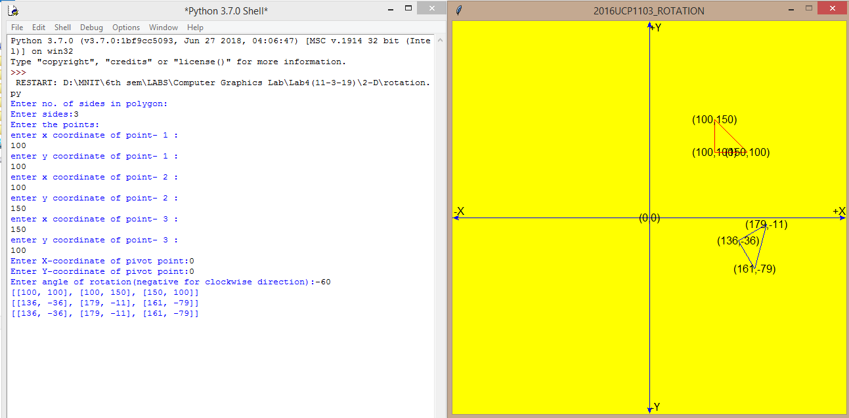

* **REFLECTION:**

**from graphics import \***

**import math**

**#function for rotation**

**def rotation(phi):**

**for i in range(0,s):**

**#angle=math.radians(phi)**

**x=pbt[i][0]**

**y=pbt[i][1]**

**pbt[i][0]=int((x*math.cos(phi))-(y*math.sin(phi)))**

**pbt[i][1]=int((x*math.sin(phi))+(y*math.cos(phi)))**

**print(pbt)**

**#function for translation**

**def translation(tx,ty):**

**for i in range(0,s):**

**pbt[i][0]=int(pbt[i][0]+tx)**

**pbt[i][1]=int(pbt[i][1]+ty)**

**print(pbt)**

**#function for reflection**

**def reflection(a):**

**if a=="x":**

**for i in range(0,s):**

**pbt[i][1]*=(-1)**

**if a=="y":**

**for i in range(0,s):**

**pbt[i][0]*=(-1)**

**if a=="o":**

**for i in range(0,s):**

**pbt[i][0]*=(-1)**

**pbt[i][1]*=(-1)**

**if a=="a":**

**print("Enter 2 coordinates of arbitrary line")**

**a0=float(input("Enter x0:"))**

**b0=float(input("Enter y0:"))**

**a1=float(input("Enter x1:"))**

**b1=float(input("Enter y1:"))**

**line=Line(Point(a0,b0),Point(a1,b1))**

**line.setFill("green")**

**line.draw(window)**

**if a1-a0==0:**

**phi=(90*math.pi)/180**

**else:**

**phi=math.atan((b1-b0)/(a1-a0))**

**translation(-a0,-b0)**

**rotation(-phi)**

**for i in range(0,s):**

**pbt[i][1]*=(-1)**

**rotation(phi)**

**translation(a0,b0)**

**#taking input from user**

**print("Enter no. of sides in polygon:")**

**s=int(input("Enter sides:"))**

**print("Enter the points:")**

**pbt=[]**

**for i in range(0,s):**

**print("enter x coordinate of point-",i+1,":")**

**x=int(input())**

**print("enter y coordinate of point-",i+1,":")**

**y=int(input())**

**a=[x,y]**

**pbt.append(a)**

**window=GraphWin("2016UCP1103_REFLECTION",600,600) #for viewport(device coordinates)**

**window.setCoords(-300,-300,300,300) #for window(user coordinates)**

**window.setBackground("yellow")**

**#drwing user coordinate system**

**X=Line(Point(-300,0),Point(300,0)) #for drawing X-axis**

**X.setArrow('both')**

**X.setOutline('blue')**

**X.draw(window)**

**msg=Text(Point(290,10), "+X")**

**msg.draw(window)**

**msg=Text(Point(-290,10), "-X")**

**msg.draw(window)**

**Y=Line(Point(0,-300),Point(0,300)) #for drawing Y-axis**

**Y.setArrow('both')**

**Y.setOutline('blue')**

**Y.draw(window)**

**msg=Text(Point(10,290), "+Y")**

**msg.draw(window)**

**msg=Text(Point(10,-290), "-Y")**

**msg.draw(window)**

**msg=Text(Point(0,0), "(0,0)") #for origin**

**msg.draw(window)**

**#drawing original polygon**

**for i in range(1,s):**

**x1=pbt[i-1][0]**

**y1=pbt[i-1][1]**

**x2=pbt[i][0]**

**y2=pbt[i][1]**

**line=Line(Point(x1,y1),Point(x2,y2))**

**line.setFill("red")**

**line.draw(window)**

**Text(Point(x1,y1),"("+str(x1)+","+str(y1)+")").draw(window)**

**x1=pbt[0][0]**

**y1=pbt[0][1]**

**x2=pbt[s-1][0]**

**y2=pbt[s-1][1]**

**line=Line(Point(x1,y1),Point(x2,y2))**

**line.setFill("red")**

**line.draw(window)**

**Text(Point(x2,y2),"("+str(x2)+","+str(y2)+")").draw(window)**

**#calling reflection**

**print("Enter x for reflection about x axis")**

**print("Enter y for reflection about y axis")**

**print("Enter o for reflection about origin")**

**print("Enter a for reflection about arbitrary line")**

**opt=input("Enter option:")**

**reflection(opt)**

**#drawing reflected polygon**

**for i in range(1,s):**

**x1=pbt[i-1][0]**

**y1=pbt[i-1][1]**

**x2=pbt[i][0]**

**y2=pbt[i][1]**

**line=Line(Point(x1,y1),Point(x2,y2))**

**line.setFill("blue")**

**line.draw(window)**

**Text(Point(x1,y1),"("+str(x1)+","+str(y1)+")").draw(window)**

**x1=pbt[0][0]**

**y1=pbt[0][1]**

**x2=pbt[s-1][0]**

**y2=pbt[s-1][1]**

**line=Line(Point(x1,y1),Point(x2,y2))**

**line.setFill("blue")**

**line.draw(window)**

**Text(Point(x2,y2),"("+str(x2)+","+str(y2)+")").draw(window)**

**window.getMouse()**

**window.close()**

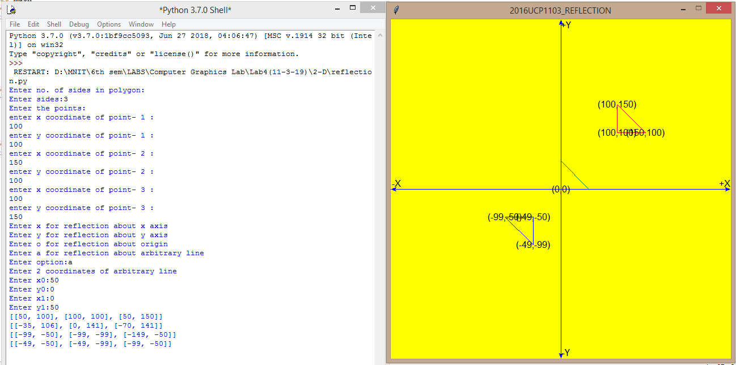

* **SHEARING:**

**from graphics import \***

**#function for center of polygon**

**def getcenter():**

**global cx,cy**

**for i in range(0,s):**

**cx+=pbt[i][0]**

**cy+=pbt[i][1]**

**cx/=s**

**cy/=s**

**#function for translation**

**def translation(tx,ty):**

**for i in range(0,s):**

**pbt[i][0]=int(pbt[i][0]+tx)**

**pbt[i][1]=int(pbt[i][1]+ty)**

**print(pbt)**

**#function for scaling**

**def scaling(sx,sy):**

**for i in range(0,s):**

**pbt[i][0]=int(pbt[i][0]*sx)**

**pbt[i][1]=int(pbt[i][1]*sy)**

**print(pbt)**

**#taking input from user**

**print("Enter no. of sides in polygon:")**

**s=int(input("Enter sides:"))**

**print("Enter the points:")**

**pbt=[]**

**for i in range(0,s):**

**print("enter x coordinate of point-",i+1,":")**

**x=int(input())**

**print("enter y coordinate of point-",i+1,":")**

**y=int(input())**

**a=[x,y]**

**pbt.append(a)**

**window=GraphWin("2016UCP1103_SCALING",600,600) #for viewport(device coordinates)**

**window.setCoords(-300,-300,300,300) #for window(user coordinates)**

**window.setBackground("yellow")**

**#drwing user coordinate system**

**X=Line(Point(-300,0),Point(300,0)) #for drawing X-axis**

**X.setArrow('both')**

**X.setOutline('blue')**

**X.draw(window)**

**msg=Text(Point(290,10), "+X")**

**msg.draw(window)**

**msg=Text(Point(-290,10), "-X")**

**msg.draw(window)**

**Y=Line(Point(0,-300),Point(0,300)) #for drawing Y-axis**

**Y.setArrow('both')**

**Y.setOutline('blue')**

**Y.draw(window)**

**msg=Text(Point(10,290), "+Y")**

**msg.draw(window)**

**msg=Text(Point(10,-290), "-Y")**

**msg.draw(window)**

**msg=Text(Point(0,0), "(0,0)") #for origin**

**msg.draw(window)**

**#drawing original polygon**

**for i in range(1,s):**

**x1=pbt[i-1][0]**

**y1=pbt[i-1][1]**

**x2=pbt[i][0]**

**y2=pbt[i][1]**

**line=Line(Point(x1,y1),Point(x2,y2))**

**line.setFill("red")**

**line.draw(window)**

**Text(Point(x1,y1),"("+str(x1)+","+str(y1)+")").draw(window)**

**x1=pbt[0][0]**

**y1=pbt[0][1]**

**x2=pbt[s-1][0]**

**y2=pbt[s-1][1]**

**line=Line(Point(x1,y1),Point(x2,y2))**

**line.setFill("red")**

**line.draw(window)**

**Text(Point(x2,y2),"("+str(x2)+","+str(y2)+")").draw(window)**

**#calling translation**

**sx=float(input("Enter Scaling in x:Sx="))**

**sy=float(input("Enter Scaling in y:Sy="))**

**cx=0**

**cy=0**

**getcenter()**

**translation(-cx,-cy)**

**scaling(sx,sy)**

**translation(cx,cy)**

**#drawing scaled polygon**

**for i in range(1,s):**

**x1=pbt[i-1][0]**

**y1=pbt[i-1][1]**

**x2=pbt[i][0]**

**y2=pbt[i][1]**

**line=Line(Point(x1,y1),Point(x2,y2))**

**line.setFill("blue")**

**line.draw(window)**

**Text(Point(x1,y1),"("+str(x1)+","+str(y1)+")").draw(window)**

**x1=pbt[0][0]**

**y1=pbt[0][1]**

**x2=pbt[s-1][0]**

**y2=pbt[s-1][1]**

**line=Line(Point(x1,y1),Point(x2,y2))**

**line.setFill("blue")**

**line.draw(window)**

**Text(Point(x2,y2),"("+str(x2)+","+str(y2)+")").draw(window)**

**window.getMouse()**

**window.close()**

