**CPP LAB**

**ASSIGNMENT-5**

**NAME-**ABHISHEK TIBREWAL

**ID-**2016UCP1103

**BATCH-**A (1, 2)

**Q.Write program(s) implementing use of below MPI functions.**

**MPI_Init**

**MPI_Finalize**

**MPI_Comm_size**

**MPI_Comm_rank**

**MPI_Send**

**MPI_Recv**

**MPI_Bcast**

**MPI_Reduce**

**MPI_Wtime**

**CODE1:**

#include <stdio.h>

#include <mpi.h>

int main(int argc, char* argv[])

{

MPI_Init(&argc,&argv);

int world_size;

MPI_Comm_size(MPI_COMM_WORLD, &world_size);

int world_rank;

MPI_Comm_rank(MPI_COMM_WORLD, &world_rank);

float a1=MPI_Wtime();

printf("start time for process %d is=%f\n\n",world_rank,a1);

printf("From process %d out of %d,Hello World!\n\n", world_rank,world_size);

// Finalize the MPI environment.

float a2=MPI_Wtime();

printf("end time for process %d is=%f\n\n", world_rank,a2);

MPI_Finalize();

}

**OUTPUT:**

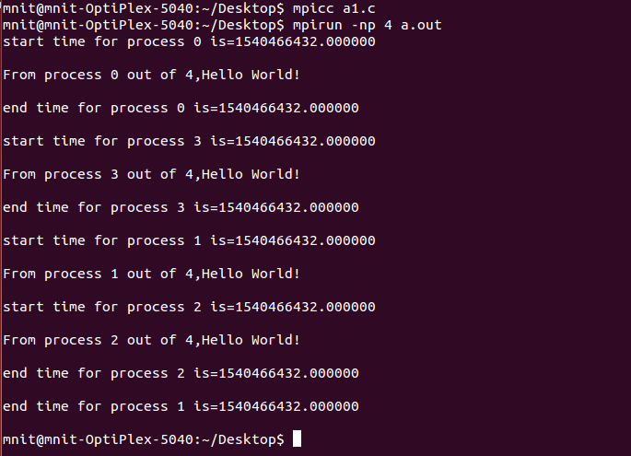

**CODE2:**

#include <stdio.h>

#include <stdlib.h>

#include <mpi.h>

void main(int argc, char *argv[])

{

int r, i, c;

float d[100],v[200];

MPI_Status status;

MPI_Init(&argc,&argv);

MPI_Comm_rank(MPI_COMM_WORLD,&r);

if(r==1)

{

for(i=0;i<100;++i)

{

d[i]=i;

}

MPI_Send(d,100,MPI_FLOAT,0,55,MPI_COMM_WORLD);

}

else

{

MPI_Recv(v,200,MPI_FLOAT,MPI_ANY_SOURCE,55,MPI_COMM_WORLD,&status);

printf("Process:%d Got data from processor %d \n",r,status.MPI_SOURCE);

MPI_Get_count(&status,MPI_FLOAT,&c);

printf("Process:%d Got %d elements \n",r,c);

printf("Process:%d value[5]=%f \n",r,v[5]);

}

MPI_Finalize();

}

**OUTPUT:**

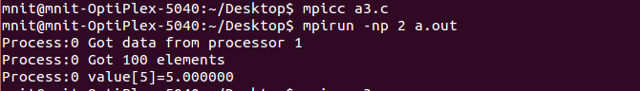

**CODE3:**

#include <mpi.h>

#include <stdio.h>

int main(int argc, char** argv)

{

int r;

int b;

const int rt=0;

MPI_Init(&argc, &argv);

MPI_Comm_rank(MPI_COMM_WORLD, &r);

if(r == rt) {

b = 777;

}

printf("[%d]: Before Bcast, buf is %d\n", r, b);

MPI_Bcast(&b, 1, MPI_INT, rt, MPI_COMM_WORLD);

printf("[%d]: After Bcast, buf is %d\n", r, b);

MPI_Finalize();

return 0;

}

**OUTPUT:**

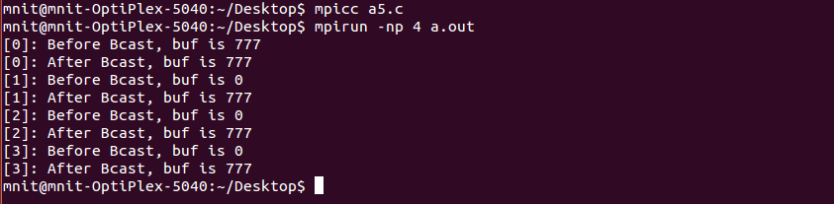

**CODE4:**

#include<stdio.h>

#include <mpi.h>

void main (int argc, char *argv[])

{

int r;

struct {

double v;

int r;

} in, out;

int rt;

MPI_Init(&argc, &argv);

MPI_Comm_rank(MPI_COMM_WORLD,&r);

in.v=r+1;

in.r=r;

rt=7;

MPI_Reduce(&in, &out, 1, MPI_DOUBLE_INT, MPI_MAXLOC, rt,MPI_COMM_WORLD);

if(r==rt) printf("PE:%d max=%lf at rank %d\n", r, out.v, out.r);

MPI_Reduce(&in, &out, 1, MPI_DOUBLE_INT, MPI_MINLOC, rt, MPI_COMM_WORLD);

if(r==rt) printf("PE:%d min=%lf at rank %d\n", r, out.v, out.r);

MPI_Finalize();

}

**OUTPUT:**

