**CPP LAB**

**ASSIGNMENT-6**

**NAME-**ABHISHEK TIBREWAL

**ID-**2016UCP1103

**BATCH-**A (1, 2)

**Q. Write program(s) using below MPI functions.**

**MPI_Gather()**

**MPI_Allgather()**

**MPI_Scatter()**

**MPI_Alltoall()**

**MPI_Alltoallv()**

**MPI_Get_count()**

**MPI_Issend()**

**MPI_Irecv()**

**MPI_Test()**

**CODE1:**

#include <mpi.h>

#include <stdio.h>

#include <stdlib.h>

int main(int argc, char **argv)

{

int size, rank, i;

MPI_Init(&argc, &argv);

MPI_Comm_size(MPI_COMM_WORLD, &size);

MPI_Comm_rank(MPI_COMM_WORLD, &rank);

int *globaldata=NULL;

int localdata;

if (rank == 0)

{

globaldata = malloc(size * sizeof(int) );

for ( i=0; i<size; i++)

globaldata[i] = 2*i+1;

printf("Processor %d has values: ", rank);

for ( i=0; i<size; i++)

printf("%d ", globaldata[i]);

printf("\n");

}

MPI_Scatter(globaldata, 1, MPI_INT, &localdata, 1, MPI_INT, 0, MPI_COMM_WORLD);

printf("Processor %d has value %d\n", rank, localdata);

localdata *= 2;

printf("Processor %d doubling the value, now has %d\n", rank, localdata);

MPI_Gather(&localdata, 1, MPI_INT, globaldata, 1, MPI_INT, 0, MPI_COMM_WORLD);

if (rank == 0) {

printf("Processor %d has value: ", rank);

for ( i=0; i<size; i++)

printf("%d ", globaldata[i]);

printf("\n");

}

if (rank == 0)

free(globaldata);

MPI_Finalize();

return 0;

}

**OUTPUT:**

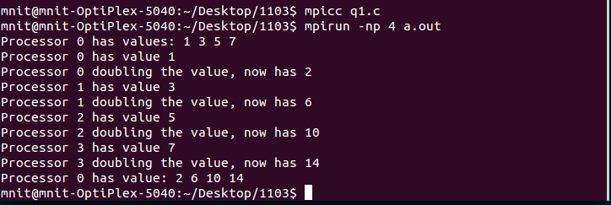

**CODE2:**

#include <stdio.h>

#include <stdlib.h>

#include "mpi.h"

struct mystruct{

int sendarray[4];

int a;

char array2[4];

};

typedef struct mystruct struct_t;

int main (int argc, char ** argv)

{

int rank, size;

struct_t fd;

struct_t recv;

int i, j;

MPI_Init(&argc, &argv);

MPI_Comm_rank(MPI_COMM_WORLD, &rank);

MPI_Comm_size(MPI_COMM_WORLD, &size);

for (i=0;i<4;i++)

{

fd.sendarray[i] = 0;

fd.array2[i] = 0;

recv.sendarray[i] =999;

recv.array2[i] = 99;

}

recv.a =999;

fd.sendarray[rank] = rank*10;

fd.array2[rank] = (char)(rank*20);

fd.a = rank;

printf("rank : %d, fd.sendarray[%d] : %d\n", rank, rank, fd.sendarray[rank]);

// gather data from all now.. send the int:

MPI_Allgather (&(fd.sendarray[rank]), 1, MPI_INT, recv.sendarray, 1, MPI_INT, MPI_COMM_WORLD);

// then the char

MPI_Allgather (&(fd.array2[rank]), 1, MPI_CHAR, recv.array2, 1, MPI_CHAR, MPI_COMM_WORLD);

// check if correct data has been received

if (rank == 0) {

printf("Received:\n");

printf("---\n");

printf("int array: ");

for (j=0; j<4; j++) printf("%3d ", recv.sendarray[j]);

printf("\nchar array: ");

for (j=0; j<4; j++) printf("%3d ", (int)(recv.array2[j]));

printf("\n");

}

MPI_Finalize();

return 0;

}

**OUTPUT:**

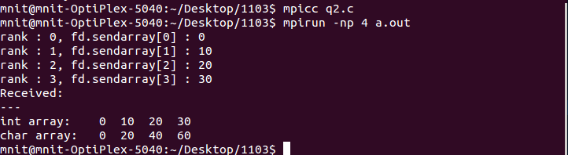

**CODE3:**

#include <stdio.h>

#include "mpi.h"

int main( int argc, char **argv )

{

int send[4], recv[3];

int rank, size, k;

MPI_Init( &argc, &argv );

MPI_Comm_rank( MPI_COMM_WORLD, &rank );

MPI_Comm_size( MPI_COMM_WORLD, &size );

if (size != 4) {

printf("Error!:no. of processors must be equal to 4");

printf("Programm aborting...............................................................");

MPI_Abort(MPI_COMM_WORLD, 1);

}

for (k=0;k<size;k++)

send[k] = (k+1) + rank*size;

printf("rank- %d : send = %d %d %d %d\n", rank, send[0], send[1], send[2], send[3]);

MPI_Alltoall(&send, 1, MPI_FLOAT, &recv, 1, MPI_INT, MPI_COMM_WORLD);

printf("rank- %d : recv = %d %d %d %d\n", rank, recv[0], recv[1], recv[2], recv[3]);

MPI_Finalize();

return 0;

}

**OUTPUT:**

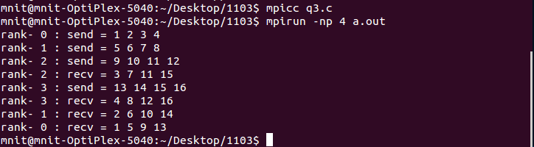

**CODE4:**

#include <mpi.h>

#include <stdio.h>

#include <stdlib.h>

#include <time.h>

int main(int argc, char** argv)

{

MPI_Init(NULL, NULL);

int world_size;

MPI_Comm_size(MPI_COMM_WORLD, &world_size);

int world_rank;

MPI_Comm_rank(MPI_COMM_WORLD, &world_rank);

int number_amount;

if (world_rank == 0)

{

const int MAX_NUMBERS = 100;

int numbers[MAX_NUMBERS];

srand(time(NULL));

number_amount = (rand() / (float)RAND_MAX) * MAX_NUMBERS;

MPI_Send(numbers, number_amount, MPI_INT, 1, 0, MPI_COMM_WORLD);

printf("rank 0 sent %d numbers to 1\n", number_amount);

}

else if (world_rank == 1)

{

MPI_Status status;

MPI_Probe(0, 0, MPI_COMM_WORLD, &status);

MPI_Get_count(&status, MPI_INT, &number_amount);

int* number_buf = (int*)malloc(sizeof(int) *number_amount);

MPI_Recv(number_buf, number_amount, MPI_INT, 0, 0, MPI_COMM_WORLD,MPI_STATUS_IGNORE);

printf("rank 1 dynamically received %d numbers from 0.\n",number_amount);

free(number_buf);

}

MPI_Finalize();

}

**OUTPUT:**

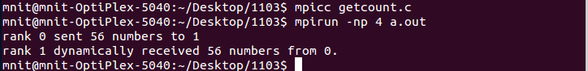

**CODE5:**

#include "mpi.h"

#include <stdio.h>

int main(int argc, char *argv[])

{

int myid, numprocs, i, j;

int buffer[10], buffer2[10];

MPI_Request req, req2;

MPI_Status status;

MPI_Init(NULL,NULL);

MPI_Comm_size(MPI_COMM_WORLD, &numprocs);

MPI_Comm_rank(MPI_COMM_WORLD, &myid);

j = (myid + 1) % numprocs;

i = myid - 1;

if (i < 0)

i = numprocs - 1;

if(MPI_Issend(buffer2, 10, MPI_INT,j, 123, MPI_COMM_WORLD, &req2)==0)

{

printf("Success in Issend()\n");

}

if(MPI_Irecv(buffer, 10, MPI_INT,i, 123, MPI_COMM_WORLD, &req)==0)

{

printf("Success in Irecv()\n");

}

MPI_Wait(&req, &status);

MPI_Wait(&req2, &status);

MPI_Finalize();

return 0;

}

**OUTPUT:**

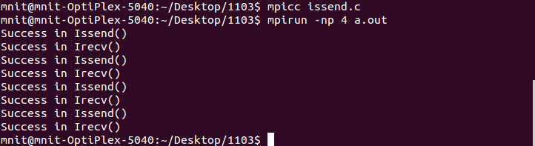

**CODE6:**

#include "mpi.h"

#include <stdio.h>

int main(int argc, char *argv[])

{

int myid, numprocs, left, right, flag=0;

int buffer[10], buffer2[10];

MPI_Request request;

MPI_Status status;

MPI_Init(&argc,&argv);

MPI_Comm_size(MPI_COMM_WORLD, &numprocs);

MPI_Comm_rank(MPI_COMM_WORLD, &myid);

right = (myid + 1) % numprocs;

left = myid - 1;

if (left < 0)

left = numprocs - 1;

MPI_Irecv(buffer, 10, MPI_INT, left, 123, MPI_COMM_WORLD, &request);

MPI_Send(buffer2, 10, MPI_INT, right, 123, MPI_COMM_WORLD);

MPI_Test(&request, &flag, &status);

if(flag)

printf("Test Passed request Accepted\n");

else

printf("Test Failed\n");

MPI_Finalize();

return 0;

}

**OUTPUT:**

