**ASSIGNMENT-2**

**DBMS LAB**

NAME-Abhishek Tibrewal

ID-2016UCP1103

BATCH-A(1,2)

* **CREATE DATABASE AND TABLES:**

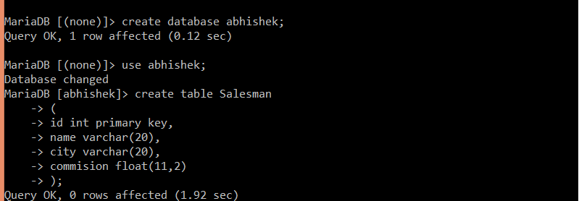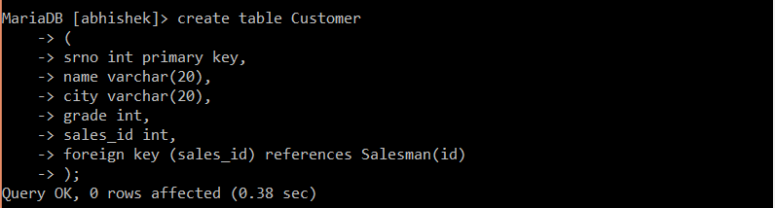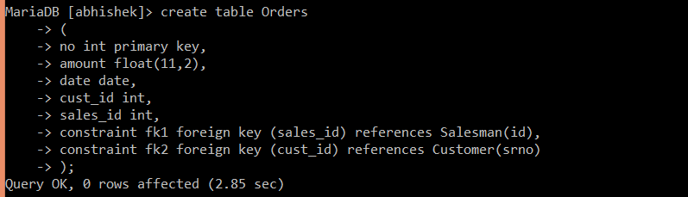

* **FILLING OF TABLES:**

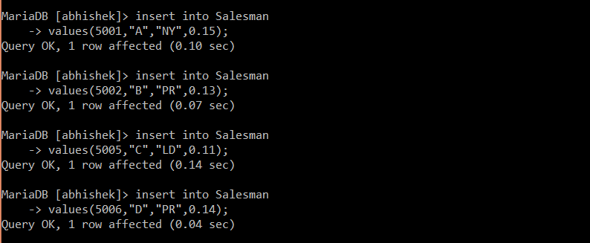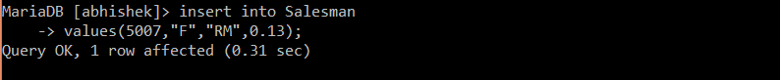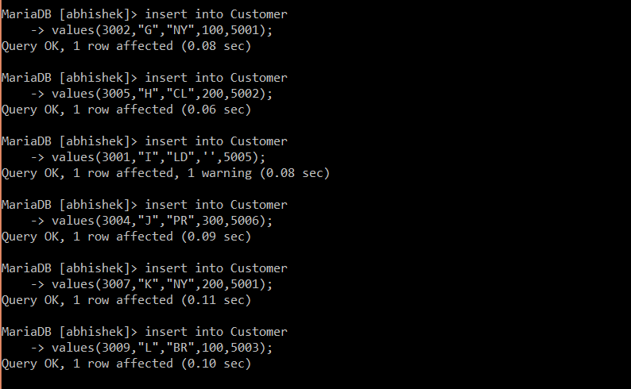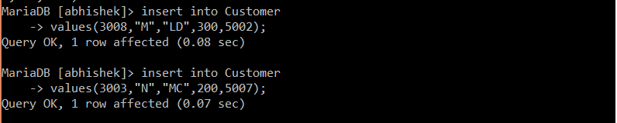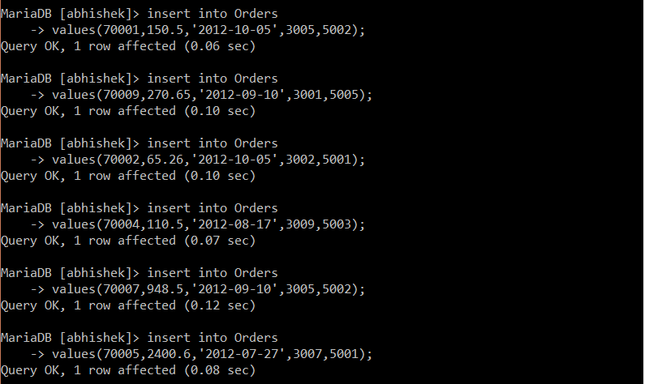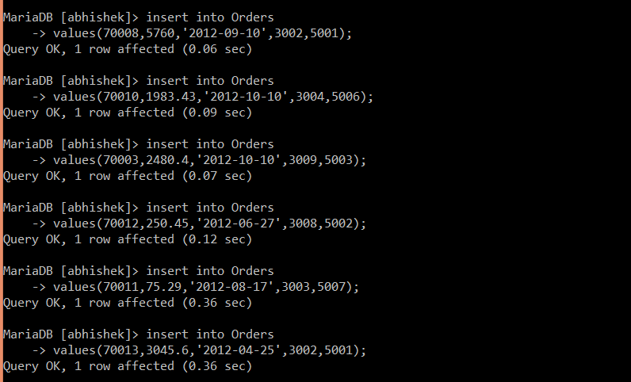

* **SHOW TABLES:**

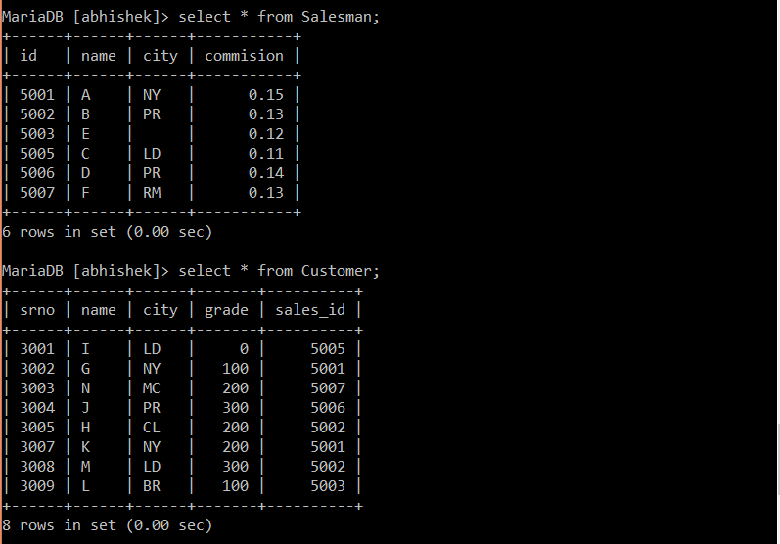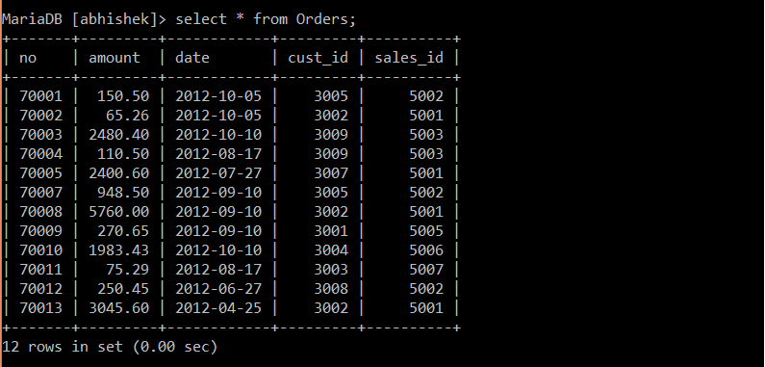

* **QUERIES:**

1. Write a SQL statement to prepare a list with salesman name, customer name and their cities for the salesmen and customer who belongs to the same city.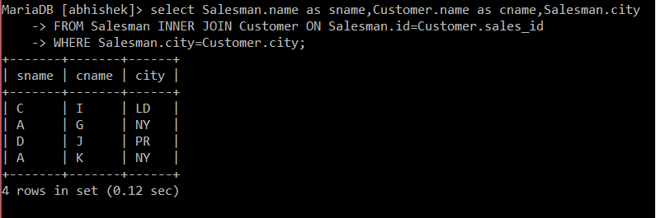
2. Write a SQL statement to find the list of customers who appointed a salesman for their jobs who does not live in the same city where their customer lives.

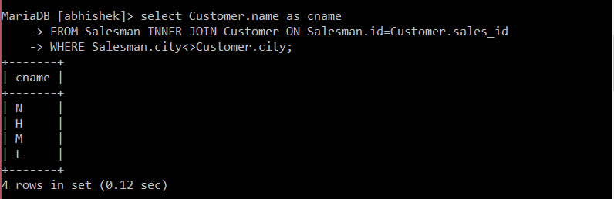

1. Write a SQL statement to know which salesman are working for which customer.

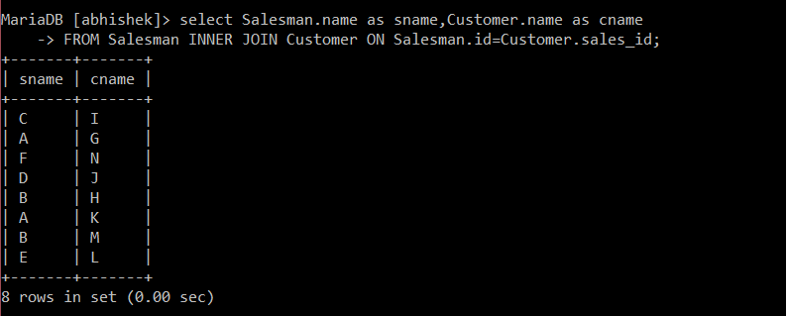

1. Write a SQL statement to make a list with order no, purchase amount, customer name and their cities for those orders which order amount between 500 and 2000.

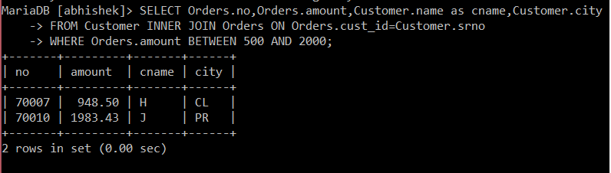

1. Write a SQL statement to find the list of customers who appointed a salesman for their jobs who gets a commission from the company is more than 12%.

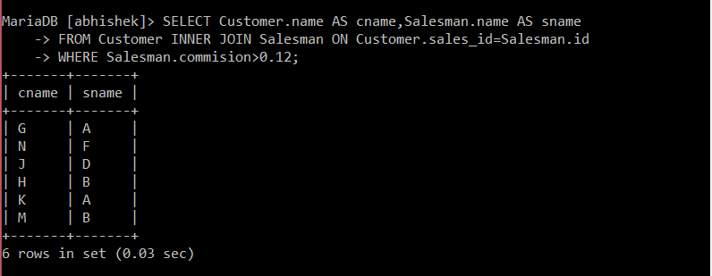

1. Write a SQL statement to find the details of a order i.e. order number, order date, amount of order, which customer gives the order and which salesman works for that customer and how much commission he gets for an order.

