**ASSIGNMENT-3**

ORDER BY AND GROUP BY CLAUSE

**DBMS LAB**

NAME-Abhishek Tibrewal

ID-2016UCP1103

BATCH-A(1,2)

1. **)** **Schema : customer(ID,NAME,AGE,ADDRESS,SALARY);**

* **CREATE AND SHOW TABLE:**

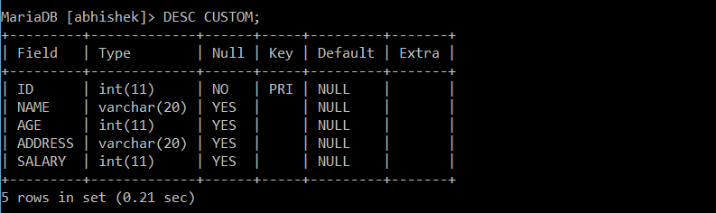 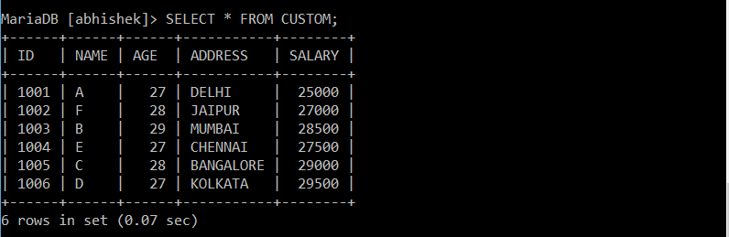

* **Query 1: Find the total amount of the salary on each customer;**

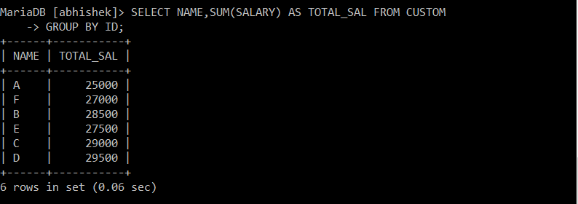

* **Query 2: Find the list of customers in chronological order by the NAME and the SALARY**

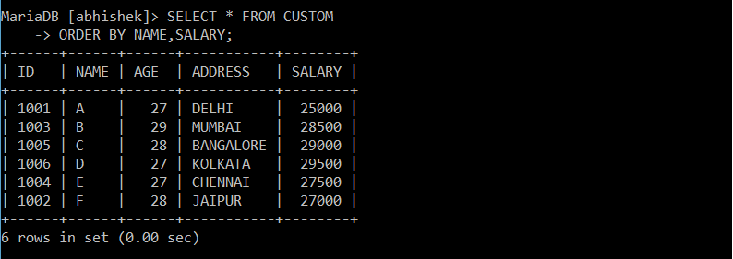

1. **)** **Schema :Salesman (id,name,city,commission);**

**Customer(srno,name,city,grade,sales_id);**

**Orders(no,amount,date,cust_id,sales_id);**

* **CREATE TABLE:**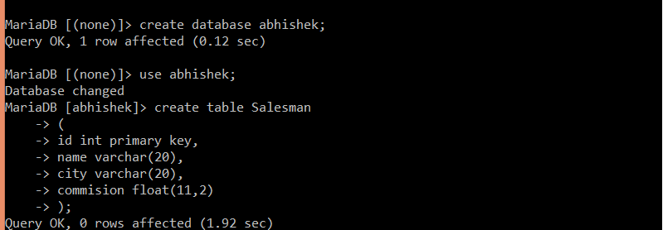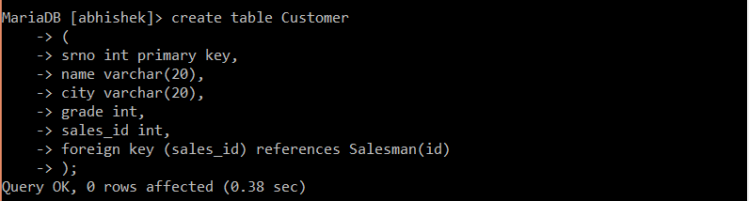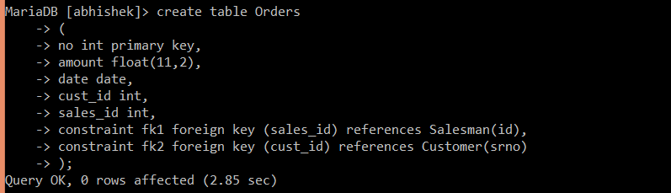
* **FILLING OF TABLES:**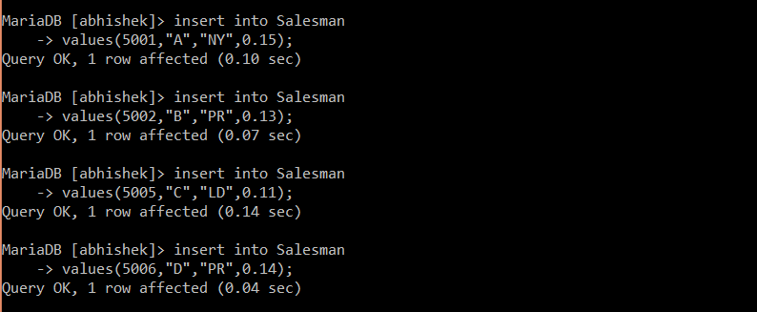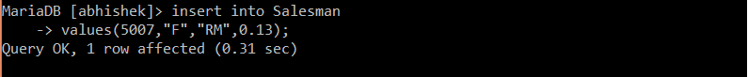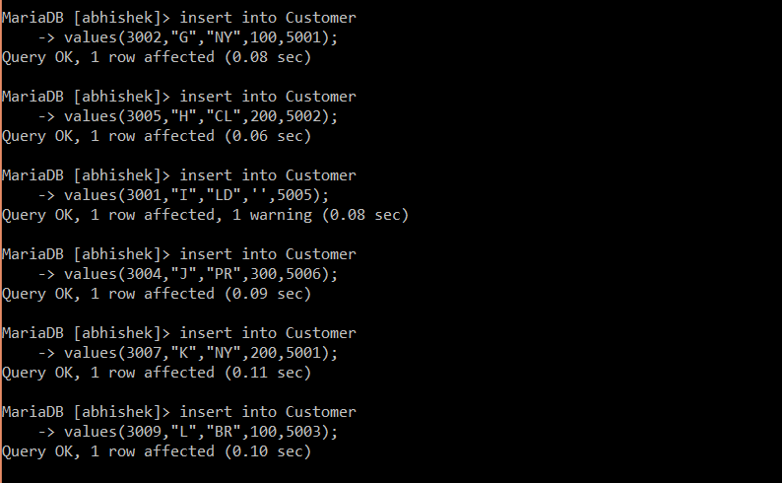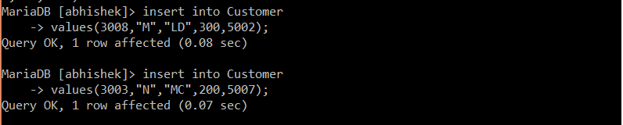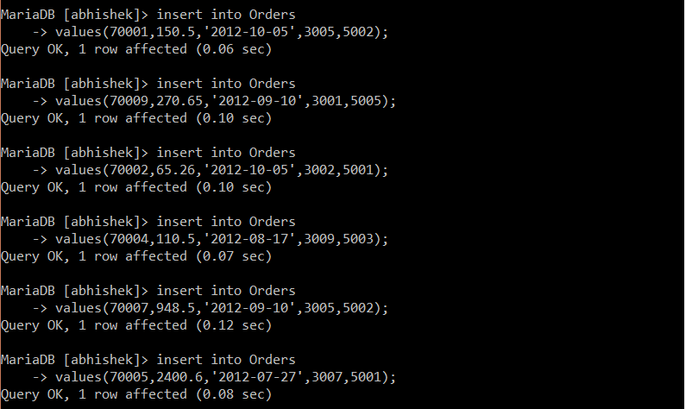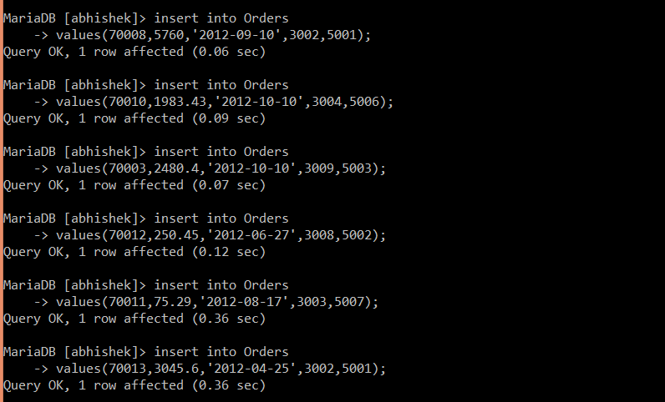
* **SHOW TABLES:**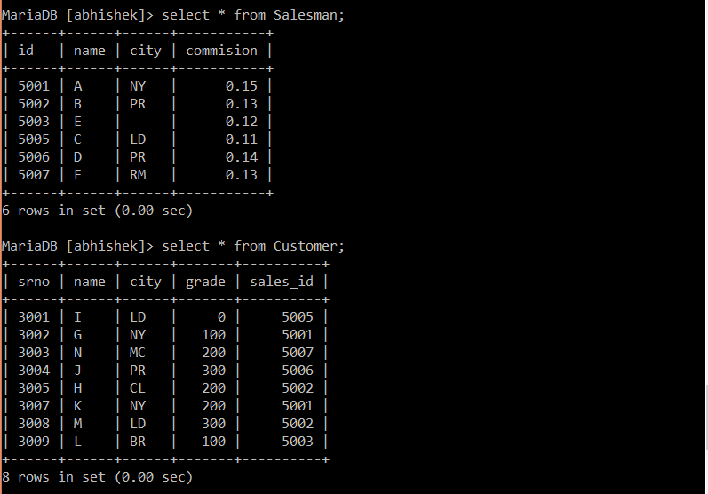

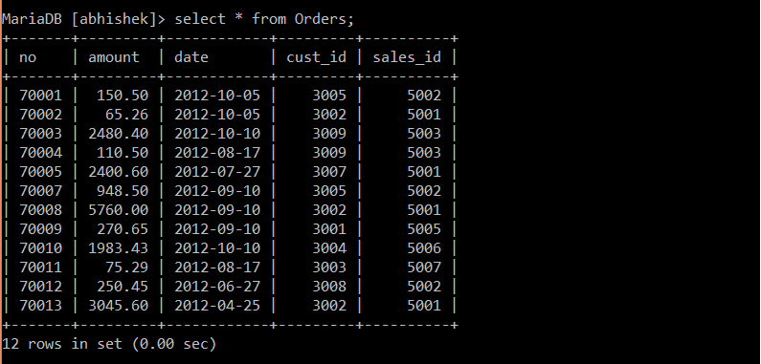

* **Query1: Find the total no of orders served by all the salesman belonging to the same city.**

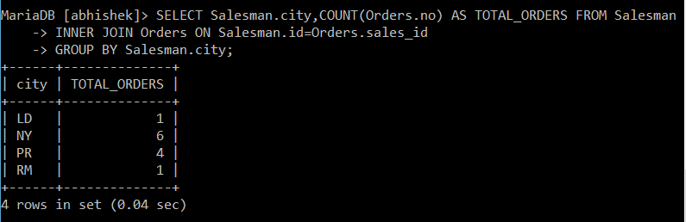

* **Query 2: Write a SQL statement to find the details of commission the salesman gets provided that his commission is more than or equal to the average commission in the city**

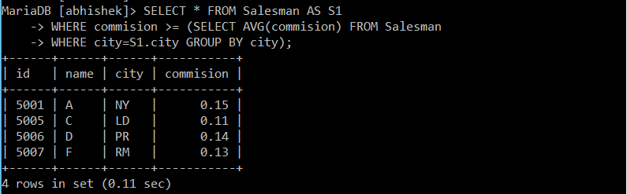

1. **)** **Schema: bookstore(bookid,year,month,volume,author,price);**

* **CREATE AND SHOW TABLE:**

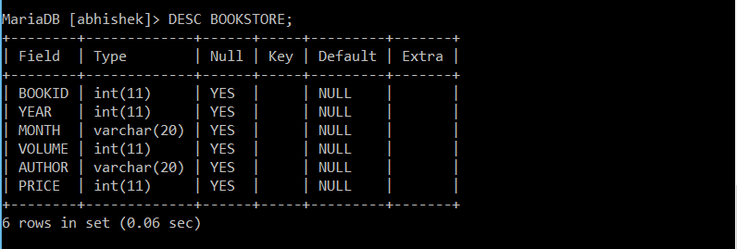

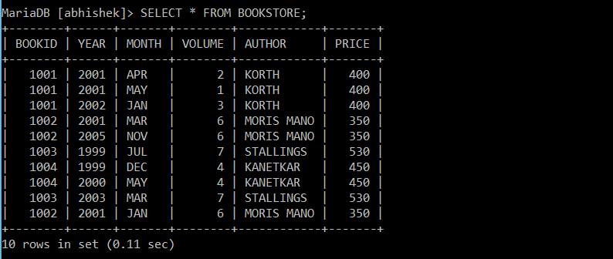

* **Query1 : Calculate the total number of books sold each month. Order your results chronologically.**

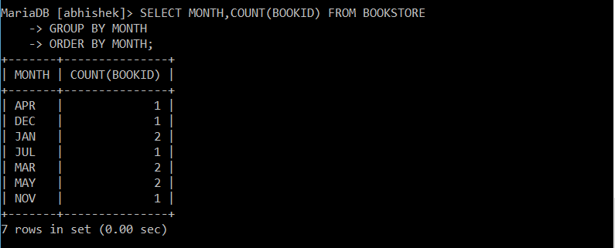

* **Query 2: Write a query that calculates the lowest and highest prices that store achieved each month.**

