**ASSIGNMENT-4**

**SQL NESTED QUERIES**

NAME-Abhishek Tibrewal

ID-2016UCP1103

BATCH-A(1,2)

* **CREATE TABLE:**

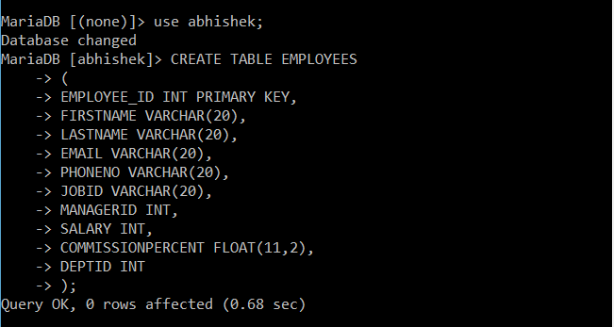

* **FILLING OF TABLES:**

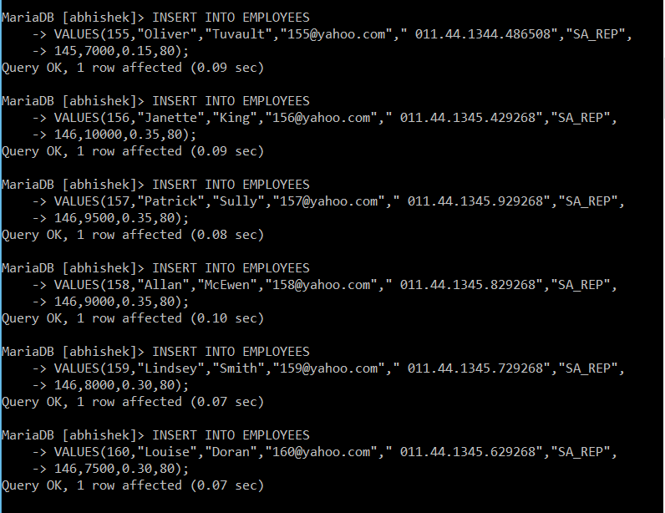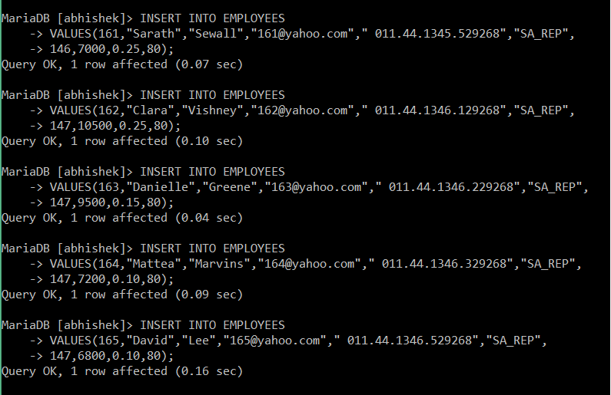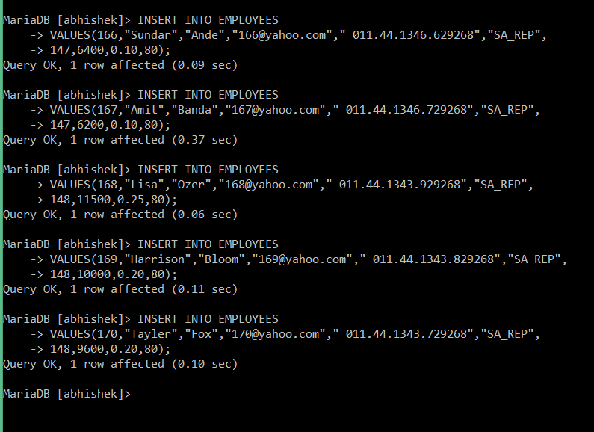

* **SHOW TABLE:**

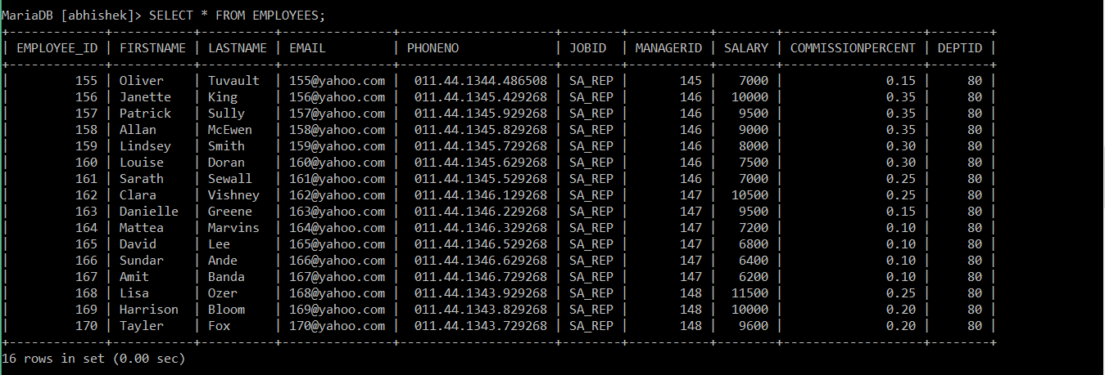

* **QUERIES:**

1. Write a query to display the name ( first name and last name ) for those employees who gets more salary than the employee whose ID is 163.

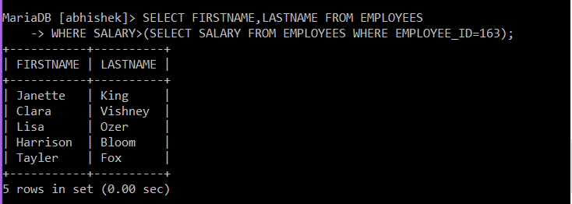

**\*\*UPDATE TABLE:**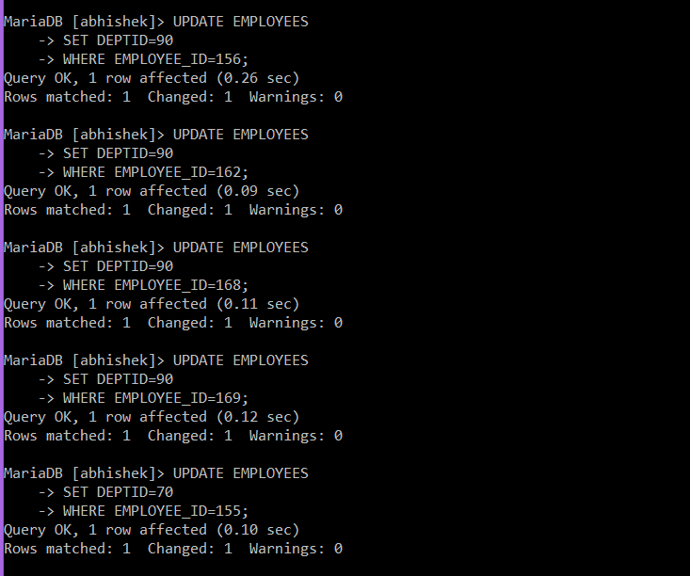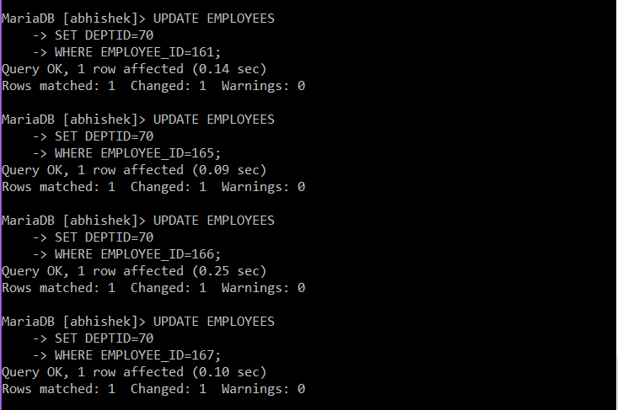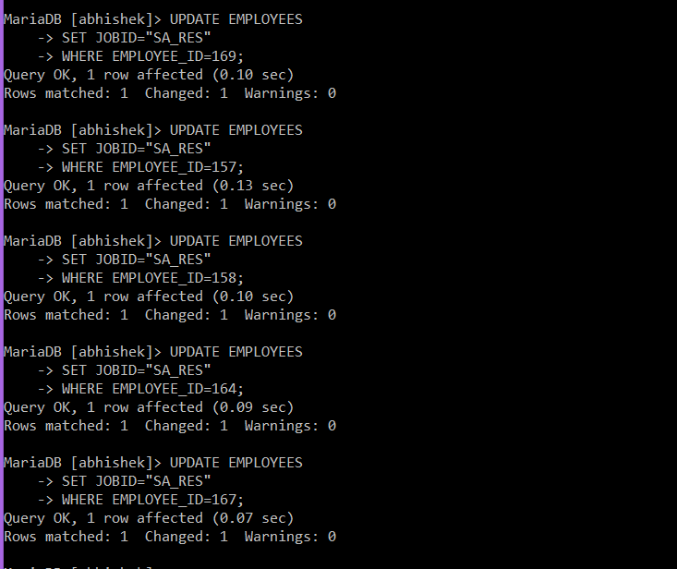

**\*\*SHOW UPDATED TABLE:**

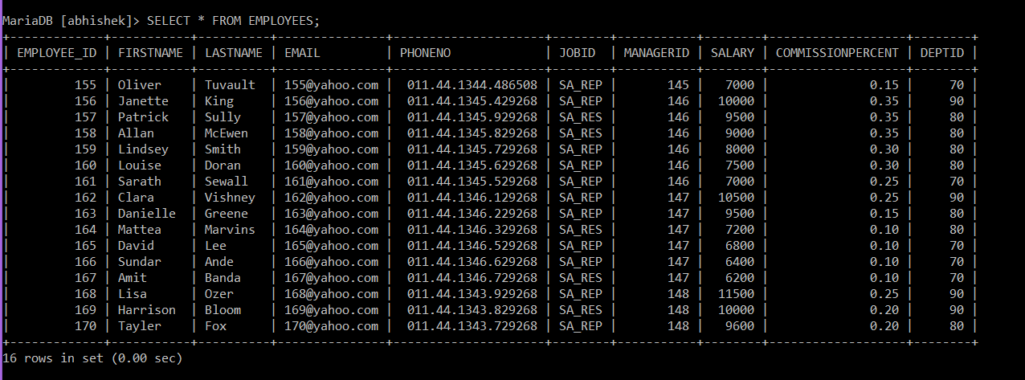

1. Write a query to display the name ( first name and last name ), salary, department id, job id for those employees who works in the same designation as the employee works whose id is 169.

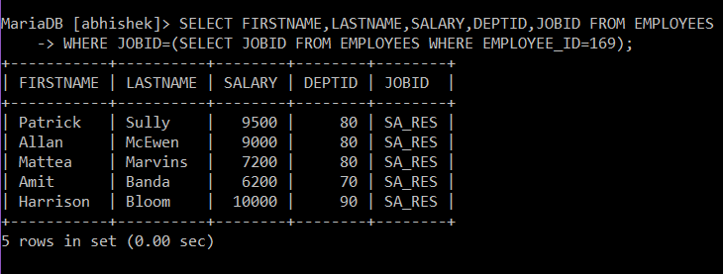

1. Write a query to display the name ( first name and last name ), salary, department id for those employees who earn such amount of salary which is the smallest salary of any of the departments.

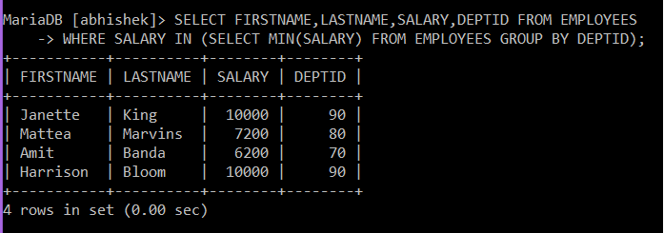

1. Write a query to display the employee id, employee name (first name and last name ) for all employees who earn more than the average salary.

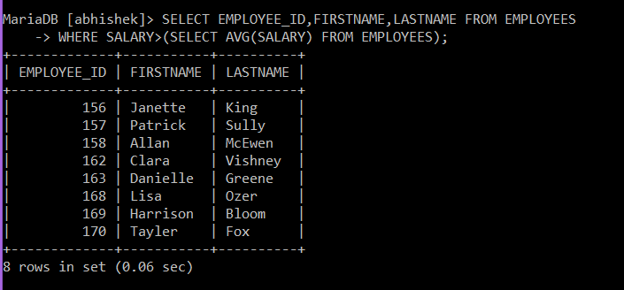

1. Write a query to display all the information of an employee whose reporting person id is 161 and 162 respectively.



1. Write a query to display all the information of the employees whose salary is within the range of smallest salary and 2500.

