***Assignment -7***

***PL/SQL***

**Name-Abhishek Tibrewal**

**Id- 2016ucp1103**

**Batch-A(1,2)**

**1-Create a procedure to find factorial of number provided by user.**

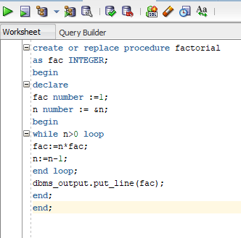

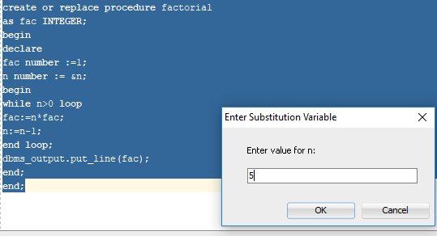

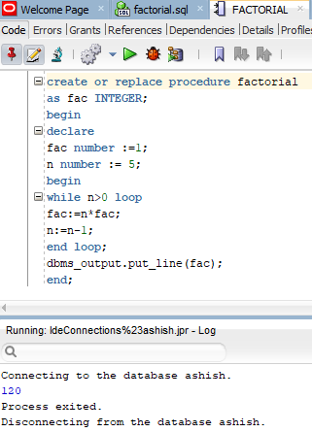

**2-Procedure for reversing a number provided by user.**

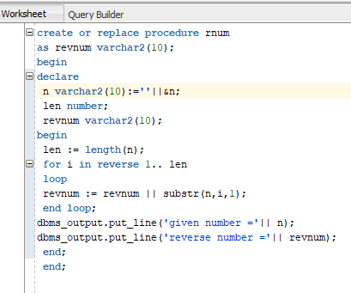

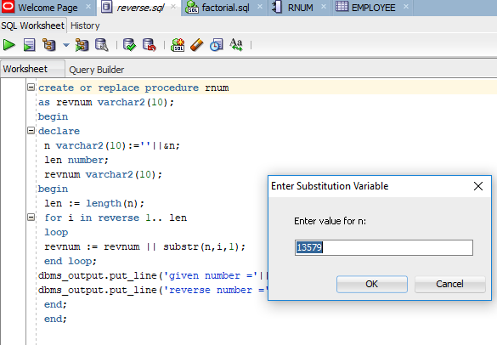

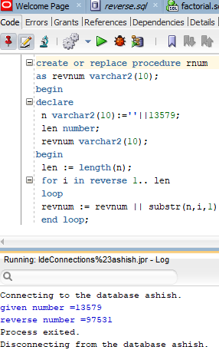

**Employee(Eno,ename,dno,salary,job)**

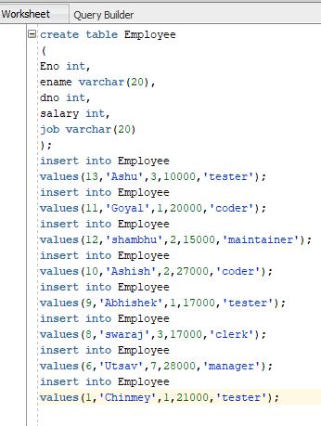

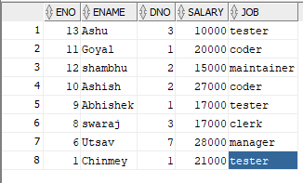

**3-Delete tuples for employee where eid is greater than 10 and display number of rows affected.**

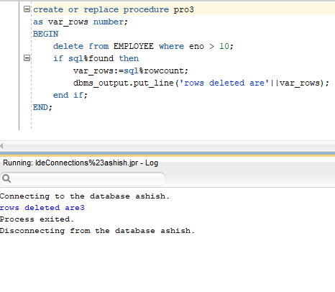

**4-Update record in table set salary =50000 where salary is greater than 20000 and less than 30000 And display number of rows affected.**

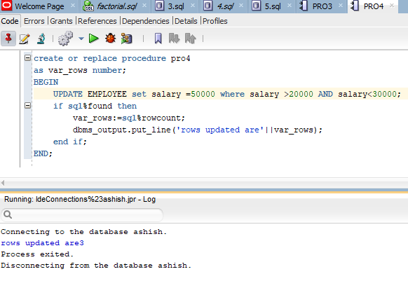

**5-Display the employee number and number of rows selected having salary equal to 17000.**

