***Assignment -8***

***MID-2***

Name-Abhishek Tibrewal

Id- 2016ucp1103

Batch-A(1,2)

* **CREATE TABLES:**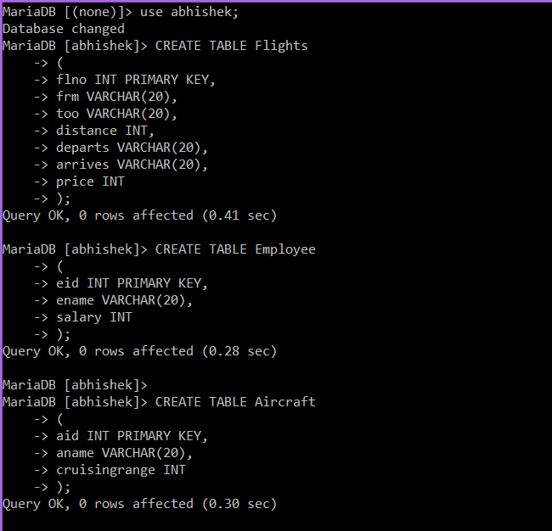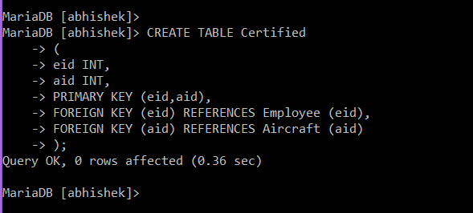
* **INSERT TABLE & SHOW TABLES:**

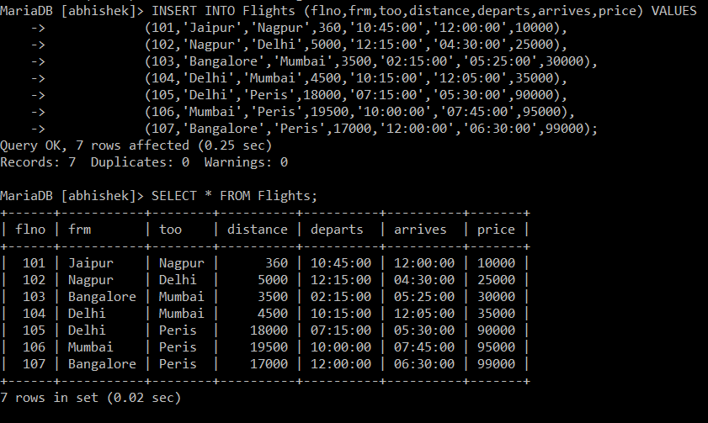

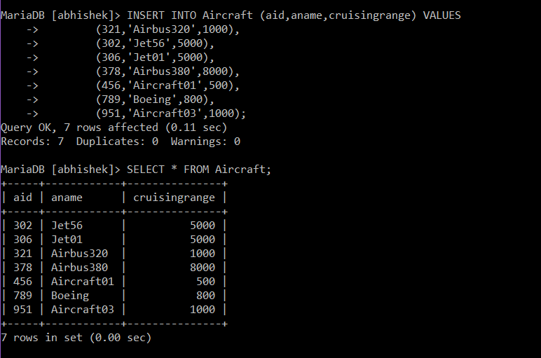

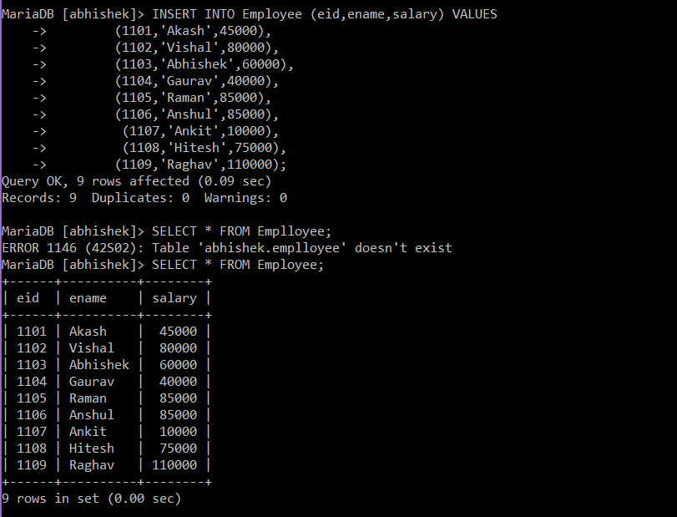

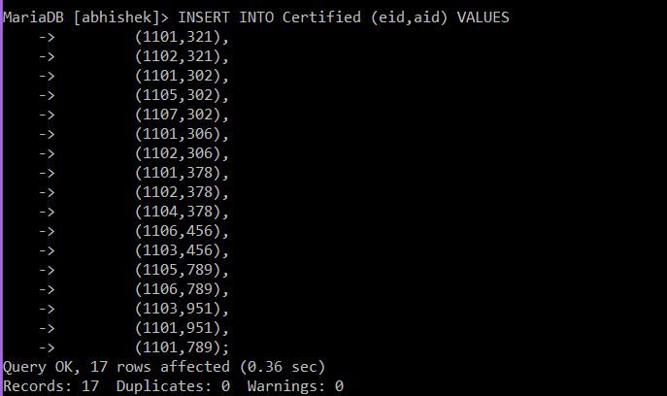

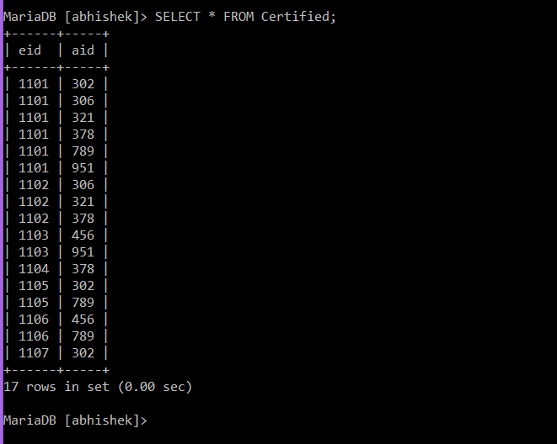

* **QUERIES:**

1)find the names of pilots certified for some Boeing aircraft.

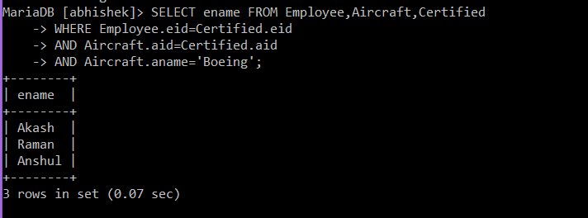

2)print name and salary of every non pilot whose salary is more than average salary of pilots.

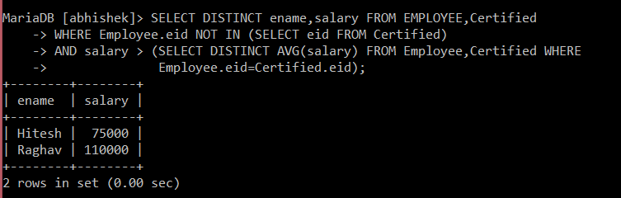

3)print names of employees who are certified only on aircrafts with cruisingrange longer than 1000 miles,but on at least 2 such aircrafts.

