**Assignment-9**

**PL/sql-2**

**Name-Abhishek Tibrewal**

**Id-2016ucp1103**

**Batch-A (1, 2)**

**EXPLICIT CURSOR**

**Employee(eno,ename,dno, salary,job)**

**Create Tables and Insert values into table:**

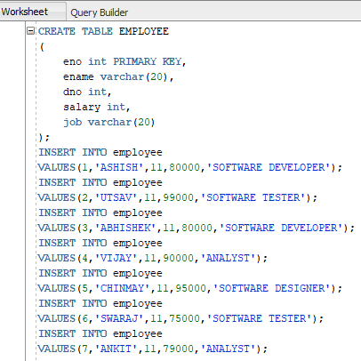

**Show tables:**

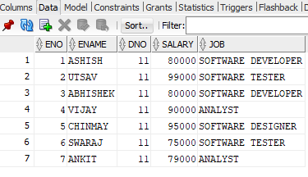

**1-Display details of top five highest paid employees.**

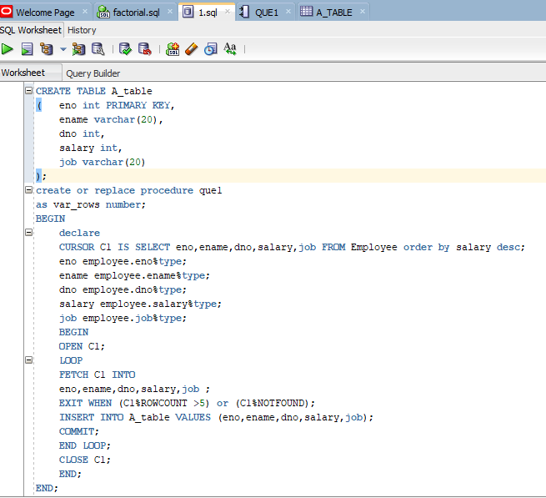

**Solution Table-**

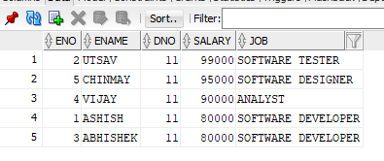

**2-Increment salaries of the employees according to their job.**

**Initial Values-**



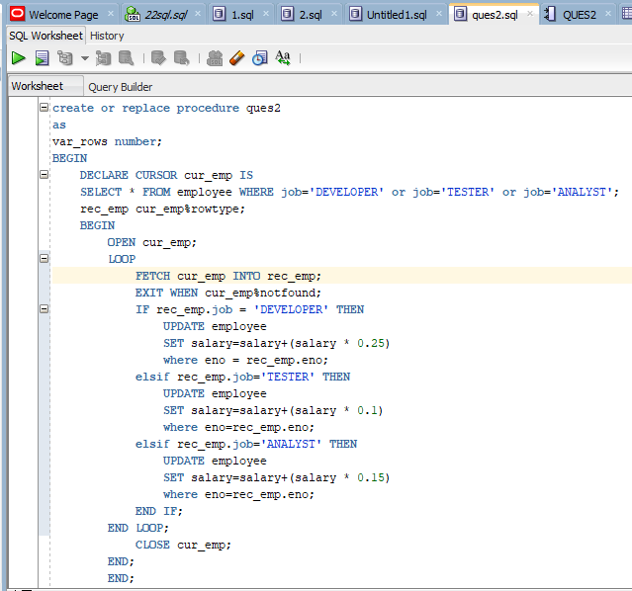

**Solution Table-**

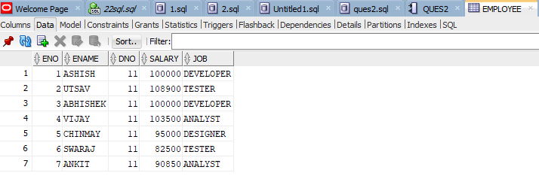

**TRIGGERS**

**3-create trigger which will get triggered on insert , update and delete in employee table.**

**Initial Values-**



**Trigger-**

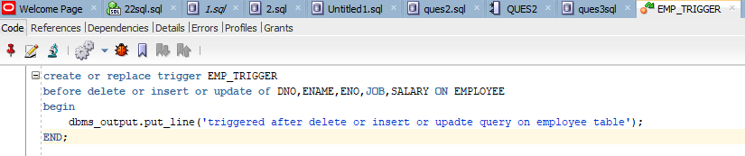

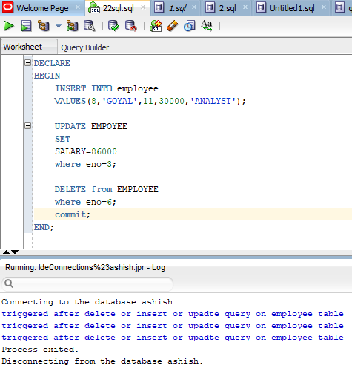

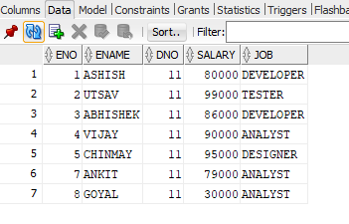

**4-**

**Student(Sid,sname,deptname)**

**Department(deptname)**

**Create Tables and Insert values into table:**

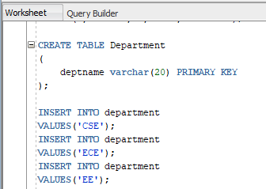

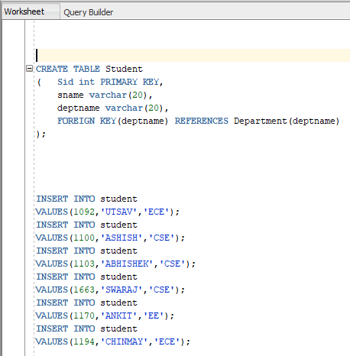

**Show tables:**

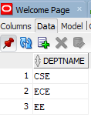

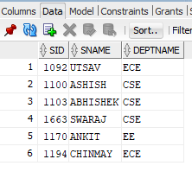

**Create a trigger to remove all students of department once department is deleted.**

