**MALAVIYA NATIONAL INSTITUTE OF TECHNOLOGY, JAIPUR**



SOFTWARE REQUIREMENTS SPECIFICATION (SRS)

FOR

WEB APPLICATION ON ONLINE TRANING & PLACEMENT MANAGEMENT SYSTEM

PREPARED BY:

ABHISHEK TIBREWAL

ID-2016UCP1103

**TABLE OF CONTENTS:**

1. **Introduction**
   1. Purpose
   2. Scope
   3. Definitions, Acronyms and Abbreviations
   4. References
   5. Overview
2. **General description**
   1. Product perspective
   2. Product function summary
   3. User characteristics
   4. General constraints
   5. Any Assumptions and dependencies
3. **Specific Requirements** 
   1. Functional requirements
   2. External interface requirements
   3. Performance requirements
   4. Design constraints
   5. Attributes
4. **Appendices**
   1. Data flow diagram
   2. Use case diagram
   3. Entity relationship diagram
   4. Class diagram
   5. Activity diagram
   6. Data dictionary
   7. Algorithms
   8. Testing
5. **Introduction:**

This section gives a scope description and overview of everything included in this SRS document. Also, the purpose for this document is described and a list of abbreviations and definitions is provided.

* 1. **Purpose:**

The purpose of this document is to give a detailed description of the requirements for the “Web Application on Online Training & Placement Management System” software. It will illustrate the purpose and complete declaration for the development of system. It will also explain system constraints, interface and interactions with other external applications. This document is primarily intended to be proposed to a customer for its approval and a reference for developing the first version of the system for the development team.

* 1. **Scope:**

The Online Training & Placement Management System can be used as a web application for the Training and Placement Officers of the college to manage the student information with regard to placement and training. It has been developed to override the problems prevailing in the practicing manual system.

This system is an online application that can be accessed throughout the organization and outside as well with proper login provided. It offers many flexible and convenient features, allowing admin, students and company to maximize time and efficiency. This system allows updating the information for students and companies. Also the admin manages both students and companies in the way such that the admin can access and update their information.

The application is reduced as much as possible to avoid errors while entering the data. It also provides error messages while entering invalid data. No formal knowledge is needed for the user to use this system. Thus by this all it proves it is user-friendly.

* 1. **Definitions, Acronyms and Abbreviations:**

|  |  |
| --- | --- |
| **Term** | **Definition/Acronym/Abbreviation** |
| SRS | Software Requirements Specification |
| Admin | System administrator who is given specific permission for managing and controlling the system |
| T & P Cell | Training & Placement Cell |
| Student login-intern | Login for internship students |
| Student login-placement | Login for placement students |
| TPO | Training & Placement officer |
| RAM | Random Access Memory |
| DFD | Data Flow Diagram |

* 1. **References:**

[1]. IEEE Software Engineering Standards Committee, “IEEE Std 830-1998, IEEE Recommended Practice for Software Requirements Specifications”, October 20, 1998.

[2].<http://www.cse.chalmers.se/~feldt/courses/reqeng/examples/srs_example_2010_group2.pdf>

* 1. **Overview:**

The remainder of this document includes two chapters and appendixes. The second one provides an overview of the system functionality and system interaction with other systems. This chapter also introduces different types of stakeholders and their interaction with the system. Further, the chapter also mentions the system constraints and assumptions about the product.

The third chapter provides the requirements specification in detailed terms and a description of the different system interfaces. Different specification techniques are used in order to specify the requirements more precisely for different audiences.

The Appendixes in the end of the document include some different types of UML diagrams.

1. **General description:**

This section will give an overview of the whole system. The system will be explained in its context to show how the system interacts with other systems and introduce the basic functionality of it. It will also describe what type of stakeholders that will use the system and what functionality is available for each type. At last, the constraints and assumptions for the system will be presented.

* 1. **Product perspective:**

In our college, T&P officers have to manage the student’s profiles and the documents of students for their training and placement manually. Also P&T officers have to collect the information of various companies who want to recruit students and notify students time to time about the internships and placements.

P&T officers also have to arrange profiles of students according to various streams and notify them according to company requirements. If any modifications or updates are required in the profile of the students of the company, it has to be searched and done manually.

The Training & Placement Management System would maintain a huge database for the complete details of the students as well as the companies in the Internship and Placement process which would help to save time and effort.

* 1. **Product function summary:**

The Online Training & Placement Management System is to be developed as an attempt to take a record of Companies and students by restricting a large database that would be used for each. The System would provide the facility of viewing both the personal and academic information of the students.

The System would also be able to search for eligible students and company with respect to their specifications and requirements. The selected students would receive an email that confirms their selection in that particular company.

The web application will be secure i.e. If any user is logged in then no other user can log in at the same time on the same browser. No one can access the WebPages (that open after login) directly by address bar of the browser.

* 1. **User characteristics:**

The major User classes in the System would be:

* **Student:** 
  + Student can register at training and placement cell.
  + Can login and view his/her profile.
  + Can update his/her information that were provided at the time of registration.
  + Student can view general notifications from T & P cell and can also see the details of companies that are visiting.
  + A student can apply for the visiting company for internship or placement if he/she is eligible for that.
  + If student forgets password for login then a new password will be send to his/her e-mail id.
  + A confirmation mail will be sent to student after he/she got selected in any company.
* **Company:** 
  + A company can register at training and placement cell.
  + Company adds basic details like, for which branch the company is coming and criteria for that branch.
* **Admin:** 
  + Can register once at training and placement cell.
  + Can login.
  + Add general notifications for the students.
  + Have access to all the information about students and companies means admin can view or update information of students and company.
  + Only the admin gives approval to the company after verifying that it’s a correct company or not.
  + Admin also update absents of the students.
  + Admin changes the status of the students from not selected to get intern/placement after receiving final result from the company.
  + Admin can view the list of students who got placement or internship in which company.
  1. **General constraints:**
* This web application can be deployed on window machine with Apache Server and MySQL server.
* Minimum RAM 3GB
* 30GB or more Storage Space.
* Internet Connectivity with Ports configured.
* This application can be accessed by user through a machine having any web browser with html, css, and javascript support.
  1. **Any Assumptions and dependencies:**
* It is assumed that the user should have some basic knowledge of computer.
* The admin provide the correct notification and information to students provided by company.
* All the non updatable details must fill correctly.

1. **Specific Requirements:**

This section contains all of the functional and quality requirements of the system. It gives a detailed description of the system and all its features.

* 1. **Functional requirements:**

**F1: Registration by admin, student, company.**

**Input:** personal information.

**Output:** acknowledgement of registration and profile on T & P Cell portal.

**F2: Login by admin, student, company.**

**Input:** name, id and password.

**Output:** related page will be open where various buttons for different purposes.

**F3: Approval to company.**

**Input:** company name

**Output:** status of approval will be approved for that company.

**F4: Apply for company.**

**Input:** company name

**Output:** student’s name will be added to registered student list for that company.

**F5: View notification.**

**Input:** click on button “view notifications” after student login.

**Output:** a notification panel will be open where student can see notifications.

**F6: Add notification.**

**Input:** particular notification or information.

**Output:** information will goes to notification panel.

**F7: View profile.**

**Input:** click on the button “view profile” after student login.

**Output:** student’s profile will be shown along with his/her photograph.

**F8: Update profile.**

**Input:** click on button “update profile” after student login.

**Output:** an update form will be open in which the student can fill the info which he/she wants to update.

* 1. **External interface requirements:**

This section provides a detailed description of all inputs into and outputs from the system. It also gives a description of the hardware, software and communication interfaces and provides basic prototypes of the user interface.

* + 1. **User interfaces:**
* There is separate login for admin, student and company. Also separate login for students for placement and internship.
* The design or layout of every form will be very clear and very interactive to the user.
* In the screen layout the background color is very light and the graphics and font style will be in proper manner and well organized.
* This will provide the better security data because if any user is logged in then no other user can log in at the same time on the same browser. Also no one can access the WebPages (that open after login) directly by address bar of the browser.
  + 1. **Hardware interfaces:**

The program will communicate with hard drive (the file system and database) via the appropriate PHP code. The user can communicate through browser using keyboard and a display through graphical interface displayed on user’s screen.

* + 1. **Software interfaces:**
* The software interface uses a XAMPP set-up.
* Operating system: Windows
* Web Server: Apache
* Database: MySQL
* Scripting Language: PHP, HTML, CSS and JavaScript

The product will host a local Apache web server where the user interface will be displayed via the web browser. The scripting language PHP will define size and overall set-up and start connection with database. PHP will also be used to create background colors, border colors and text display with help of CSS. HTML is used in forms. JavaScript will be used to control the slide show of images on main page. The MySQL database will store the images and data to be displayed at the output. All images are in jpeg/png format.

* + 1. **Communications interfaces:**

Communicational interfaces includes email, notification through web browser, forms etc. Communication security and encryption issues will handle by using PHP (session variables).

* 1. **Performance requirements:**

These are some requirements from users that will help in better performance of this system.

* User should provide correct information so that no error will be displayed.
* There is completely separate login for student, company and admin that confirm high security.
* Internet connection should be good so that email feature can work in proper way.
  1. **Design constraints:**
* Software Language Used: The languages that shall be used for coding the Online Training & Placement Management System are HTML, PHP.
* Development Tools: Will make use of the available Xampp and MySQL.
  1. **Attributes:**

The Online Training & Placement Management System has many quality attribute that are given below-

* + **Adaptability**-This software is adaptable by any organization.
  + **Availability**-The availability of the software is easy and for everyone.
  + **Correctness**-The results of the function are pure and accurate.
  + **Maintainability**-After the deployment of the project if any error occurs then it can be easily maintained by the software developer.
  + **Portability**-The software can be deployed at any machine.
  + **Reliability**-The performance of the software is better which will increase the reliability of the software.
  + **Reusability**-The data and record that are saved in the database can be reused if needed.
  + **Robustness**-If there is any error in any window or module then it does not affect the remaining part of the software.
  + **Testability**-The software will be tested at every stage, by Alpha Testing, Beta Testing, Acceptance Testing.
  + **Productivity**-This software will produce every desired result with accurately.
  + **Timelines**-The time limit is very important. It will save much time and provide fast accessing.
  + **Security**-This system is highly secure as all three types of user have separate login.

1. **Appendices:**

* **DATA FLOW DIAGRAM:**

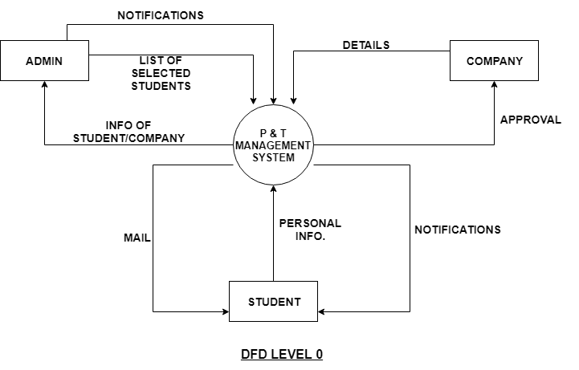

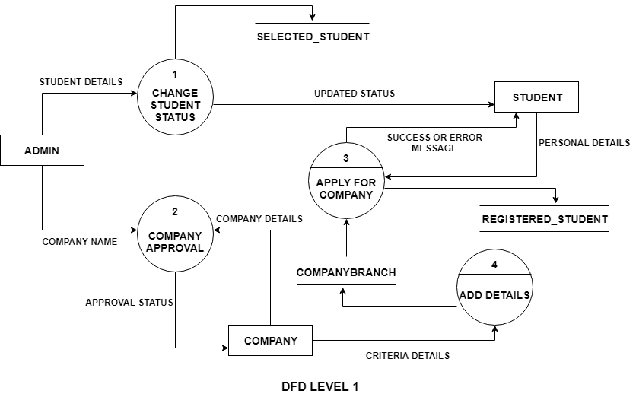

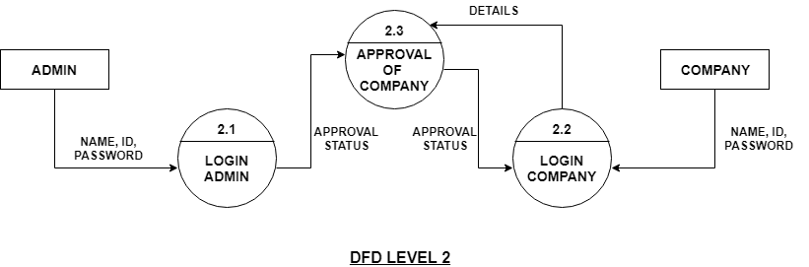

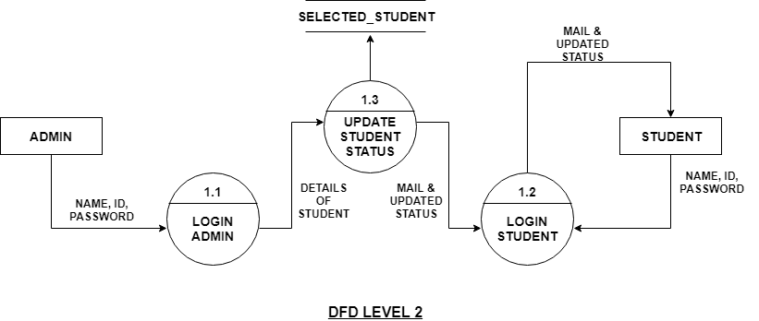

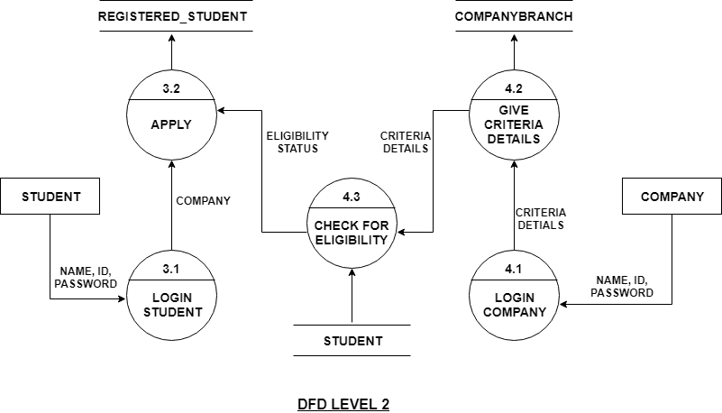

* **USE CASE DIAGRAM:**

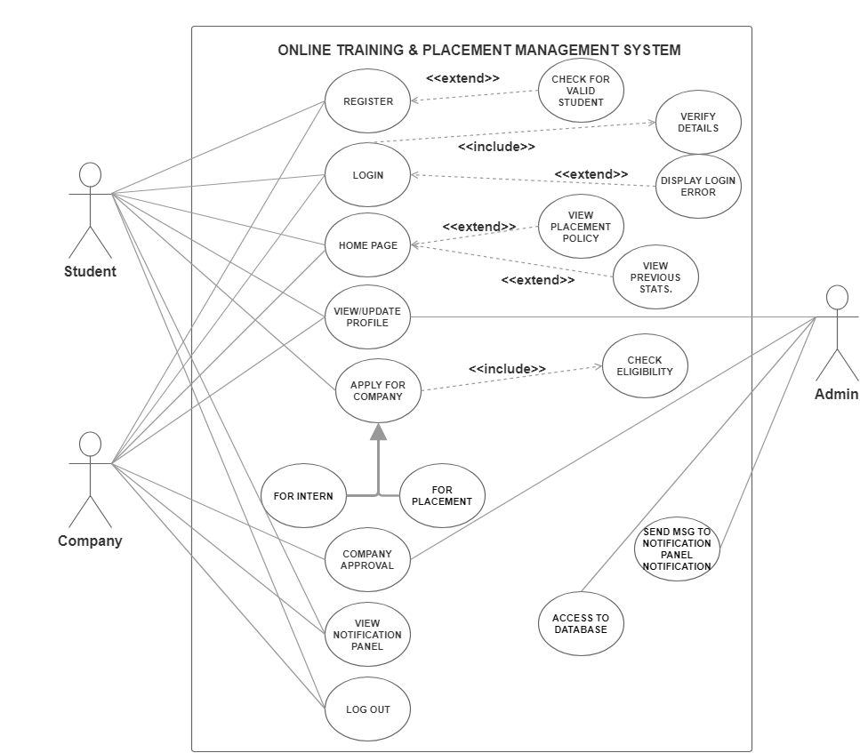

* **ENTITY-RELATIONSHIP DIAGRAM:**

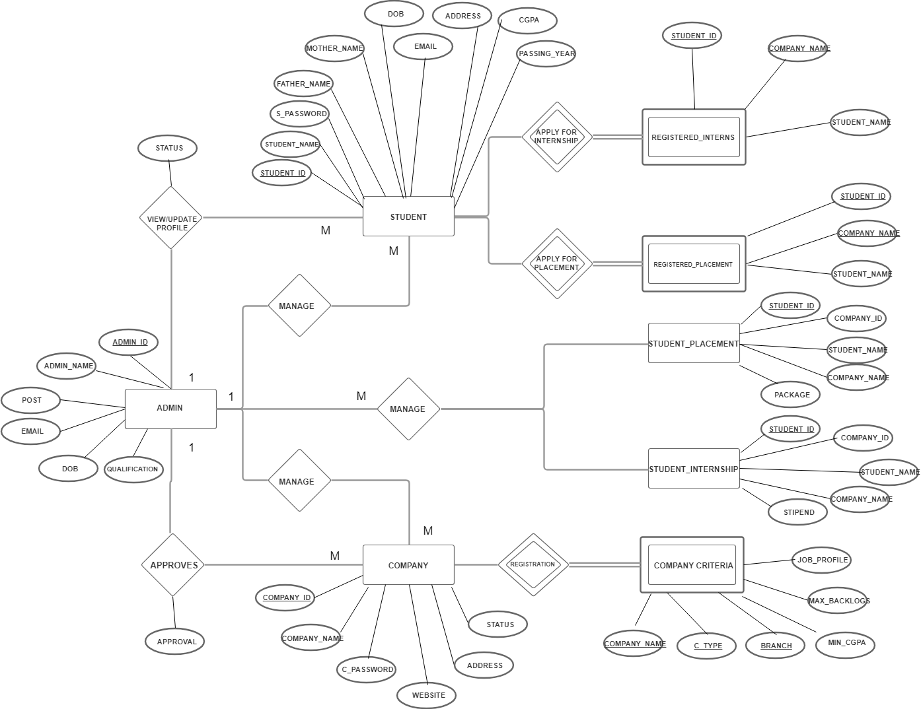

* **CLASS DIAGRAM:**

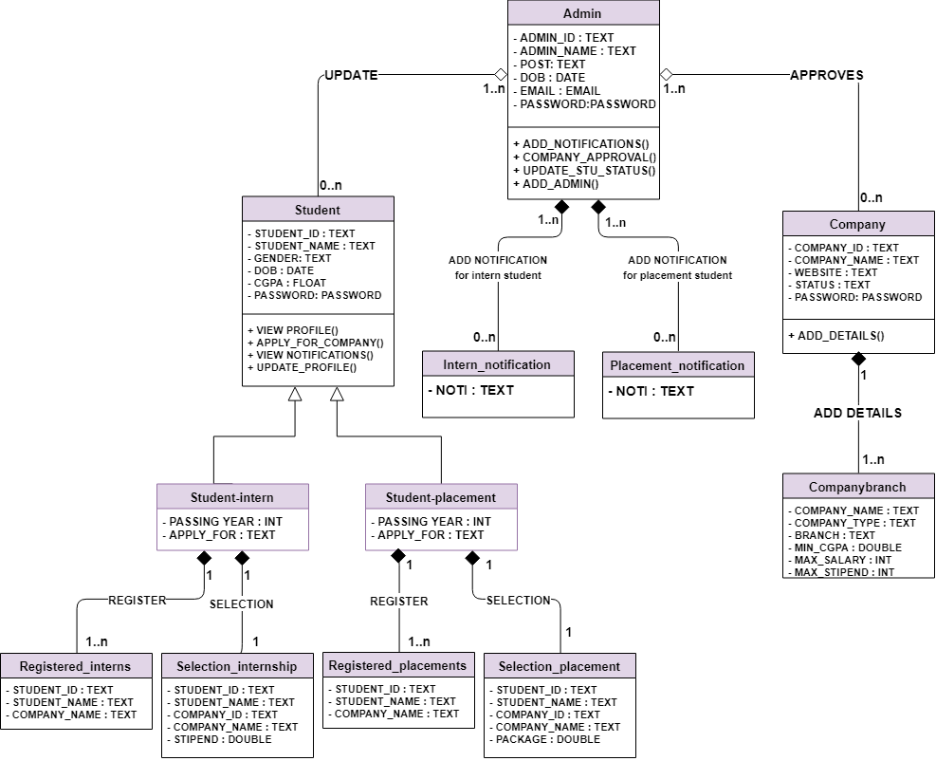

* **ACTIVITY DIAGRAM:**

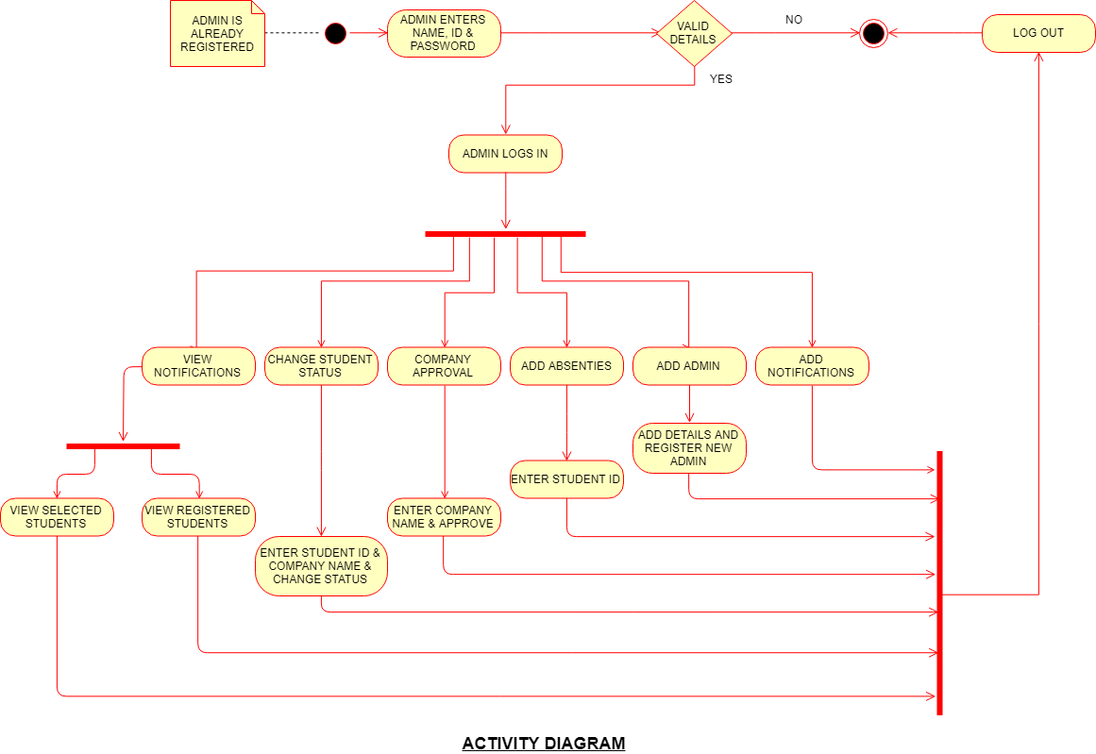

* **DATA DICTIONARY:**

**student**

|  |  |  |  |  |
| --- | --- | --- | --- | --- |
| **Column** | **Type** | **Null** | **Default** | **Description** |
| STUDENT_NAME | varchar(100) | No |  |  |
| STUDENT_ID (Primary) | varchar(50) | No |  | Institute id of the student |
| S_PASSWORD | varchar(100) | No |  | password of the student. |
| GENDER | varchar(100) | No |  |  |
| DOB | date | No |  | Date of birth. |
| EMAIL | varchar(100) | No |  |  |
| ADDRESS | varchar(100) | No |  |  |
| CONTACT_NO | varchar(100) | No |  |  |
| BRANCH | varchar(100) | No |  |  |
| APPLY_FOR | varchar(100) | No |  | Apply for internship or placement. |
| STATUS | varchar(50) | Yes | NS | student is selected or not selected. |
| APPLY_COUNT | int(11) | Yes | 0 | how many times applied for company. |
| ABSENT | int(11) | Yes | 0 | how many times student was absent. |
| IMAGE | longblob | No |  | image of the student. |
| TENTH_PER | varchar(100) | No |  | % in 10th class. |
| TENTH_PASS_YEAR | int(11) | No |  | 10th class passing year. |
| TWELTH_PER | varchar(100) | No |  | % in 12th class. |
| TWELTH_PASS_YEAR | int(11) | No |  | 12th class passing year. |
| CGPA | double | No |  | Current cgpa of the student. |
| PASSING_YEAR | int(11) | No |  |  |
| BACKLOGS | int(11) | No |  | No. of backlogs. |

**admin**

|  |  |  |  |  |
| --- | --- | --- | --- | --- |
| **Column** | **Type** | **Null** | **Default** | **Description** |
| ADMIN_NAME | varchar(100) | No |  |  |
| ADMIN_ID *(Primary)* | varchar(50) | No |  | Id of the admin. |
| DOB | date | No |  | date of birth |
| QUALIFICATION | varchar(100) | No |  |  |
| A_PASSWORD | varchar(100) | No |  | Password of the admin |
| POST | varchar(100) | No |  |  |
| EMAIL | varchar(100) | No |  |  |
| CONTACT_NO | varchar(100) | No |  |  |

**company**

|  |  |  |  |  |
| --- | --- | --- | --- | --- |
| **Column** | **Type** | **Null** | **Default** | **Description** |
| COMPANY_NAME | varchar(100) | No |  |  |
| COMPANY_ID *(Primary)* | varchar(50) | No |  | Id of the company. |
| C_PASSWORD | varchar(100) | No |  | Password of the company. |
| WEBSITE | varchar(100) | No |  | Website of the company. |
| ADDRESS | varchar(100) | No |  |  |
| STATUS | varchar(50) | Yes | visiting | Company is visiting or already visited. |
| COMING_DATE | date | No |  | on which date company is coming in institute. |
| APPROVAL | varchar(50) | Yes | not approved | Company is approved by admin or not approved. |

**registered_placements**

|  |  |  |  |  |
| --- | --- | --- | --- | --- |
| **Column** | **Type** | **Null** | **Default** | **Description** |
| STUDENT_NAME | varchar(100) | No |  |  |
| STUDENT_ID *(Primary)* | varchar(50) | No |  | Institute id of the student. |
| COMPANY_NAME *(Primary)* | varchar(100) | No |  |  |

**registered_interns**

|  |  |  |  |  |
| --- | --- | --- | --- | --- |
| **Column** | **Type** | **Null** | **Default** | **Description** |
| STUDENT_NAME | varchar(100) | No |  |  |
| STUDENT_ID *(Primary)* | varchar(50) | No |  | Institute id of the student. |
| COMPANY_NAME *(Primary)* | varchar(100) | No |  |  |

**companybranch**

|  |  |  |  |  |
| --- | --- | --- | --- | --- |
| **Column** | **Type** | **Null** | **Default** | **Description** |
| COMPANY_NAME *(Primary)* | varchar(100) | No |  |  |
| C_TYPE *(Primary)* | varchar(50) | No |  | Placement or internship |
| BRANCH *(Primary)* | varchar(50) | No |  | Name of the branches in which company is interested. |
| MIN_CGPA | double | No |  | Minimum required cgpa |
| MAX_BACKLOGS | int(11) | Yes | 0 | Maximum backlogs possible |
| JOB_PROFILE | varchar(100) | No |  |  |
| PLACE_OF_POSTING | varchar(100) | No |  |  |
| MAX_SALARY | double | No |  | Maximum salary |
| MAX_STIPEND | double | No |  | Maximum stipend |

**intern_notification**

|  |  |  |  |  |
| --- | --- | --- | --- | --- |
| **Column** | **Type** | **Null** | **Default** | **Description** |
| noti *(Primary)* | varchar(200) | No |  | Notifications for internship students |

**place_notification**

|  |  |  |  |  |
| --- | --- | --- | --- | --- |
| **Column** | **Type** | **Null** | **Default** | **Description** |
| noti *(Primary)* | varchar(200) | No |  | Notifications for placement students |

**student_placement**

|  |  |  |  |  |
| --- | --- | --- | --- | --- |
| **Column** | **Type** | **Null** | **Default** | **Description** |
| STUDENT_NAME | varchar(100) | No |  |  |
| COMPANY_NAME | varchar(100) | No |  |  |
| STUDENT_ID *(Primary)* | varchar(50) | No |  | Institute id of the student. |
| COMPANY_ID | varchar(100) | No |  | Id of the company. |
| PACKAGE | double | No |  | Salary offered for placement students. |

**student_internship**

|  |  |  |  |  |
| --- | --- | --- | --- | --- |
| **Column** | **Type** | **Null** | **Default** | **Description** |
| STUDENT_NAME | varchar(100) | No |  |  |
| COMPANY_NAME | varchar(100) | No |  |  |
| STUDENT_ID *(Primary)* | varchar(50) | No |  | Institute id of the student. |
| COMPANY_ID | varchar(100) | No |  | Id of the company. |
| STIPEND | double | No |  | Stipend offered for placement students. |

* **ALGORITHMS:**
  + **For admin register page:**

Admin_Register ( )

{

1. show form for registration

2. store the input values entered by user in corresponding values like admin_name, email etc.

3. if click on Sign up button

if username or id matches with any exiting or id of admin then

show error “username or id already exists.”

if password and confirm password do not match then

show error “password doesn’t match.”

if any field is empty then

show error “fill required field.”

if email is not a valid one then

show error “not a valid email.”

if there is no error and there is no entry in database then

insert all the values in admin table in database and show “successfully registered ” message

if admin already exists then

show error “only admin can register new admin”

4. else if click on Sign in option

Login page of admin opens

}

* **For admin login page:**

Admin_Login ( )

{

1. show form for login

2. store the input values entered by user in corresponding values like admin_name, password etc.

3. if click on Sign in button

if any field is empty then

show error “fill required field.”

if any detail is not matched with detail store in admin table in database then

show error “wrong username/password combination”

if there is no error then

an index page for admin opens that contains many options (like company approval, add admin etc.) for the functions that an admin can do.

4. else if click on Sign up option

Register page of admin opens

}

* + **For add admin page:**

Add_Admin ( )

{

1. show form for registration of new admin

2. store the input values entered by user in corresponding values like admin_name, email etc.

3. if click on Sign up button

if username or id matches with any exiting or id of admin then

show error “username or id already exists.”

if password and confirm password do not match then

show error “password doesn’t match.”

if any field is empty then

show error “fill required field.”

if email is not a valid one then

show error “not a valid email.”

if there is no error then

insert all the values in admin table in database and back to the admin index page

}

* **For home page:**

Home_Page ( )

{

1. Show all the options.

2. click on any option.

3. if click on admin

Admin page opens that contains register and login options

4. if click on student

student page opens that contains register and login options for both internship and placement student

5. if click on company

Company page opens that contains register and login options

6. if click on placement and training policy

Placement and training policy for MNIT students opens.

7. if click on previous placement and internship report

Previous year’s Placement and internship report of MNIT opens.

8. if click on About us

Training and placement cell information page of MNIT website opens

9. if click on Contact us

Contact information page for Training and placement cell opens on MNIT website

}

* **TESTING:**
* **White Box Testing:**

**For register & login:**

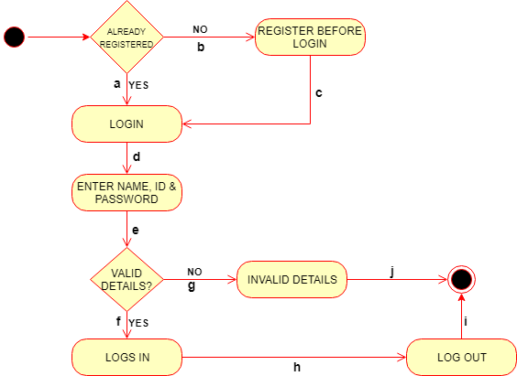

1. **Statement Coverage Testing:**

**Input-** already registered or not, login details

**Test case 1:** already registered, valid login details

**Test case 2:** not registered, invalid login details

1. **Decision Coverage Testing:**

**Input-** already registered or not, login details

**Test case 1:** already registered, valid login details (adefhi)

**Test case 2:** not registered, invalid login details (bcdegj)

**Test case 3:** already registered, invalid login details (adegj)

**Test case 4:** not registered, valid login details (bcdefhi)

* **Black Box Testing:**

1. **Equivalence Class Partitioning:**

* **For 12th percentage:**

|  |  |
| --- | --- |
| **Class** | **Expected outcome** |
| <1 | invalid |
| >=1 and <=100 | valid |
| >100 | invalid |

* **For digits in phone-no.:**

|  |  |
| --- | --- |
| **Class** | **Expected outcome** |
| <10 | invalid |
| =10 | valid |
| >10 | invalid |

1. **Boundary Value Analysis:**

* **For 12th percentage:**

|  |  |
| --- | --- |
| **Boundary value** | **Expected outcome** |
| =1 | valid |
| =100 | valid |

* **For digits in phone-no.:**

|  |  |
| --- | --- |
| **Boundary value** | **Expected outcome** |
| =10 | valid |