1. Ping uses icmp.

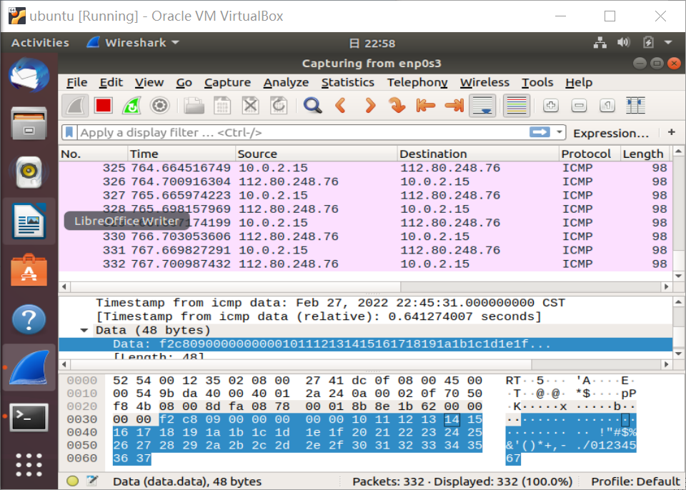

Traceroute uses icmp, dns.

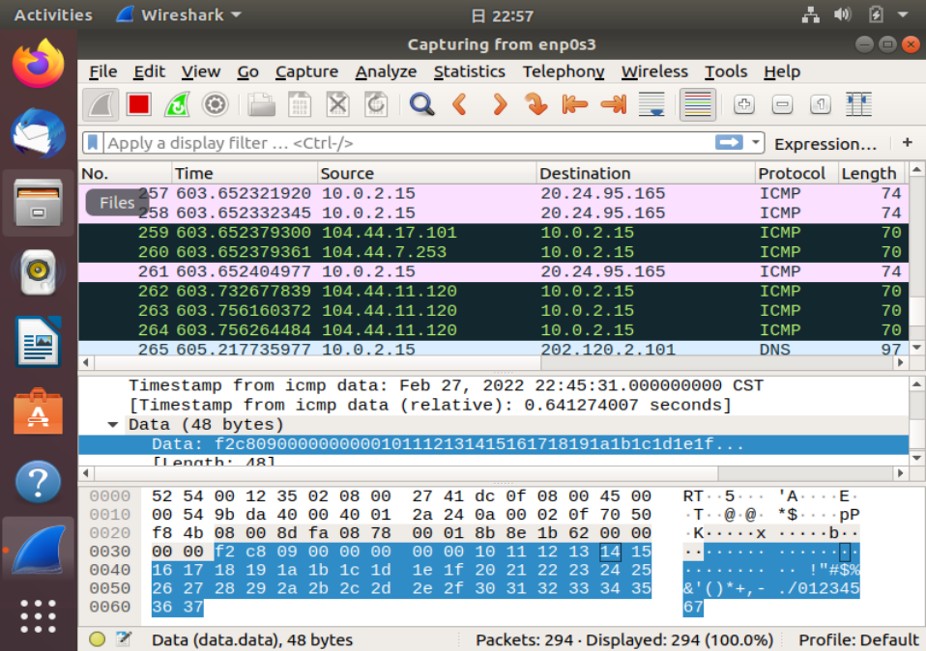

1. Ip :112.80.248.76

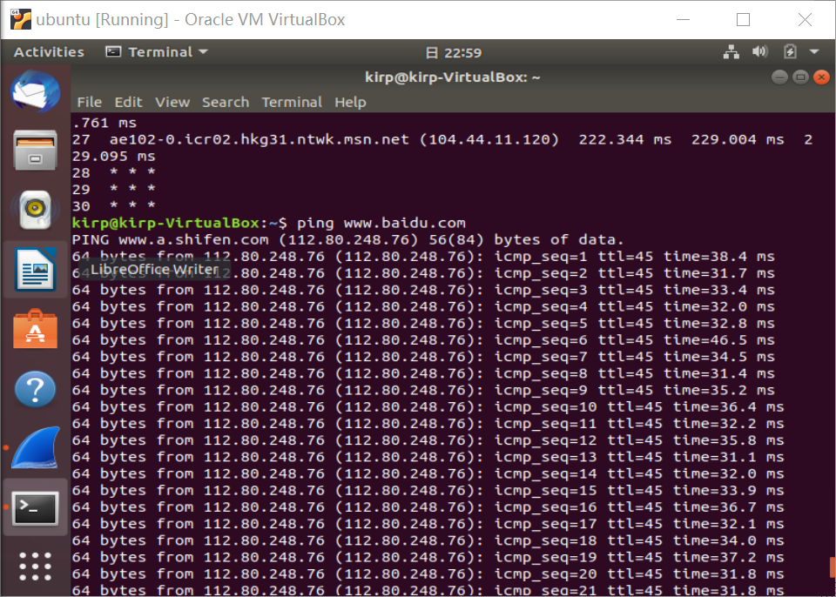

1. the average round trip time

Baidu: 31.107

Mit: 256.752

The reason why pinging mit costs more time is that the server of mit.edu is farther from us than baidu. So, it spend more time routing.

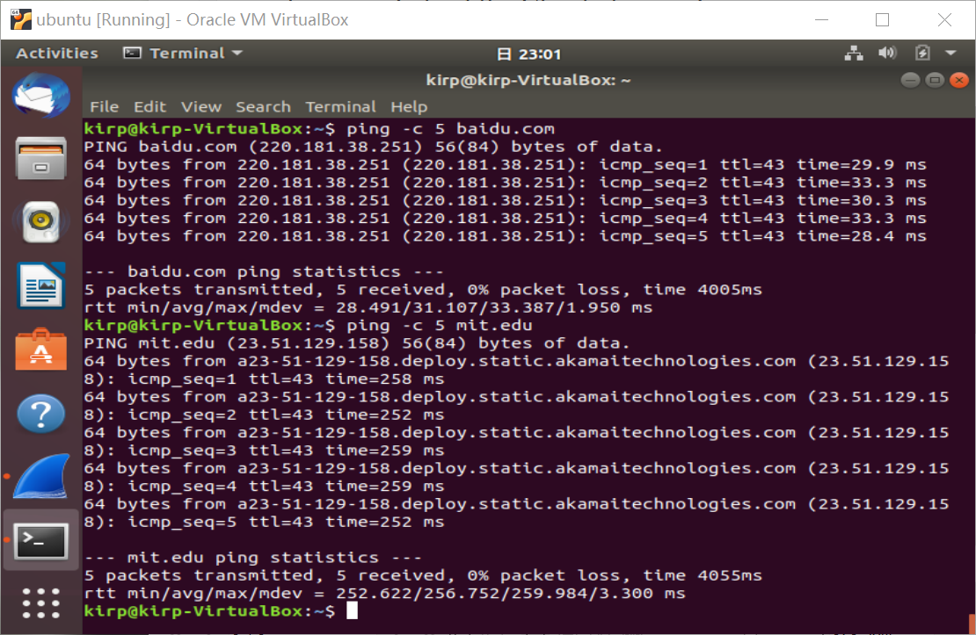

1. 1.77Gb/s

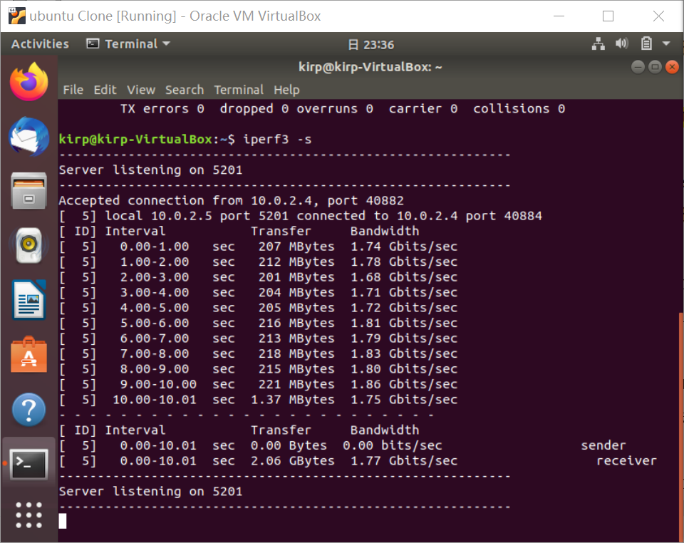

1. 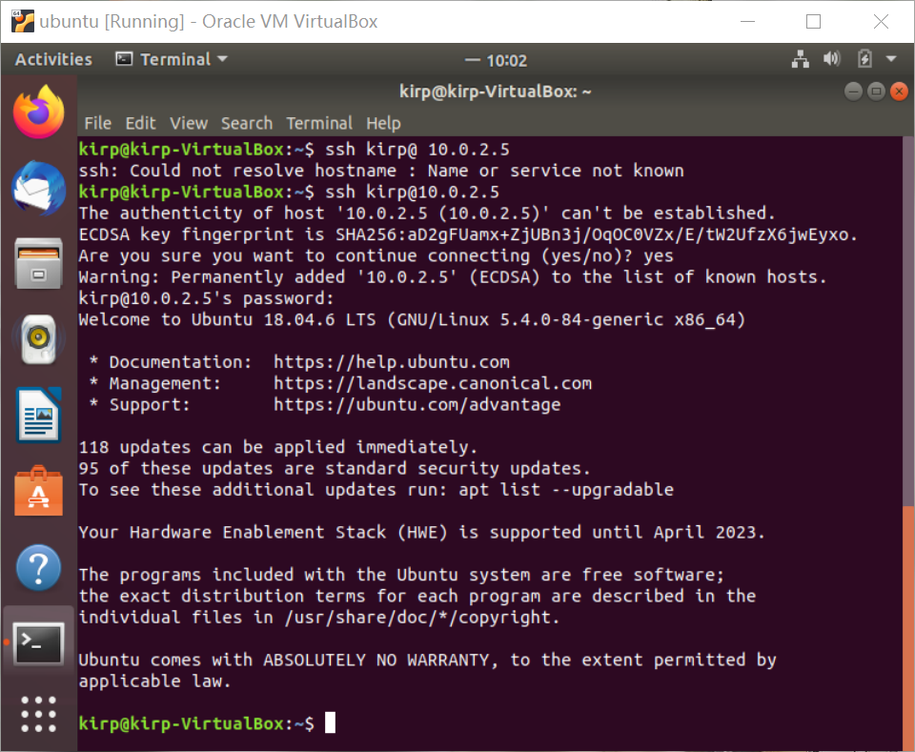

6.