Layout

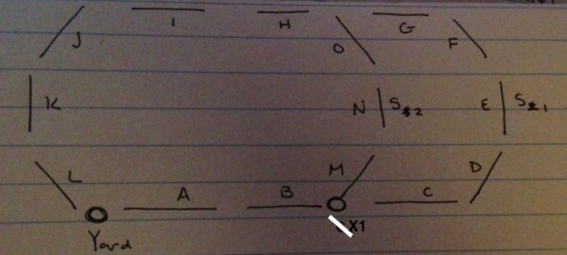

Prototype Info:

* Yard placed at beginning of A, enf of L
* Station 1 @ E, Station 2 @ N
  + 3 options: 1. Have one train visit one station 2. Traverse track twice with one train, change switch orientation 3. Traverse once with two trains, change switch
* X1 is only Switch, originally oriented toward C
  + If CTC gives authority 111… the train will continue on to CDEFG path
  + If CTC gives authority 110… switch orientation must change and train follows MNO path
* H will be a tunnel - no grade/elevation change but need to show lights turn on/off
* Remember time delay for stopping at stations - how long do we want this to be
* No need to convert lengths, already in km in excel file - unless you guys want to change to mi for the physics calculations, I don’t know which you use

General Project Info:

* Track model will send grade after each block ends
* Track model: speed, authority, grade at same time
* Station at end of block
* Broken segment shown as train on track
* Beacon placement (64 bytes): beginning of segment,
  + Station number: short, each module can hold an array for identification
* Blocks will be comprised of segments, segment size: 100m