**Chapter – 1**

**Introduction to DevOps**

**Myth :-**

Some people who are new to DevOps feels that DevOps is a new tool or a new technology that came in the market.

**What actually is DevOps?**

* DevOps is definitely not a new tool or technology.
* DevOps is actually a culture/process that we follow

**Definition :-**

*DevOps is a culture or process to develop release and maintain software application/project/product with higher quality in very fast way.*

* And it is achieved it by using automation tools

In an organization for any software product two group/team of engineers works.

1. Development Group ~ Dev
2. Operations Group ~ Ops

These two groups are further divided into small set of groups.

**Development Team/Group :-** The group of people who are involved in

👉 Planning

👉 Coding

👉 Testing

👉 Building

Of software product or application are considered in Development Group.

* **Ex :-**
* Business Analyst (BA)
* System Analyst (SA)
* Design Architect (DA)
* Developers/Coders
* Build Engineers
* Test Engineers

**Operations Team/Group :-** The group of people who are involved in

👉 Release

👉 Deployment

👉 Operations

👉 Monitoring

Of software product or application are considered in operational group.

* **Ex :-**
* Configuration Engineers
* System Administrator
* Database Admin
* Network Administrator
* Etc.

**NOTE :-** Operations team can only start their work when the task of development team is completed.

*“DevOps is a combination of development and Operations”*

**Main Objective of DevOps**

The main objective of DevOps is to establish collaboration between these two teams i.e. Dev and Ops Team to deliver the project between less time with high quality.

To better Understand DevOps culture, we need to understand existing SDLC Models. Which will clarify why we are moving towards DevOps.

**SDLC =** Software Development Life Cycle

There are several models of SDLC

1. Waterfall Model
2. Prototype Model
3. Incremental Model
4. Spiral Model
5. RAD or R&D Model
6. Big-Bang Model
7. Fish Model
8. Agile Model

Briefly discuss about two of them waterfall and agile

**Waterfall Model :-**

There are some phases/steps for any Software Development Approach.

1. Requirement Gathering
2. Requirement Analysis
3. Design
4. Coding
5. Testing
6. Release

*In waterfall model every step must be completely done before proceeding to next one.*

*We cannot move back to previous step as same as water flows on stairs.*

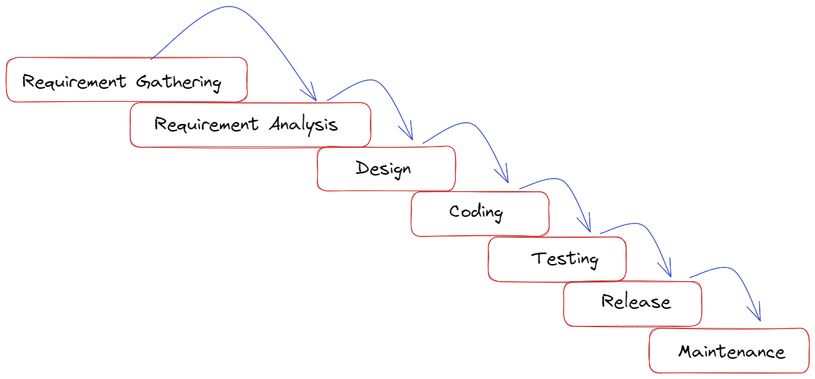

Waterfall model is also known as Linear Sequential model

**Limitation of Waterfall model**

1. Development time increased
2. Cost of development increased
3. It won’t accept requirement changes in middle
4. Client satisfaction is very-very low
5. Bug fixing is very costly
6. Not suitable if requirement keeps on changing
7. Not Suitable for large projects

**Advantages of waterfall model**

1. It is very simple to implement
2. Best suitable for small project
3. Best suitable if requirement are fixed

**Agile Model**

This was the most frequently used and hot cake model in Software development.

**Agile Model is divided into multiple sub-models**

1. Relational Unify Process (RUP)
2. Adaptive Software Development (ASD)
3. Feature Driven Development (FDD)
4. Crystal Clear
5. Dynamic Software Development Method (DSDM)
6. Extreme Programming (XP)
7. SCRUM Model

*Among all these sub-model SCRUM is most popular and frequently used.*

[Agile means Speed]

* **SCRUM** is agile based model
* **Agile** is an iterative model
* **Sprint** is the small part of task in Agile

*Agile is an iterative model. Total software product will be developed in sub parts and each part is called Sprint.*

**Advantages**

1. Continuous delivery
2. Continuous feedback
3. Requirement changes in the middle
4. Client Satisfaction is very high
5. Less development time
6. Less development cost

**Why we should go for DevOps ?**

For answering this question we need to just understand the similarities and Difference between Agile and DevOps.

There are many some similarities between Agile and DevOps and that’s why there is a myth also that

*# DevOps is derivative of Agile*

**But DevOps and Agile are different models**

**Similarities between DevOps and Agile**

1. Both are Software development methodologies
2. Both models concentrating of rapid software development with team collaboration.

**Difference Between DevOps and Agile**

The real difference between DevOps and agile will be visible hen the development part of project is completed.

1. Agile model talks only about development but no operations, But DevOps talk about complete product lifecycle like development and operations
2. In Agile model, separate people are responsible for development, testing, deployment, etc. But in DevOps the DevOps engineer is responsible for everything from development to operation.
3. Agile won’t force us to use automation tools, but DevOps is completely based on automation.
4. Agile always give high priority to Speed, But DevOps gives priority to both quality and speed.
5. In Agile, client is responsible to give the feedback for Sprint. But is DevOps immediate feedback is available from the monitoring tools.

**“DevOps is the process of continuous development, continuous build, continuous test, continuous release of software.”**

**Key Points**

* DevOps is not a new tool/technology
* DevOps is a culture or process to develop release and maintain software product.
* DevOps is a combination of development and Operations.
* The main objective of DevOps is to implement collaboration between development and operation teams.
* The beauty of DevOps is everything is automated and we can use several automation tools for Development and operation.
* DevOps engineers should be aware of every phases of Software Development lifecycle.
* DevOps is not agile model, it is more than that because it covers both “Development” and “operation” Whereas agile covers only development not operation.
* DevOps lifecycle is an infinite loop where everything is continuous.