Success rate plotted: 9% of founders are successful:
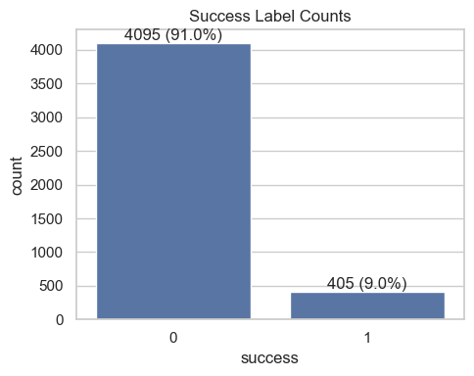

IPO and Acquisition data are only present in <20% of cases:
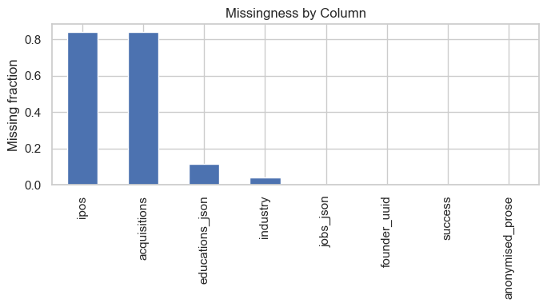

Widespread success rate across many top industries. Would be interesting to scrape growth rate of top-N industries to try and normalise/explain this trend:
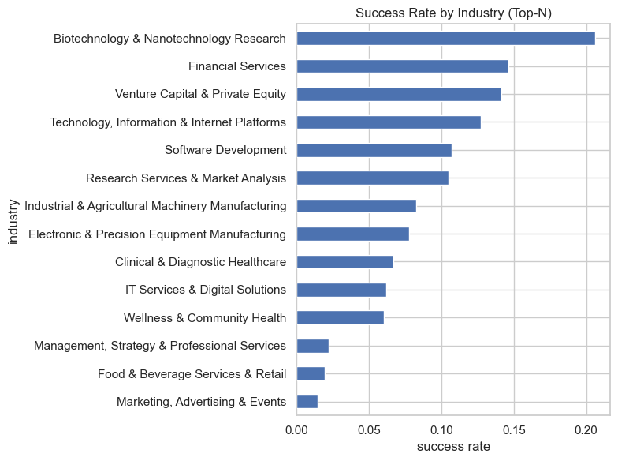

IPOs and Acquisitions
Vast majority of IPOs and Acquisitions are 0 in count, and unknown in valuation/amount:
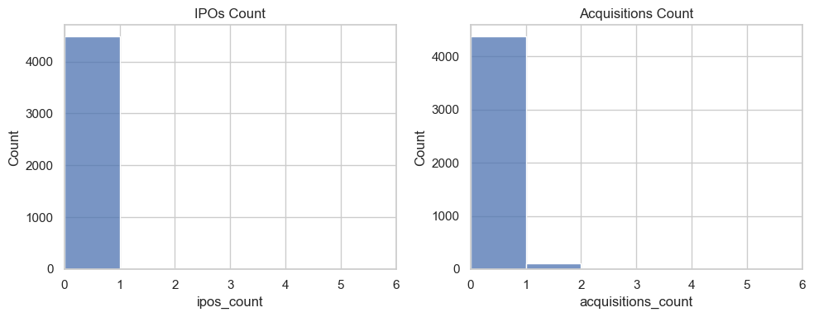
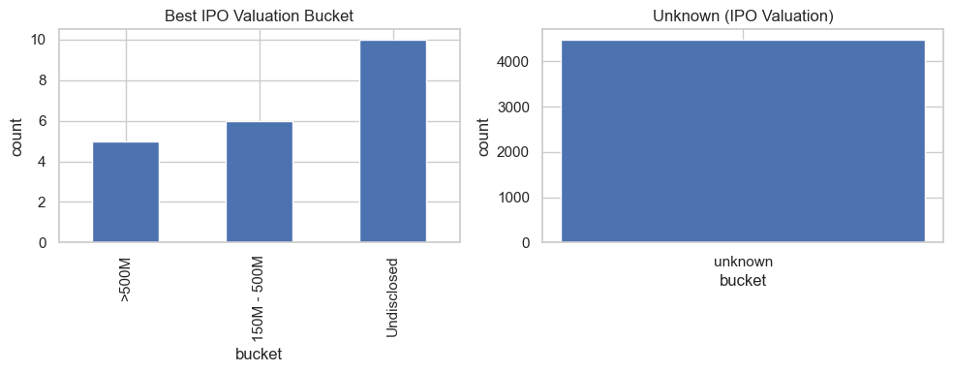
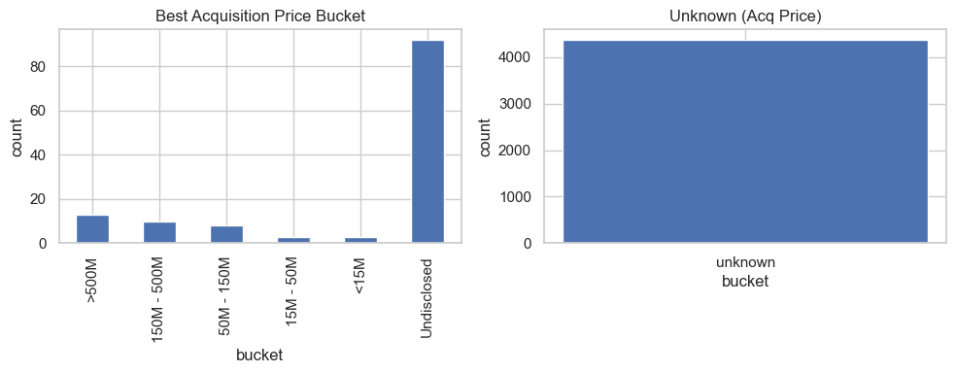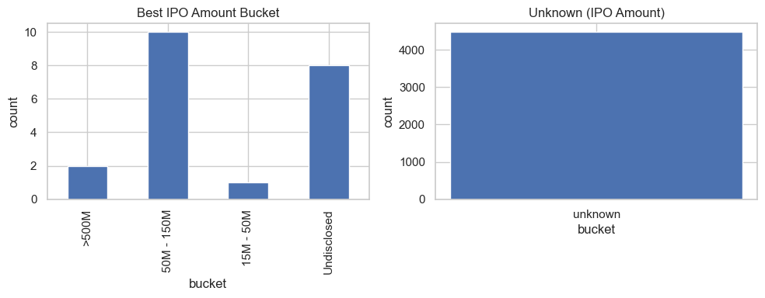

Despite small sample, IPO and Acquisition count does correlate with success rate:
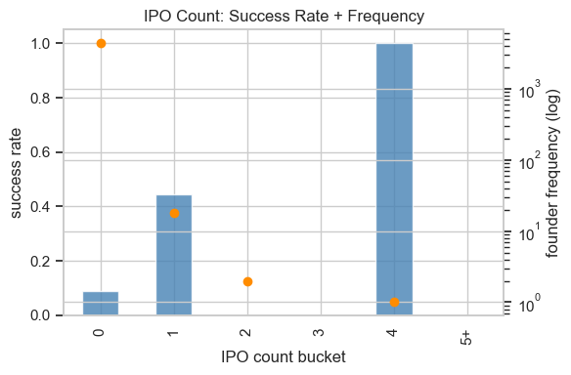
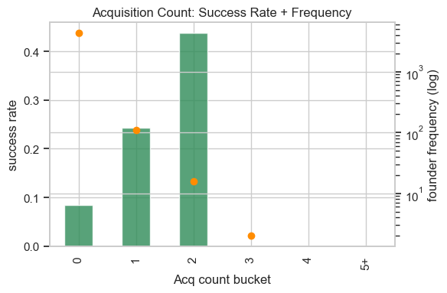

Education/Job Json Data
Education count and job count vs frequency look Poisson distributed:
