● Quiet
Your inbox, without the inbox.
Email is broken. Nobody talks about fixing it correctly.
Most people receive 50–150 emails a day. They open their inbox, scan the noise, miss what matters, and feel vaguely anxious about what they didn’t get to.
Existing solutions such as smarter inboxes, keyboard shortcuts, AI drafting all make the same experience faster. They don’t change the experience.
Quiet does something different. It removes the inbox entirely and replaces it with a decision interface. You don’t scan messages. You see what needs you, what was handled, and what was silenced… and nothing else.

Three things Quiet does

Act | Surfaces only what needs a human decision. Everything else is handled or gone.

Handle | Replies, archives, logs, and routes email autonomously & explains every decision.

Suppress | Mutes, unsubscribes, and auto-removes senders you repeatedly ignore.

The problem with email today
Every productivity tool built around email assumes the same mental model: open your inbox, process what’s inside, feel better. The inbox is the workspace.
This model has three fundamental problems.

01 — Volume is a UI problem, not a filtering problem
- Spam filters and smart folders reduce count but not cognitive load.
- You still open a list. You still scan. You still decide what to skip.
- The act of opening your inbox is itself the failure mode.

02 — AI assistance still requires the human to be present
- Superhuman, Copilot, and Shortwave make you faster at processing email.
- They do not process email without you.
- You are still the operator. The inbox is still your workspace.

03 — Unsubscribe is manual and reactive
- You have to notice a sender, decide to act, find the link, and click it.
- Most people never do. Noise accumulates silently over years.
- No product learns from your ignoring behaviour and acts on it for you.

What people actually want
- To know if anything needs them, without opening a list.
- To trust that important things will never be missed.
- To stop thinking about email entirely.

How Quiet works
Quiet runs a continuous agent loop against your mailbox. You never interact with email directly.

The pipeline
Ingest → Score → Route → Learn
- Ingest: All accounts polled every 5 minutes.
- Score: Sender importance and actionability calculated for every message.
- Route: Each email is assigned to Act, Handle, or Suppress.
- Learn: Behavioural patterns updated continuously from your interactions.

The scoring engine
Every email receives two scores, calculated from behavioural signals:

Sender importance score
- Boss, colleagues → Critical
- Banks, government → High
- Newsletters → Low
- Retail marketing → Suppress

Actionability score
- Needs reply
- Contains deadline
- Contains attachment
- FYI only / Promotional

Ignore threshold logic
Ignores | Action | Detail
5 | Mute | Sender disappears from all views until you re-enable.
10 | Suggest unsubscribe | Quiet surfaces the sender for a one-tap unsubscribe decision.
20 | Auto-unsubscribe | Quiet unsubscribes automatically (requires List-Unsubscribe header).

The agent note
Every autonomous action includes a plain-English explanation of why it was taken. Trust through transparency.

Market opportunity & next steps

Competitive landscape
Product | Removes inbox? | Autonomous? | Learns ignores? | Explains actions?
Gmail / Outlook | No | No | No | No
Superhuman | No | No | No | No
SaneBox | No | Partial | No | No
Lindy | No | Partial | No | No
Quiet | Yes | Yes | Yes | Yes

Why now
- LLM capability: Sender classification, actionability detection, and auto-reply are all solvable with current models at acceptable cost.
- Microsoft Graph API: Single API covers Outlook and M365 which is the dominant email platform in professional life.
- Agent infrastructure: Platforms like AgentMail (YC S25, $6M seed) prove the market is ready for email-native agents.
- Universal pain: Email overload affects every knowledge worker. The TAM is not niche.

Prototype roadmap
Phase 1 | UI prototype | Decision interface with mocked data. Validate concept with 5–10 people.
Phase 2 | Live inbox | Connect Microsoft Graph API. Score real emails from M365 and Outlook.
Phase 3 | Agent actions | Auto-archive, auto-reply, unsubscribe. Behavioural learning loop.
Phase 4 | SaaS evaluation | Onboard 10 beta users. Measure open rate vs. inbox open rate.

Mobile Mock-up:

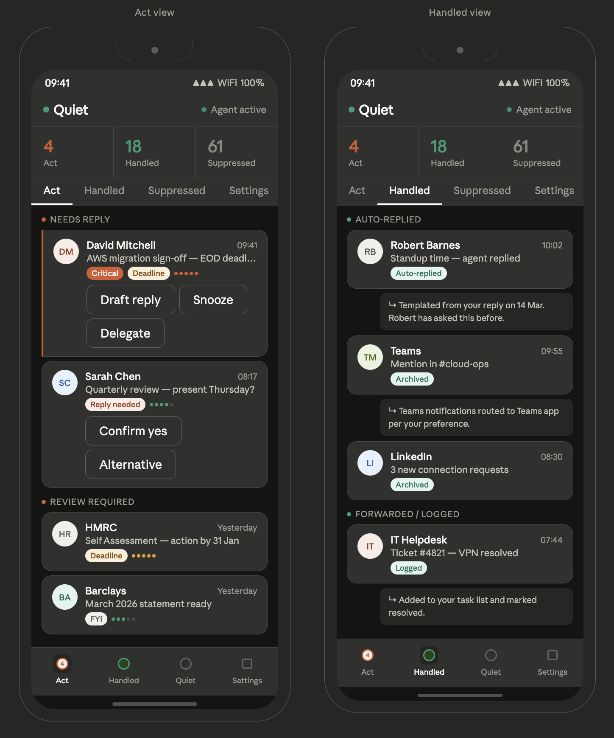
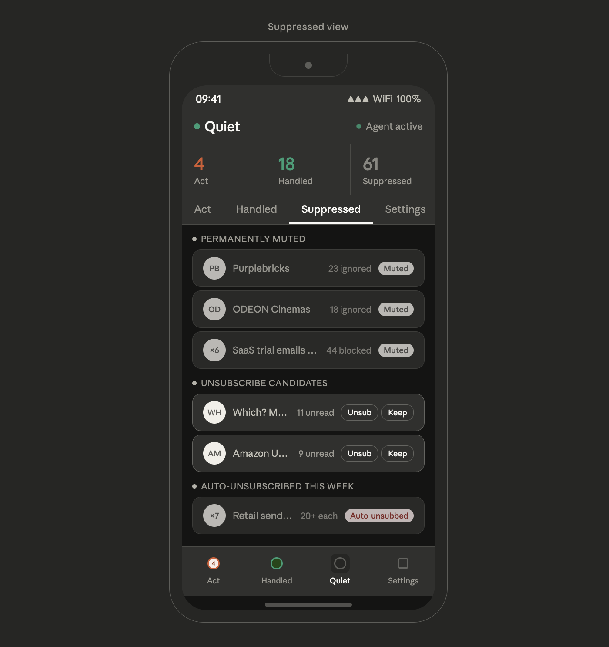

Mobile Mock-up – Quiet Protect:

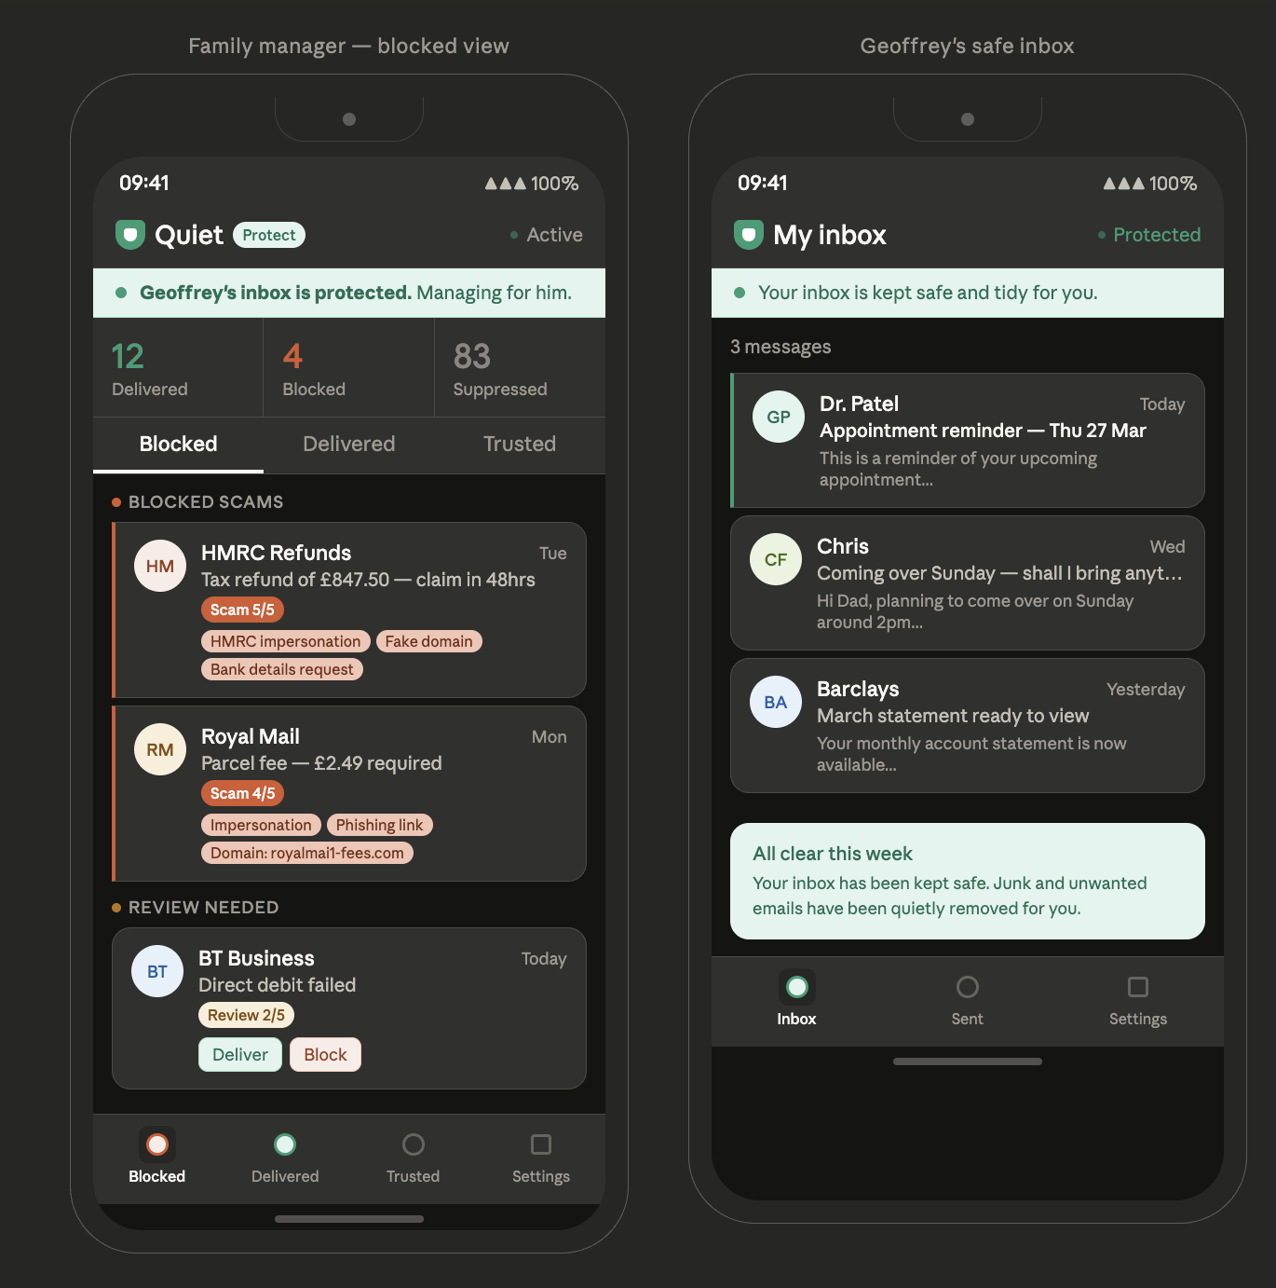
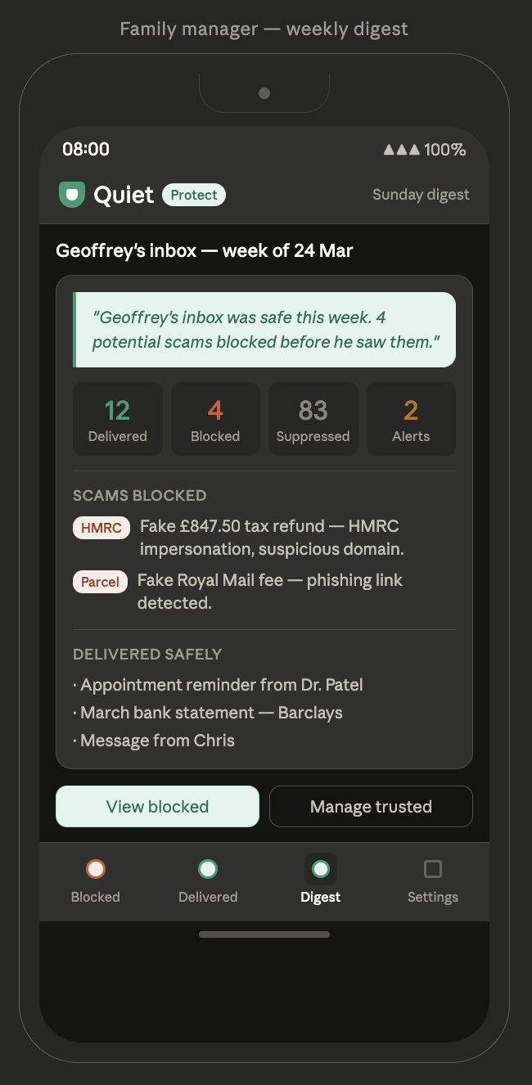

Quiet is a prototype concept. This document is for early feedback only, not for distribution.

