PUBLIC LEARNING RECORD | VERSION 1.0

From Repository to
Live Subdomain
  - Building and deploying the Ticker Bell SWE hero page with GitHub Pages
A first-person project record and reusable public guide covering the code, repository, GitHub Pages, WHOIS.com DNS, custom-domain routing, HTTPS, difficulty, troubleshooting, and lessons learned.
Project: Ticker Bell SWE
Live site: https://swe.tickerbell.biz
Repository: tickerbell-biz/swe-tickerbell
Prepared by: Dr. Mehrzad Abdi Khalife / Ticker Bell Kft.
Date: 31 July 2026
Status: Public draft - editable
Learn deeply. Build boldly.

Table of Contents
Editing note: This is an automatic Word table of contents. After adding or moving sections, press Ctrl+A and F9 in Microsoft Word, or right-click the table and choose Update Field.
Project overview 3
Difficulty assessment 5
Build and deployment record 5
What the page code does 9
Troubleshooting record 11
Lessons I learned 11
Preparing this project for public use 12
Maintenance procedure 13
Recommended next improvements 13
Appendix: exact configuration values 14
Appendix: exact deployed index.html 15
Sources and further reading 17

Project overview
Objective. I wanted a separate software-engineering landing page at swe.tickerbell.biz while keeping tickerbell.biz unchanged. The page needed to be simple, fast, inexpensive to host, easy to update, and public enough to become the starting point for a wider software-engineering learning platform.
Final outcome. A responsive one-page hero site is stored in a public GitHub repository, published from the main branch through GitHub Pages, connected to a WHOIS.com-managed DNS subdomain, and served over HTTPS.
Overall difficulty: 3/5 - moderate for a first-time deployment. Writing the landing page was relatively easy; understanding DNS, the two different CNAME uses, and asynchronous HTTPS certificate provisioning required the most attention.

Final architecture
Item | Project configuration
Main domain | tickerbell.biz - existing website, unchanged
New subdomain | swe.tickerbell.biz - separate SWE landing page
DNS manager | WHOIS.com
Source repository | github.com/tickerbell-biz/swe-tickerbell
Hosting | GitHub Pages
Publishing source | main branch, /(root) folder
Entry file | index.html in the repository root
Repository custom-domain file | CNAME containing swe.tickerbell.biz
DNS record | CNAME: swe -> tickerbell-biz.github.io
Transport security | HTTPS enforced after certificate provisioning

What was created
- A public GitHub repository named swe-tickerbell under the tickerbell-biz organization.
- A single index.html file containing semantic HTML and embedded responsive CSS.
- A repository-root CNAME file containing swe.tickerbell.biz.
- A GitHub Pages deployment sourced from main and /(root).
- A WHOIS.com DNS CNAME record connecting swe to tickerbell-biz.github.io.
- An HTTPS-protected public page with a branded hero section and contact link.
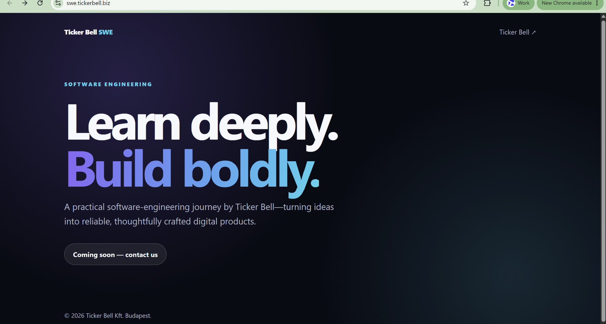
Figure 1. Final live hero section at swe.tickerbell.biz.

Difficulty assessment
The ratings below describe the learning difficulty for a first deployment, not the amount of code. A score of 1 means straightforward; 5 means the stage is likely to cause confusion or require troubleshooting.
Stage | Score | Level | Why
Clarify hosting architecture | 1/5 | Easy | The key decision was to use GitHub Pages for a static landing page.
Create and organize the repository | 1/5 | Easy | The repository name, owner, visibility, and purpose were straightforward.
Build the responsive hero section | 2/5 | Easy-moderate | Only one HTML file and embedded CSS were needed, but visual decisions still required care.
Enable GitHub Pages | 2/5 | Easy-moderate | The source had to be set to the main branch and root folder.
Connect the custom subdomain | 3/5 | Moderate | The DNS CNAME target and the repository CNAME file serve different roles and are easy to confuse.
Wait for and diagnose HTTPS | 4/5 | Most difficult | DNS could be correct while GitHub was still issuing the certificate, temporarily producing a hostname-mismatch error.
Overall first-time experience | 3/5 | Moderate | The coding was simple; the main challenge was understanding the boundaries between GitHub, DNS, and certificate provisioning.
Main insight: The hardest part was not HTML or CSS. It was recognizing that source control, hosting, DNS routing, and TLS certificates are separate systems that become ready at different times.

Build and deployment record
The following sequence records the actual workflow used for this project. It is also the recommended order for another GitHub Pages subdomain deployment.

Step 1: Define the hosting model
Difficulty: 1/5 Purpose: Separate the new SWE page from the existing company website.
- Keep tickerbell.biz as the main company site.
- Use swe.tickerbell.biz as a separate website with its own source repository and deployment.
- Choose GitHub Pages because the first version is a static landing page using HTML and CSS only.
Result: The new page could evolve independently without changing the main website.

Step 2: Create the public repository
Difficulty: 1/5 Purpose: Give the website a permanent, version-controlled home.
- Owner: tickerbell-biz.
- Repository name: swe-tickerbell.
- Description: Software engineering learning platform for swe.tickerbell.biz.
- Visibility: Public, which supports public learning and GitHub Pages on the free organization plan.
- Default branch: main.
Result: The repository became the single source of truth for the landing page.
Naming lesson: The repository does not need to be named swe.tickerbell.biz. The custom-domain setting connects the repository to the subdomain later. A short project name such as swe-tickerbell is clearer for source control.

Step 3: Build the hero page
Difficulty: 2/5 Purpose: Create a complete, responsive first screen with no build system.
- Create index.html at the top level of the main branch.
- Add the document metadata, viewport setting, page title, and search description.
- Use semantic nav, main, and footer elements.
- Embed the CSS in the same file to keep the first deployment simple.
- Use CSS variables for the color system and clamp() for responsive heading and body sizes.
- Add a link back to tickerbell.biz and a temporary mailto contact button.
Result: GitHub Pages had a valid entry file and the hero page rendered responsively without external dependencies.
Minimal repository structure
Repository root
├── index.html
└── CNAME

Step 4: Add the repository CNAME file
Difficulty: 2/5 Purpose: Tell GitHub Pages which custom hostname belongs to this site.
- Create a plain text file named CNAME in the repository root.
- Place exactly one hostname in the file: swe.tickerbell.biz.
- Do not add https://, a path, or additional text.
Result: The repository permanently recorded the desired custom domain.
Exact CNAME file content
swe.tickerbell.biz

Step 5: Enable GitHub Pages
Difficulty: 2/5 Purpose: Publish the repository as a website.
- Open the repository and go to Settings > Pages.
- Under Build and deployment, select Deploy from a branch.
- Select the main branch.
- Select the /(root) folder.
- Save the publishing source.
- In Custom domain, enter swe.tickerbell.biz and save.
Result: GitHub started the Pages build and associated the deployment with the custom subdomain.

Step 6: Create the DNS record in WHOIS.com
Difficulty: 3/5 Purpose: Route the public subdomain to GitHub Pages.
- Open the DNS management area for tickerbell.biz.
- Add a CNAME record.
- Set Host Name to swe.
- Set Value or Destination to tickerbell-biz.github.io.
- Keep the provider's default TTL; 38400 was acceptable in the interface used.
- Save the record and leave the main domain's existing records unchanged.
Result: DNS began resolving swe.tickerbell.biz to the GitHub Pages organization hostname.
Exact DNS mapping
Type: CNAME
Host: swe
Target: tickerbell-biz.github.io
TTL: provider default
Critical distinction: The repository CNAME file contains swe.tickerbell.biz, but the WHOIS.com DNS CNAME record points to tickerbell-biz.github.io. Reversing or combining these values breaks the setup.

Step 7: Wait for DNS and deployment propagation
Difficulty: 3/5 Purpose: Allow distributed systems to recognize the new configuration.
- Return to Settings > Pages and refresh the page.
- Wait for GitHub to show DNS check successful.
- Open the custom domain in a browser and distinguish page errors from certificate errors.
- Avoid repeatedly changing a correct DNS record while propagation is still in progress.
Result: GitHub confirmed that the custom hostname resolved correctly.

Step 8: Provision and enforce HTTPS
Difficulty: 4/5 Purpose: Protect traffic and make the final URL trustworthy.
- After the DNS check, allow GitHub time to request and install the TLS certificate.
- Expect the Enforce HTTPS option to be temporarily unavailable while provisioning runs.
- When the option becomes available, select Enforce HTTPS.
- If provisioning appears stuck, remove and re-enter the custom domain in GitHub Pages settings to restart the request; do not delete a correct DNS record.
Result: HTTP requests redirect to HTTPS and the browser can validate the certificate for swe.tickerbell.biz.

Step 9: Verify the live result
Difficulty: 2/5 Purpose: Confirm that the complete path works from source to browser.
- Confirm the GitHub Pages source is main and /(root).
- Confirm DNS check successful is visible.
- Confirm Enforce HTTPS is selected.
- Open https://swe.tickerbell.biz in a fresh browser session.
- Check the navigation link, heading, responsive layout, contact button, and footer.
Result: The hero section was online at the intended custom HTTPS subdomain.

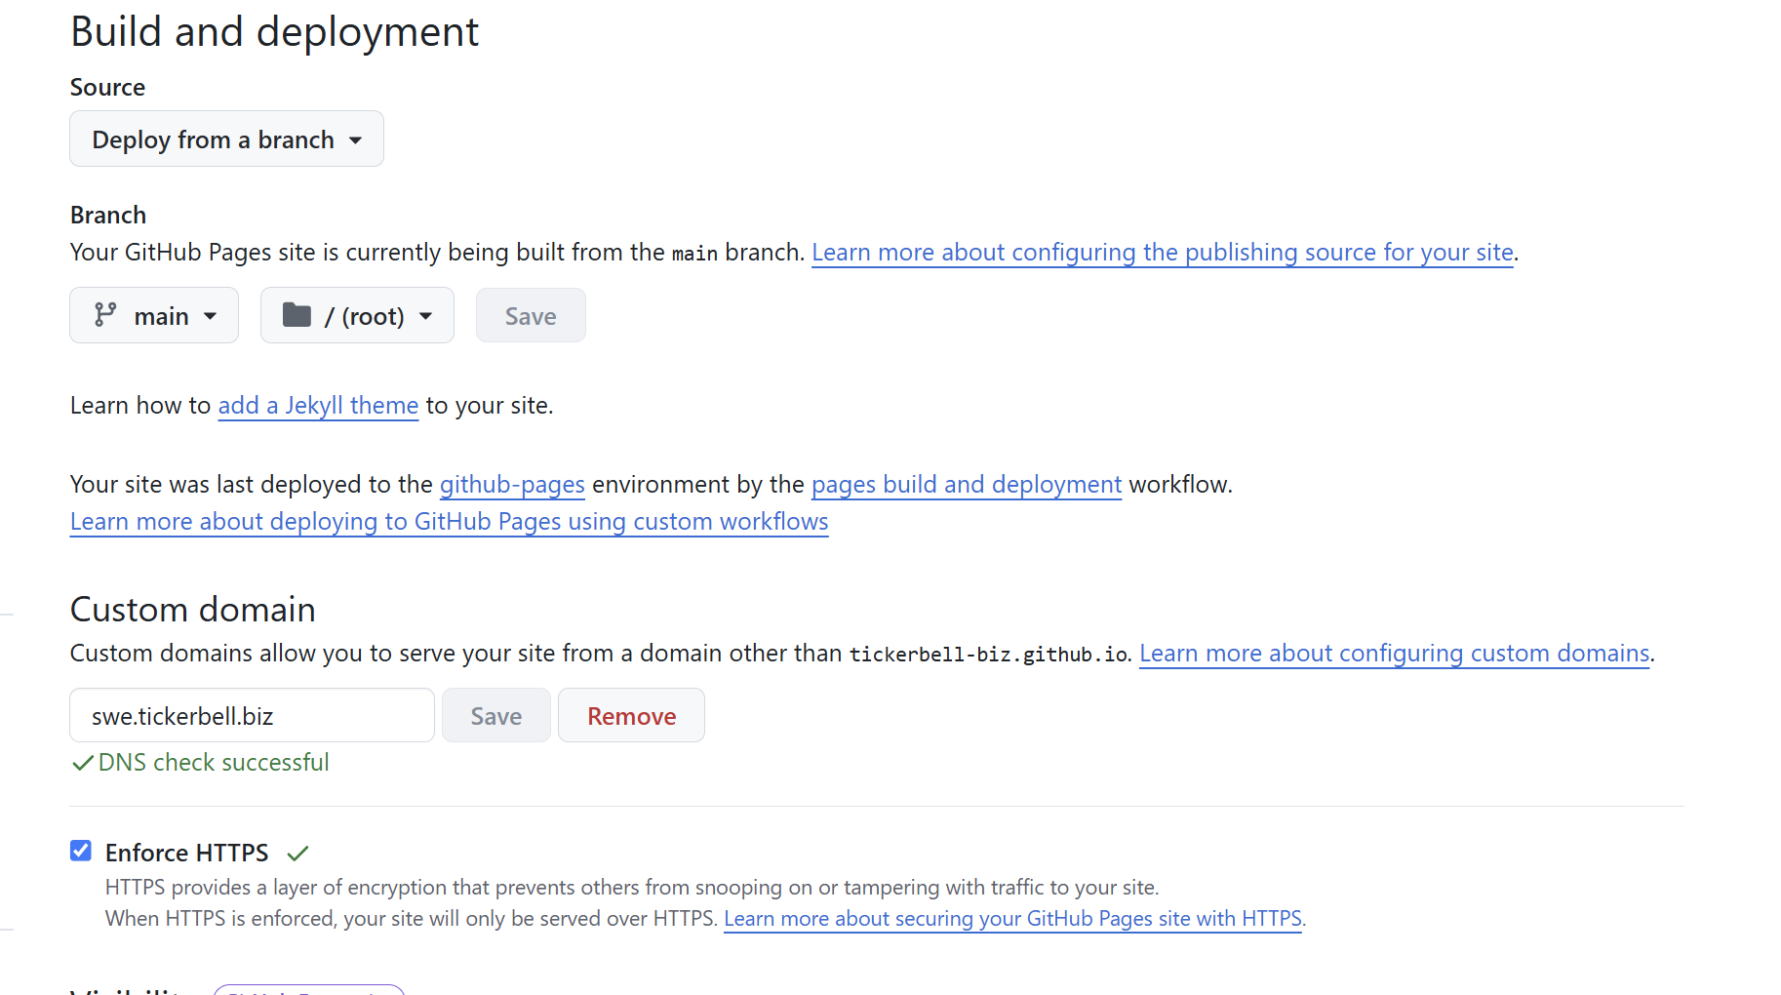
Figure 2. Final GitHub Pages configuration: main branch, root folder, successful DNS check, custom domain, and enforced HTTPS.

What the page code does

Document and metadata
- The HTML5 doctype gives the browser standards-mode rendering.
- The UTF-8 declaration supports the brand text and punctuation.
- The viewport meta tag makes responsive sizing behave correctly on mobile devices.
- The description meta tag gives search engines a concise summary.
- The title identifies the browser tab and search result title.

Visual system
- CSS custom properties centralize the dark background, text, muted text, purple accent, and cyan accent.
- Two radial gradients create depth without image files or external requests.
- The layout uses a maximum width with responsive side margins.
- The hero heading uses clamp() so it grows with the viewport but stays within safe minimum and maximum sizes.
- The highlighted phrase uses a purple-to-cyan text gradient that matches the Ticker Bell SWE identity.

Interaction and structure
- The navigation links the SWE project back to the main Ticker Bell website.
- The call-to-action uses a mailto link as a simple temporary contact mechanism.
- The button hover state provides lightweight visual feedback.
- Semantic nav, main, and footer elements make the document structure easier to understand and maintain.
- No JavaScript, package manager, framework, or server is required for the first version.
Platform limitation: GitHub Pages is static hosting. It can serve HTML, CSS, JavaScript, images, and generated files, but it does not run a server-side Python, PHP, or database application. A future backend should be deployed separately and called through an API.

Troubleshooting record
The temporary certificate error was the most important diagnostic lesson. A working DNS path can exist before a valid HTTPS certificate is available.
Symptom or mistake | What it means | Correct action
Subdomain points to itself | A DNS loop; the page will not resolve correctly. | Use CNAME host swe with target tickerbell-biz.github.io.
DNS target includes https:// or /swe-tickerbell | CNAME values are hostnames, not full URLs or repository paths. | Use tickerbell-biz.github.io only.
Pages source is not selected | GitHub has files but no publishing source. | Settings > Pages > Deploy from a branch > main > /(root).
Custom domain is absent from GitHub | DNS may point to GitHub, but GitHub does not know which site should answer. | Set swe.tickerbell.biz in Pages settings and keep the repository-root CNAME file.
DNS check succeeds but HTTPS is unavailable | Certificate provisioning is still running. | Wait, refresh, and enable Enforce HTTPS when available.
502 certificate hostname mismatch | The browser reached an endpoint whose certificate was not yet ready for the custom hostname. | Treat it as a provisioning state if DNS is correct; do not rewrite working page code.
Latest edit is not visible | Pages deployment or browser caching has not caught up. | Check the Pages deployment, wait several minutes, then hard-refresh.
Recorded incident: The cloud browser temporarily showed 502 Bad Gateway - Certificate verify failed: hostname mismatch. This did not indicate broken HTML. The DNS route had reached GitHub, but certificate provisioning for the custom hostname had not finished. After GitHub completed provisioning and HTTPS was enforced, the site loaded normally.

Lessons I learned
- A domain, DNS, hosting, and source control are different layers. WHOIS.com managed the DNS record, GitHub stored the code, and GitHub Pages served the website.
- Start with the hosting destination, then configure DNS. I needed the correct GitHub Pages hostname before I could create the DNS CNAME record.
- There are two CNAME concepts in this project. The repository CNAME file declares the public custom domain; the DNS CNAME record points that domain to GitHub.
- A CNAME target is a hostname, not a URL. It must not include https://, a repository path, or a trailing page path.
- Repository naming and domain naming are independent. The readable repository name swe-tickerbell works even though the public hostname is swe.tickerbell.biz.
- The root entry file matters. Publishing main/(root) requires index.html at the root of main.
- Correct configuration does not become globally visible instantly. DNS propagation, Pages deployment, browser caching, and certificate provisioning each have their own timing.
- A certificate error can be a waiting-state signal. When DNS is already successful, a hostname mismatch can mean TLS provisioning is still in progress.
- Static hosting is an excellent first step. For a hero page, avoiding a framework and build pipeline kept the project small, understandable, and fast.
- Public repositories require publication discipline. Secrets, private keys, passwords, customer information, and unpublished material must never be committed.
- Responsive design should be built in from the beginning. Viewport metadata, flexible widths, and clamp() avoided a desktop-only layout.
- Documentation should be created while the decisions are still fresh. Recording exact values and errors makes the next deployment much faster and turns personal experience into reusable knowledge.

Preparing this project for public use
The repository is already public, but a public project should explain how others may understand, reuse, and contribute to it. The following items are recommended before actively promoting it.
- Add a README.md explaining the purpose, live URL, local preview method, file structure, and update workflow.
- Choose a code license. MIT is a common permissive option for a simple website, but the final choice should match Ticker Bell's intended reuse policy.
- Choose a document/content license if this guide is published separately. CC BY 4.0 is a practical option when attribution is desired.
- Add CONTRIBUTING.md if outside contributions will be accepted.
- Add a CODE_OF_CONDUCT.md if a contributor community is expected.
- Verify tickerbell.biz in the GitHub organization to reduce custom-domain takeover risk.
- Keep the repository free of secrets and personal or customer data.
- Replace the visible email link with a protected contact method if spam becomes a problem.
- Add descriptive alternative text to future content images and test keyboard navigation and color contrast.
- Add a privacy-aware analytics solution only after deciding what data is necessary and publishing an appropriate privacy notice.
- Add a custom 404 page, favicon, Open Graph image, canonical URL, and social metadata.
- Test the page on mobile, tablet, desktop, and multiple browsers after each meaningful visual update.
Publication note: This document records a real project and includes public company, domain, repository, and contact information. Before external publication, recheck every screenshot and code block for information that should not be public.

Maintenance procedure

Routine content update
- Edit index.html on a new branch or through a reviewed local workflow.
- Preview the page locally before merging to main.
- Check desktop and mobile layouts.
- Merge or commit the approved change to main.
- Wait for the GitHub Pages deployment to finish.
- Open the live HTTPS domain and hard-refresh.
- Record major changes in the README or a changelog.

Configuration checks after a domain or repository change
- The repository root still contains index.html and CNAME.
- The CNAME file still contains only swe.tickerbell.biz.
- Pages still publishes from main and /(root).
- WHOIS.com still has swe as a CNAME to tickerbell-biz.github.io.
- GitHub still reports DNS check successful.
- Enforce HTTPS remains enabled.
- The final live URL displays the intended repository.

Recommended next improvements
The hero page is a solid deployment foundation. The next work should increase usefulness without making the architecture unnecessarily complex.
Area | Next improvement
Content | Add a clear learning roadmap, current projects, and recent lesson entries.
Navigation | Add About, Learning Log, Projects, Resources, and Contact sections or pages.
Quality | Add HTML validation, link checking, and responsive screenshot tests in GitHub Actions.
Accessibility | Test keyboard focus, contrast, heading order, reduced-motion behavior, and screen-reader labels.
Search and sharing | Add canonical URL, structured metadata, Open Graph image, and sitemap.
Operations | Add README, license, issue templates, and a lightweight release/change log.
Architecture | Keep the front end static until a real backend need appears; then host the API separately.

Appendix: exact configuration values
Item | Project configuration
GitHub owner | tickerbell-biz
Repository | swe-tickerbell
Repository visibility | Public
Branch | main
Pages folder | /(root)
Entry file | index.html
Custom domain | swe.tickerbell.biz
Repository CNAME content | swe.tickerbell.biz
DNS type | CNAME
DNS host/name | swe
DNS target/value | tickerbell-biz.github.io
Final URL | https://swe.tickerbell.biz
HTTPS | Enforced

Appendix: exact deployed index.html
The following is the exact source retrieved from the public main branch on 31 July 2026. It can be edited directly in the repository or locally and then committed.
index.html
<!DOCTYPE html>
<html lang="en">
<head>
<meta charset="UTF-8">
<meta name="viewport" content="width=device-width, initial-scale=1.0">
<meta name="description" content="Ticker Bell Software Engineering — learning, building, and shipping well-crafted software.">
<title>Ticker Bell SWE | Software Engineering</title>
<style>
:root {
color-scheme: dark;
--bg: #080b14;
--surface: #111728;
--text: #f7f8fc;
--muted: #aeb7ca;
--accent: #8b5cf6;
--accent-2: #22d3ee;
}
* { box-sizing: border-box; }
body {
margin: 0;
min-height: 100vh;
font-family: Inter, ui-sans-serif, system-ui, -apple-system, BlinkMacSystemFont, "Segoe UI", sans-serif;
color: var(--text);
background:
radial-gradient(circle at 20% 20%, rgba(139, 92, 246, .22), transparent 32rem),
radial-gradient(circle at 85% 80%, rgba(34, 211, 238, .14), transparent 28rem),
var(--bg);
}
nav, main, footer { width: min(1120px, calc(100% - 40px)); margin-inline: auto; }
nav {
height: 88px;
display: flex;
align-items: center;
justify-content: space-between;
}
.brand { font-weight: 800; letter-spacing: -.03em; }
.brand span { color: var(--accent-2); }
nav a, .button {
color: var(--text);
text-decoration: none;
}
nav a { color: var(--muted); }
main {
min-height: calc(100vh - 158px);
display: grid;
align-content: center;
padding: 72px 0 110px;
}
.eyebrow {
color: var(--accent-2);
font-size: .82rem;
font-weight: 800;
letter-spacing: .16em;
text-transform: uppercase;
}
h1 {
max-width: 900px;
margin: 18px 0 24px;
font-size: clamp(3.4rem, 9vw, 7.5rem);
line-height: .93;
letter-spacing: -.065em;
}
h1 em {
font-style: normal;
background: linear-gradient(100deg, var(--accent), var(--accent-2));
-webkit-background-clip: text;
background-clip: text;
color: transparent;
}
.intro {
max-width: 680px;
margin: 0 0 36px;
color: var(--muted);
font-size: clamp(1.05rem, 2vw, 1.3rem);
line-height: 1.65;
}
.button {
display: inline-flex;
width: fit-content;
padding: 14px 20px;
border: 1px solid rgba(255,255,255,.18);
border-radius: 999px;
background: rgba(255,255,255,.07);
font-weight: 750;
transition: transform .2s ease, background .2s ease;
}
.button:hover { transform: translateY(-2px); background: rgba(255,255,255,.12); }
footer {
min-height: 70px;
color: var(--muted);
font-size: .9rem;
}
</style>
</head>
<body>
<nav>
<div class="brand">Ticker Bell <span>SWE</span></div>
<a href="https://tickerbell.biz">Ticker Bell ↗</a>
</nav>
<main>
<div class="eyebrow">Software Engineering</div>
<h1>Learn deeply.<br><em>Build boldly.</em></h1>
<p class="intro">A practical software-engineering journey by Ticker Bell—turning ideas into reliable, thoughtfully crafted digital products.</p>
<a class="button" href="mailto:admin@mehr.gallery">Coming soon — contact us</a>
</main>
<footer>© 2026 Ticker Bell Kft. Budapest.</footer>
</body>
</html>

Sources and further reading
Ticker Bell SWE public repository - project source, index.html, and CNAME. Accessed 31 July 2026.
GitHub Docs: Creating a GitHub Pages site - repository, entry file, publishing source, deployment, and static-hosting guidance. Accessed 31 July 2026.
GitHub Docs: Managing a custom domain for a GitHub Pages site - custom subdomain, CNAME, DNS propagation, and domain-security guidance. Accessed 31 July 2026.
GitHub Docs: Securing a GitHub Pages site with HTTPS - HTTPS enforcement and certificate-provisioning troubleshooting. Accessed 31 July 2026.
End of record: This guide is designed to remain editable. Update the version number, date, screenshots, code appendix, and table of contents whenever the architecture or live page changes.

