# วงจรประตูนิรภัย

## สมาชิกในกลุ่ม

* นาย
* นางสาว

## โครงสร้างระบบ

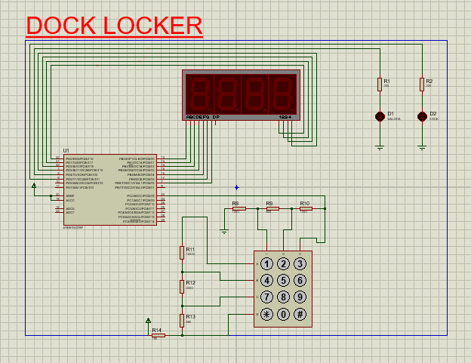

## หลักการทำงาน

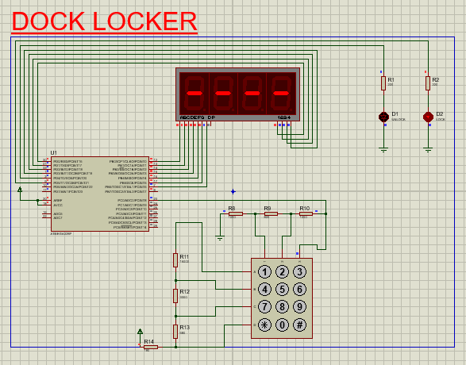

เมื่อเปิดโปรแกรม

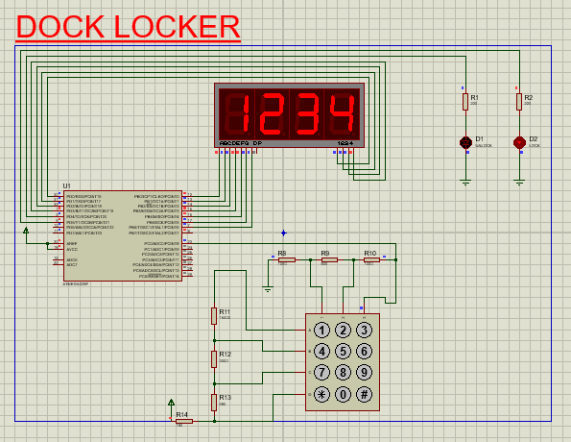

หลักจากที่กด password

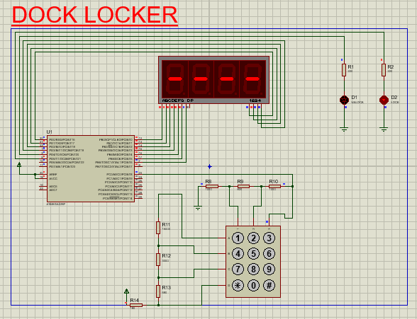

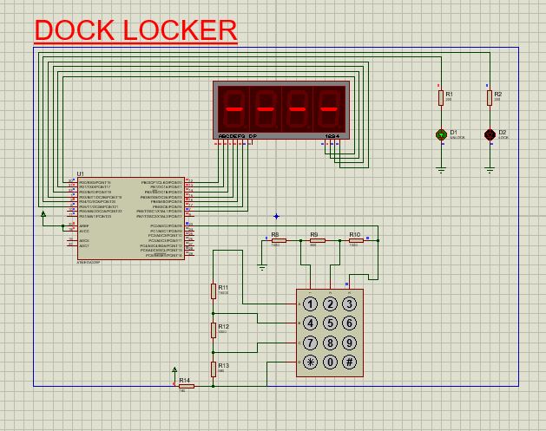

หลังจากกด ตรวจสอบ password ( ปุ่ม # ) หาก password ตรงออกเขียว หากไม่ ออกแดง

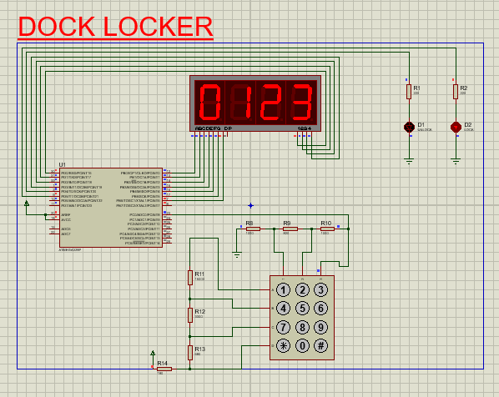

เมื่อกดตั้งค่า password ( ปุ่ม * ) หลังจากที่กดตั้งค่าครบ 4 หลักโปรแกรมจะกลับไปหาเริ่มต้นโปรแกรม

## สรุปเทคนิคที่ใช้

## Source code

#include <inttypes.h>

#include <avr/io.h>

#include <avr/interrupt.h>

#include <avr/sleep.h>

#define TURN_ALL_LED_OFF 0xFF

#define INTERVAL_time 65528

unsigned int ACCUMULATED, DIVISOR, QUOTIENT, DECODE, DECODED, STATE, SWITCH;

volatile unsigned int DISPLAY_COL, INPUT_COL, SET_PWD_COL, DISPLAY_PWD[4] = {16,16,16,16}, SET_PWD[4] = {0,1,2,3}, SET_TIMEOUT_PWD;

unsigned char TABLE7SEG[] ={

0b00111111, // 0

0b00000110, // 1

0b01011011, // 2

0b01001111, // 3

0b01100110, // 4

0b01101101, // 5

0b01111101, // 6

0b00100111, // 7

0b01111111, // 8

0b01101111, // 9

0b01110111, // A

0b11111100, // b

0b00111001, // C

0b00111111, // D

0b01111001, // E

0b01110001, // F

0b01000000, // -

0b00000000 }; // turn off all segment

ISR(TIMER1_OVF_vect){

TCNT1 = INTERVAL_time;

SET_TIMEOUT_PWD++;

if(SWITCH){

PORTD = 1 << DISPLAY_COL;

PORTB = ~TABLE7SEG[SET_PWD[DISPLAY_COL]];

DISPLAY_COL = (DISPLAY_COL + 1)%4;

}

else{

PORTD = 1 << DISPLAY_COL;

PORTB = ~TABLE7SEG[DISPLAY_PWD[DISPLAY_COL]];

DISPLAY_COL = (DISPLAY_COL + 1)%4;

}

if(STATE) PORTD |= 0b00010000; // to check password ture or false

else PORTD |= 0b00100000;

if(SET_TIMEOUT_PWD > 1000){ // when over at 1000 time will set STATE = 0 and SET_TIMEOUT_PWD for back to normal state

STATE = 0;

SET_TIMEOUT_PWD = 0;

}

}

ISR(ADC_vect){

if(ADCH > 9){

ACCUMULATED += ADCH;

DIVISOR++;

}

else {

ACCUMULATED = 0;

DIVISOR = 0;

}

if(DIVISOR == 10){

QUOTIENT = ACCUMULATED/DIVISOR;

if ((QUOTIENT>9) && (QUOTIENT<16)) DECODED = 1 ;

else if ((QUOTIENT>18) && (QUOTIENT<26)) DECODED = 2 ;

else if ((QUOTIENT>29) && (QUOTIENT<37)) DECODED = 3 ;

else if ((QUOTIENT>46) && (QUOTIENT<53)) DECODED = 4 ;

else if ((QUOTIENT>74) && (QUOTIENT<81)) DECODED = 5 ;

else if ((QUOTIENT>99) && (QUOTIENT<107)) DECODED = 6 ;

else if ((QUOTIENT>133) && (QUOTIENT<141)) DECODED = 7 ;

else if ((QUOTIENT>169) && (QUOTIENT<177)) DECODED = 8 ;

else if ((QUOTIENT>192) && (QUOTIENT<199)) DECODED = 9 ;

else if ((QUOTIENT>212) && (QUOTIENT<220)) DECODED = 10 ;

else if ((QUOTIENT>228) && (QUOTIENT<236)) DECODED = 0 ;

else if ((QUOTIENT>236) && (QUOTIENT<244)) DECODED = 11 ;

else DECODED = 16 ;

if(DECODED < 10){ // hit keypad

if(SWITCH){

SET_PWD[SET_PWD_COL] = DECODED;

SET_PWD_COL = SET_PWD_COL + 1;

if(SET_PWD_COL == 4){

SET_PWD_COL = 0;

SWITCH = 0;

}

}

else{

DISPLAY_PWD[INPUT_COL] = DECODED;

INPUT_COL = (INPUT_COL + 1)%4;

}

}

if(DECODED == 10){ // set password

SWITCH = 1;

}

if(DECODED == 11){ // check password

if(DISPLAY_PWD[0] == SET_PWD[0] &&

DISPLAY_PWD[1] == SET_PWD[1] &&

DISPLAY_PWD[2] == SET_PWD[2] &&

DISPLAY_PWD[3] == SET_PWD[3]){

STATE = 1;

DISPLAY_PWD[0] = 16;

DISPLAY_PWD[1] = 16;

DISPLAY_PWD[2] = 16;

DISPLAY_PWD[3] = 16;

}

else{

STATE = 0;

DISPLAY_PWD[0] = 16;

DISPLAY_PWD[1] = 16;

DISPLAY_PWD[2] = 16;

DISPLAY_PWD[3] = 16;

}

}

}

}

int main(void)

{

DDRB = 0xFF;

DDRD = 0xFF;

PORTB = TURN_ALL_LED_OFF;

ADMUX = 0b00100000;

//[7:6] AREF Pin

//[5] ADLR1

//[3:0] ADC0

ADCSRA = 0b10101101;

ADCSRB = 0b00000110; // Time1 OVF

TIMSK1 = 0x01;

TCCR1A = 0x00;

TCCR1B = 0x05;

cli();

TCNT1 = INTERVAL_time;

sei();

DIVISOR = 0;

DISPLAY_COL = 0;

INPUT_COL = 0;

STATE = 0;

SWITCH = 0;

while(1);

}