
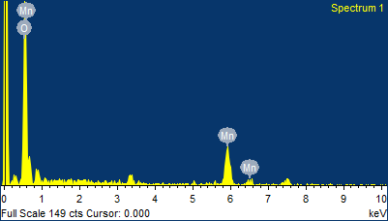
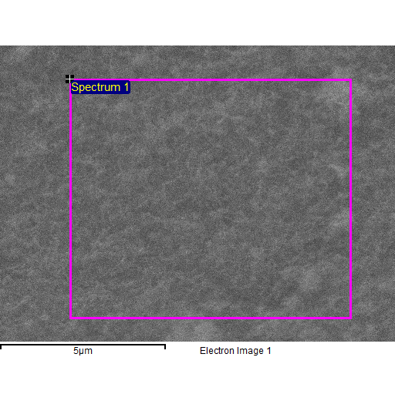
Spectrum processing :
Peak possibly omitted : 3.311 keV

Processing option : All elements analyzed (Normalised)
Number of iterations = 2

Standard :
O SiO2 1-Jun-1999 12:00 AM
Mn Mn 1-Jun-1999 12:00 AM

Element | Weight% | Atomic%
O K | 49.74 | 77.27
Mn K | 50.26 | 22.73
Totals | 100.00

Comment:
1/13/2026 10:30:32 AM
Project 1

