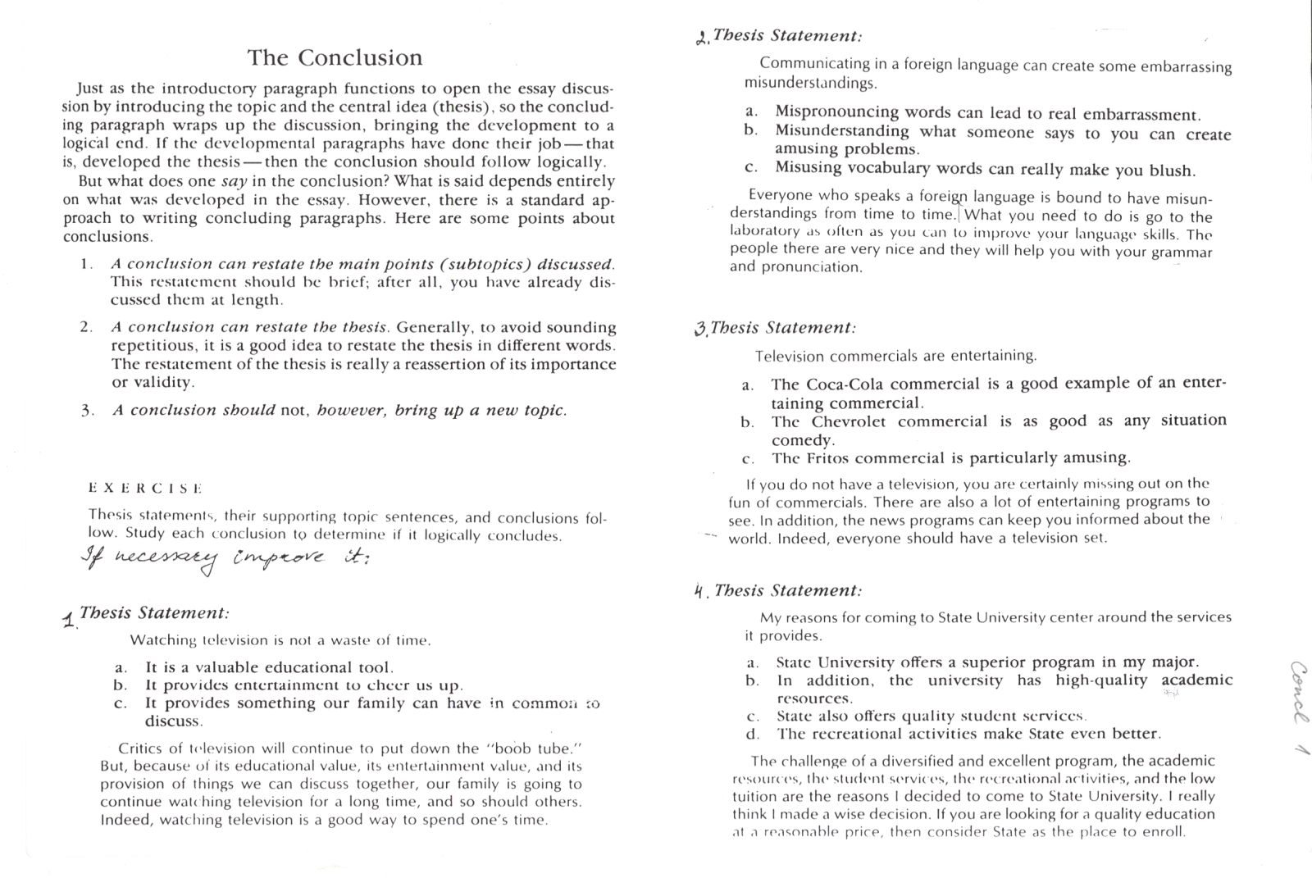

1. No logical conclusion. Developing other ideas.

2. Good conclusion.

3. Not an ideal conclusion. Sentence In addition is not needed

4. Good conclusion.