CS/ECE/ISyE 524 Introduction to Optimization L. Lessard, Spring 2017

**Problem:** A rubber is a team contest consisting of a sequence of successive games won by the side that wins a majority of the games. Unlike singles matches, team clashes (rubbers) do not depend solely on individual prowess. Rubbers can be won purely on the basis of a match-up strategy (who plays whom), despite being at a disadvantage in terms of individual ability or expertise. One example of this scenario was the 2016 Chess Olympiad where the Russian team, despite being top seeds, was beaten by Ukraine.

Our project is to build an optimization model to determine the best match-up strategy for a team in a sequence of individual games (chess, tennis, boxing and the like).

**Progress:**

**Stage 1:** Determine a team composition and order for a chess match to maximize their score (chances of winning) with an assumption that the team has obtained/predicted their opponent team's strategy.

1. Assignment problem without order (only 3 values: win, lose, draw)
2. Assignment problem with order, fix opponent’s plan
3. Probabilistic model for score, fix opponent’s plan

**Stage 2:** Determining winning strategies without assumption of opposition strategy using Nash equilibrium to choose the best strategy for both teams (primal/dual formulation)

* Define score function: given 2 strategies, return the expected score of our team
* Define a function for Nash equilibrium (A, B):
  + A: Team 1’s set => n! strategy (permutation) => probability p
    - Maximin (primal)
  + B: Team 2’s set
    - Minimax (dual)

Having same optimal score? Depends.

* + Get the optimal score and best strategy (highest p)

**Stage 3:** Optimizing team composition to maximize winning probability

1. Choosing the optimum team composition from a pool of available players (like basketball, soccer) under budget constraints under the assumption that the best players are also the most expensive.

Max (over all possible set of 4 players)

Max score (using Nash equilibrium for 4! strategies vs P(6, 4) opponent’s )

- alpha * budget

* Define score functions
* Define price and budgets? Real data
* Alpha => Pareto graph

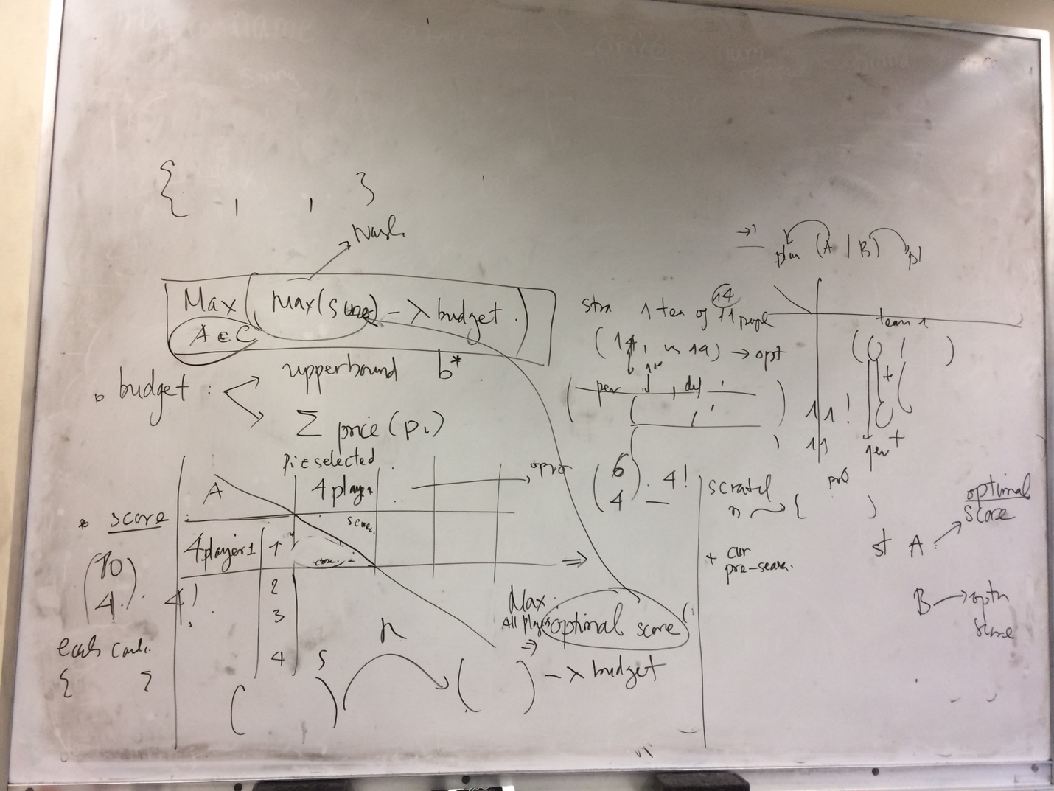

1. Pre-season (add players to current team) ~ more realistic

**Corollary:**

1. Finding any interesting result?
2. Simple example: horse racing
3. Consider reverse players (chess: 4 + 2, soccer: 11 + 3)
4. Score model for other sports
5. Apply the model to assist coaches to quickly modify team’s strategy during the match as and when the result of each round is known.

**Data:** Match specification, team players list and Elo score from Chess Olympiad 2016

(<http://chesshive.com/live/russia-vs-usa-round-8-baku-2016-chess-olympiad> ).

1. Type of model (LP, QP, MIP, etc.) and an approximate count of the number of variables and constraints in the model:

* Type of model: Linear programing for Stage 1. May require MIP formulation for other parts.
* Mathematical model would be probabilistic in nature due to the uncertainty of winning a match. The probabilities of head-to-head superiority would be based on ranks of players.
* The number of variables: 48 - 60
* The number of constraints: 60