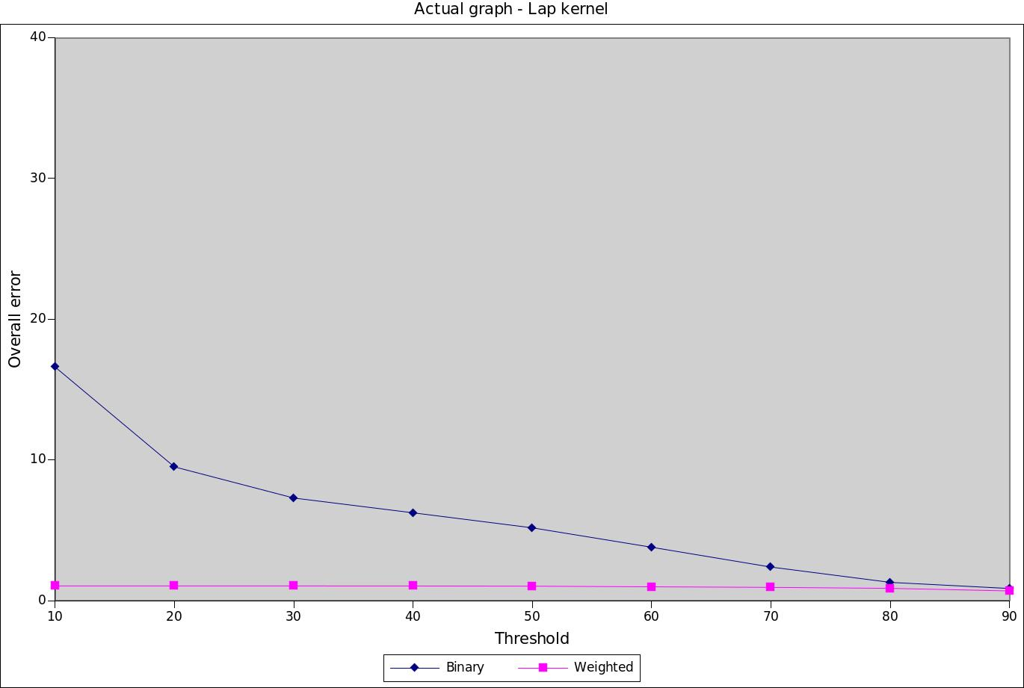
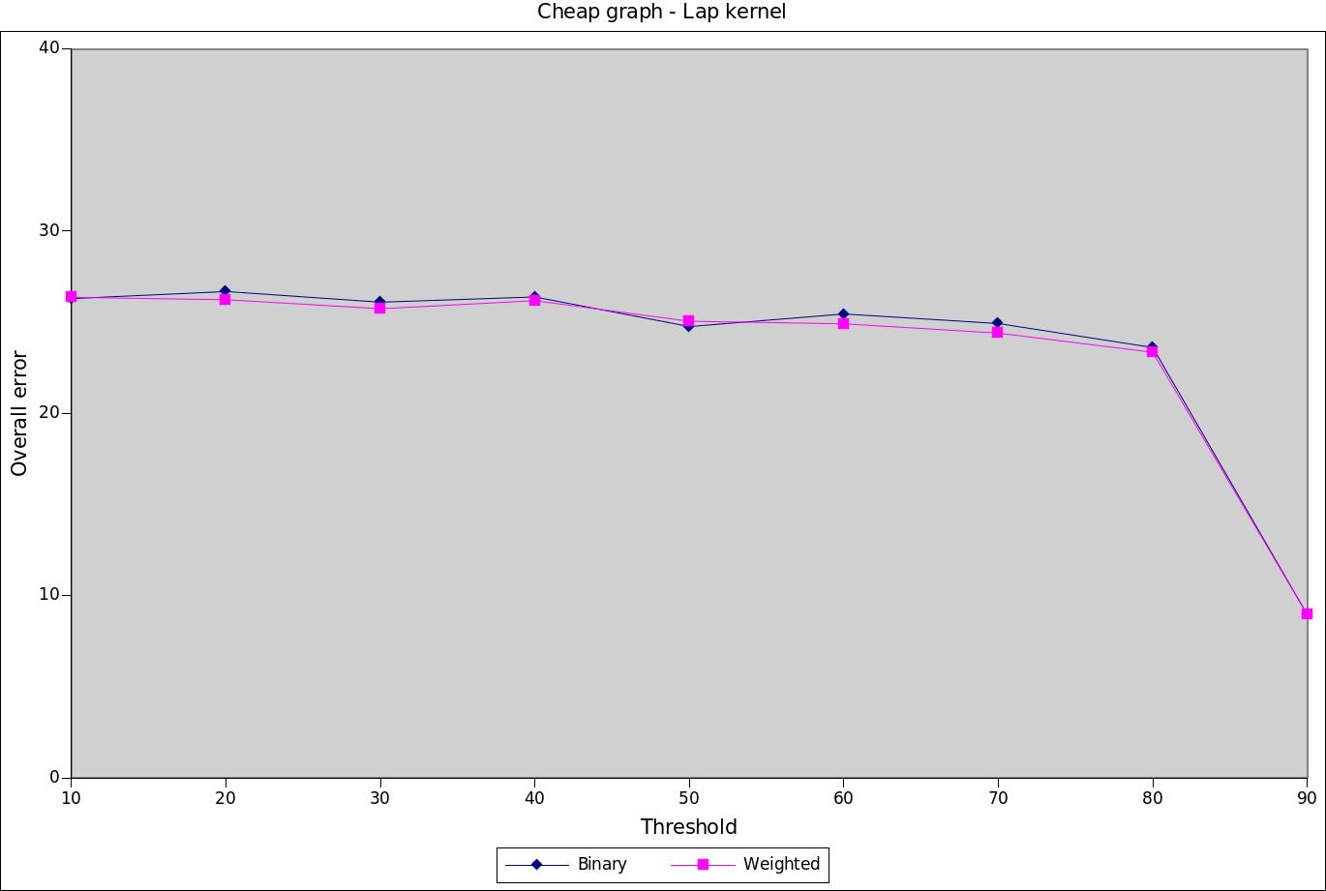
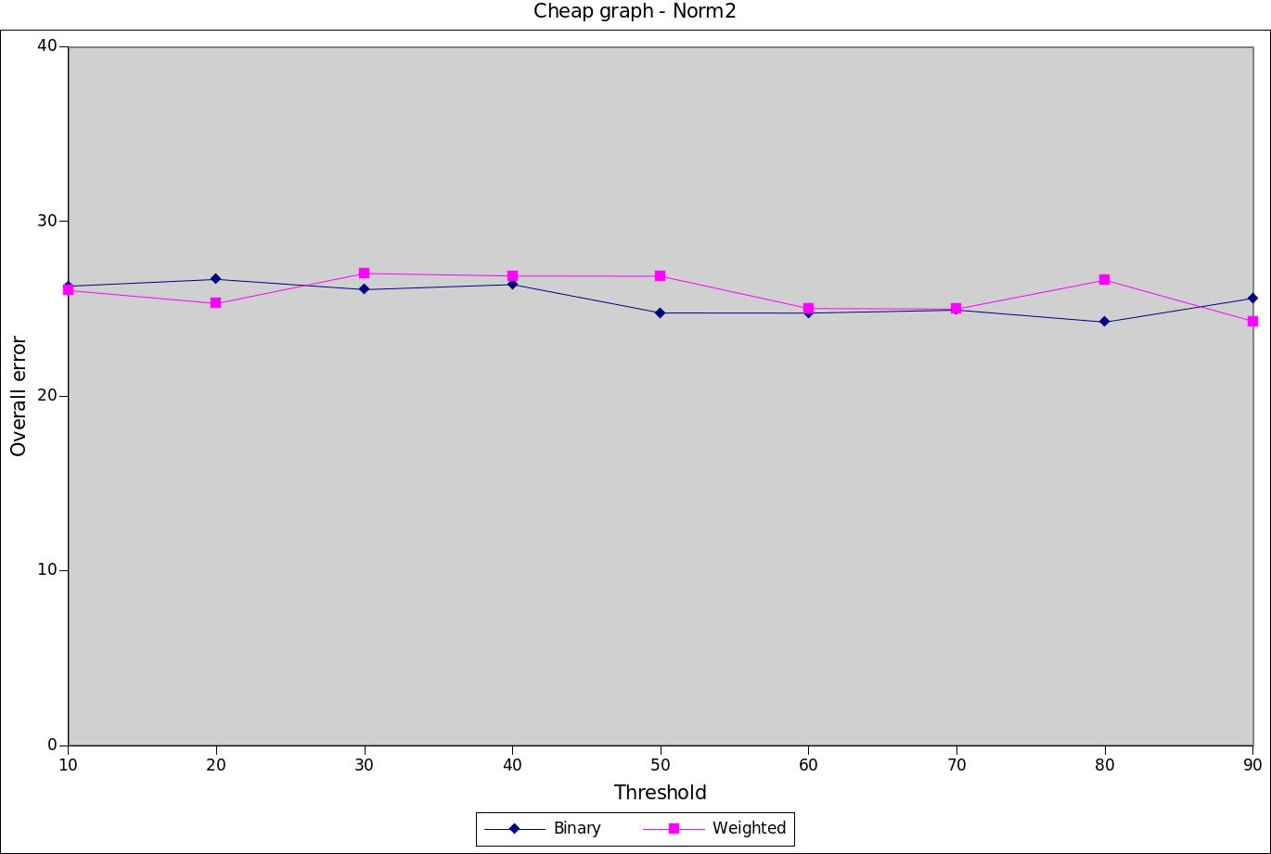
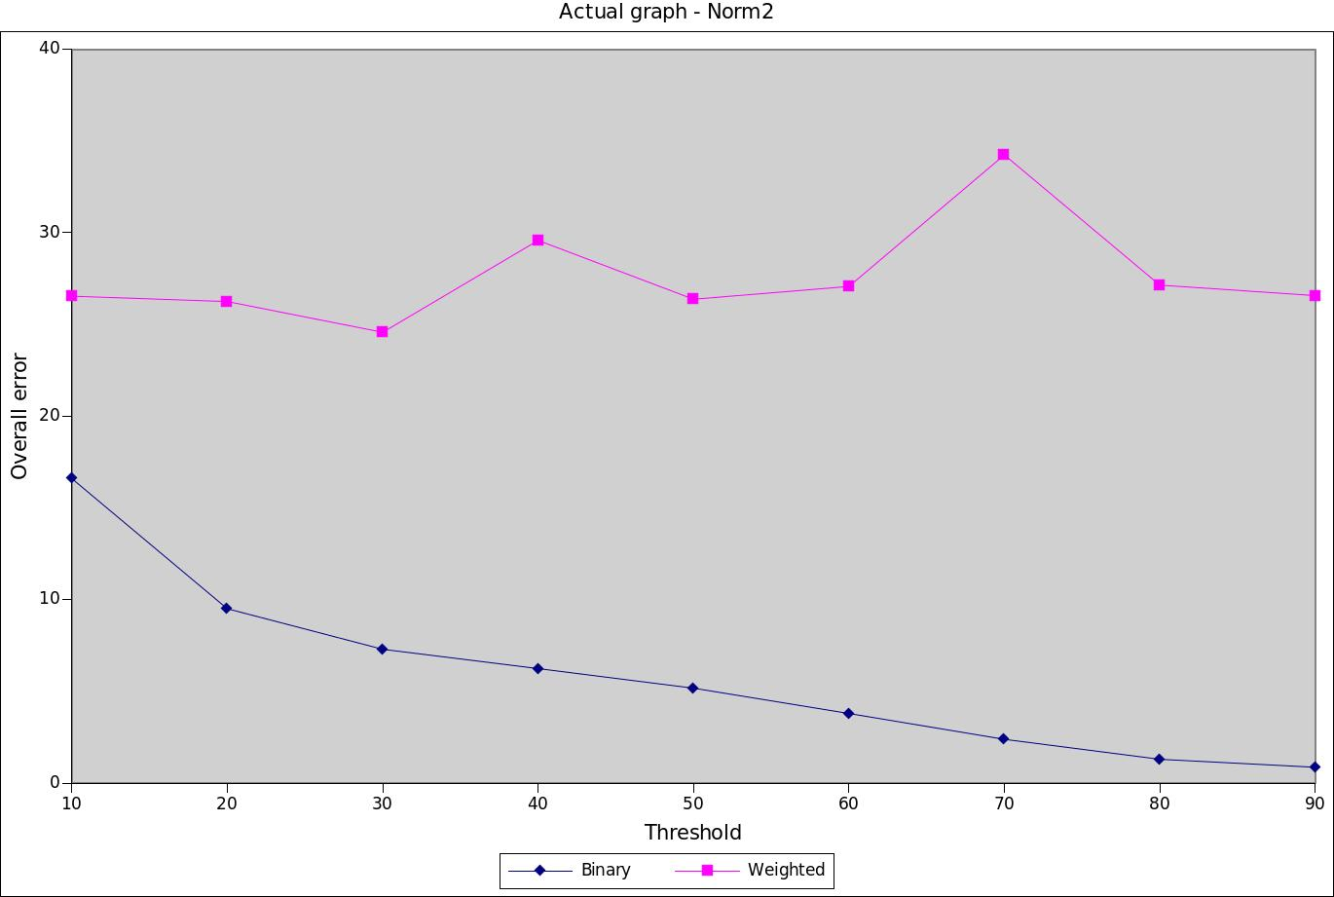
Setting:
- Observed data: 40%
- Error: overall percentage error
- Threshold on similarity score of adjacency matrix: percentile
- Compare: Weighted vs Binary graphs; Actual and cheap graphs; Norm vs RBF kernels

