# Using Table Auto Suggest Toolbar Pickers

## Introduction

In WNC.X20M20 a new feature, Table Auto Suggest Toolbar Picker, was added to standard MVC tables. The feature allows users to add rows to tables using Auto Suggest fields in addition to pickers.

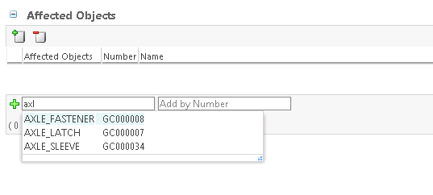

When the user select “AXLE_FASTENER” from the suggest box list, by clicking on it with the mouse or by selecting it with arrow keys and pressing enter, the part is added to the table. The result is shown below.

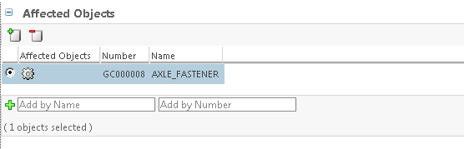

## Implementation

### Building a PickerConfig object.

The first step to implementation is to create a Picker Configuration java class. You should extend either AbstractGenericPickerConfig or AbstractItemPickerConfig based on the type of objects you would like the user to add to the table. Additional PickerConfig object types will be added for Context, ItemMaster, Organization and User pickers although the Generic Picker can be used for all object types.

The configuration is performed by overriding (@Override) the getXXX() methods from the abstract class. Common examples are getComponentId(), getMultiSelect() and getPickerCallback(). Each method configures the picker in a different way. See the javadoc comments in the Absract classes for details on what each configuration does.

If you writing a configuration for an existing picker there is a one-to-one correspondence for jsp tag attributes and the getXXX() methods. It is easy to create a PickerConfig from an existing JSP tag as highlighted below.

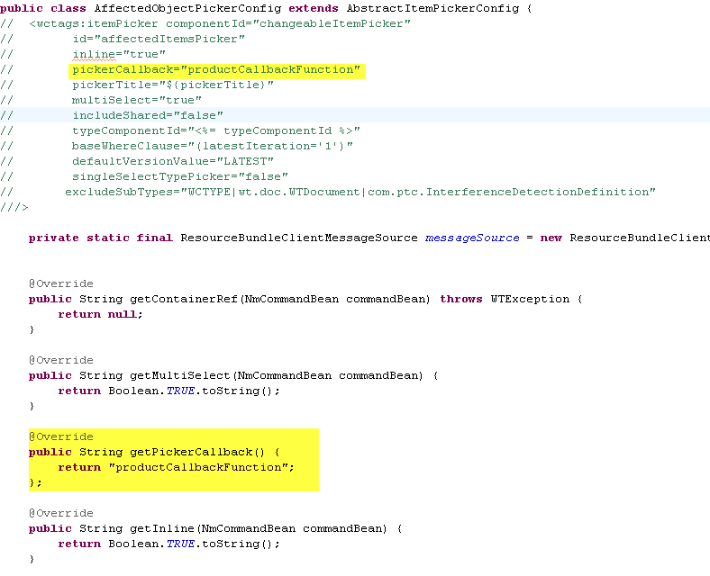

For the Table Auto Suggest Toolbar Picker to work you will need to provide configurations for the methods getTableSuggestAttributeAndLabel() and getPickerCallback().

If you use Eclipse as your development IDE it is easy to see the available configuration methods and their javadoc. Press ctrl-space where the method should be added and select from the list. The javadoc appears to the side as you scroll through the methods.

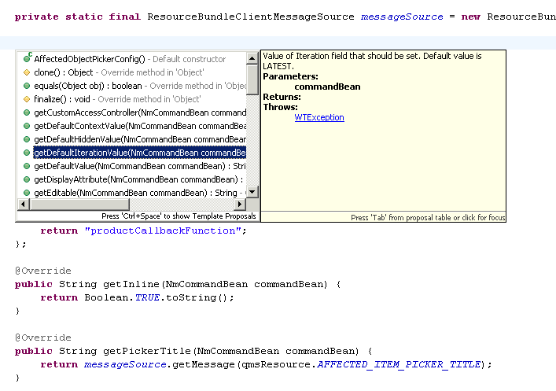

### Adding your PickerConfig to a Table Builder.

In your MVC table build you will need to call setToolbarAutoSuggestPickerConfig() with an instance of your Picker Config class.

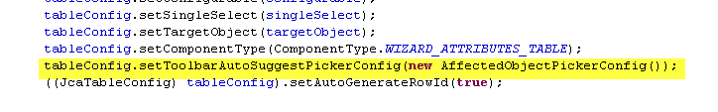

### Using your PickerConfig to Configure the top toolbar picker

It is best to configure your top toolbar picker to use the same configuration as the Auto Suggest toolbar so the user gets the same results in both locations. The genericPicker.tag and itemPicker.tag files have a new attribute “pickerConfig” that configures the picker based upon the new PickerConfig classes. Provide an instance of the pickerConfig and tag files will do the rest.

