Table of Contents

Windchill Client Architecture Search Customization 3

Search customization Scenarios 3

Scenario A 3

Objective 3

Background 3

Scope/Applicability/Assumptions 3

Intended Outcome 3

Solution 4

Prerequisite knowledge 4

Solution Elements 4

Procedure – Adding new attribute in Criteria drop down 4

Sample Code 4

Scenario B 6

Objective 6

Background 6

Scope/Applicability/Assumptions 6

Intended Outcome 6

Solution 7

Prerequisite knowledge 7

Solution Elements 7

Procedure – Adding new action to Search Result table 7

Sample Code 7

Scenario C 8

Objective 8

Background 8

Scope/Applicability/Assumptions 8

Intended Outcome 8

Solution 10

Prerequisite knowledge 10

Solution Elements 10

Procedure - Add new Object type to Object Type picker 10

Sample Code 10

Search Elements and Associated JSPs 13

# Windchill Client Architecture Search Customization

# Search customization Scenarios

* Scenario A - Best practice to add attribute in criteria drop down on advanced search page
* Scenario B - Best practice to add new action to search result table
* Scenario C - Best practice to add new item type to search item picker

## Scenario A

### Objective

* Scenario A: Allow user to add customized attribute to Criteria drop down

### Background

* Scenario A - An out-of-the-box user can search on all the modeled attributes as well as soft attributes for given Object Type. User cannot see attributes that are added by modeling the Object. Newly created soft attributes are visible after a page refresh happens.

### Scope/Applicability/Assumptions

* New attributes are added to item by modeling.

### Intended Outcome

Adding new criteria to search criteria drop down:

An out-of-the-box user will not get added extra attributes in Criteria drop down on advanced search page. Once user adds entry for logical attribute name for new attributes in SearchableAttributesByType.properties.xconf, user can see new attribute criteria drop down.

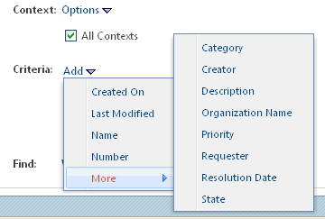

In above case user has added new attribute Priority to the object model.

### Solution

Add the logical attribute name against given Object Type in <Windchill>/codebase/com/ptc/windchill/enterprise/search/server/ SearchableAttributesByType.properties.xconf

### Prerequisite knowledge

To achieve this objective, you need to have an understanding of the following:

* Basic development involving HTML forms, JSP, XML, Java

### Solution Elements

|  |  |  |
| --- | --- | --- |
| **Element** | **Type** | **Description** |
| Scenario A -  SearchableAttributesByType.properties.xconf | properties | Runtime location  <Windchill>/codebase/com/ptc/windchill/enterprise/search/server/ SearchableAttributesByType.properties.xconf |

### Procedure – Adding new attribute in Criteria drop down

To add attributes for a particular type, simply add the logical attribute name to the comma separated list for that type in SearchableAttributesByType.properties.xconf. The logical attribute name is the attribute retrieved from introspection or defined within the <Windchill>/codebase/LogicalAttributes.xml file.

For example, if we were to add "theIssuePriority" to wt.change2.WTChangeIssue, it would look like this:

<Property **name=**"[advancedSearch.wt.change2.WTChangeIssue](http://ah-grok/s?path=advancedSearch.wt.change2.WTChangeIssue&project=main)" **default=**"theCategory,[thePersistInfo.createStamp](http://ah-grok/s?path=thePersistInfo.createStamp&project=main),number,requester,resolutionDate,[state.state](http://ah-grok/s?path=state.state&project=main),name,[thePersistInfo.modifyStamp](http://ah-grok/s?path=thePersistInfo.modifyStamp&project=main),[organization.id](http://ah-grok/s?path=organization.id&project=main),creatorRef,description, theIssuePriority "/>

We need to run xconf manager to propagate the change to the actually properties file.

### Sample Code

Entries from in SearchableAttributesByType.properties.xconf for new attribute added on WTChangeIssue type

<Property **name=**"[advancedSearch.wt.change2.WTChangeIssue](http://ah-grok/s?path=advancedSearch.wt.change2.WTChangeIssue&project=main)" **default=**"theCategory,[thePersistInfo.createStamp](http://ah-grok/s?path=thePersistInfo.createStamp&project=main),number,requester,resolutionDate,[state.state](http://ah-grok/s?path=state.state&project=main),name,[thePersistInfo.modifyStamp](http://ah-grok/s?path=thePersistInfo.modifyStamp&project=main),[organization.id](http://ah-grok/s?path=organization.id&project=main),creatorRef,description, theIssuePriority "/>

## Scenario B

### Objective

* Allow user to add new action for given type to search result table

### Background

* The preference /com/ptc/windchill/enterprise/search/allSearchTypes, determines the list of types that are to be included when a user searches across "all" Object types. This is the same list that a user can choose from within the Object Type picker for the Add Type link on the Search page

### Scope/Applicability/Assumptions

New actions are defined

### Intended Outcome

Adding new action to search result table.

Out-of-the-box there is fixed actions defined for all Object type on search page. Out-of-the-box on simple search page a few default actions are provided. We have to add action Set State on simple search page.

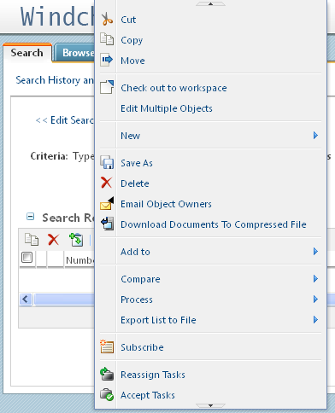

### Solution

Add action name and type in <Windchill>/codebase/config/actions/searchactionmodels.

xml

### Prerequisite knowledge

To achieve this objective, you need to have an understanding of the following:

* Basic development involving HTML forms, JSP, XML, Java

### Solution Elements

|  |  |  |
| --- | --- | --- |
| **Element** | **Type** | **Description** |
| Scenario B - search-actionmodels.xml | XML | Runtime  <Windchill>/codebase/config/actions/se  a rch-actionmodels.xml |

### Procedure – Adding new action to Search Result table

To add new action to search result table, add entries to search-actionmodels.xml file.Suppose we want to add new action Set State on simple search page, add following entry to search-actionmodels.xml as:

**<model name="search table actions">**

**<action name="list_copy" type="object"/>**

**<action name="list_delete" type="object"/>**

**..**

**..**

**<action name="setState" type="object"/>**

**</model>**

### Sample Code

Entries from search-actionmodels.xml

**<model name="search table actions">**

**<action name="list_copy" type="object"/>**

**<action name="list_delete" type="object"/>**

**<action name="setState" type="object"/>**

**</model>**

# Scenario C

## Objective

* Allow user to add new customized type to search item picker

## Background

* The allSearchTypes preference defines a base list of types; out of-the-box searching rules include all soft types defined from one of these types. It does not, however, include any modeled subclasses. Any new modeled object type should be defined in the allSearchTypes preference to make it available for searches.

## Scope/Applicability/Assumptions

* New item or object type is modeled

## Intended Outcome

Adding new item to search item picker

The allSearchTypes preference defines a base list of types; out-of-the-box searching rules include all soft types defined from one of these types. It does not, however, include any modeled subclasses. Any new modeled object type should be defined in the allSearchTypes preference to make it available for searches.

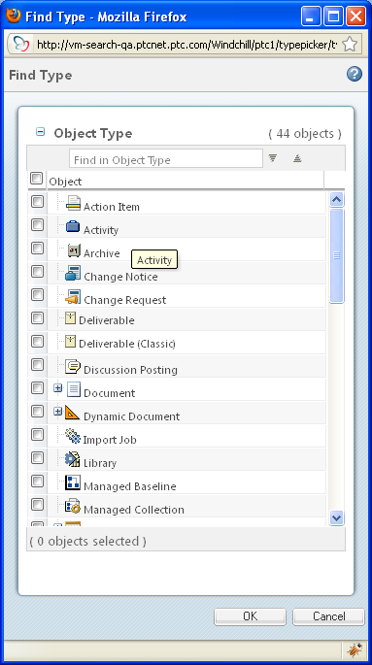

## Solution

Add new sub class modeled type entry in

<Windchill>/codebase/com/ptc/windchill/enterprise/search/server/ SearchableTypes.properties.xconf.

## Prerequisite knowledge

To achieve this objective, you need to have an understanding of the following:

* Basic development involving HTML forms, JSP, XML, Java

## Solution Elements

|  |  |  |
| --- | --- | --- |
| **Element** | **Type** | **Description** |
| Scenario C -  SearchableTypes.properties.xconf | properties | Runtime location  <Windchill>/codebase/com/ptc/windchill/enterprise/search/server/ SearchableTypes.properties.xconf |

## Procedure - Add new Object type to Object Type picker

To add new Object type for picker, add new object name to SearchableTypes.properties.xconf. We have new sub class as searchPart. For this new object add entry to add in SearchableTypes.properties.xconf as:

<Property name="WindchillPDM.allSearch" multivalued="," default="wt.change2.WTChangeIssue,wt.change2.WTChangeRequest2,wt.change2.WTChangeOrder2,wt.change2.WTChangeActivity2,wt.part.WTPart,wt.doc.WTDocument,${domain}.DefaultEPMDocument,wt.workflow.engine.WfProcess,wt.effectivity.ConfigurationItem,wt.part.WTProductInstance2,wt.part.WTProductConfiguration,wt.query.template.ReportTemplate,wt.vc.baseline.ManagedBaseline,wt.meeting.Meeting,wt.dataops.archive.Archive,wt.workflow.forum.DiscussionPosting,wt.workflow.notebook.ImportedBookmark,wt.workflow.work.WorkItem,wt.change2.WTVariance,com.ptc.windchill.enterprise.report.Report, wt.part.WTPart.searchPart "/>

After adding the new type you should set the property

com.ptc.windchill.search.refreshTypesFromProperties to "true" in wt.properties.

## Sample Code

Entries from SearchableTypes.properties.xconf

<Property name="WindchillPDM.allSearch" multivalued="," default="wt.change2.WTChangeIssue,wt.change2.WTChangeRequest2,wt.change2.WTChangeOrder2,wt.change2.WTChangeActivity2,wt.part.WTPart,wt.doc.WTDocument,${domain}.DefaultEPMDocument,wt.workflow.engine.WfProcess,wt.effectivity.ConfigurationItem,wt.part.WTProductInstance2,wt.part.WTProductConfiguration,wt.query.template.ReportTemplate,wt.vc.baseline.ManagedBaseline,wt.meeting.Meeting,wt.dataops.archive.Archive,wt.workflow.forum.DiscussionPosting,wt.workflow.notebook.ImportedBookmark,wt.workflow.work.WorkItem,wt.change2.WTVariance,com.ptc.windchill.enterprise.report.Report, wt.part.WTPart.searchPart "/>

## Search Elements and Associated JSPs

Search element and their associated JSP for Search Page

|  |  |  |
| --- | --- | --- |
| **Search UI Element** | **Search sub**  **Element** | **Associated JSP** |
| Search Page |  | /netmarkets/jsp/search/executeSearch.jsp |
| Saved Query Name | Saved Query Name  Save this search link  Edit Search Link  Start New Search link | \netmarkets\jsp\search\commonSearch.jsp |
| Search Criteria | Keyword  Type  Context  Query Builder  And Or Option | \netmarkets\jsp\search\advancedSearchCriteria.jspf |
| Search Results Table |  | /netmarkets/jsp/search/searchResults.jsp |
| Buttons | Search button | \netmarkets\jsp\search\searchButton.jsp |