Authorization Change Collection Rules

When creating a package, various objects that can be changed can be added to a package with a picker or paste. Furthermore, users can collect related Change Objects. In 10.1 we introduced a new collection rule which allows users to collect related Authorizing Change Notices and Tasks. If WADM is installed, the rule allows you to additionally collect Change Notices and Tasks for any approved Unincorporated Change.

This collection rule is independent of any other collection rule selected in the Set Collection Rules wizard, and therein it can be used in addition to other rules or by itself. For example, even if the Change Notices rule is set to None, but the Authorizing Changes rule is set to All approved resulting changes, the collector will still collect the Authorized Change Notices and Change Tasks.

# Definitions:

**Authorized Change Notice** – This is a change notice that released the objects that can be changed. In the case of Unincorporated Changes, it means the Change Notice that approved the Unincorporated Change.

# Preferences:

If WADM is installed, the preference “Unincorporated Change Creation” should be enabled in order to show additional options to collect the authorized unincorporated changes in the Authorizing Changes rule.

When WADM is installed and the preference is enabled, the collection options look like this:

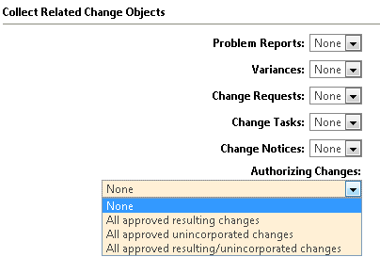

When WADM is not installed, or the preference is disabled, the collection options look like this:

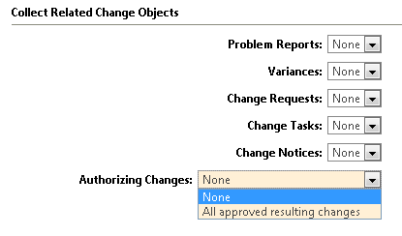

# Collection Rules – what is collected for each option?

None – nothing is collected.

All approved resulting changes – For a given seed object, this will collect any Authorized Change Notices and Change Tasks.

All approved unincorporated changes – For a given seed object, this will collect any Authorized Change Notices and Change Tasks which approved the unincorporated change.

All approved resulting/unincorporated changes – This will collect a union of the “All approved resulting changes” option and the “All approved unincorporated changes” option.