Windchill Development Best Practice

**Name:** *Change Management Transitions* Best Practice

<INTERNAL>

By: Michael McLachlan

Change History:

|  |  |  |
| --- | --- | --- |
| **Date** | **Author** | **Description** |
| 03/14/2012 | Michael McLachlan | Initial draft |
| 03/15/2012 | Michael McLachlan | Rework comments after development review |
| 10/04/2013 | Robert Lach | Add section for modifying change notice workflow |

</INTERNAL>

# Best Practice Name and Classification

## Name

## Change Management Transitions Best Practice

## Classifications

Usage – what are Change Management Transitions and how can I use them?

# Objective

## Problem Statement

When releasing a Change Notice, you might not always want the Resulting Objects to go to the Released state. You may want them to go into a different state.

## Scope/Applicability/Assumptions

This document assumes familiarity with the Resulting Objects table found on the Change Task wizard. Knowledge regarding Life Cycle Transitions will also be helpful.

## Intended Outcome

To understand how to choose what state you want Resulting Objects to enter into once the Change Notice is released.

# Solution

In order to choose what state the Resulting Objects will go into when they are released, you will need to select a Release Target for the Resulting Object on the create or edit Change Task Wizard. If a Resulting Object has a Release Target set during the time of the Change Notice release, the Resulting Object will go into the state defined by the Release Target transition. Release Target Transitions can be customized to include additional Change Management Transitions. See section 3.2 for customization steps.

## Prerequisite knowledge

To apply this best practice, you need to have an understanding of the following:

* Change Task Resulting Objects Table
* Life Cycle Transitions
* Workflow Template Administration

Properties:

wt.change2.changeTransitions

wt.change2.showAllChangeTransitions

Preference:

Change Management/Multiple Transitions on the Release Target Column

## Create Change Management Transitions

Follow these steps to create Change Management transitions.

1. Create new enumerated types to represent transitions. See Enumerated Types section of the Windchill Customization Guide: <http://www.ptc.com/WCMS/files/132336/en/10_WindchillCustomizationGuide_HKMC.pdf>
2. Once the enumerations are successfully created, in order to make the new transitions official “Change Management Transitions”, you must add the transition to the property wt.change2.changeTransitions. This property is a comma delimited list of Transitions. The set of transitions identified by this property are the Change Management Transitions.

## Setup the Life Cycle to use the Change Management Transitions

Now that you have a Change Management Transition setup, you must pick the State you want the Transition to go into when the Change Notice is released.

1. Open the Life Cycle Template Administration found on the Utilities page
2. Edit the Life Cycle that represents your Resulting Object (in this case I’ll go with Basic)
3. Setup a Transition such that when you are in any state, the Obsolescence Transition sets the object to the Canceled state. This is how you configure what State the Obsolescence transition will navigate to.

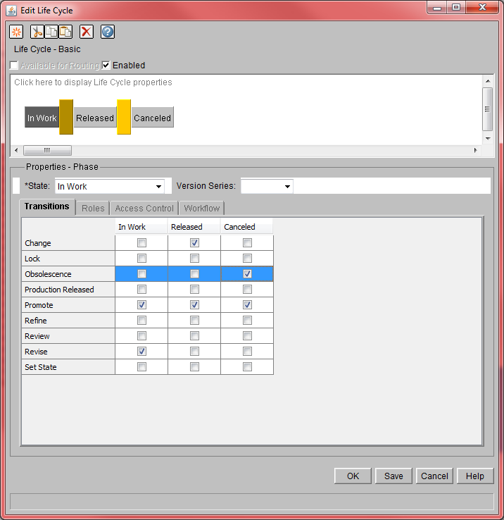

## Change Notice Workflow Modifications for Updated/Upgraded Systems In order to use alternate transition targets on Windchill installation that have been updated or upgraded from a release prior to 10.1 M010 you will need to modify the change notice workflow template. Fresh Windchill installations of release 10.1 M010 and beyond do not require this modification.

1. Open Workflow Template Administration found on the Utilities page.
2. Edit the change notice workflow used for your change process.
3. Find all expressions like:  
   com.ptc.windchill.pdmlink.change.server.impl.WorkflowProcessHelper.promoteChangeables((wt.change2.WTChangeOrder2)primaryBusinessObject);
4. And change them to:  
   com.ptc.windchill.pdmlink.change.server.impl.WorkflowProcessHelper.releaseChangeables((wt.change2.WTChangeOrder2)primaryBusinessObject);

In an out-of-the-box Windchill installation the above change would be made in the Release Changeables expression robot of the Change Notice Workflow.

## Executing the case

1. Create a part.
2. Reassign it to have the same life cycle as you configured above.
3. Create a change notice
4. When creating the change notice, add the part to the resulting objects table of the default change task.
5. **On the Release Target column, select Obsolescence.**

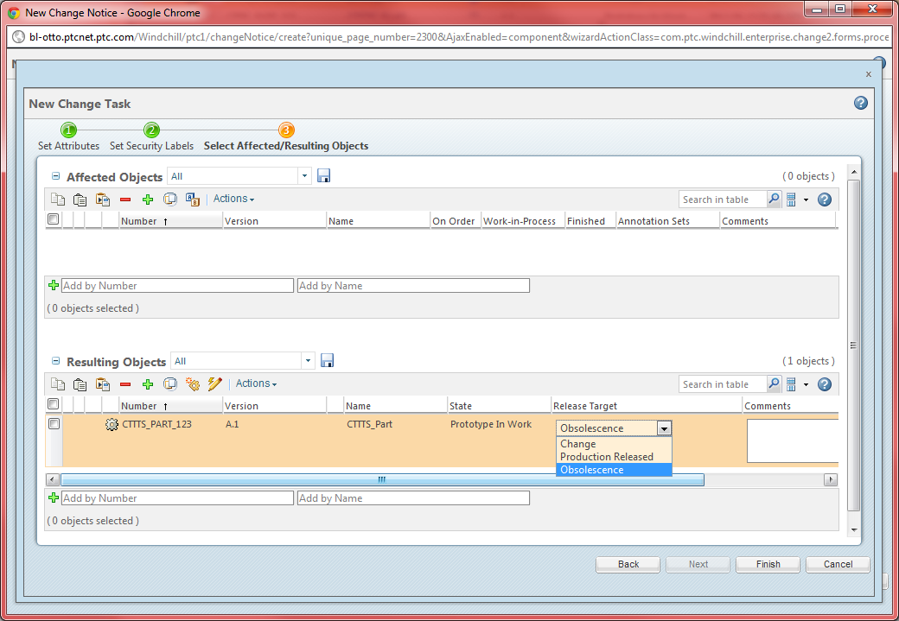

1. Create the change notice
2. Now once the change notice is resolved, the resulting object will go into the **Canceled** state because the **Obsolescence** transition was selected.