Name: Evaluate Business Rules on Demand

<INTERNAL>

By:

Change History:

|  |  |  |
| --- | --- | --- |
| **Date** | **Author** | **Description** |
| 07/11/2013 | Nathan Kral | Initial Draft |
| 07/16/2013 | Nathan Kral | Incorporate review comments from Bob |
| 05/18/2015 | Michael McLachlan | Update wizard jsp example to have a javascript line:  <script src="netmarkets/javascript/businessRules/businessRulesResultsPlugin.js"></script> |

</INTERNAL>

<INTERNAL>

# Best Practice Name and Classification

## Name

*Evaluate Business Rules on Demand* Best Practice

## Classifications

Low Level

## Also Known As

</INTERNAL>

# Objective

## Problem Statement

Problem: You want to create an action associated with a business object which will immediately execute a set of business rules and provide feedback on the outcome.

## Background

Business rules can be executed using the workflow and the results are displayed on a workflow task. The change notice workflow, for example, executes the Changeable Pre-Release rule set for the Audit Change Notice task and again prior to releasing the resulting objects on the change notice. Users working on or reviewing Change Tasks may want to get feedback before the Change Notice Audit task runs, to verify that there are no conflicts before completing the task.

## Scope/Applicability/Assumptions

This best practice provides steps to define a new action on the Change Notice details page to execute a set of business rules and display the results. In order to configure business rules see [Customizing Business Rules](http://ah-pubs.ptcnet.ptc.com/Windchill-WHC/WCCG_BusLogicCust_ChangeMgmt_BusRules.html?queryId=13fe395fdc2).

## Intended Outcome

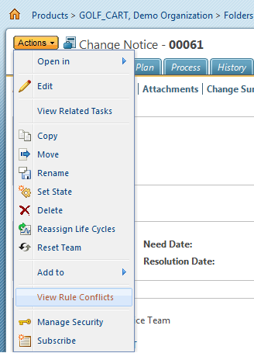

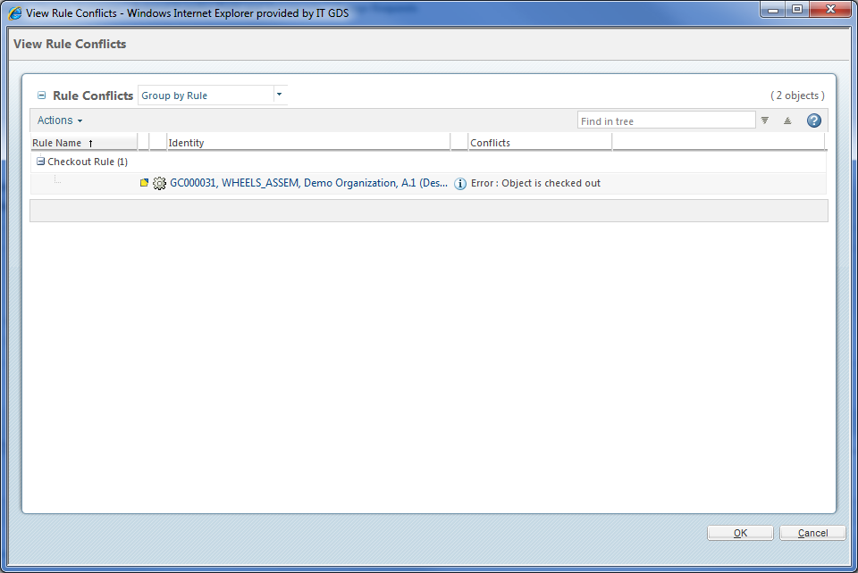

# Solution

## Solution Statement

Solution: Create a new single step wizard which calls a customized MVC builder to execute a set of business rules and view the results.

## Prerequisite knowledge

To apply this best practice you need to have an understanding of the following:

* Basic development involving HTML forms, JSP, and XML.
* The actions framework in the Windchill client architecture.
* The MVC component framework in the Windchill client architecture.
* The management of RBINFO file customizations.
* The Business Rules and how to execute business rules.

The See Also section below includes references to many or all of these subjects.

## Solution Elements

|  |  |  |
| --- | --- | --- |
| **Element** | **Type** | **Description** |
| com.ptc.windchill.enterprise.businessRules.mvc.builders.AbstractBusinessRulesResultsTable | Java | Given the result of executing the business rules displays the failed results. The results are displayed in a table or tree, depending on the table view selected. The "Group by Object" view results are listed by object in a simple table. The "Group by Rule" results are listed by rule in a tree table. |
| CustomBusinessRulesResultsTable | Java | An example of a custom business rules result table builder which executes the business rules for the resulting object on a change notice. |
| config/mvc/custom.xml | xml | Registers the new CustomBusinessRulesResultTable builder. |
| config/actions/custom-actions.xml | xml | Defines a new custom action to evaluate a set of business rules. |
| Custom Action Resource Info File | rbInfo | Localized properties for your action (optional). |
| config/actions/custom-actionModels.xml | xml | Include an action in action menu. |

## Procedure – Steps to Create a Custom Business Rule Result Action

The following steps provide an example of how to create a custom action which executes a set of business rules for Change Notice resulting objects and display the results. The action to evaluate the business rule results is made available in the change notice action menu.

### Extend Business Rules Results Table

Extend the AbstractBusinessRulesResultsTable class and override the getRuleValidationResultSet API to execute the desired rule sets. See [Customizing Business Rules](http://ah-pubs.ptcnet.ptc.com/Windchill-WHC/WCCG_BusLogicCust_ChangeMgmt_BusRules.html?queryId=13fe395fdc2) for more details on executing a set of business rules. The following is an example of a custom business rules result table builder which executes the business rules for the resulting object on a change notice:

package com.custom.businessRules.mvc.builders;

@ComponentBuilder("CustomBusinessRulesResultsTable")

public class CustomBusinessRulesResultsTable extends AbstractBusinessRulesResultsTable {

private static final Logger logger = LogR.getLogger(CustomBusinessRulesResultsTable.class.getName());

/**

* {@inheritDoc}

*/

@Override

public RuleValidationResultSet getRuleValidationResultSet(NmCommandBean commandBean) throws WTException {

RuleValidationResultSet resultSet = new RuleValidationResultSet();

logger.debug("Get context object.");

NmOid contextOid = commandBean.getActionOid();

if(contextOid.isA(WTChangeOrder2.class)) {

logger.debug("Context object is a change notice.");

BusinessRuleSetBean[] ruleSetBeans = new BusinessRuleSetBean[] {

BusinessRuleSetBean.newBusinessRuleSetBean("CHANGEABLE_PRE_RELEASE",

ChangeRecord2.class.getName())

};

logger.debug("Executing the CHANGEABLE_PRE_RELEASE rule set for the change notice resulting objects.");

resultSet = BusinessRulesHelper.engine.execute(contextOid.getRefObject(), ruleSetBeans);

}

return resultSet;

}

}

### Register the Custom Table Builder

The builder is registered by adding the following line in /*<windchill>/*codebase/config/mvc/custom.xml.

<mvc:builder-scan base-package="com.custom.businessRules.mvc.builders"/>

### Define Actions

#### Define Business Rules Results Action

Define a new action in /*<windchill>/*codebase/config/actions/custom-actions.xml to launch a popup window that displays the business rules results.

<objecttype name="customBusinessRules" resourceBundle="com.custom.customClientActionsRB">

<action name="customBusinessRulesResultWizard">

<command windowType="popup"/>

</action>

</objecttype>

The new action requires new action properties defined in a custom resource file. See [Windchill Client Architecture Action Framework Overview](http://ah-pubs.ptcnet.ptc.com/Windchill-WHC/WCCG_UICust_AddActionsHook_WCClientArchAction.html?queryId=13fe394b573) for more details on defining new actions. The following is an example of properties configured for the custom action:

@RBEntry("View Rule Conflicts")

@RBComment("Title of the wizard that displays business rules results")

**public** **static** **final** String *PRIVATE_CONSTANT_0* = "customBusinessRules.customBusinessRulesResultWizard.description";

@RBEntry("View Rule Conflicts")

@RBComment("Title of the wizard that displays business rules results")

**public** **static** **final** String *PRIVATE_CONSTANT_1* = "customBusinessRules.customBusinessRulesResultWizard.title";

@RBEntry("View Rule Conflicts")

@RBComment("Title of the wizard that displays business rules results")

**public** **static** **final** String *PRIVATE_CONSTANT_2* = "customBusinessRules.customBusinessRulesResultWizard.tooltip";

@RBEntry("width=940,height=600")

@RBPseudo(**false**)

@RBComment("DO NOT TRANSLATE")

**public** **static** **final** String *VIEW_CONFLICTS_MOREURLINFO* = "customBusinessRules.customBusinessRulesResultWizard.moreurlinfo";

#### Define Business Rules Results Table Step Action

Using the ComponentId defined in the custom table builder in 3.4.1 define a new action to display the business results table in /*<windchill>/*codebase/config/actions/custom-actions.xml.

<objecttype name="customBusinessRules" resourceBundle="com.custom.customClientActionsRB">

<action name="customBusinessRulesResultStep">

<component name="CustomBusinessRulesResultsTable"/>

</action>

</objecttype>

### Define Business Rules Results Action JSP

In order to display the table when launching the custom business rule action a single step wizard needs to be defined using a jsp file. The name of the jsp should match the name of the action and should be in a package with the same name of the action object type under directory /*<windchill>/*codebase/netmarkets/jsp. For the action defined in 3.4.3.1 the package and name is:

/*<windchill>/*codebase/netmarkets/jsp/customBusinessRules/customBusinessRulesResultWizard.jsp

The following jsp sample describes a single step wizard which includes the action defined in 3.4.3.2. For more details about describing wizards see [Windchill Client Architecture Wizard](http://ah-pubs.ptcnet.ptc.com/Windchill-WHC/WCCG_UICust_ConstructWizards_WCClientArchWizard.html?queryId=13fe395b7ef)

.

<%@ taglib prefix="jca" uri="http://www.ptc.com/windchill/taglib/components"%>

<%@ include file="/netmarkets/jsp/components/beginWizard.jspf"%>

<!-- Need to set isWizard and popupWindow to false in order to display links on

number and the info page action icon. -->

<% request.setAttribute("isWizard","false"); %>

<script src="netmarkets/javascript/businessRules/businessRulesResultsPlugin.js"></script>

<script type="text/javascript">

<!-- Converts all links to open in new window -->

PTC.onReady(function() {

JCAappendFormHiddenInput(getMainForm(), "popupWindow", "false");

});

</script>

<jca:wizard buttonList="OkCancelWizardButtons">

<jca:wizardStep action="customBusinessRulesResultStep" type="customBusinessRules"/>

</jca:wizard>

<%@include file="/netmarkets/jsp/util/end.jspf"%>

### Add the Business Rules Results Action to a Menu

The new custom action must be added to an object action model. A /*<windchill>/*codebase/config/actions/custom-actionModels.xml is available for adding or overriding actions models. The following sample shows how to add a custom action to existing action model for a change notice:

<actionmodels resourceBundle="com.ptc.windchill.enterprise.change2.changeManagementActionsRB">

<model name="more change notice row actions" menufor="wt.change2.WTChangeOrder2">

<description>Change notice row actions</description>

<action name="customBusinessRulesResultWizard" type="customBusinessRules"/>

.

.

<!-- Existing Actions -->

.

.

</model>

</actionmodels>

# Limitations

The execution of Business Rules against large data sets may take longer to complete than is normally expected from an on-demand action. In these cases it may be better to execute the Business Rules as part of a workflow process.

# Sample Code

## Examples of Usage in Windchill Code

### Viewing Workflow Task Business Rules Conflicts

Uses the work flow task page object to get the Business rules validation results and returns the list of target objects with Business Rule conflicts. See [Viewing Rule Conflicts](http://ah-pubs.ptcnet.ptc.com/Windchill-WHC/BusRulesViewConflictsTableRef.html?queryId=13fe39855ec) topic

* com.ptc.windchill.enterprise.businessRules.mvc.builders.BusinessRulesResultsTable
* config/mvc/BusinessRulesClient-configs.xml
* config/actions/BusinessRulesClient-actions.xml
* nemarkets/jsp/businessRules\businessRulesResultWizard.jsp

# See Also

<INTERNAL>

## Related Best Practices

* [Constructing and Rendering a Table Using the JSP Framework](http://ah-pubs.ptcnet.ptc.com/Windchill-WHC/WCCG_UICust_PresentInfoUI_ConstructRender.html?queryId=13fe39413e3)
* [Windchill Client Architecture Action Framework Overview](http://ah-pubs.ptcnet.ptc.com/Windchill-WHC/WCCG_UICust_AddActionsHook_WCClientArchAction.html?queryId=13fe394b573)
* [Resource Info (.rbInfo) Files](http://ah-pubs.ptcnet.ptc.com/Windchill-WHC/WCCG_Serv_Internationalization_ResourceInfoFiles.html?queryId=13fe3950549)
* [MVC Components Overview](http://ah-pubs.ptcnet.ptc.com/Windchill-WHC/WCCG_UICust_MVC_Overview.html?queryId=13fe3954ce1)
* [Windchill Client Architecture Wizard](http://ah-pubs.ptcnet.ptc.com/Windchill-WHC/WCCG_UICust_ConstructWizards_WCClientArchWizard.html?queryId=13fe395b7ef)
* [Customizing Business Rules](http://ah-pubs.ptcnet.ptc.com/Windchill-WHC/WCCG_BusLogicCust_ChangeMgmt_BusRules.html?queryId=13fe395fdc2)

</INTERNAL>

## Related Package/Class Javadoc

* com.ptc.core.businessRules.engine.BusinessRulesEngine

## Related Customization Documentation

## Other Related Windchill Documentation

## Related Websites

## Other

<INTERNAL>

## Internal Windchill Dev Resources

None

</INTERNAL>

# <INTERNAL>Other Windchill Development Considerations

None

</INTERNAL>

<INTERNAL>