Windchill Development Best Practice

**Name:** *Locking Annotations In Change Workflows*

<INTERNAL>

By: Charlie Cadwell

Change History:

|  |  |  |
| --- | --- | --- |
| **Date** | **Author** | **Description** |
| 03/30/2015 | Charlie Cadwell | Final Draft |
|  |  |  |
|  |  |  |

</INTERNAL>

# Best Practice Name and Classification

## Name

Locking Annotations In Change Workflows.

## Classifications

Customization/configuration of Workflow Templates designed for the Change Management process.

# Objective

## Problem Statement

For use in Change Management workflow processes, it can be desirable to have annotations associated to the change be locked and unlocked at various points in the workflow.

## Scope/Applicability/Assumptions

This document assumes familiarity with, creating and/or customizing Workflow Templates.

## Intended Outcome

This document describes on how to add annotation locking and unlocking to Workflow Templates.

# Solution

This solution will be a walk through example of adding a “Lock” operation and an “Unlock” operation to a workflow.

## Prerequisite Knowledge

To apply this best practice, you need to have an understanding of the following:

* Modifying and/or creating Workflow Templates.
* Working with expressions in workflow nodes using the Java Language

## Define a workflow robot to lock annotations

### Define a new Execute Expression workflow robot.

To lock annotations on a Change Notice after the Change Notice is resolved, insert a new robot in between the “Set Change Notice Resolution Date” node and the “Or” node.

Select the new Execute Expression robot from the toolbar.

Insert the expression in between the “Set Change Notice Resolution” and the “Or” as indicated below.

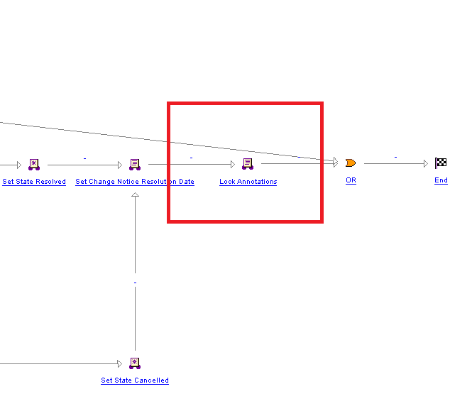

Insert a description and name as desired.

Enter the following Java into the Expression tab to lock the annotations:

wt.fc.collections.WTSet changeObjects = wt.fc.collections.CollectionsHelper.singletonWTSet(primaryBusinessObject);

wt.change2.ChangeLockHelper.service.lockRelatedMaterials(revisedChangeObjects, wt.change2.ChangeApplicationLock.LOCK_SUPPORTINGMATERIAL);

## Define a workflow robot to unlock annotations

### Define a new Execute Expression workflow robot.

To unlock annotations when a Change Notice is revised, insert a new robot in between the “Reassign to Original Author” node and the “Or” node.

Select the new Execute Expression robot from the toolbar as above and insert the new expression.

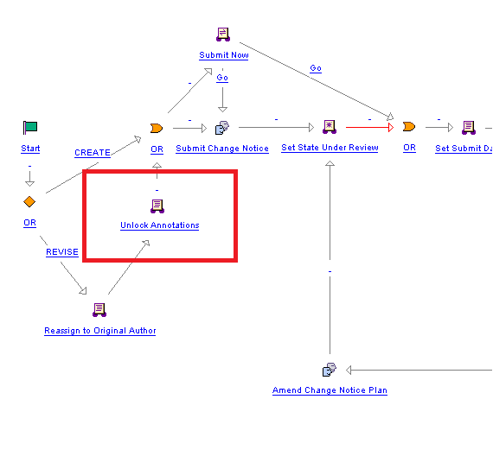

Insert a description and name as desired as above.

Enter the following Java into the Expression tab to unlock the annotations:

wt.fc.collections.WTSet revisedChangeObjects = wt.fc.collections.CollectionsHelper.singletonWTSet(primaryBusinessObject);

wt.change2.ChangeLockHelper.service.unlockRelatedMaterials(revisedChangeObjects, wt.change2.ChangeApplicationLock.LOCK_SUPPORTINGMATERIAL);