Windchill Development Best Practice

**Name:** *Workflow Process variables displayed on the Primary Business Object info page*

<INTERNAL>

By: Michael McLachlan

Change History:

|  |  |  |
| --- | --- | --- |
| **Date** | **Author** | **Description** |
| 10/21/2010 | Michael McLachlan | Initial draft |
| 11/04/2010 | Michael McLachlan | Review changes |
|  |  |  |

</INTERNAL>

# Best Practice Name and Classification

## Name

## Adding WFVariables of the WFProcess object to the primary business object’s info page.

## Classifications

How to add customized workflow process attributes to the info page of an object.

# Objective

## Problem Statement

There are times when customers wish to view variables from a workflow process on the primary business object’s info page as an attribute.

## Scope/Applicability/Assumptions

This document assumes familiarity with the type attribute layouts, creating new xconf entries and using xconfmanager, resource bundles, as well as defining variables in a workflow process.

## Intended Outcome

To show how to add workflow process variables to a given primary business object’s info page.

# Solution

This solution will be a walk through example of adding a work flow item attribute to the info page of a Problem Report object.

## Adding the custom workflow attribute to the workflow process

Add a new workflow item variable to a task by using the workflow process manager. In this case, we will add a variable with the name **testNewAttribute** to the WFProcess. The supported data types for the data utility are **String, Date, Boolean, and Number.**

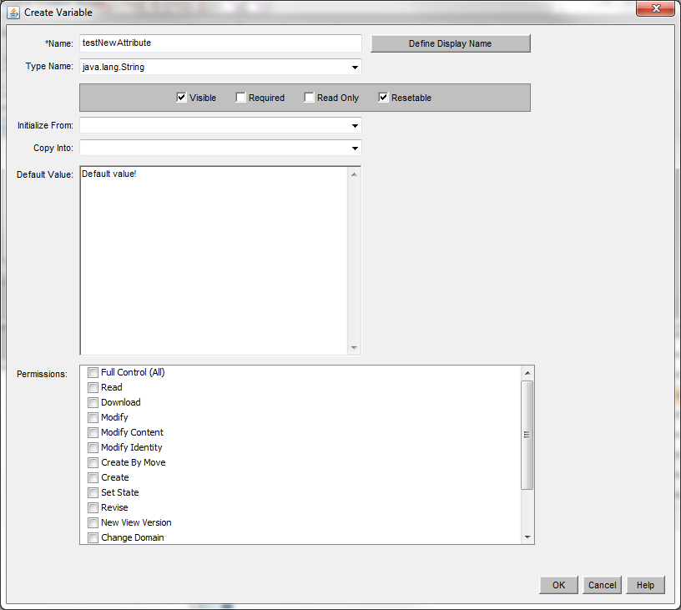

## Adding the new attribute to the type attribute layout

Next, we will need to add a new attribute to the type attribute layout of the Primary Business Object. In this case, I will add this entry to the info page attribute layout for the loadFiles/type/WTChangeIssue.xml. The csvname is important. The csvname must be the string “WFVAR_” followed by the variable name we chose above for the WfProcess’s new variable. In this case, the full text of the csvname is “WFVAR_testNewAttribute”.

<csvBeginAttributeDefView handler="com.ptc.core.lwc.server.TypeDefinitionLoader.beginProcessAttributeDefinition">

**<csvname>WFVAR_testNewAttribute</csvname>**

<csvattDefClass>com.ptc.core.lwc.server.LWCNonPersistedAttDefinition</csvattDefClass>

<csvdatatype>java.lang.String</csvdatatype>

<csvIBA/>

<csvQoM/>

<csvviewStyle/>

<csveditStyle/>

<csvdefaults/>

</csvBeginAttributeDefView>

## Registering the new attribute with xconfmanager

You will have to add this new attribute to be registered against the WorkItemAttributeDataUtility. This can be done by adding the following to an xconf entry to WorkItem-components.dataUtilities.properties, and propogating xconf properties (xconfmanager –pF)

<Option cardinality="duplicate"

requestor="null"

selector="WFVAR_testNewAttribute" serviceClass="com.ptc.windchill.enterprise.workitem.dataUtilities.WorkItemAttributeDataUtility"

/>

## Changing the name of the attribute in the UI

By default, the name of the attribute would use the name of the key. At this point, examining the info page would reveal a new attribute with the name testNewAttribute. If you want to customize this value to a localized attribute, you can add a new entry within the **WorkItem/src/com/ptc/windchill/enterprise/workitem/workItemAttributeResource.java** resource.

The name of the rbinfo key should match the variable name:



Once this step is taken, the attribute will now show up with the value defined by the RBEntry annotation:

## Done!

At this point, you should be complete and your customized attribute will show up on the info page of the primary business object.

