<INTERNAL>

By:

Change History:

|  |  |  |
| --- | --- | --- |
| **Date** | **Author** | **Description** |
| 04/10/2012 | Nathan Kral | Initial draft |

</INTERNAL>

<INTERNAL>

# Best Practice Name and Classification

## Name

*Bypass Business Rules* Best Practice

## Classifications

**Core Capability**

## Also Known As

None

</INTERNAL>

# Objective

## Problem Statement

You want to be able to initially show some or all business rule failures but only some business rule failures should prevent the workflow process from continuing or completing.

### Example Use Case 1:

You want to check that certain attributes are filled in (e.g. Material), but it’s ok if the attributes are blank but the life cycle state check must pass.

### Example Use Case 2:

You have requirements that the Material and Weight attributes have to be filled in for parts. The part Number needs to start with PTC- and have a length of ten. The part attributes such as Finish and Description should be filled, but if they are blank, you should only get a warning.

## Scope/Applicability/Assumptions

This document assumes you have customized business rule sets and rules defined that you would like to run as part of the workflow process.

# Solution

## Solution Statement

Create two business rule sets. One of the business rule sets has business rules that are required to continue or complete the workflow process. The second business rule set has business rules that you want reported but are not required to continue the workflow process. Having two separate business rule sets will allow you to configure a workflow process that allows you to call both or one of the business rule sets at different points in the workflow process. The workflow process can be configured to execute all required and non-required business rule sets for a workflow task such as the Change Notice Audit task. This task is configured to continue once it has been completed (See 4.1.7 Execute All Required and Non-Required Business Rule Sets). A second workflow task in the process can be configured to execute only the required business rule sets. This task will continue to be generated until all errors are resolved (See 4.1.8 Execute Required Business Rule Sets).

## Prerequisite knowledge

To apply this best practice, you need to have an understanding of the following:

* Business Rules see the Business Rules Best Practice and Business Rules Engine Best Practice.
* How to configure a workflow process

The See Also section below includes references to many or all of these subjects.

# Example

The following example uses Example Use Case 1 from above to show how to create two sets of rules to execute in a change notice workflow process. The example shows how to configure a set of rules to be required to proceed in the workflow process and a second set of rules that are not required but shown as informational data.

## Steps for Example Use Case 1:

### Create a Non Required Business Rule Set for the Attribute Checks

|  |
| --- |
| <?xml version="1.0" encoding="UTF-8" ?>  <!DOCTYPE BusinessRuleSet SYSTEM "standardX20.dtd">  <BusinessRuleSet>  <ObjectID><localId>wt.businessRules.BusinessRuleSet:10001</localId></ObjectID>  <objectContainerPath>/wt.inf.container.OrgContainer=Demo Organization/wt.pdmlink.PDMLinkProduct=Example1TestProduct</objectContainerPath>  <key>EXAMPLE1_NON_REQUIRED_ATTRIBUTE_RULE_SET</key>  <name>EXAMPLE1_NON_REQUIRED_ATTRIBUTE_RULE_SET</name>  <description>EXAMPLE1_NON_REQUIRED_ATTRIBUTE_RULE_SET</description>  <enabled>true</enabled>  <overridable>true</overridable>  <updateIfExists>true</updateIfExists>  </BusinessRuleSet> |

### Create an Attribute rule for Material

|  |
| --- |
| <?xml version="1.0" encoding="UTF-8" ?>  <!DOCTYPE BusinessRule SYSTEM "standardX20.dtd">  <BusinessRule>  <ObjectID><localId>wt.businessRules.BusinessRule:10002</localId></ObjectID>  <objectContainerPath>/wt.inf.container.OrgContainer=Demo Organization/wt.pdmlink.PDMLinkProduct=Example1TestProduct</objectContainerPath>  <key>EXAMPLE1_ATTRIBUTE_RULE</key>  <selector>ATTRIBUTE_RULE</selector>  <name>Example 1 Attribute Rule</name>  <description>Example 1 Attribute Rule</description>  <enabled>true</enabled>  <updateIfExists>true</updateIfExists>  <configs>  <config name="objectType" value="com.ptc.Part"></config>  <config name="Material" value="SET"></config>  </configs>  </BusinessRule> |

### Create a Link for the Attribute Rule and Non Required Rule Set

|  |
| --- |
| <?xml version="1.0" encoding="UTF-8" ?>  <!DOCTYPE BusinessRuleLink SYSTEM "standardX20.dtd">  <BusinessRuleLink>  <ObjectID><localId>wt.businessRules.BusinessRuleLink:10003</localId></ObjectID>  <ruleSet><ObjectReference><localId>wt.businessRules.BusinessRuleSet:10001</localId></ObjectReference></ruleSet>  <rule><ObjectReference><localId>wt.businessRules.BusinessRule:10002</localId></ObjectReference></rule>  <blockNumber>1</blockNumber>  <updateIfExists>true</updateIfExists>  </BusinessRuleLink> |

### Create a Required Business Rule Set for Release Target Rule

|  |
| --- |
| <?xml version="1.0" encoding="UTF-8" ?>  <!DOCTYPE BusinessRuleSet SYSTEM "standardX20.dtd">  <BusinessRuleSet>  <ObjectID><localId>wt.businessRules.BusinessRuleSet:20001</localId></ObjectID>  <objectContainerPath>/wt.inf.container.OrgContainer=Demo Organization/wt.pdmlink.PDMLinkProduct=Example1TestProduct</objectContainerPath>  <key>EXAMPLE1_RELEASE_RULE_SET</key>  <name>Example1_ReleaseRuleSet</name>  <description>Example1_ReleaseRuleSet</description>  <enabled>true</enabled>  <overridable>true</overridable>  <updateIfExists>true</updateIfExists>  </BusinessRuleSet> |

### Reload Site Release Target Rule

|  |
| --- |
| <?xml version="1.0" encoding="UTF-8" ?>  <!DOCTYPE BusinessRule SYSTEM "standardX20.dtd">  <BusinessRule>  <ObjectID><localId>wt.businessRules.BusinessRule:20002</localId></ObjectID>  <key>RELEASE_TARGET</key>  <selector>RELEASE_TARGET</selector>  <name>com.ptc.windchill.enterprise.change2.change2ClientResource:RELEASE_TARGET_RULE_NAME</name>  <description>com.ptc.windchill.enterprise.change2.change2ClientResource:RELEASE_TARGET_RULE_DESC</description>  <enabled>true</enabled>  <updateIfExists>true</updateIfExists>  </BusinessRule> |

### Create Link for the Target Rule and Required Rule Set

|  |
| --- |
| <?xml version="1.0" encoding="UTF-8" ?>  <!DOCTYPE BusinessRuleLink SYSTEM "standardX20.dtd">  <BusinessRuleLink>  <ObjectID><localId>wt.businessRules.BusinessRuleLink:20003</localId></ObjectID>  <ruleSet><ObjectReference><localId>wt.businessRules.BusinessRuleSet:20001</localId></ObjectReference></ruleSet>  <rule><ObjectReference><localId>wt.businessRules.BusinessRule:20002</localId></ObjectReference></rule>  <blockNumber>1</blockNumber>  <updateIfExists>true</updateIfExists>  </BusinessRuleLink> |

### Execute All Required and Non-Required Business Rule Sets

In order to display all required and not required rule conflicts update the Audit Change Notice workflow task conditional to use both rule sets EXAMPLE1_RELEASE_RULE_SET and EXAMPLE1_NON_REQUIRED_ATTRIBUTE_RULE_SET.

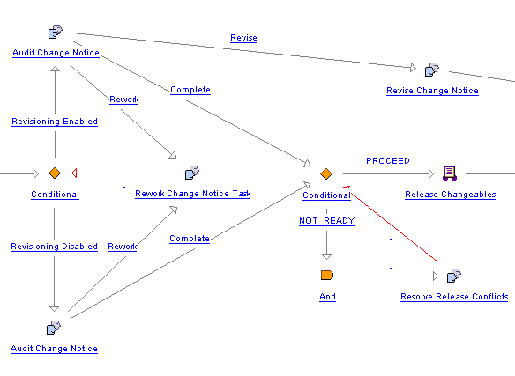

|  |
| --- |
| if (wt.change2.ChangeHelper2.isTrackingChange((wt.inf.container.WTContained)primaryBusinessObject)) {  result = "Revisioning Enabled";  } else {  result = "Revisioning Disabled";  }  com.ptc.core.businessRules.engine.BusinessRuleSetBean[] beans = new com.ptc.core.businessRules.engine.BusinessRuleSetBean[] {    **// Configure to call non-required rule set**com.ptc.core.businessRules.engine.BusinessRuleSetBean.newBusinessRuleSetBean("**EXAMPLE1_NON_REQUIRED_ATTRIBUTE_RULE_SET**", "wt.change2.ChangeRecord2"),  **// Configure to call required rule set**  com.ptc.core.businessRules.engine.BusinessRuleSetBean.newBusinessRuleSetBean("**EXAMPLE1_RELEASE_RULE_SET**", "wt.change2.ChangeRecord2")  };  com.ptc.core.businessRules.validation.RuleValidationResultSet resultSet = wt.businessRules.BusinessRulesHelper.engine.execute(primaryBusinessObject, beans);  **if ( resultSet.hasResultsByStatus(com.ptc.core.businessRules.validation.RuleValidationStatus.FAILURE)) {**  businessRulesResultSetGlobal = wt.businessRules.BusinessRulesHelper.serialize(resultSet);  preReleaseConflictsMsg = new wt.util.WTMessage("com.ptc.windchill.enterprise.change2.change2ClientResource", com.ptc.windchill.enterprise.change2.change2ClientResource.BUSINESS_RULES_PRERELEASE_VALIDATION_MSG, null).getLocalizedMessage();  preReleaseConflictsMsg = preReleaseConflictsMsg + "\n" + resultSet.getFailedRulesMessage(java.util.Locale.getDefault());  } |

The following is an example of the conflicts shown on the Audit Change Notice workflow task:

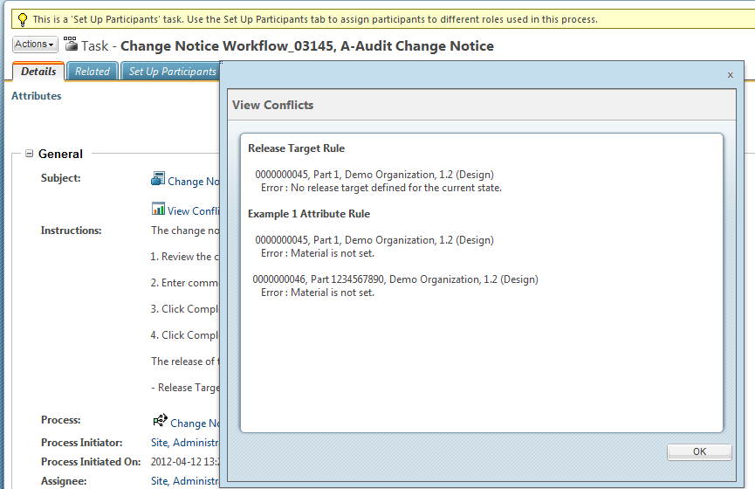

### Execute Required Business Rule Sets

In order to prevent the Change Notice workflow process from proceeding for the required business rules update the conditional to only use the required rule set EXAMPLE1_RELEASE_RULE_SET for the Resolve Release Conflicts workflow task.



|  |
| --- |
| result = "NOT_READY";  com.ptc.core.businessRules.engine.BusinessRuleSetBean[] beans = new com.ptc.core.businessRules.engine.BusinessRuleSetBean[] {  **// Configure to call required rule set only**  com.ptc.core.businessRules.engine.BusinessRuleSetBean.newBusinessRuleSetBean("**EXAMPLE1_RELEASE_RULE_SET**", "wt.change2.ChangeRecord2")  };  com.ptc.core.businessRules.validation.RuleValidationResultSet resultSet = wt.businessRules.BusinessRulesHelper.engine.execute(primaryBusinessObject, beans);  **if ( !resultSet.hasResultsByStatus(com.ptc.core.businessRules.validation.RuleValidationStatus.FAILURE)) {**  **result = "PROCEED";**  **}**  **else {**  businessRulesResultSetGlobal = wt.businessRules.BusinessRulesHelper.serialize(resultSet);  preReleaseConflictsMsg = new wt.util.WTMessage("com.ptc.windchill.enterprise.change2.change2ClientResource", com.ptc.windchill.enterprise.change2.change2ClientResource.BUSINESS_RULES_PRERELEASE_VALIDATION_MSG, null).getLocalizedMessage();  preReleaseConflictsMsg = preReleaseConflictsMsg + "\n" + resultSet.getFailedRulesMessage(java.util.Locale.getDefault());  } |

The following is an example of the conflicts shown on the Resolve Release Conflicts workflow task. Note that the Resolve Release Conflicts workflow task will continue to regenerate the task until all conflicts have been resolved.

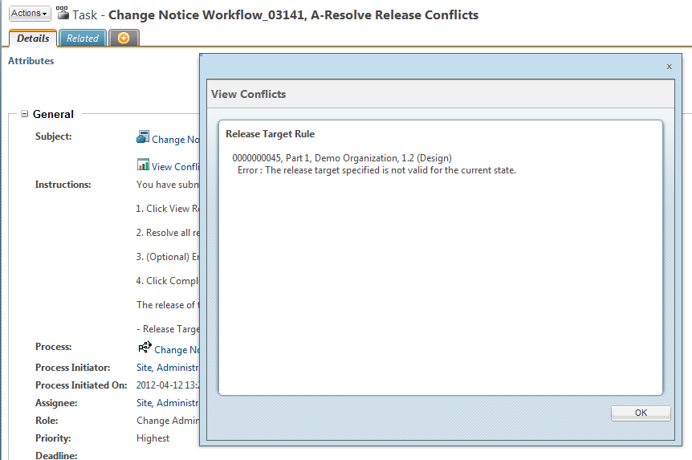

# See Also

<INTERNAL>

## Related Best Practices

[Business Rules Best Practice](http://ah-opengrok/raw/x-22-M010/wcmod/modules/BusinessRules/src/doc-files/wt/businessRules/LoadBusinessObjectsBestPractice.doc)

[Business Rules Engine Best Practice](http://ah-grok/xref/x-22-M010/wcmod/modules/BusinessRules/src/doc-files/com/ptc/core/businessRules/engine/BusinessRulesBestPractice.docx)

</INTERNAL>