Names: Tiddy Mukhenso Mdluli
Student number : ST10507124
Institution: Rosebank International

Table of Content Pages

. Proposal1: Childhood Cancer Foundation South Africa
. Organization Overview…………………………………………………………………………………………………………1
. Website Goals and objectives……………………………………………………………………………………………….1
. Current website Analysis……………………………………………………………………………………………………….2
. Proposed website features and the factuality……………………………………………………………………….2
. The design and User experience……………………………………………………………………………………………3
. Technical Requirements………………………………………………………………………………………………………..4
.Timeline and Milestones………………………………………………………………………………………………………..4
.Reference………………………………………………………………………………………………………………………………5

.Proposed2: Meal on Wheel Community service SA
.Organization Overview………………………………………………………………………………………………………..6
.Website Goals and Objectives…………………………………………………………………………………………..…6
.Current website Analysis……………………………………………………………………………………………..……..6
.Proposed website features and the factuality……………………………………………………………………..7
.The design and User experience………………………………………………………………………………………….7
.Technical Requirements………………………………………………………………………………………………………7
.Timeline and Milestone……………………………………………………………………………………………………….8
.Reference……………………………………………………………………………………………………………………………8
.Content Research and Sourcing …………………………………………………………………………………………9

CHOC Childhood Cancer foundation South Africa

1 Organization Overview
Name: CHOC Childhood Cancer foundation South Africa
Brief history :CHOC was created in 1979 by the parents of children who had cancer . They felt like families needed more support during treatment. 45 years later CHOC grew into SA`s leading childhood cancer organization, with offices and support houses in 9 provinces. Over 4000 children and teenagers with cancer and life threatening blood disorders were supported by CHOC.
Mission : The mission is to create awareness of early warning signs as well as provide national support to all the children and teenagers who already have the sickness .
Vision : To a better world where a child with cancer or living with a disorder never walks alone .
Target Audience :
- Parents, guardians and caregivers of children living with cancer in SA.
- Health care professionals ,donors and volunteers.
- The public to raise awareness and fundraising .

2 Websites Goals and objectives
Goals :
- Increase donations and fundraising : make it easy for people to donate online even when they are not near the CHOC house.
- Volunteers Hiring : Volunteers can apply online
- Provide Valuable information : have the public be educated on early warning signs and support services.
- Increase website traffic : rank for “childhood cancer South Africa “ and “ support for sick children”
KPIs to measure success :
- Donation Conversion Rate : certain percentage of visitors who complete an online donation.
- Volunteer sign-ups : Number of new volunteers applications every month.
- Traffic and Engagement : average times on the number of visitors on monthly website.
- Event Registration : CHOC walks signed up

3 Current Website Analysis
Based on choc.org.za
What is good about it :
- It has clear information on the CHOC houses.
- You are able to see events and donate online.  It is based on real stories .
What its not good about it :
- Some of the website pages do not work well on phones .
- The forms of donations and volunteers are to long to fill.
- CHOC does not have a lot of videos or work done by them.
What can be improved :
- The forms can be made shorter
- Have the website fixed and work properly

4 proposed website features and the factuality
Important pages needed:
- Home page : have pictures ,buttons saying donate and learn about the sicknesses.
- About US : CHOC`s story ,goals and team
- Our programs: info about the education ,goals and accommodation.
- Resources: early warning signs posts and guides for parents.
- Contact : contact info
- News : stories from other children.
Important Features:
- Have safe paying methods for online donations .
- Have easy fill in forms for volunteers.
- Have the event calendar shown.
- Have an website that will be easy to use.
- Have it updated at all times

5 The design and user experience
The design style : warm , hopeful and care ,using the colours:
- Different shades of blue: to present how happy and clear free kids can be .
- Lime: to present the smiles on their faces
- Different shades of brown: presents sand ,how their love playing in it.
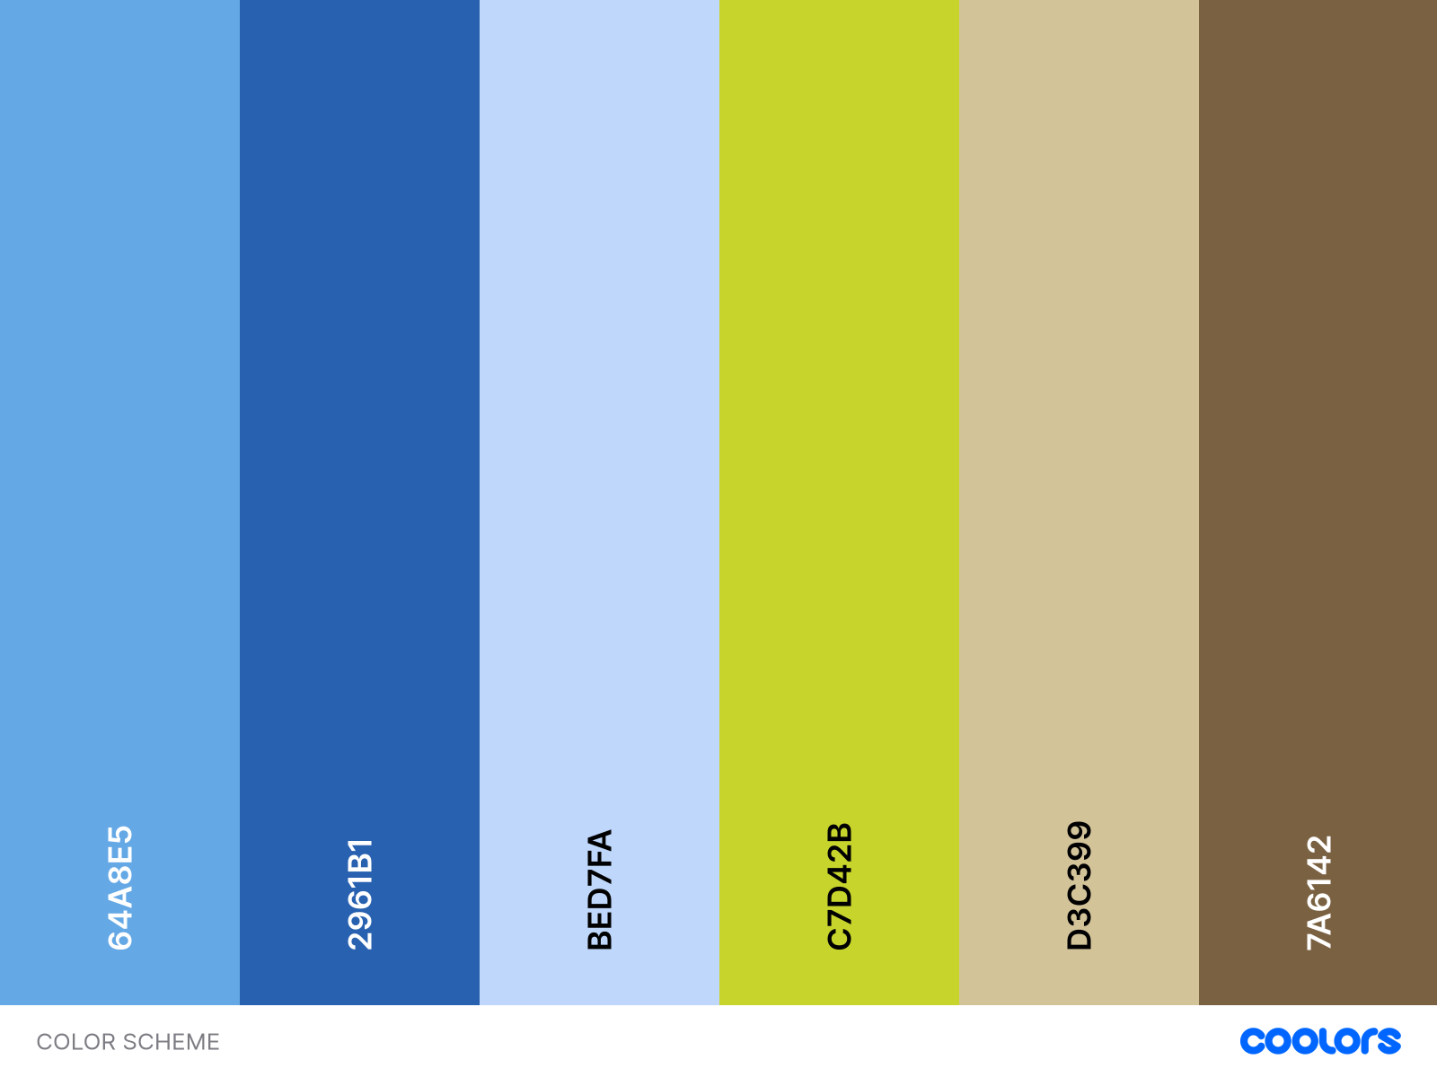

How the website should make the users feel :
- Have big letters ,clear for every person to use Have clear buttons and get help button should be easy to find .
- Have real pictures of children and stories to show care.
- Have it easy to click and use.
- Have big and bold letters so that everyone is able to read to see.

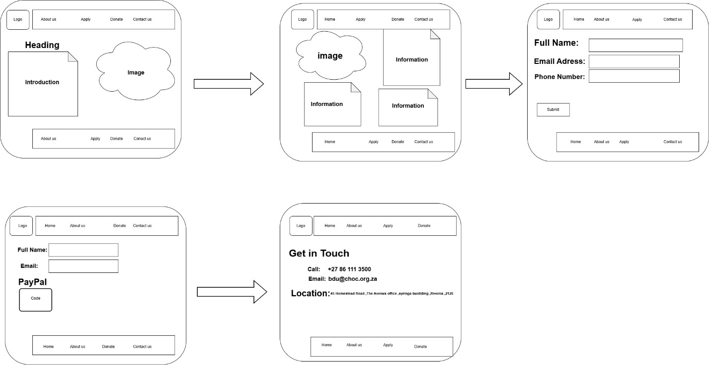

Technical Requirements
What the website needs to work:
- A host from a company to keep the website online and working.
- A name of the website e.g. choc.org.za
- WordPress for the choc staff to be able to add new news, stories and pictures.
- The html ,CSS and JavaScript for language.

Timeline and milestones
- Week 1-2 : have the planning ready , talk with choc , finalize the design and everything else.
- Week 3-4 : have the design showed to CHOC and all the website pages.
- Week5-7: build the website ,add all things needed.
- Week 8: add pictures and have the website tested.
- Week 9: fix changes requested by CHOC.
- Week 10 : have the website launched and train staff members how to use it .

9 Reference

. Childhood Cancer Foundation South Africa .(2025). About CHOC. Retrieved from choc.org.za
. Childhood Cancer Foundation South Africa .(2025). Our programs and support. Retrieved from choc.org.za
. Childhood Cancer Foundation South Africa .(2025). Donate to CHOC. Retrieved from choc.org.za
. Childhood Cancer Foundation South Africa .(2025). Contact us . Retrieved from choc.org.za
. pay fast .(2025) .payment Gateway for NPOs. Retrieved from payfast.co.za

Meals on Wheel Community service SA 1 Organization overview
Name :Meals on Wheels Community Service South Africa
Brief History : Meals on Wheel started in 1950 in south Africa. Volunteers wanted to help old people ,who were sick and could not cook for themselves. Today going on Meal on wheels delivers hot ,healthy food across South Africa.
Mission :the mission is to provide nutrition food and support old people and sick people to show that we care ,there is nothing wrong with how they are .
Vision : to a country where no one goes to bed hungry.
Target Audience:
- Old people ,sick people and disable people who are in need of food.
- Volunteers ,sponsors and people who want to donate.
- Communities and families who are in need of help.

2 Website Goals and Objectives
Goals :
- Make is easy to donate online ,to feed more people.
- Have more people signed up to help cook and deliver.
- Spread the information, let people know how to apply for food .
- Raise awareness, let the public know.
KPI`s :
1. The number of donations per month. 2. Number of new volunteer sign ups 3. The number of food applications .
4. Monthly visitors at the site.
3 Current Website Analysis
Based on the meaonwheel.co.za
What is good about it :
- Is has clear information about what the organization do .
- It has all the contacts of different branches.
- It shows how people can help.

What is not good about it :

- The organization does not look good.
- There are no forms online for volunteers to fill.
- It is hard to find information about the branches

What is needed to improve :

- Make the organization look good.
- Have online forms for people who want to volunteer or donate .
- Add as well as a page where people can be able to apply online.

4 Proposed Website Features and Functionality
Essential Pages:
- Have the first page with big letters and buttons stating donate here ,request a meal and volunteer sign up .
- Have a about us page ,showcasing the branches ,history and mission 3. Have a Our service page showing the delivers made as well as the programs.
- Get the volunteers , donators involved.
- Make a simple form to request for a meal.
- Have all the contact of all branches on the page.
- Design and User experience
  - Have big buttons and easy letters for elderly to use.
  - Upload real photos to have the trusts of donators .
  - Have the donate or request button easy to find.

- Technical Requirements
  - A host from a company to keep the website online and working.
  - A name of the website e.g. mealsonwheel.org.za
  - WordPress for the Meals on wheel staff to be able to add new news, stories and
pictures.

7 Timeline and Milestones
- Week1-2 : Plan with meals on wheels.
- Week3-4 : Design the pages
- Week5-6 : build the website.
- Week7 : finalize it.
- Week8 : upload the website and train the staff how to use it

9 Reference
. Meals on Wheel Community service SA.(2025).Get involved ,Retrieved from melsonwheel.co.za
. Meals on Wheel Community service SA.(2025).About US ,Retrieved from melsonwheel.co.za
. Pay Fast . (2025).NPO Payment solutions. Retrieved from mealsonwheel.co.za

3 Content Research and Sourcing 3.1Research for CHOC- Childhood Cancer Foundation South Africa

To build the website I have gathered information from the source of CHOC ,to make sure that each page has the correct information.

Content source used:

- For the organization website: I used choc.org.za as the main source for the history ,Mission ,services and contact details.
- For social media: Checked choc.org.za and Instagram pages for their recent photo`s ,events and stories
- Public Domain and Creative : Used pictures from google .Images including the children.
File Organisation
To keep the file nice and neat:
- I will create a main project folder called CHOC_Website
- Create subfolders for images ,text and pdf documents
- And use clear file names to help find it easily later

