From https://glam1.gsfc.nasa.gov/; retrieved
April 21, 2025 and shared by
New Mexico Department of Agriculture

Terra MODIS 8-day Normalized Difference Vegetation Index (NDVI)
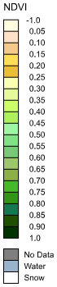
May 9-16, 2025
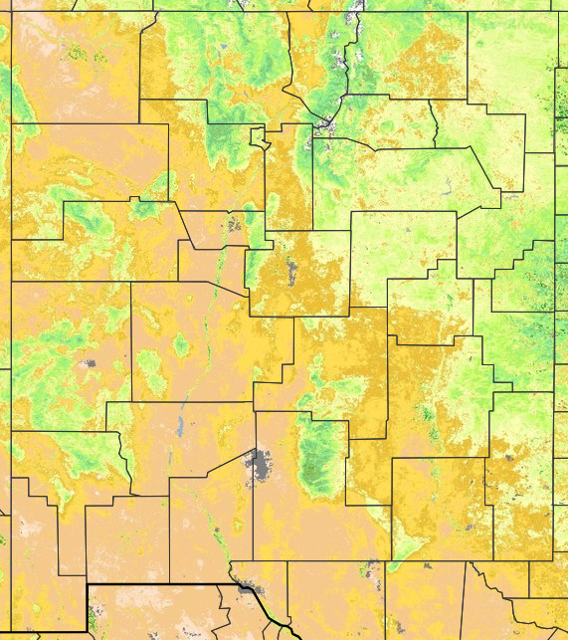
NDVI is used to quantify vegetation greenness and is useful in understanding vegetation density and assessing changes in plant health.
Terra MODIS 8-day Normalized Difference Vegetation Index (NDVI) Anomaly %
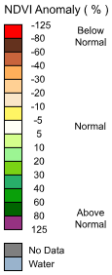
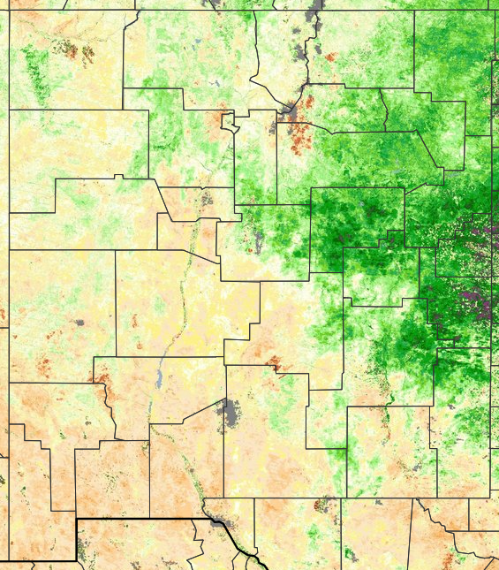
May 9-16, 2025
An NDVI anomaly is the difference between the average NDVI for a particular month of a given year and the average NDVI for the same month over a specified number of years.

