Terra MODIS 8-day Normalized Difference Vegetation Index (NDVI) Anomaly %
September 30 – October 7
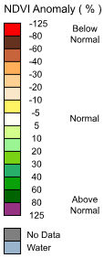
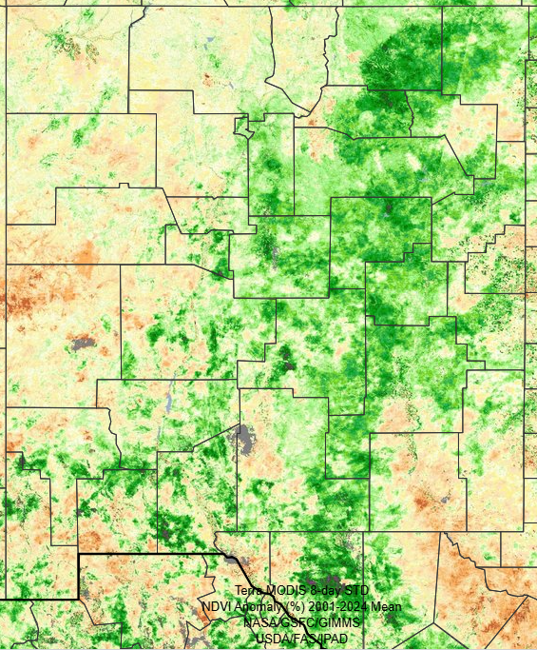
NDVI anomaly is the difference between the average NDVI for a particular timeframe of a given year and the average NDVI for the same month over a specified number of years.
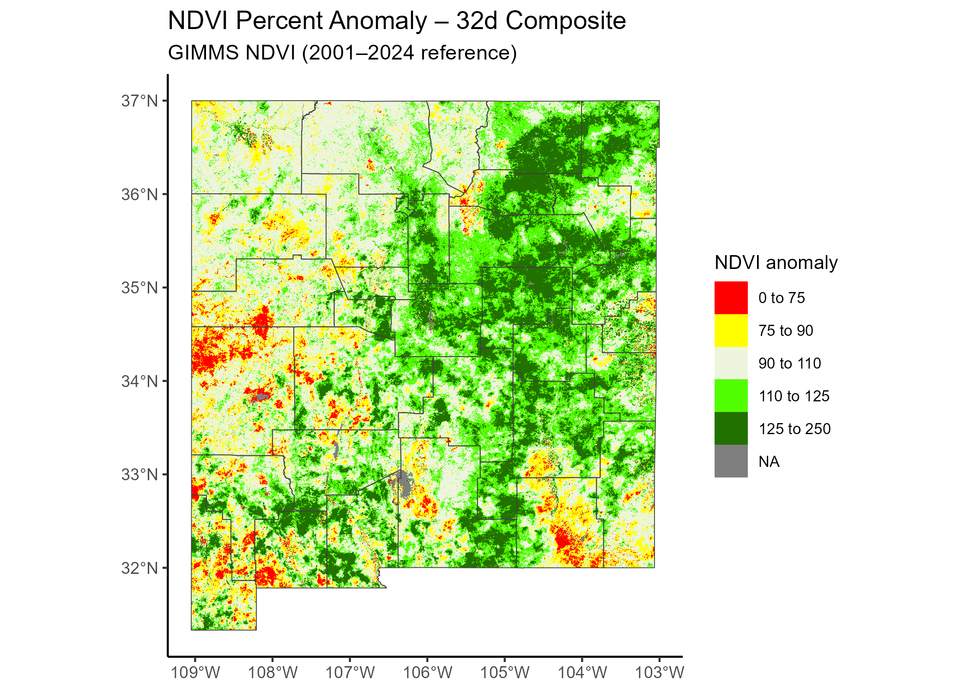

32-day composite: Most sensitive to short pulses of greenness, especially in arid rangelands and desert grasslands.


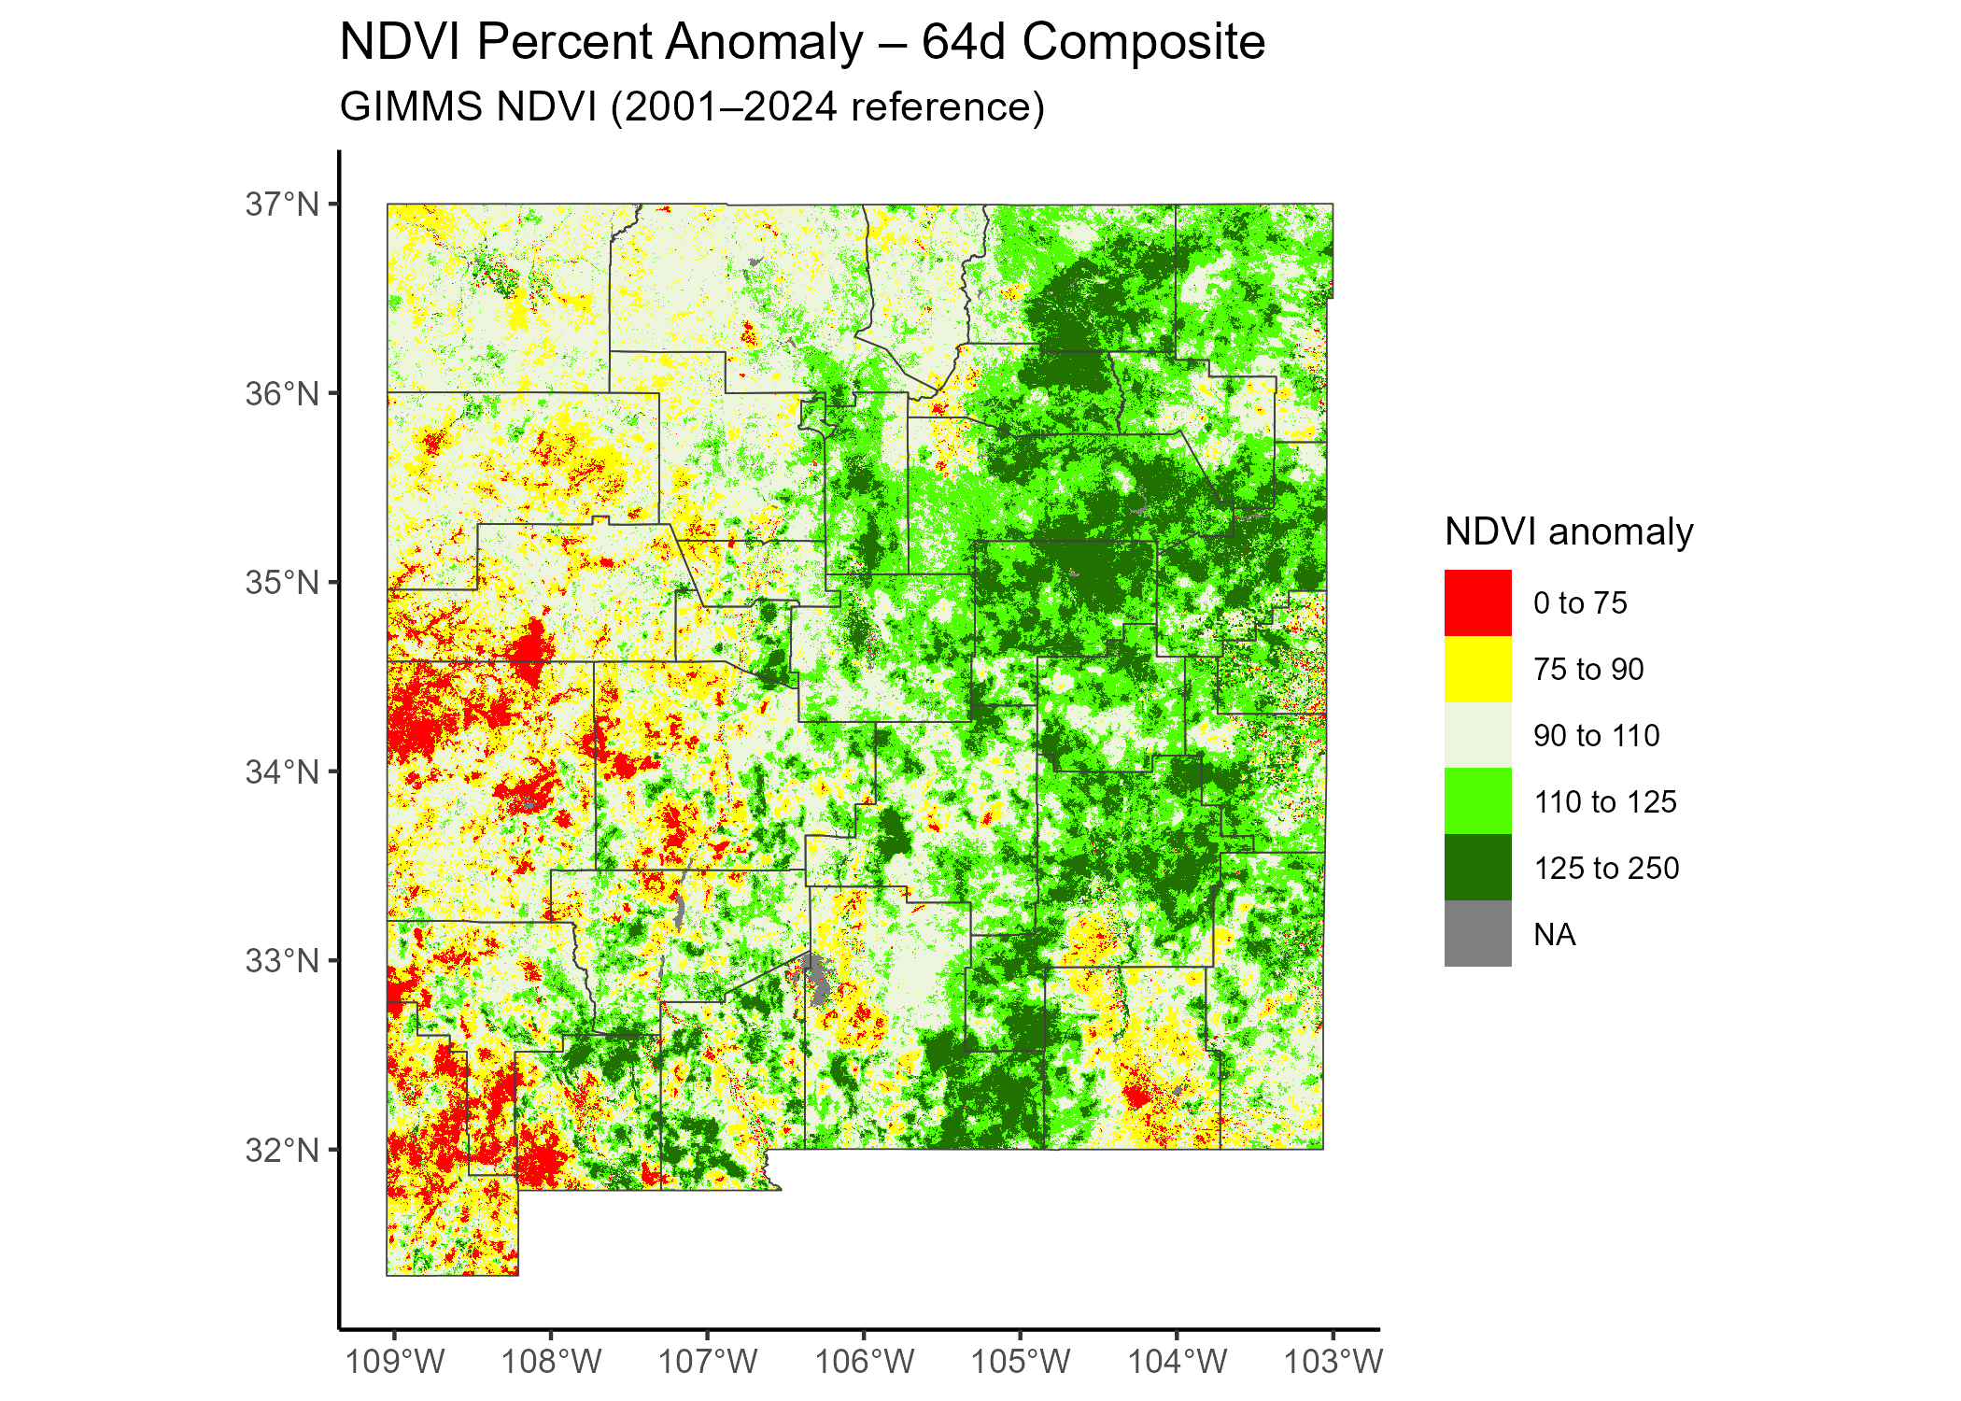
64-day composite: Reduces sensitivity to short-term fluctuations but still reacts to broad precipitation patterns.



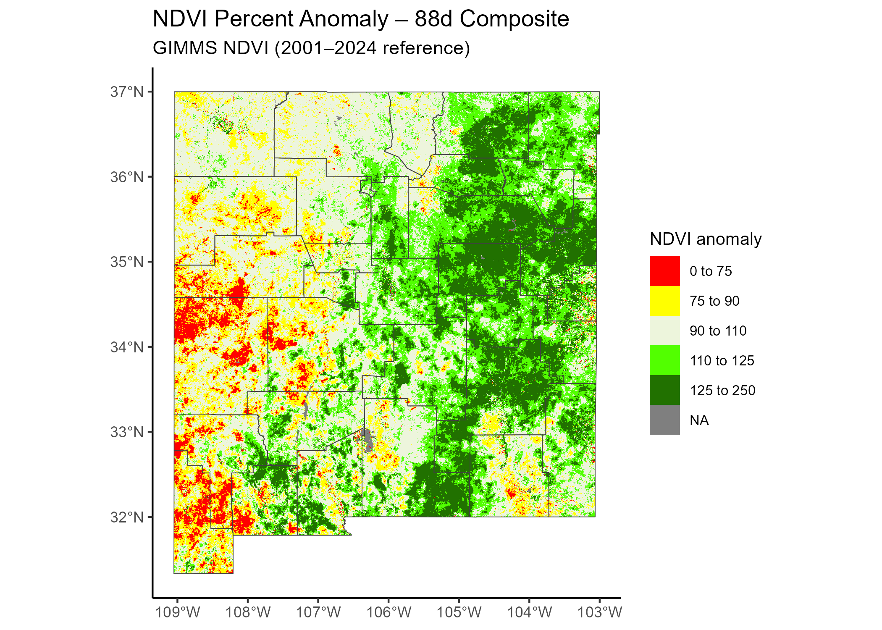
88-day composite: Represents quarterly, season-integrated vegetation anomaly. Best for seasonal-to-interannual comparisons


