# Instructions for Voxel Segmentation

Scott Quadrelli 2015

The matlab function ‘svs_voxel_seg.mat’ will batch process prescription mprage files and their associated .rda files to output the grey/white and CSF fractions for each participant in a single folder.

Requirements to run:

1. A decent computer
2. Matlab with parallel computing toolbox installed ( need to work out if this helps with speed or not, currently disabled in the current code)
3. FSL
4. SPM

## Command:

svs_voxel_seg(‘<location of folder to be batch processed>’)

**Inputs:**

Layout of folder to be processed:

An example of the folder and the files required is shown below. The prescription T1 MPRAGE is likely to come of the scanner in a different format. You can use the package ‘DCM2NII’ to convert the image. In preference select ‘ reorient images to nearest orthogonal plane’. When selecting the output from DCM2NII use the .nii with ‘o’ as a prefix to the filename.

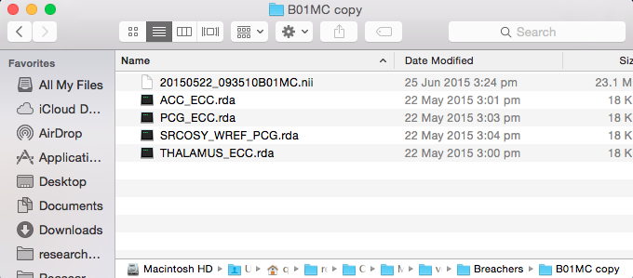

Within the root folder add all the subjects you want processed.

For example:

* Subject 1
* Subject 2
* Subject 3

Each subject folder contains the data shown above for the example folder. The function will iterate through each participants folder.

**\*\* It is important that there is no white space character(s) in the name of the .rda file. If there are white space characters there will be no output for that .rda in the ‘results.txt ‘ ouput.**

The following is performed for each folder:

* Three new folders for the output of BET (structural), FAST (fast_output), and mask function (masks)
* Brain extraction using FSL BET2
* Brain segmentation using FAST
* Voxel masking
* Calculation of the partial volume fractions using the mask created above.

## Outputs:

* Each output should be opened in FSLview to ensure that skull stripping and brain segmentation has worked correctly
* The skull stripped brain is within the ‘structural’ folder
* The fsfast output is located in the ‘fast_output’ folder. Have a look at the FSL wiki for more info on the outputs of FAST.
* The folder ‘masks’ is an important one because it contains a .jpeg that shows the voxel location in three planes. Every mask .jpeg should be checked to ensure that the voxel is in the correct location. Confirm that the masks .jpeg looks the same as the screen shot that has been taken on the scanner.
* In the root directory a file named ‘Results.txt’ is saved. This file contains the segmentation fractions for each voxel in columns by participant (rows).