## 芒市机场航显数据提供接口字段说明

连接方式：

通过ActiveMQ以Json格式传输，在每次航班信息变动后会有相应的消息传入。

队列名称为：Aofis.Airshow

队列IP：以机场所分配的服务器IP为准。

端口号：8089

用户名：admin

密码：1q2w3e$r

字段说明：

|  |  |  |  |
| --- | --- | --- | --- |
| 字段 | 说明 | 示例 | 备注 |
| Airshowtype | 航显接口类型 |  |  |
| Routeoid | 航班主键 | 96580 |  |
| Shareflightno | 共享航班号 |  |  |
| FlightDateTime | 航班日期 | 2018-02-26T00:00:00 |  |
| ExecutionDateTime | 航班执行日期 | 2018-02-26T00:00:00 |  |
| FlightNo2 | 航班号 | JD5608 |  |
| FlightNo3 | 三字码航班号 | CBJ5608 |  |
| AirlineCode2 | 航司二字码 | JD |  |
| AirlineCode3 | 航司三字码 | CBJ |  |
| FlightNum | 航班号（除航司部分） | 5608 |  |
| FlightMssion | 航班性质 | W/Z | 对应内容见下表 |
| FlightType | 航班类型 | D | 对应内容见下表 |
| DepFIV1NO3 | 出港经停1三字码 |  |  |
| DepFIV1NO4 | 出港经停1四字码 |  |  |
| DepFIV2NO3 | 出港经停2三字码 |  |  |
| DepFIV2NO4 | 出港经停2四字码 |  |  |
| ArrFIV1NO3 | 进港经停1三字码 |  |  |
| ArrFIV1NO4 | 进港经停1四字码 |  |  |
| ArrFIV2NO3 | 进港经停2三字码 |  |  |
| ArrFIV2NO4 | 进港经停2四字码 |  |  |
| Fiv1No3 | 经停1三字码 |  |  |
| Fiv1No4 | 经停1四字码 |  |  |
| Fiv2No3 | 经停2三字码 |  |  |
| Fiv2No4 | 经停2四字码 |  |  |
| ForgNo3 | 起场三字码 | CKG |  |
| ForgNo4 | 起场四字码 | ZUCK |  |
| FestNo3 | 落场三字码 | LJG |  |
| FestNo4 | 落场四字码 | ZPLJ |  |
| DepPlanTime | 计划起飞时间 | 2018-02-26T09:10:00 | 1753-01-01T00:00:00  表示该项时间没有值 |
| DepForecastTime | 预计起飞时间 | 2018-02-26T09:12:00 |
| DepartTime | 实际起飞时间 | 1753-01-01T00:00:00 |
| ArrPlanTime | 计划落地时间 | 2018-02-26T11:00:00 |
| ArrForecastTime | 预计落地时间 | 2018-02-26T11:00:00 |
| ArriveTime | 实际落地时间 | 1753-01-01T00:00:00(表示为空) |
| FlightStatus | 航班状态 | FPL | 对应内容见下表 |
| Gate | 登机口 | 11 |  |
| Gateopentime | 登机口计划开启时间 | 2018-02-26T08:40:00 |  |
| Gateclosetime | 登机口计划关闭时间 | 2018-02-26T09:00:00 |  |
| Carousel | 行李转盘 | 3 |  |
| CheckinLoad | 值机岛 |  |  |
| CheckinCounter | 值机柜台 |  |  |
| CheckinTimeStart | 值机开始时间 |  |  |
| CheckinTimeEnd | 值机结束时间 |  |  |
| FlightCirculationStatus | 航班流转状态 | SCHD | 对应内容见下表 |
| FlightAbnormalReason | 异常原因 |  | 对应内容见下表 |
| Freg | 机号 | B6415 |  |
| DeporArrCode | 进出港标记 | J/ C | 进/出 |
| LocalAirportCode | 本场代码 | LJG |  |
| Xlsjtime | 行李上架时间 |  |  |
| Xlxjtime | 行李下架时间 |  |  |
|  |  |  |  |
|  |  |  |  |
|  |  |  |  |
| RouteType | 操作类型 | MODIFY | 广播相关字段 |
| Playtime | 播放次数 |  |
| Playarea | 播放区域 |  |
| Playtype | 播放类型 |  |
| Dlytype | 延误类型 |  |
| Dlytime | 延误时间 |  |
| Counterno | 柜台号码 |  |
| TableName | 表名 |  | 这些字段为生产系统自用字段 |
| TableSchema |  |  |
| Ismixed | 是否混合 | False |
| FooterSql |  |  |
| WhereSql |  |  |
| ClientIp | 客户端IP |  |
| ClientMachineName | 客户端电脑名称 |  |
| GroupSql |  |  |
| OrderSql |  |  |
| UserId | 用户ID |  |
| UserName | 用户名 |  |
| IsPrintAll |  | False |
| Operator |  | 0 |

**示例：**

{"Airshowtype":"","Routeoid":96580,"Shareflightno":"","FlightDateTime":"2018-02-26T00:00:00","ExecutionDateTime":"2018-02-26T00:00:00","FlightNo2":"JD5608","FlightNo3":"CBJ5608","AirlineCode2":"JD","AirlineCode3":"CBJ","FlightNum":"5608","FlightMssion":"W/Z","FlightType":"D","DepFIV1NO3":"","DepFIV1NO4":"","DepFIV2NO3":"","DepFIV2NO4":"","ArrFIV1NO3":"","ArrFIV1NO4":"","ArrFIV2NO3":"","ArrFIV2NO4":"","Fiv1No3":"TYN","Fiv1No4":"ZBYN","Fiv2No3":"","Fiv2No4":"","ForgNo3":"CKG","ForgNo4":"ZUCK","FestNo3":"LJG","FestNo4":"ZPLJ","DepPlanTime":"2018-02-26T09:10:00","DepForecastTime":"2018-04-14T09:12:00","DepartTime":"1753-01-01T00:00:00","ArrPlanTime":"2018-02-26T11:00:00","ArrForecastTime":"2018-02-26T10:34:00","ArriveTime":"1753-01-01T00:00:00","FlightStatus":"FPL","Gate":11,"Gateopentime":"2018-02-26T08:40:00","Gateclosetime":"2018-02-26T09:00:00","Carousel":3,"CheckinLoad":"","CheckinCounter":"","CheckinTimeStart":"1753-01-01T00:00:00","CheckinTimeEnd":"1753-01-01T00:00:00","FlightCirculationStatus":"SCHD","FlightAbnormalReason":"","Freg":"B6415","DepOrArrCode":"J","LocalAirportCode":"LJG","Xlsjtime":"1753-01-01T00:00:00","Xlxjtime":"1753-01-01T00:00:00","RouteType":"MODIFY","Playtime":"","Playarea":"","Playtype":"","Dlytype":"","Dlytime":"","Counterno":"","Countertype":"","TableName":"V_FLIGHTDYNAMICDETAIL_AIRSHOW","TableSchema":"","Ismixed":false,"FooterSql":"","WhereSql":"","ClientIp":"","ClientMachineName":"","GroupSql":"","OrderSql":"","UserId":-2147483648,"UserName":"","IsPrintAll":false,"Operator":0}

## 航班性质

|  |  |
| --- | --- |
| 代码 | 中文 |
| RTN | 返航 |
| PVH | 火情 |
| T/W | 支线 |
| Z/X | 要客 |
| C/B | 加班 |
| H/G | 货包 |
| H/Y | 货加 |
| X/L | 训练 |
| V/U | 降雨 |
| N/M | 调机 |
| Z/P | 补班 |
| OM | 军航 |
| ALN | 备降 |
| PJP | 加降 |
| K/L | 本训 |
| A/V | 熟练 |
| B/W | 专机 |
| D/Y | 带飞 |
| X/D | 护林 |
| Y/A | 养调 |
| B/F | 播种 |
| F/J | 校飞 |
| G/X | 磁测 |
| H/F | 航摄 |
| J/B | 专机 |
| L/W | 客包 |
| M/X | 鱼苗 |
| O/F | 急救 |
| P/A | 林化 |
| P/F | 单飞 |
| Q/C | 农化 |
| Q/U | 磨发 |
| R/W | 日航 |
| R/Z | 试航 |
| S/F | 试飞 |
| S/Q | 视察 |
| U/B | 物探 |
| U/H | 公务 |
| W/A | 转场 |
| Y/H | 夜航 |
| K/Y | 旅游 |
| VIP | 要客 |
| DLA | 延误 |
| CHG | 修正 |
| W/Z | 正班 |
| A/C | 正班 |

## 航班类型

|  |  |
| --- | --- |
| 代码 | 中文 |
| I | 国际 |
| D | 国内 |
| Q | 地区 |

## 航班状态

|  |  |
| --- | --- |
| 代码 | 中文名 |
| NOR | 正常 |
| DEP | 起飞 |
| CNL | 取消 |
| DLY | 延误 |
| ARR | 到达 |
| FAL | 落地 |
| BCK | 备降 |
| FPL | FPL |
| CPL | CPL |
| RLS | Release |
| FPL? | FPL? |
| DEP? | Dep? |
| ARR? | Arr? |
| RTN | 返航 |

## 航班流转状态

|  |  |  |  |
| --- | --- | --- | --- |
| 代码 | 中文名 |  |  |
| EARR | 预计到达 | 正常航班预告广播 |  |
| BOR | 登机 | 正常登机广播/更改登机口广播 | 原数据有登机口，登机口变化播‘更改登机口广播’ |
| ARR | 到达 |  |  |
| POK | 关闭 |  |  |
| TBR | 过站登机 |  |  |
| DEP | 起飞 |  |  |
| ONR | 起飞 |  |  |
| NST | 到达 |  |  |
| CKI | 值机 | 开始办理乘机手续广播 |  |
| CKOFF | 值机截止 | 结束办理乘机手续广播 |  |
| URBOR | 催促登机 | 催促登机广播 |  |
| DLY | 延误 | 航班延误通知广播/延误航班预告广播 | 和起飞及到达有关 |
| CAN | 取消 | 航班取消通知广播/航班取消通知广播 | 和起飞及到达有关 |
| ALT | 备降 |  |  |
| RTN | 返航 |  |  |
| LBAG | 末行李 |  |  |
| FBAG | 首行李 | 航班行李提取 |  |
| PEND | 等待最新的状态 |  |  |
| SCHD | 计划 |  |  |
| EDEP | 预计起飞 |  |  |
| ONSTAND | 上轮档 |  |  |
| OFFSTAND | 下轮档 |  |  |
| NOR | 正常 |  |  |
| READY | 客齐 |  |  |

## 异常原因

|  |  |
| --- | --- |
| 代码 | 中文名 |
| DLY08 | 因航行管制原因延误 |
| DLY02 | 因航路天气原因延误 |
| DLY01 | 因天气原因延误(本站) |
| DLY09 | 因飞机晚到延误 |
| DLY04 | 因飞机周转原因延误 |
| DLY05 | 因飞机机械原因延误 |
| CP | 公司 |
| WX | 天气 |
| TT | 流量 |
| MA | 军事活动 |
| TOC | 空管 |
| AP | 机场 |
| IS | 联检 |
| OIL | 油料 |
| DP | 离港系统 |
| PAX | 旅客 |
| CS | 公共安全 |
| DLY03 | 因某站天气原因延误 |
| DLY10 | 因某站机场关闭 |

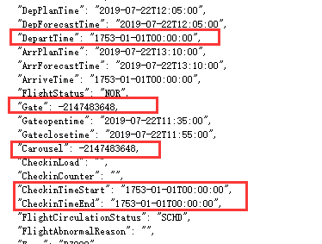

这是我们拿到的现场数据包：1、【登机口】【行李转盘】编号是负数2、各种时间是1735年这是例子错了，还是需要做一些转换处理？

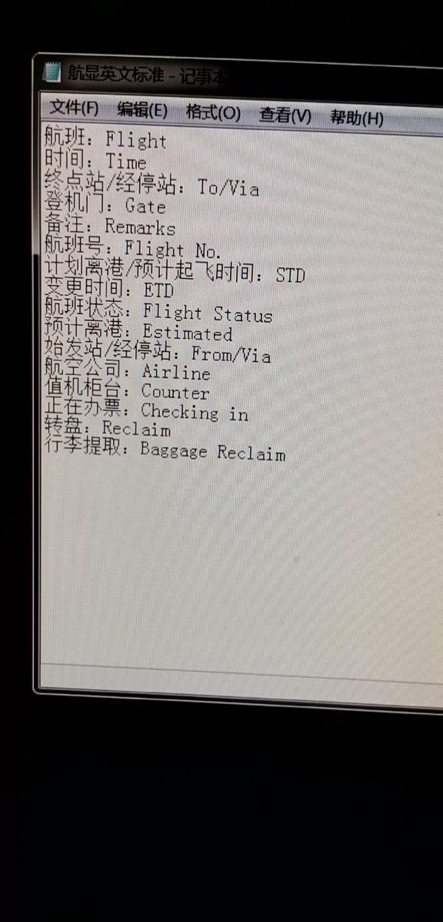

航显英文标准

航班:Flight

时间:Time

终点站/经停站:To/Via

登机门:Gate

备注:Remarks

航班号: Flight No.

计划离港/预计起飞时间:STD

变更时间:ETD

航班状态: Flight Status

预计离港: Estimated

始发站/经停站:From/Via

航空公司:Airline

值机柜台

Counter

正在办票: Checking in

转盘: Reclaim

行李提取: Baggage Reclaim