University of Rochester. ECE 449 Machine Vision.

Author: Tiecheng Su, Dept. of Electrical Engineering

HW2. Submission: 5 February 2016

**Select a single threshold to segment the given image.**

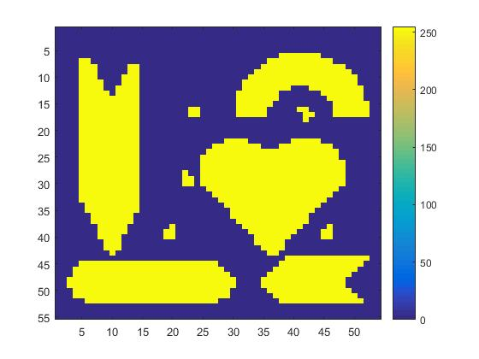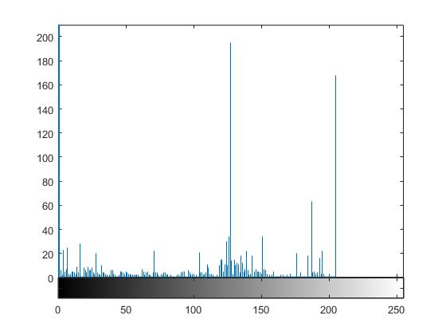We can simply obtain the histogram of the image and try to find a threshold that can segment all major objects. Assign all the object pixels a value of 255 and the background a value of 0

**Label connected components**

1. First pass: Search the entire image S row by row and assign a non-zero value label to each non-zero pixel. The value label is chosen according to the labels of the pixel’s neighbors, where the property neighboring is the 8 pixel around the non-zero pixel,

If all the neighbors are background pixels, then S(i,j) is assigned a new unused label.

If there is just one neighboring pixel with a non-zero label, assign this label to the pixel S(i,j).

If there is more than one non_zero pixel among the neighbors, assign the label of the smallest one to the labeled pixel. If the labels of any of the neighbors differ, store the label pair as being equivalent. Equivalence pairs are stored in a sequence data structure-an equivalence table.

The intermediate map after the first pass is shown as below

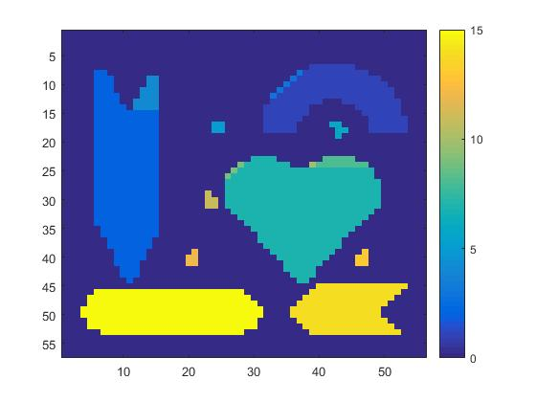

1. 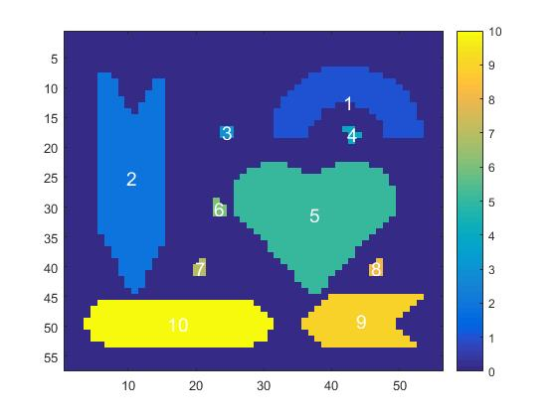Second pass: All of the region pixels were labeled during the first pass, but some regions have pixels with different labels(due to label collisions). The whole image is scanned again, and pixels are re-labeled using the equivalence table information.

**Perform region selection**

Remove all regions having areas smaller than 10 pixels, just simply count the number of a specific value, and set the value equals to zeros if it’s amount is less than 10.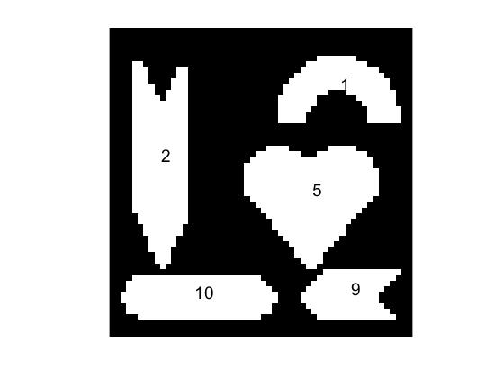

Remove all skinny regions having aspect ratios over 3:1(use rectangular bounding boxes to decide). Find out the maximum and minimum difference between row and column of each label. Set the value to zero if the aspect ratios over 3:1.

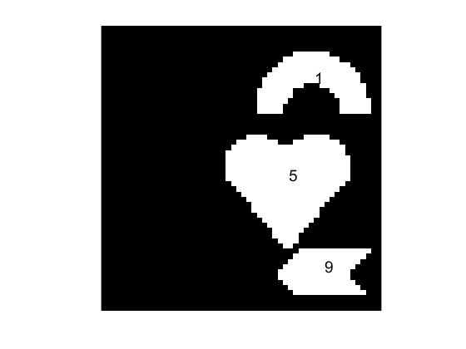

Detect the heart shape

We can find out that among all the region, only the aspect ratio of heart shape is 1. Therefore, we can simply set the value of other region equal to 0.

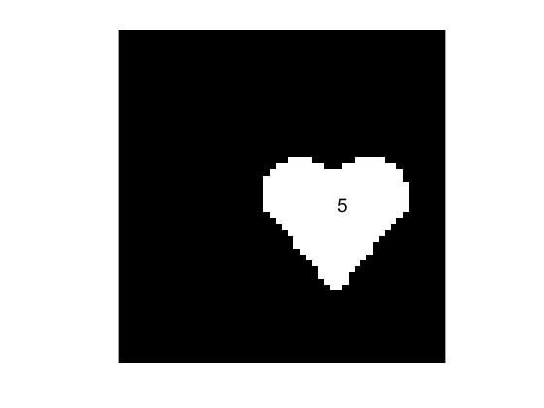

References

**[1].** Connected-component labeling Wikipedia

<https://en.wikipedia.org/wiki/Connected-component_labeling>

People that I discuss with

Taolue Chen

**Appendix**

(MATLAB Code).

%%Initialization

close all; clc; clear;

%% Select a single threshold to segment the given image

close all;

I = imread('E:\2016Spring\MV\HW2\Shapes-blurred.png');

figure

imhist(I);

%Create a binary map in which all major objects are segmented

S = I;

threshold = 60;

%Assign all the object pixels a value of 255 and the background a value of

%0

S(I > threshold) = 255;

S(I <= threshold) = 0;

imshow(I);

figure()

imagesc(S);

figure()

himage = imshow(S);

hfigure = figure;

hpanel = impixelregionpanel(hfigure, himage);

%% Label connected components

%first pass

close all; clc

linked = {};

[rows,cols]=size(S);

S_pad = zeros(rows+2,cols+2);

S_pad(2:1+rows,2:1+cols) = S;

[r,c]=size(S_pad);

B = zeros(r,c);

label = 1;

for i = 2:r-1

for j = 2:c-1

if S_pad(i,j)==255

if S_pad(i,j-1)==0&&S_pad(i-1,j-1)==0&&S_pad(i-1,j)==0&&S_pad(i-1,j+1)==0

linked{label} = label;

B(i,j)= label;

label = label + 1;

else

neighbors = [B(i,j-1);B(i-1,j-1);B(i-1,j);B(i-1,j+1);B(i,j+1)];

L = min(neighbors(neighbors>0));

B(i,j)=L;

for ii = 1:5

if neighbors(ii)>0;

linked{neighbors(ii)} = union(linked{neighbors(ii)},(neighbors(neighbors>0))');

end

end

end

end

end

end

figure()

imagesc(B);

figure()

himage = imshow(B);

hfigure = figure;

hpanel = impixelregionpanel(hfigure, himage);

%% second pass

clc;close all

%uniquely labeled

length = size(linked,2);

ID = [];

ID1 = [];

for i=1:length

ID(i) = min(linked{i});

end

%consecutive label

temp = unique(ID(:));

for ii=1:size(temp,1)

ID1(ID==temp(ii))=ii;

end

C = zeros(r,c);

for i=1:length

C(B==i)=ID1(i);

end

s = regionprops(C, 'Centroid');

imagesc(C);

hold on

for k = 1:numel(s)

m = s(k).Centroid;

text(m(1), m(2), sprintf('%d', k),'Color','w','FontSize',14,...

'HorizontalAlignment', 'center', 'VerticalAlignment', 'middle');

end

hold off

%% Perform region Selection

%Remove all regions having areas smaller than 10 pixels

clc;

C1 = C(2:r-1,2:c-1);

temp = unique(ID1(:));

for i = 1:size(temp,1)

if sum(C1(:)==temp(i))< 10

C1(C1(:)==temp(i)) = 0;

end

end

imshow(C1);

hold on

for k = 1:numel(s)

m = s(k).Centroid;

text(m(1), m(2), sprintf('%d', k),'FontSize',14,...

'HorizontalAlignment', 'center', 'VerticalAlignment', 'bottom');

end

hold off

%% Remove all skinny regions having aspect ratio over 3:1

temp = unique(C1(C1>0));

for i = 1:size(temp,1)

[row,col] = find(C1 == temp(i));

row_diff = peak2peak(row);

col_diff = peak2peak(col);

if(max(row_diff,col_diff)/min(row_diff,col_diff)>3)

C1(C1(:)==temp(i)) = 0;

end

end

imshow(C1);

hold on

for k = 1:numel(s)

m = s(k).Centroid;

text(m(1), m(2), sprintf('%d', k),'FontSize',14,...

'HorizontalAlignment', 'center', 'VerticalAlignment', 'bottom');

end

hold off

%% Dectect the heart shape(Valentine's Day bonus)

clc;

temp = unique(C1(C1>0));

for i = 1:size(temp,1)

[row,col] = find(C1 == temp(i));

row_diff = peak2peak(row);

col_diff = peak2peak(col);

if int8(max(row_diff,col_diff)/min(row_diff,col_diff))~=1;

C1(C1(:)==temp(i)) = 0;

end

end

imshow(C1);

hold on

for k = 1:numel(s)

m = s(k).Centroid;

text(m(1), m(2), sprintf('%d', k),'FontSize',14,...

'HorizontalAlignment', 'center', 'VerticalAlignment', 'bottom');

end

hold off