

EXPOS

PLATFORM FOR INVESTIGATING PRIVACY CONCERNS IN INTELLIGENT VOICE ASSISTANTS

RAHUL LAO

Master Thesis

July 2018

Rheinische Friedrich-Wilhelms-Universität Bonn

Institute of Computer Science 4

Methods in Multi-Layer Usable Security Research

Platform for Investigating Privacy Concerns in Intelligent Voice Assistants

Master Thesis

Submitted by Rahul Lao

Date of submission: July 2018

First examiner / Erstgutachter: Dr. Emanuel von Zezschwitz

Second examiner / Zweitgutachter: Prof. Dr. Matthew Smith

Supervisor / Betreuer: Christian Tiefenau

Rheinische Friedrich-Wilhelms-Universität Bonn

Institute of Computer Science 4

Methods in Multi-Layer Usable Security Research

MOTIVATION

______________________________________________________________________

As Artificial Intelligence (AI) is growing, there has been recent breakthroughs in Natural Language Understanding (NLU) systems like Echo by Amazon, Home by Google and Siri by Apple that are also known as Intelligent Voice Assistants (IVAs).

An intelligent voice assistant opens a new world, where you communicate with a machine as if it were a human and the machine will perform the work you requested [1]. For example, you may want to know the weather “Hey Alexa, what’s the weather today?”. These devices can not only respond to voice commands but also play music, search on internet, order items, interact with other devices connected to internet and much more [2].

For these devices to work they are usually powered by a virtual brain (AI) that may reside on a virtual place e.g. a cloud [1]. Thus, all user queries have to be transferred over the network to the cloud where the actual processing and query resolution takes place. This raises many user privacy concerns like how the data is stored, where the data is stored, who has access to the user data? While watching television or listening to radio if the activation command is said can also trigger interaction with smart speakers [4]. As these smart devices are always listening, this could be a big threat. User voice data has the potential to carry bio metric data and with the emergence of voice biometrics over the internet [5] a rogue IVA can be used to capture user voice commands and authentication.

RELATED WORK

______________________________________________________________________

Chung et al. [1] published a paper in which they explain the ecosystem of intelligent voice assistants. Along with that they talk about identifying threat vectors of IVA and consequences of having a rogue IVA.

By utilizing the reviews posted online and responses to a survey for IVAs Lydia Manikonda et al. [6] provides a set of insights about the detected markers related to user privacy interests and privacy challenges.

In an ISTR special report by Candid Wueest in 2017, risks IVAs possess to one’s cyber security have been pointed out. It is even possible to control a voice assistant from outside the home by using ultrasound frequencies to avoid human detection.

Drawing from user reviews of the Echo posted to Amazon.com, A Purington et al. [8] explores the degree to which user reviews indicate personification of the device, sociability level of interaction, factors linked with personification, and influences on user satisfaction.

As intelligent voice assistants (IVA) operate based on the cloud computing architecture, Chung et al. [7] show and categorize types of IVA-related data that can be collected from popular IVA, Amazon Alexa. Forming an experimental dataset covering three months with Alexa service, they then analyze to characterize the properties of user’s lifestyle and life patterns. The results presented provide important implications for and privacy threats to IVA vendors and users as well.

GOAL

______________________________________________________________________

Our goal is to develop a platform that can be used to capture user voice commands which can be later used for performing studies related to privacy issues with intelligent voice assistants.

FIRST OUTLINE

______________________________________________________________________

Figure 1 shows three components of the entire platform. Raspberry Pi with a microphone attached, running a service that has the capability to record user voice commands forms the first component. We can call this component to be our private on device voice assistant (PODVA).

A web application hosted on Raspberry Pi will be the second component. From the web application the user can manage its interaction with PODVA and hence we can define this application as its management portal.

Finally, an app running on smart watch to give feedback upon intent classification of user query will form the third component. From Figure 1 we can see that user will interact will all three components.

Raspberry Pi

Web Application



Figure 1: Main components of entire platform



Our PODVA is Raspberry Pi 3 Model B+ connected with USB microphone. Figure 2 shows the complete workflow of various components of the platform interacting with each other. A service runs on raspberry pi that can take user voice commands. Once a voice command from user is captured, it is then converted to .wav and JSON file. A watcher service uses the newly generated files to interact with an API to store user query along with intent, wake word, timestamp and .wav file location in database.

A notification is then sent on a smart watch running our custom app to capture user feedback and store in database. Figure 3 shows a sequence diagram for overall interaction.

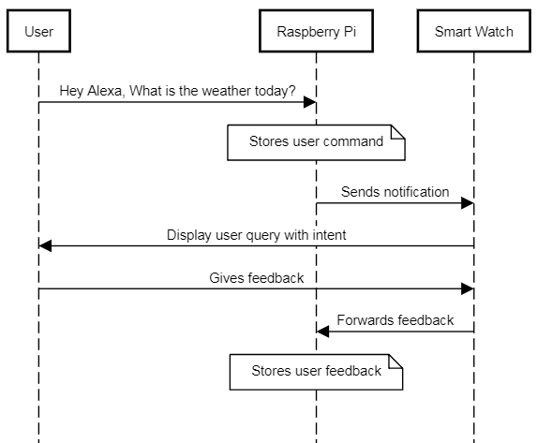

Figure 3: Sequence Diagram for interaction between user and various components



Voice Service



Watcher

API

Web Application



Raspberry Pi

Figure 2: First draft of complete platform workflow

OUTCOME

______________________________________________________________________

By having a private on device voice assistant (PODVA), no user data will be transferred over the network to the cloud and hence the final outcome of this thesis would be a platform to monitor privacy concerns related with intelligent voice assistants. The outcome will enable us to do important research in the IoT area since it is very difficult to get real world data.

PLANNED TIMELINE / MILESTONES

______________________________________________________________________

|  |  |  |
| --- | --- | --- |
| Title | Start | End |
| Literature review | 20.06.2018 | 29.06.2018 |
| Proposal Writing | 02.07.2018 | 22.07.2018 |
| Design | 23.07.2018 | 05.08.2018 |
| Implementation 1.0 | 06.08.2018 | 26.08.2018 |
| Feedback and changes | 27.08.2018 | 09.09.2018 |
| Implementation 2.0 | 10.09.2018 | 23.09.2018 |
| Feedback and changes | 24.09.2018 | 07.10.2018 |
| Writing First Draft | 08.10.2018 | 11.11.2018 |
| Feedback and changes | 12.11.2018 | 18.11.2018 |
| Writing Final Draft | 19.11.2018 | 09.12.2018 |
| Presentation | 10.12.2018 | 24.12.2018 |

SOURCES

______________________________________________________________________

[1] H Chung, M Iorga, J Voas, S Lee: „Alexa, Can I Trust You? “. (2017)

[2] Virtual Assistant – Wikipedia, <https://en.wikipedia.org/wiki/Virtual_assistant>

[4] Candid Wueest: „ A guide to the security of voice-activated smart speakers “(2017)

[5] Laurent Besacier, Aladdin M. Ariyaeeinia, John S. Mason, Jean-Francois Bonastre, Pedro Mayorga, Corinne Fredouille, Sylvain Meignier, Johann Siau, Nicholas W. D. Evans, Roland Auckenthaler, Robert Stapert: „ Voice Biometrics over the Internet in the Framework of COST Action 275 “(2003)

[6] Lydia Manikonda, Aditya Deotale, Subbarao Kambhampati: „What's up with Privacy? User Preferences and Privacy Concerns in Intelligent Personal Assistants “(2017)

[7] H Chung, S Lee: „Intelligent Virtual Assistant knows Your Life “. (2018)

[8] A Purington, J G. Taft, S Sannon, N N. Bazarova, S H Taylor: „Alexa is my new BFF: Social Roles, User Satisfaction, and Personification of the Amazon Echo “. (2017)