Moduldokumentation

Modul Englisch 3 (e3)

Simon Wächter

2016

Inhalt

1 Einleitung 3

1.1 Einleitung 3

1.2 Lernziele 3

1.3 Prüfungen 3

2 Woche 1 4

2.1 Presentation structure 4

3 Woche 2 5

3.1 Reading 5

3.1.1 Surveying 5

3.1.2 Skimming 5

3.1.3 Scanning 5

3.2 Introduction of a presentation 6

3.3 Example of an introduction for Bill Gates 7

3.4 Example of an introduction for an own presentation 7

4 Woche 3 8

4.1 Body structure 8

4.2 Signposting 8

4.3 Grammar 10

4.4 Overview 10

5 Woche 4 11

5.1 Infinite 11

5.2 Gerund 11

6 Woche 5 12

7 Woche 6 13

8 Woche 7 14

9 Woche 8 15

10 Woche 9 16

11 Woche 10 17

12 Woche 11 18

13 Woche 12 19

14 Woche 13 20

15 Woche 14 21

16 Woche 15 22

17 Woche 16 23

18 Woche 17 24

# Einleitung

## Einleitung

Dieses Dokument stellt die Moduldokumentation für das Modul e3 dar. Allfällige Unterlagen sind im Modulordner zu finden.

## Lernziele

Das Modul beinhaltet folgende Lernziele:

* Texte lesen und verstehen
* Präsentationen halte

## Prüfungen

Die Modulnote setzt sich aus drei Aufgaben (Summary des Vortrags, Selbstreflexion und Reflexion an einem Partner) zu je 10% und der Präsentation zu 70% zusammen.

# Woche 1

## Presentation structure

* Introduction
  + Lead in: Catch listeners attention
  + Organize = Outline
  + Introduce yourself
* Main point (3 items)
* Summary
* Conclusion

# Woche 2

## Reading

### Surveying

Surveying allows a reader to quickly distinguish the content of a document. Surveying is a technique we often use when we have a quick look through a magazine to see what kinds of information it contains and to assess if it interests us enough to buy it. Used as a pre-reading technique, it allows a reader to identify how a document (such as a book or journal) is organized, which parts of a document are relevant to the reading purpose, or even if the entire document is not relevant or useful for that purpose.

How to survey:

* Look through the document only very briefly, reading the titles of chapters in a book, articles of the journal/magazine or title and headings of paragraphs within an article
* Decide which parts of the document, if any, are relevant to your reading purpose
* Mark the relevant areas you wish to read in a more in-depth manner

### Skimming

Skimming is a technique which allows the reader to get a broad idea of the main topic of a text and also to roughly determine main arguments within a text. Skimming is more thorough than surveying

How to skim a text:

* Read the introductory paragraph
* Read the first sentence of each paragraph – the first sentence is often the topic sentence, containing the main idea of the paragraph
* Look for key words that state the main idea and highlight them
* Look for information which answers so-called ‘journalist questions’: Who? What? Where? When? How? Why?
* Notice linking words which show relationships between ideas or show text organization
* Repeat the skimming steps for the entire text, including the conclusion

Skim the article that you are using for your practice presentation:

1. What is the main idea presented in the introductory paragraph?
2. Why is the innovation presented in the article significant?
3. What are the (three) main points made in the article?

### Scanning

Scanning is a reading technique used to rapidly locate information. You can use scanning to located specific information such as names, dates and figures, to skip over unimportant or irrelevant information, and to locate supporting details such as definitions or examples.

How to scan:

* Decide what you’re looking for (e.g. name, date, key word);
* Move your eyes systematically and quickly over the text
* Skip over all information which is not relevant to your search;
* If you are not sure if the information is relevant, mark it with a note so you can return quickly to it later;
* When you find something you’re searching for, highlight it and read more carefully around it;
* If necessary, re-read the sentence containing the highlighted information to understand how the information fits into the overall context.

## Introduction of a presentation

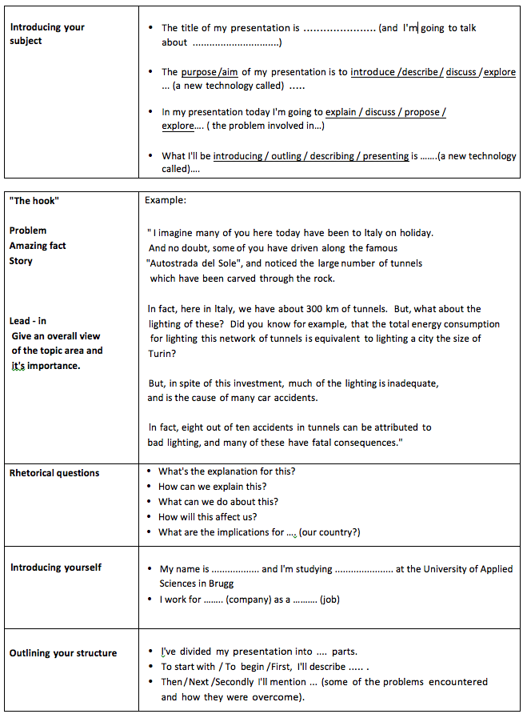

Introduction:

## Example of an introduction for Bill Gates

* Introduction:
  + Hello everyone. My name is Simon Wächter, I am a computer science student at the school of Applied Science
* Lead-In:
  + Normally people don’t sleep at our or other universities, but a soften there is an exception to this rule
  + I want to talk about one of these people that often slept during class
  + He changed the way we communicate today
  + His name is Bill Gates
* Outline:
  + I want to split my presentation of around 6 minutes into three parts:
  + First part is about Bill Gates childhood
  + The second part is about his university life and the beginning of Microsoft
  + And the third one is the vision of Microsoft, that formed the company like we know it today
  + So let’s begin

## Example of an introduction for an own presentation

Introduction:

* Hello everyone. As you might know my name is Simon Wächter and I am 22 years old

Lead-in:

* I am studying computer science at the school of applied science here in Windisch. To be more precise I am studying 60% and working 40%, sometimes 60% as a software developer
* So my time table is quite full and I have to plan my life through, especially during the final exam week
* So I am really happy about the topic I got from Mister Czarnecki think it’s a problem that everyone is facing, especially if you study and work at the same time

Outline:

* So I want to create about 3 main point. Understand what makes you unhappy, change it and keep it:
  + Why your job sucks, what do you hate? What makes you angry?
  + How to eliminate these things? How to accomplish your daily work life in a happy way?
  + How to keep the situation in the future? How not to fall back to the old habits?
* So let’s start with the first topic: What sucks and how to understand it?

# Woche 3

## Body structure

At the beginning of each main part, you should state the objective of each section.

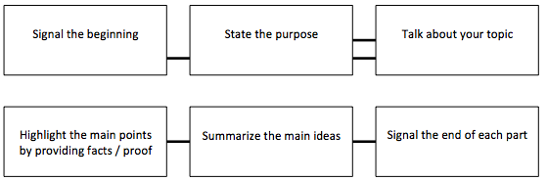

## Signposting

When you are on a journey, signposts show the direction you are going, where you are now, and where you have been.

In a presentation, signposts are short phrases that help the audience follow the direction and structure of what you are saying. They are not part of the main information.

Look at the diagram below. Imagine that the different parts of your presentation are in a cupboard. When opening and closing each cupboard or when starting and ending a part of your presentation, use signposting language to inform the listener.

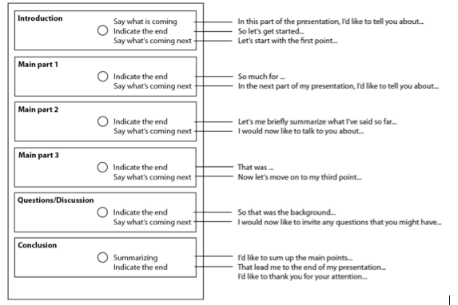

In the following presentation, the speaker is trying to persuade the managers of a large retail chain to stock Reiko watches. Underline all the examples of signposting that you can find in the extract below. One example has been done for you.

How many times do you look at your watch every day? You may be surprised to know that the average person looks at his or her watch about 347 times in one day. That makes the watch a very important accessory and one where buyers value design and quality. My name is Arthur Bowler and I am Vice President of Sales at Reiko Watchers. I’m going to talk to you today about Reiko watches. First I’ll talk about the technology that goes into a Reiko, then we’ll look at the design, and after that of course, the image of our watches in the market.

So, let’s start by looking at the technology. Our new range of watches features a technological miracle. We have replaced the battery with a very small generator that makes its own electrical power by the movements of your hand. It’s ecological, reliable and efficient: wear it one day to gain energy for at least two weeks. And all our watches are made of titanium – a light material, yet strong and kind to your skin. OK, that’s all I want to say about the technical details. Any questions so far?

Right, let’s move on to the design and style of a Reiko. Every Reiko watch combines classical elegance with modern design. This represents both tradition and innovation. In addition, our market research department makes sure that every generation of watches uses the latest style, the style that the customer really wants. Before going on, I’d just like to mention that of course we support retailers who stock our products with a full range of promotional material such as counter displays, window displays and posters. I have some examples here to show you.

OK, finally I’d like to turn to the most important point: the image of our watches, and the feeling that our customers have when they wear one. As you know, Reiko watches are not cheap, but people who buy a Reiko are not looking for a cheap product. Clearly, they are looking for something special, for something that gives confidence and represents the status they have achieved. To put it simply, they are looking for the best.

To sum up, I have talked about three main areas. First, the sophisticated modern technology that goes into a Reiko watch, second, the design of a Reiko that is based on the most up-to-date market research, and third, the luxury image of a Reiko. I also mentioned the promotional support that we offer to retailers.

I’d like to conclude by saying that, as I mentioned, there are very few personal belongings which become such a part of a person as their watch. We, as professional sales people have the opportunity of turning that fact into profit, by providing your customers with Reiko watches.

Thank you very much for your attention. And now, if anyone has any questions, I’d be happy to try to answer them.

## Grammar

## Overview

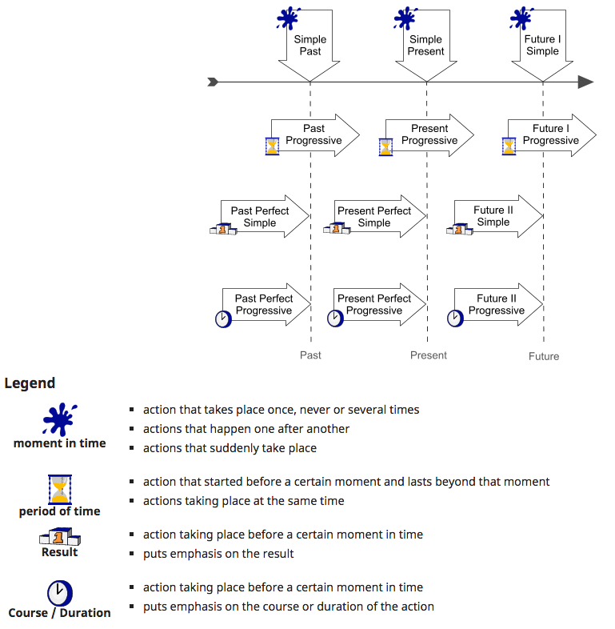

# Woche 4

## Infinite

* Used for facts
* Examples:
  + I can swim.
  + He made her swim.
  + Why not go to the cinema?

## Gerund

* Used as a description of a fact
* Examples:
  + Cycling is good for your health
  + He is afraid of going by plane
  + I enjoy cooking
  + I am looking forward to seeing you again

# Woche 5

In Woche 5 fanden weitere Vorträge statt.

# Woche 6

In Woche 6 fand aufgrund der Osterferien keine Schule statt.

# Woche 7

In Woche 7 fanden weitere Vorträge statt.

# Woche 8

In Woche 8 fanden weitere Vorträge statt.

# Woche 9

In Woche 9 fanden weitere Vorträge statt.

# Woche 10

In Woche 10 fanden weitere Vorträge statt.

# Woche 11

In der Woche 11 fand aufgrund Auffahrt kein Unterricht statt.

# Woche 12

In Woche 12 fand aufgrund der Projektwoche kein Unterricht statt.

# Woche 13

In Woche 13 fand die Evaluation der Summaries statt.

# Woche 14

In Woche 14 hielt ich meinen Vortrag.

# Woche 15

In Woche 15 fanden weitere Vorträge statt.

# Woche 16

In Woche 16 fanden weitere Vorträge statt.

# Woche 17

In Woche 17 fand eine kurze Abschlussbesprechung statt.