# Homework

## Import

%matplotlib inline  
import numpy as np  
import pandas as pd  
import matplotlib.pyplot as plt  
import seaborn as sns  
from matplotlib import style  
from sklearn.datasets import fetch_openml, make_classification  
from sklearn.linear_model import LinearRegression  
from sklearn.metrics import mean_squared_error  
from mpl_toolkits.mplot3d import Axes3D

## 1.7

def check_bmi(bmi):  
 if bmi < 18.5:  
 return 'Underweight'  
 elif bmi < 25:  
 return 'Normal weight'  
 elif bmi < 30:  
 return 'Overweight'

names = np.array(['Ann', 'Joe', 'Mark'])  
heights = np.array([1.5, 1.78, 1.6])  
weights = np.array([65, 46, 59])  
  
bmi = weights / heights ** 2  
bmi

array([28.88888889, 14.51836889, 23.046875 ])

df = pd.DataFrame({'Name': names, 'Height': heights, 'Weight': weights, 'BMI': bmi})  
df

Name Height Weight BMI  
0 Ann 1.50 65 28.888889  
1 Joe 1.78 46 14.518369  
2 Mark 1.60 59 23.046875

classify = np.vectorize(check_bmi)  
classify(bmi)

array(['Overweight', 'Underweight', 'Normal weight'], dtype='<U13')

df2 = pd.DataFrame({  
 'Name': names,   
 'Height': heights,   
 'Weight': weights,   
 'BMI': bmi,   
 'Classify': classify(bmi)})  
df2

Name Height Weight BMI Classify  
0 Ann 1.50 65 28.888889 Overweight  
1 Joe 1.78 46 14.518369 Underweight  
2 Mark 1.60 59 23.046875 Normal weight

### Data from group

data = pd.read_csv('data/no1_7.csv')  
data

name height weight  
0 anhnt 1.66 72  
1 vphuong 1.78 65  
2 vu 1.68 60  
3 nam 1.69 65  
4 dphuong 1.67 60

names = data['name'].values  
heights = data['height'].values  
weights = data['weight'].values

bmi = weights / heights ** 2  
bmi

array([26.12861083, 20.51508648, 21.2585034 , 22.75830678, 21.51385851])

df3 = pd.DataFrame({  
 'Name': names,  
 'Height': heights,  
 'Weight': weights,  
 'BMI': bmi,  
 'Classify': classify(bmi)})  
df3

Name Height Weight BMI Classify  
0 anhnt 1.66 72 26.128611 Overweight  
1 vphuong 1.78 65 20.515086 Normal weight  
2 vu 1.68 60 21.258503 Normal weight  
3 nam 1.69 65 22.758307 Normal weight  
4 dphuong 1.67 60 21.513859 Normal weight

## 1.8

#### Plotting multiple Lines in the same chart

style.use('ggplot')

plt.plot(  
 [1,2,3,4,5,6,7,8,9,10],  
 [2,4.5,1,2,3.5,2,1,2,3,2]  
)  
  
plt.plot(  
 [1,2,3,4,5,6,7,8,9,10],  
 [3,4,2,5,2,4,2.5,4,3.5,3]  
)  
  
plt.title('Results')  
plt.xlabel('Semester')  
plt.ylabel('Grade')

Text(0, 0.5, 'Grade')

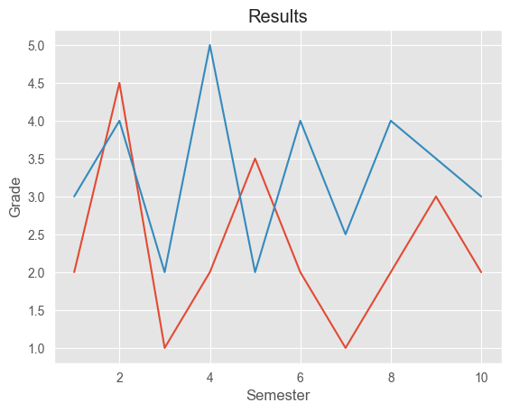

#### Adding a Legend

plt.plot(  
 [1,2,3,4,5,6,7,8,9,10],  
 [2,4.5,1,2,3.5,2,1,2,3,2],  
 label="Jim"  
)  
plt.plot(  
 [1,2,3,4,5,6,7,8,9,10],  
 [3,4,2,5,2,4,2.5,4,3.5,3],  
 label="Tom"  
)  
  
plt.title('Results')  
plt.xlabel('Semester')  
plt.ylabel('Grade')  
plt.legend()

<matplotlib.legend.Legend at 0x2347ff65550>

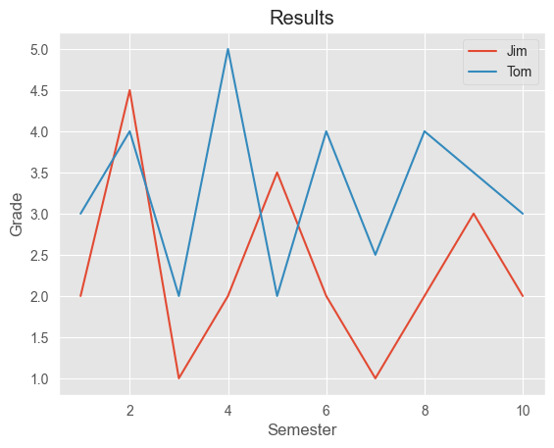

#### Plotting bar charts

plt.bar(  
 [1,2,3,4,5,6,7,8,9,10],  
 [2,4.5,1,2,3.5,2,1,2,3,2],  
 label = "Jim",  
 color = "m", # m for magenta  
 align = "center"  
)  
  
plt.title("Results")  
plt.xlabel("Semester")  
plt.ylabel("Grade")  
  
plt.legend()  
plt.grid(True, color="y")

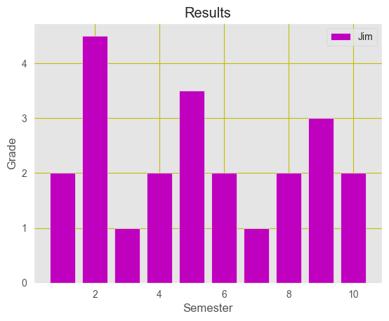

### Data from team

df = pd.read_csv('./data/no1_8.csv')  
df

Subject tienanh vphuong vu nam dphuong  
0 C 6 7 8 8 9  
1 C++ 7 8 9 10 6  
2 Java 8 9 7 9 7  
3 Python 9 8 10 10 10  
4 Swift 10 7 6 8 8

subjects = df["Subject"]  
tienanh_grade = df["tienanh"]  
vphuong_grade = df["vphuong"]  
vu_grade = df["vu"]  
nam_grade = df["nam"]  
dphuong_grade = df["dphuong"]

plt.plot(  
 subjects,   
 tienanh_grade,   
 label="tienanh",  
 )  
plt.plot(  
 subjects,   
 vphuong_grade,   
 label="vphuong",  
 )  
plt.plot(  
 subjects,   
 vu_grade,   
 label="vu",  
 )  
plt.plot(  
 subjects,  
 nam_grade,  
 label="nam",  
 )  
plt.plot(  
 subjects,  
 dphuong_grade,  
 label="dphuong",  
 )  
  
plt.title('Results')  
plt.xlabel('Semester')  
plt.ylabel('Grade')

Text(0, 0.5, 'Grade')

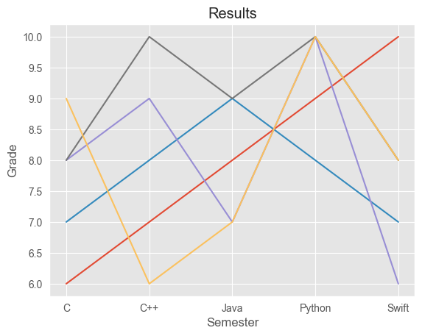

style.use('ggplot')  
  
subjects = subjects.tolist()  
subjects  
  
plt.bar(  
 subjects,   
 tienanh_grade,   
 label="tienanh",  
 color = "m",  
 align = "center"  
 )  
  
plt.title('Results')  
plt.xlabel('Semester')  
plt.ylabel('Grade')  
  
plt.legend()  
plt.grid(True, color="y")

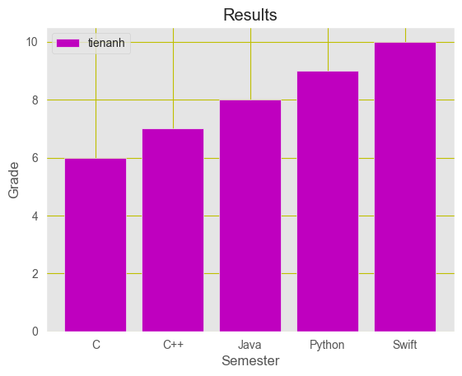

plt.plot(  
 subjects,   
 tienanh_grade,   
 label="tienanh",  
 )  
plt.plot(  
 subjects,   
 vphuong_grade,   
 label="vphuong",  
 )  
plt.plot(  
 subjects,   
 vu_grade,   
 label="vu",  
 )  
plt.plot(  
 subjects,  
 nam_grade,  
 label="nam",  
 )  
plt.plot(  
 subjects,  
 dphuong_grade,  
 label="dphuong",  
 )  
  
plt.xlabel("Subject")  
plt.ylabel("Grade")  
plt.title("Grade of Students")  
plt.legend()

<matplotlib.legend.Legend at 0x2340004ebe0>

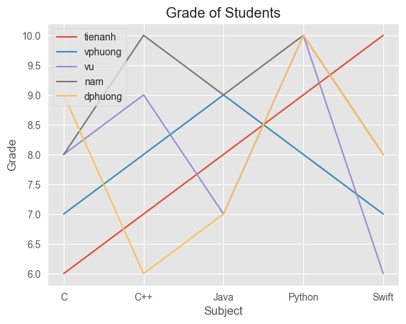

## 1.9

df = pd.read_csv('data/no1_9.csv')  
df

gender group license  
0 men A 1  
1 men A 0  
2 men A 1  
3 women A 1  
4 women A 0  
5 women A 0  
6 men B 0  
7 men B 0  
8 men B 0  
9 men B 1  
10 women B 1  
11 women B 1  
12 women B 1  
13 women B 1

g = sns.catplot(x="gender", y="license", col="group",  
 data = df, kind="bar", errorbar=None, aspect=1.0)  
  
#--- set the labels ---  
g.set_axis_labels("", "Proportion with Driving license")  
g.set_xticklabels(["Men", "Women"])  
g.set_titles("{col_var} {col_name}")  
  
#--- show plot ---  
plt.show()

c:\Users\tien2\miniconda3\lib\site-packages\seaborn\axisgrid.py:118: UserWarning: The figure layout has changed to tight  
 self._figure.tight_layout(*args, **kwargs)

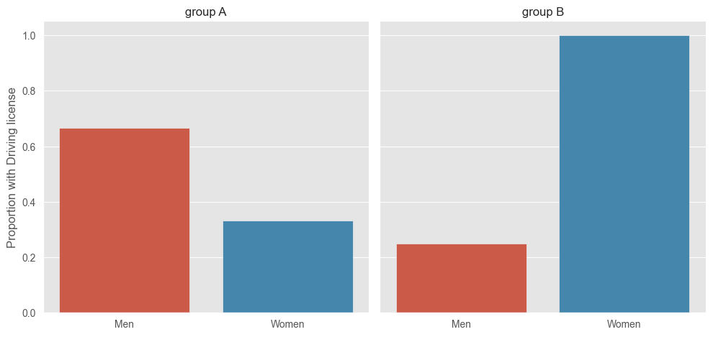

## 1.10

df = pd.read_csv('data/no1_10.csv')  
df

survived pclass sex age sibsp parch fare embarked class \  
0 0 3 male 22.0 1 0 7.2500 S Third   
1 1 1 female 38.0 1 0 71.2833 C First   
2 1 3 female 26.0 0 0 7.9250 S Third   
3 1 1 female 35.0 1 0 53.1000 S First   
4 0 3 male 35.0 0 0 8.0500 S Third   
.. ... ... ... ... ... ... ... ... ...   
886 0 2 male 27.0 0 0 13.0000 S Second   
887 1 1 female 19.0 0 0 30.0000 S First   
888 0 3 female NaN 1 2 23.4500 S Third   
889 1 1 male 26.0 0 0 30.0000 C First   
890 0 3 male 32.0 0 0 7.7500 Q Third   
  
 who adult_male deck embark_town alive alone   
0 man True NaN Southampton no False   
1 woman False C Cherbourg yes False   
2 woman False NaN Southampton yes True   
3 woman False C Southampton yes False   
4 man True NaN Southampton no True   
.. ... ... ... ... ... ...   
886 man True NaN Southampton no True   
887 woman False B Southampton yes True   
888 woman False NaN Southampton no False   
889 man True C Cherbourg yes True   
890 man True NaN Queenstown no True   
  
[891 rows x 15 columns]

g = sns.catplot(x="who", y="fare", col="alive",   
 data=df, kind="bar", errorbar=None, aspect=1.0)

c:\Users\tien2\miniconda3\lib\site-packages\seaborn\axisgrid.py:118: UserWarning: The figure layout has changed to tight  
 self._figure.tight_layout(*args, **kwargs)

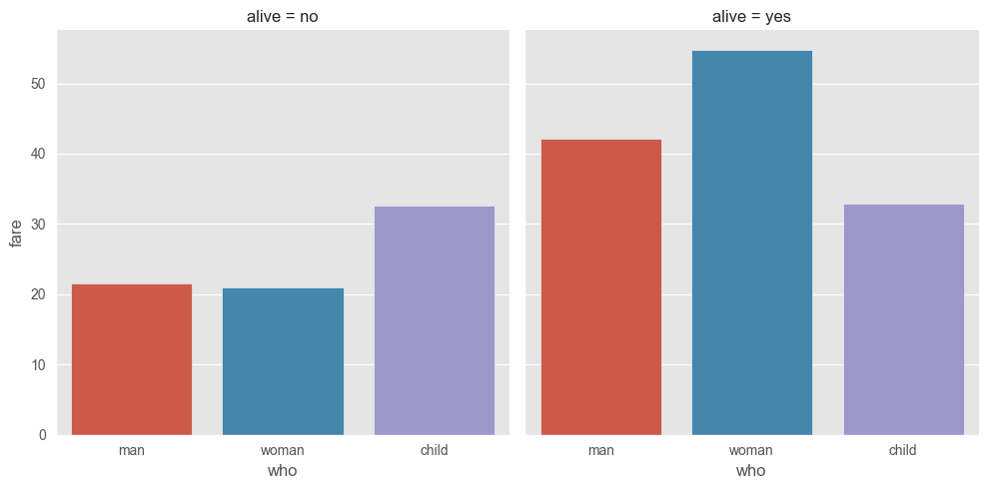

## 1.11

sns.set_style("whitegrid")  
   
#---load data---  
data = pd.read_csv('data/salary.csv')  
   
#---plot the swarm plot---  
sns.swarmplot(x="gender", y="salary", data=data)  
  
ax = plt.gca()  
ax.set_title("Salary distribution")  
   
#---show plot---  
plt.show()

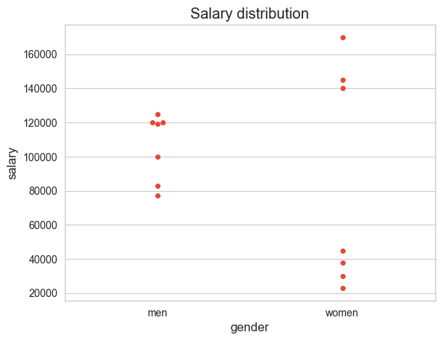

## 1.12

data = np.array([(50, 2.5), (60, 3), (65, 3.5), (70, 3.8), (75, 4), (80, 4.5), (85, 5)])  
data

array([[50. , 2.5],  
 [60. , 3. ],  
 [65. , 3.5],  
 [70. , 3.8],  
 [75. , 4. ],  
 [80. , 4.5],  
 [85. , 5. ]])

X = data[:,0].reshape(-1,1)  
y = data[:,1]  
  
model = LinearRegression()  
model.fit(X, y)  
  
new_areas = np.array([55, 68, 76, 90]).reshape(-1, 1)  
predicted_prices = model.predict(new_areas)  
  
for area, price in zip(new_areas, predicted_prices):  
 print(f"Diện tích: {area} m2, Giá dự đoán: {price:.2f} tỷ")  
  
plt.scatter(X, y, color='blue', label='Data')  
plt.plot(X, model.predict(X), color='red', label='Linear Regression')  
plt.scatter(new_areas, predicted_prices, color='green', label='Predictions')  
plt.xlabel('Diện tích (m2)')  
plt.ylabel('Giá nhà (tỷ)')  
plt.title('Dự đoán giá nhà bằng Linear Regression')  
plt.legend()  
plt.show()

Diện tích: [55] m2, Giá dự đoán: 2.75 tỷ  
Diện tích: [68] m2, Giá dự đoán: 3.67 tỷ  
Diện tích: [76] m2, Giá dự đoán: 4.23 tỷ  
Diện tích: [90] m2, Giá dự đoán: 5.21 tỷ

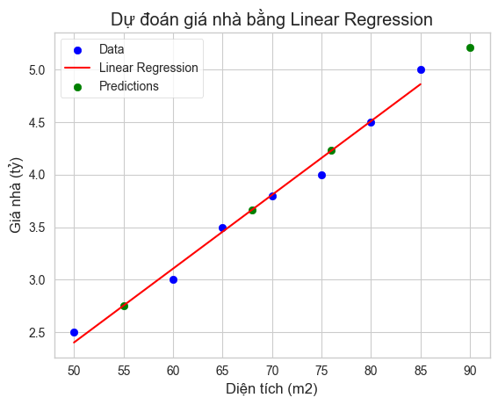

## 1.13

heights = [[1.6], [1.65], [1.7], [1.73], [1.8]]  
  
weights = [[60], [65], [72.3], [75], [80]]

# represents the weights of a group of people in kgs  
weights = [[60], [65], [72.3], [75], [80]]  
  
plt.title('Weights plotted against heights')  
plt.xlabel('Heights in meters')  
plt.ylabel('Weights in kilograms')  
  
plt.plot(heights, weights, 'k.')  
  
# axis range for x and y  
plt.axis([1.5, 1.85, 50, 90])  
plt.grid(True)

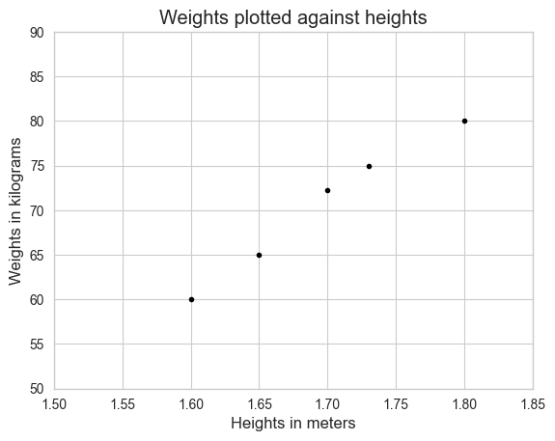

model = LinearRegression()  
model.fit(X=heights, y=weights)  
  
weight = model.predict([[1.75]])[0][0]  
print(f'Predicted weight for height 1.75 m: {round(weight,2)} kg')

Predicted weight for height 1.75 m: 76.04 kg

import matplotlib.pyplot as plt  
  
heights = [[1.6], [1.65], [1.7], [1.73], [1.8]]  
weights = [[60], [65], [72.3], [75], [80]]  
  
plt.title('Weights plotted against heights')  
plt.xlabel('Heights in meters')  
plt.ylabel('Weights in kilograms')  
plt.plot(heights, weights, 'k.')  
  
plt.axis([1.5, 1.85, 50, 90])  
plt.grid(True)  
  
# plot the regression line  
plt.plot(heights, model.predict(heights), color='r')  
  
round(model.predict([[0]])[0][0],2) # -104.75  
  
print(round(model.intercept_[0],2)) # -104.75  
  
print(round(model.coef_[0][0],2)) # 103.31

-104.75  
103.31

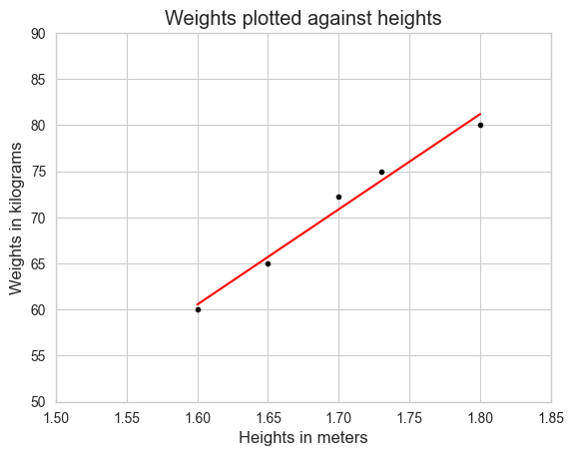

plt.title('Weights plotted against heights')  
plt.xlabel('Heights in meters')  
plt.ylabel('Weights in kilograms')  
  
plt.plot(heights, weights, 'k.')  
  
plt.axis([0, 1.85, -200, 200])  
plt.grid(True)

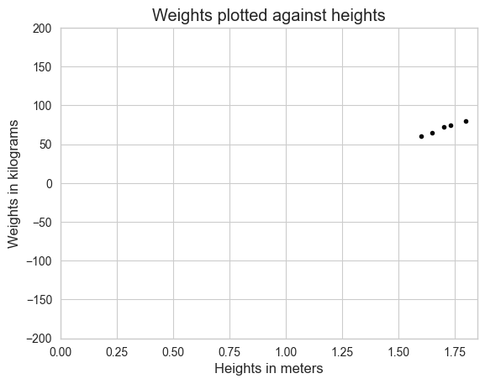

import numpy as np  
  
print('Residual sum of squares: %.2f' %  
 np.sum((weights - model.predict(heights)) ** 2))

Residual sum of squares: 5.34

# test data  
heights_test = [[1.58], [1.62], [1.69], [1.76], [1.82]]  
weights_test = [[58], [63], [72], [73], [85]]

# Total Sum of Squares (TSS)  
weights_test_mean = np.mean(np.ravel(weights_test))  
TSS = np.sum((np.ravel(weights_test) -  
 weights_test_mean) ** 2)  
print("TSS: %.2f" % TSS)  
  
# Residual Sum of Squares (RSS)  
RSS = np.sum((np.ravel(weights_test) -  
 np.ravel(model.predict(heights_test)))  
 ** 2)  
print("RSS: %.2f" % RSS)  
  
# R_squared  
R_squared = 1 - (RSS / TSS)  
print("R-squared: %.2f" % R_squared)  
  
# using scikit-learn to calculate r-squared  
print('R-squared: %.4f' % model.score(heights_test,  
 weights_test))

TSS: 430.80  
RSS: 24.62  
R-squared: 0.94  
R-squared: 0.9429

import pickle  
  
# save the model to disk  
filename = './data/HeightsAndWeights_model.sav'  
# write to the file using write and binary mode  
pickle.dump(model, open(filename, 'wb'))

# load the model from disk  
loaded_model = pickle.load(open(filename, 'rb'))  
result = loaded_model.score(heights_test,  
 weights_test)  
result

0.9428592885995254

### Personal records

heights = [[1.6], [1.65], [1.7], [1.73], [1.8]]  
  
weights = [[60], [65], [72.3], [75], [80]]  
  
model = LinearRegression()  
model.fit(heights, weights)  
  
# Predict weights for new heights  
new_heights = np.array([[1.68], [1.75]])  
predicted_weights = model.predict(new_heights)  
  
# Display predictions  
for height, weight in zip(new_heights, predicted_weights):  
 print(f"Chiều cao: {height[0]} m, Trọng lượng dự đoán: {weight[0]:.2f} kg")

Chiều cao: 1.68 m, Trọng lượng dự đoán: 68.81 kg  
Chiều cao: 1.75 m, Trọng lượng dự đoán: 76.04 kg

# Visualization  
plt.scatter(heights, weights, color='blue', label='Data')  
plt.plot(heights, model.predict(heights), color='red', label='Linear Regression')  
plt.scatter(new_heights, predicted_weights, color='green', label='Predictions')  
plt.xlabel('Chiều cao (m)')  
plt.ylabel('Trọng lượng (kg)')  
plt.title('Dự đoán trọng lượng dựa trên chiều cao')  
plt.legend()  
plt.show()

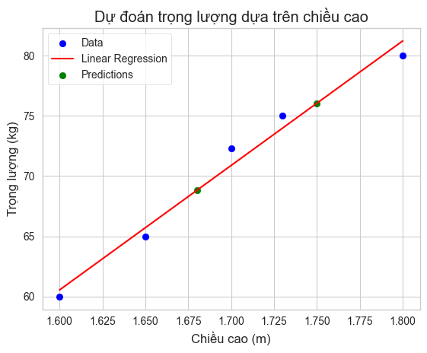

## 1.14

dataset = fetch_openml(name='boston')  
dataset.data

c:\Users\tien2\miniconda3\lib\site-packages\sklearn\datasets\_openml.py:303: UserWarning: Multiple active versions of the dataset matching the name boston exist. Versions may be fundamentally different, returning version 1.  
 warn(  
c:\Users\tien2\miniconda3\lib\site-packages\sklearn\datasets\_openml.py:1002: FutureWarning: The default value of `parser` will change from `'liac-arff'` to `'auto'` in 1.4. You can set `parser='auto'` to silence this warning. Therefore, an `ImportError` will be raised from 1.4 if the dataset is dense and pandas is not installed. Note that the pandas parser may return different data types. See the Notes Section in fetch_openml's API doc for details.  
 warn(

CRIM ZN INDUS CHAS NOX RM AGE DIS RAD TAX \  
0 0.00632 18.0 2.31 0 0.538 6.575 65.2 4.0900 1 296.0   
1 0.02731 0.0 7.07 0 0.469 6.421 78.9 4.9671 2 242.0   
2 0.02729 0.0 7.07 0 0.469 7.185 61.1 4.9671 2 242.0   
3 0.03237 0.0 2.18 0 0.458 6.998 45.8 6.0622 3 222.0   
4 0.06905 0.0 2.18 0 0.458 7.147 54.2 6.0622 3 222.0   
.. ... ... ... ... ... ... ... ... .. ...   
501 0.06263 0.0 11.93 0 0.573 6.593 69.1 2.4786 1 273.0   
502 0.04527 0.0 11.93 0 0.573 6.120 76.7 2.2875 1 273.0   
503 0.06076 0.0 11.93 0 0.573 6.976 91.0 2.1675 1 273.0   
504 0.10959 0.0 11.93 0 0.573 6.794 89.3 2.3889 1 273.0   
505 0.04741 0.0 11.93 0 0.573 6.030 80.8 2.5050 1 273.0   
  
 PTRATIO B LSTAT   
0 15.3 396.90 4.98   
1 17.8 396.90 9.14   
2 17.8 392.83 4.03   
3 18.7 394.63 2.94   
4 18.7 396.90 5.33   
.. ... ... ...   
501 21.0 391.99 9.67   
502 21.0 396.90 9.08   
503 21.0 396.90 5.64   
504 21.0 393.45 6.48   
505 21.0 396.90 7.88   
  
[506 rows x 13 columns]

dataset.feature_names

['CRIM',  
 'ZN',  
 'INDUS',  
 'CHAS',  
 'NOX',  
 'RM',  
 'AGE',  
 'DIS',  
 'RAD',  
 'TAX',  
 'PTRATIO',  
 'B',  
 'LSTAT']

dataset.DESCR

"**Author**: \n**Source**: Unknown - Date unknown \n**Please cite**: \n\nThe Boston house-price data of Harrison, D. and Rubinfeld, D.L. 'Hedonic\nprices and the demand for clean air', J. Environ. Economics & Management,\nvol.5, 81-102, 1978. Used in Belsley, Kuh & Welsch, 'Regression diagnostics\n...', Wiley, 1980. N.B. Various transformations are used in the table on\npages 244-261 of the latter.\nVariables in order:\nCRIM per capita crime rate by town\nZN proportion of residential land zoned for lots over 25,000 sq.ft.\nINDUS proportion of non-retail business acres per town\nCHAS Charles River dummy variable (= 1 if tract bounds river; 0 otherwise)\nNOX nitric oxides concentration (parts per 10 million)\nRM average number of rooms per dwelling\nAGE proportion of owner-occupied units built prior to 1940\nDIS weighted distances to five Boston employment centres\nRAD index of accessibility to radial highways\nTAX full-value property-tax rate per $10,000\nPTRATIO pupil-teacher ratio by town\nB 1000(Bk - 0.63)^2 where Bk is the proportion of blacks by town\nLSTAT % lower status of the population\nMEDV Median value of owner-occupied homes in $1000's\n\n\nInformation about the dataset\nCLASSTYPE: numeric\nCLASSINDEX: last\n\nDownloaded from openml.org."

dataset.target

0 24.0  
1 21.6  
2 34.7  
3 33.4  
4 36.2  
 ...   
501 22.4  
502 20.6  
503 23.9  
504 22.0  
505 11.9  
Name: MEDV, Length: 506, dtype: float64

df = pd.DataFrame(dataset.data, columns=dataset.feature_names)  
df.head()

CRIM ZN INDUS CHAS NOX RM AGE DIS RAD TAX PTRATIO \  
0 0.00632 18.0 2.31 0 0.538 6.575 65.2 4.0900 1 296.0 15.3   
1 0.02731 0.0 7.07 0 0.469 6.421 78.9 4.9671 2 242.0 17.8   
2 0.02729 0.0 7.07 0 0.469 7.185 61.1 4.9671 2 242.0 17.8   
3 0.03237 0.0 2.18 0 0.458 6.998 45.8 6.0622 3 222.0 18.7   
4 0.06905 0.0 2.18 0 0.458 7.147 54.2 6.0622 3 222.0 18.7   
  
 B LSTAT   
0 396.90 4.98   
1 396.90 9.14   
2 392.83 4.03   
3 394.63 2.94   
4 396.90 5.33

df['MEDV']=dataset.target  
df.head()

CRIM ZN INDUS CHAS NOX RM AGE DIS RAD TAX PTRATIO \  
0 0.00632 18.0 2.31 0 0.538 6.575 65.2 4.0900 1 296.0 15.3   
1 0.02731 0.0 7.07 0 0.469 6.421 78.9 4.9671 2 242.0 17.8   
2 0.02729 0.0 7.07 0 0.469 7.185 61.1 4.9671 2 242.0 17.8   
3 0.03237 0.0 2.18 0 0.458 6.998 45.8 6.0622 3 222.0 18.7   
4 0.06905 0.0 2.18 0 0.458 7.147 54.2 6.0622 3 222.0 18.7   
  
 B LSTAT MEDV   
0 396.90 4.98 24.0   
1 396.90 9.14 21.6   
2 392.83 4.03 34.7   
3 394.63 2.94 33.4   
4 396.90 5.33 36.2

df.info()

<class 'pandas.core.frame.DataFrame'>  
RangeIndex: 506 entries, 0 to 505  
Data columns (total 14 columns):  
 # Column Non-Null Count Dtype   
--- ------ -------------- -----   
 0 CRIM 506 non-null float64   
 1 ZN 506 non-null float64   
 2 INDUS 506 non-null float64   
 3 CHAS 506 non-null category  
 4 NOX 506 non-null float64   
 5 RM 506 non-null float64   
 6 AGE 506 non-null float64   
 7 DIS 506 non-null float64   
 8 RAD 506 non-null category  
 9 TAX 506 non-null float64   
 10 PTRATIO 506 non-null float64   
 11 B 506 non-null float64   
 12 LSTAT 506 non-null float64   
 13 MEDV 506 non-null float64   
dtypes: category(2), float64(12)  
memory usage: 49.0 KB

print(df.isnull().sum())

CRIM 0  
ZN 0  
INDUS 0  
CHAS 0  
NOX 0  
RM 0  
AGE 0  
DIS 0  
RAD 0  
TAX 0  
PTRATIO 0  
B 0  
LSTAT 0  
MEDV 0  
dtype: int64

corr = df.corr()  
corr

CRIM ZN INDUS CHAS NOX RM AGE \  
CRIM 1.000000 -0.200469 0.406583 -0.055892 0.420972 -0.219247 0.352734   
ZN -0.200469 1.000000 -0.533828 -0.042697 -0.516604 0.311991 -0.569537   
INDUS 0.406583 -0.533828 1.000000 0.062938 0.763651 -0.391676 0.644779   
CHAS -0.055892 -0.042697 0.062938 1.000000 0.091203 0.091251 0.086518   
NOX 0.420972 -0.516604 0.763651 0.091203 1.000000 -0.302188 0.731470   
RM -0.219247 0.311991 -0.391676 0.091251 -0.302188 1.000000 -0.240265   
AGE 0.352734 -0.569537 0.644779 0.086518 0.731470 -0.240265 1.000000   
DIS -0.379670 0.664408 -0.708027 -0.099176 -0.769230 0.205246 -0.747881   
RAD 0.625505 -0.311948 0.595129 -0.007368 0.611441 -0.209847 0.456022   
TAX 0.582764 -0.314563 0.720760 -0.035587 0.668023 -0.292048 0.506456   
PTRATIO 0.289946 -0.391679 0.383248 -0.121515 0.188933 -0.355501 0.261515   
B -0.385064 0.175520 -0.356977 0.048788 -0.380051 0.128069 -0.273534   
LSTAT 0.455621 -0.412995 0.603800 -0.053929 0.590879 -0.613808 0.602339   
MEDV -0.388305 0.360445 -0.483725 0.175260 -0.427321 0.695360 -0.376955   
  
 DIS RAD TAX PTRATIO B LSTAT MEDV   
CRIM -0.379670 0.625505 0.582764 0.289946 -0.385064 0.455621 -0.388305   
ZN 0.664408 -0.311948 -0.314563 -0.391679 0.175520 -0.412995 0.360445   
INDUS -0.708027 0.595129 0.720760 0.383248 -0.356977 0.603800 -0.483725   
CHAS -0.099176 -0.007368 -0.035587 -0.121515 0.048788 -0.053929 0.175260   
NOX -0.769230 0.611441 0.668023 0.188933 -0.380051 0.590879 -0.427321   
RM 0.205246 -0.209847 -0.292048 -0.355501 0.128069 -0.613808 0.695360   
AGE -0.747881 0.456022 0.506456 0.261515 -0.273534 0.602339 -0.376955   
DIS 1.000000 -0.494588 -0.534432 -0.232471 0.291512 -0.496996 0.249929   
RAD -0.494588 1.000000 0.910228 0.464741 -0.444413 0.488676 -0.381626   
TAX -0.534432 0.910228 1.000000 0.460853 -0.441808 0.543993 -0.468536   
PTRATIO -0.232471 0.464741 0.460853 1.000000 -0.177383 0.374044 -0.507787   
B 0.291512 -0.444413 -0.441808 -0.177383 1.000000 -0.366087 0.333461   
LSTAT -0.496996 0.488676 0.543993 0.374044 -0.366087 1.000000 -0.737663   
MEDV 0.249929 -0.381626 -0.468536 -0.507787 0.333461 -0.737663 1.000000

print(corr.abs().nlargest(3, 'MEDV').index)  
  
print(corr.abs().nlargest(3, 'MEDV').values[:,13])

Index(['MEDV', 'LSTAT', 'RM'], dtype='object')  
[1. 0.73766273 0.69535995]

plt.scatter(df['LSTAT'], df['MEDV'], marker='o')  
plt.xlabel('LSTAT')  
plt.ylabel('MEDV')

Text(0, 0.5, 'MEDV')

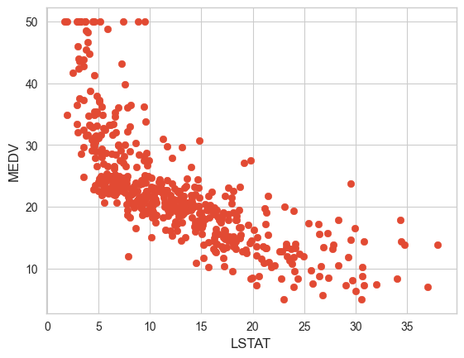

plt.scatter(df['RM'], df['MEDV'], marker='o')  
plt.xlabel('RM')  
plt.ylabel('MEDV')

Text(0, 0.5, 'MEDV')

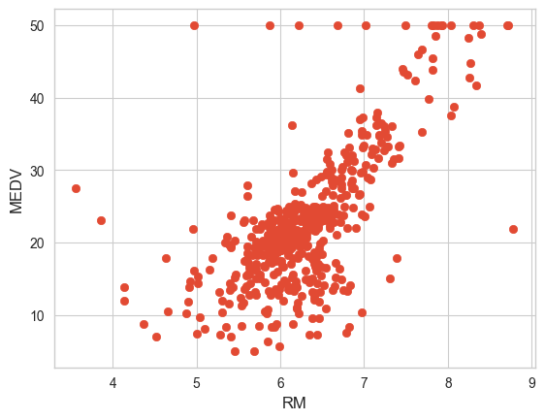

fig = plt.figure(figsize=(18,15))  
ax = fig.add_subplot(111, projection='3d')  
   
ax.scatter(df['LSTAT'],  
 df['RM'],  
 df['MEDV'],  
 c='b')  
   
ax.set_xlabel("LSTAT")  
ax.set_ylabel("RM")  
ax.set_zlabel("MEDV")  
plt.show()

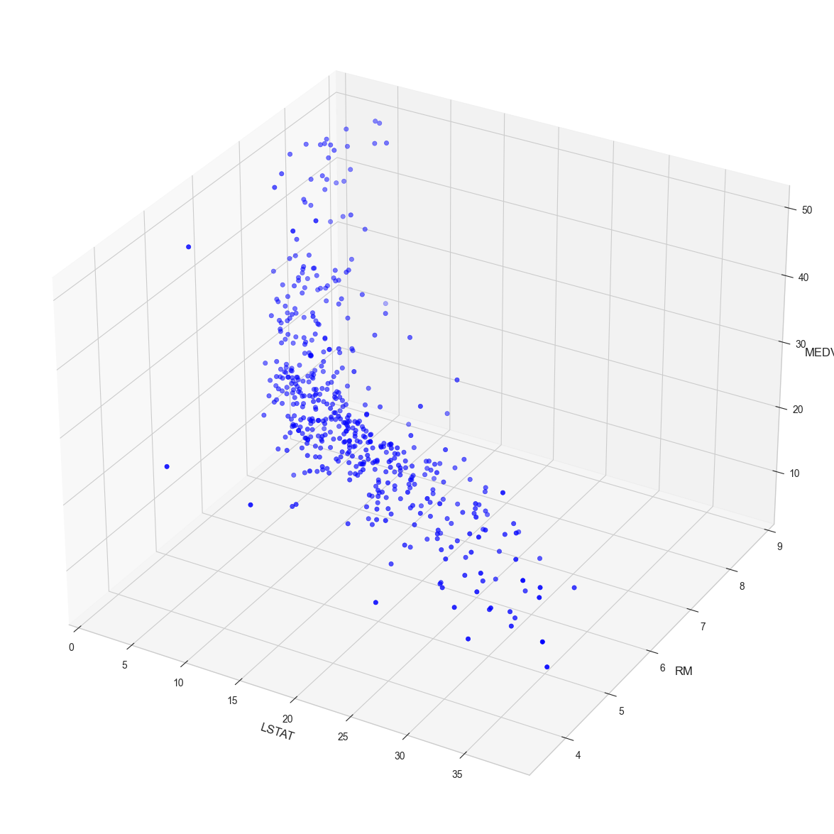

x = pd.DataFrame(np.c_[df['LSTAT'], df['RM']], columns = ['LSTAT','RM'])  
Y = df['MEDV']

from sklearn.model_selection import train_test_split  
x_train, x_test, Y_train, Y_test = train_test_split(x, Y, test_size = 0.3, random_state=5)

print(x_train.shape)  
print(Y_train.shape)

(354, 2)  
(354,)

print(x_test.shape)  
print(Y_test.shape)

(152, 2)  
(152,)

model = LinearRegression()  
model.fit(x_train, Y_train)  
price_prediction = model.predict(x_test)

print('R-Squared: %.4f' % model.score(x_test,Y_test))

R-Squared: 0.6162

mse = mean_squared_error(Y_test, price_prediction)  
mse

36.49422110915324

plt.scatter(Y_test, price_prediction)  
plt.xlabel("Actual price")  
plt.ylabel("Predicted prices")  
plt.title("Actual prices vs Predicted prices")

Text(0.5, 1.0, 'Actual prices vs Predicted prices')

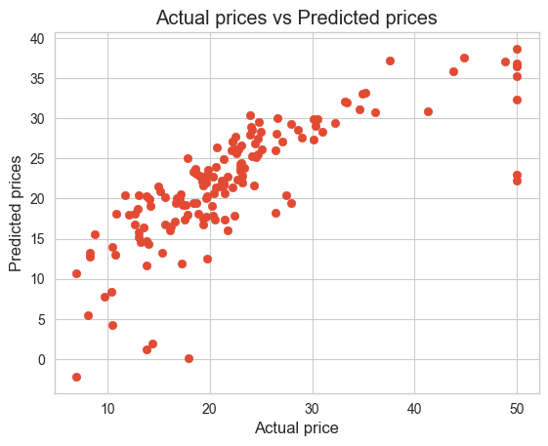

print(model.intercept_)  
print(model.coef_)

0.38437936780346504  
[-0.65957972 4.83197581]

print(model.predict([[30,5]]))

[4.75686695]

c:\Users\tien2\miniconda3\lib\site-packages\sklearn\base.py:464: UserWarning: X does not have valid feature names, but LinearRegression was fitted with feature names  
 warnings.warn(

### Plotting the 3D Hyperlane

import matplotlib.pyplot as plt  
import pandas as pd  
import numpy as np  
from mpl_toolkits.mplot3d import Axes3D  
   
from sklearn.datasets import fetch_openml  
  
dataset = fetch_openml(name='boston')  
   
df = pd.DataFrame(dataset.data, columns=dataset.feature_names)  
df['MEDV'] = dataset.target  
  
x = pd.DataFrame(np.c_[df['LSTAT'], df['RM']], columns = ['LSTAT','RM'])  
Y = df['MEDV']  
   
fig = plt.figure(figsize=(18,15))  
ax = fig.add_subplot(111, projection='3d')  
   
ax.scatter(x['LSTAT'],  
 x['RM'],  
 Y,  
 c='b')  
   
ax.set_xlabel("LSTAT")  
ax.set_ylabel("RM")  
ax.set_zlabel("MEDV")  
   
#---create a meshgrid of all the values for LSTAT and RM---  
x_surf = np.arange(0, 40, 1) #---for LSTAT---  
y_surf = np.arange(0, 10, 1) #---for RM---  
x_surf, y_surf = np.meshgrid(x_surf, y_surf)  
   
from sklearn.linear_model import LinearRegression  
model = LinearRegression()  
model.fit(x, Y)  
   
#---calculate z(MEDC) based on the model---  
z = lambda x,y: (model.intercept_ + model.coef_[0] * x + model.coef_[1] * y)  
   
ax.plot_surface(x_surf, y_surf, z(x_surf,y_surf),  
 rstride=1,  
 cstride=1,  
 color='None',  
 alpha = 0.4)  
   
plt.show()

c:\Users\tien2\miniconda3\lib\site-packages\sklearn\datasets\_openml.py:303: UserWarning: Multiple active versions of the dataset matching the name boston exist. Versions may be fundamentally different, returning version 1.  
 warn(  
c:\Users\tien2\miniconda3\lib\site-packages\sklearn\datasets\_openml.py:1002: FutureWarning: The default value of `parser` will change from `'liac-arff'` to `'auto'` in 1.4. You can set `parser='auto'` to silence this warning. Therefore, an `ImportError` will be raised from 1.4 if the dataset is dense and pandas is not installed. Note that the pandas parser may return different data types. See the Notes Section in fetch_openml's API doc for details.  
 warn(

