Phase Coherent generation with HVI and FPGA processing

**Objective:**

* Generate phase coherent amplitude modulated RF pulses.
* Outputs. Ch0 and CH1 from AWG (M3202A), Trg from Digitizer (M3102A)
* Precise control of the carrier phase and frequency in each channel
* Perform a coherent phase shift from pulse to pulse.
* Realtime phase measurement with FPGAflow
* Accurate timing and synchronization control using HVI
* Realtime frequency adaptation base on phase measurement with HVI

**HW setup:**

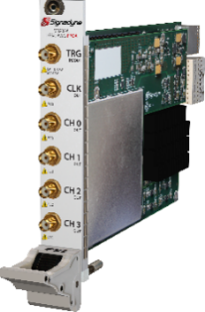

**AWG**

**M3202A**

**Digitizer**

**M3102A**

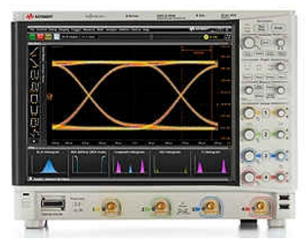

**=>**

**Scope**

**Ch0**

**Scope**

**Ch1**

**Scope**

**Ch3**

**Screenshots:**

1. Oscilloscope

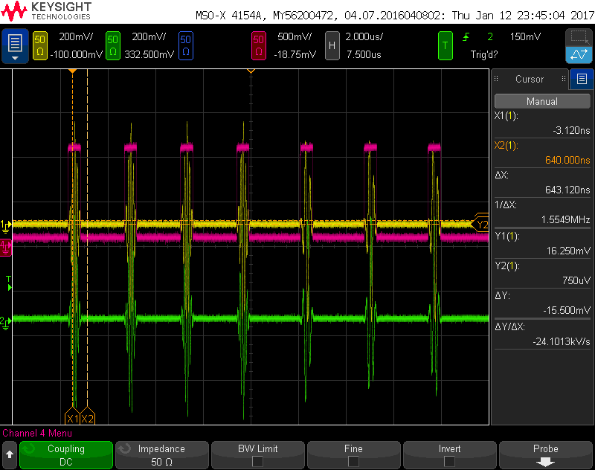

1. VIRTUALknob

